Supplementary Material

Preliminary analysis of intestinal flora characteristics in children with obstructive sleep apnea hypopnea syndrome

Zhihui Wang1,2†, Luting Zhou1#, Yanyu He1, Xueyun Xv1, Meng Lv1, Zhen Zhang1, Fengqian Wang1, Shuqi Wang1, Yuqing Wang1*

1 Department of Respiration, Children’s Hospital of Soochow University, No.303 Jing De Road, Suzhou 215003, China

2 Jinan Maternity And Child Care Hospital Affiliated to Shandong First Medical University, No.22029, Jing Shi Road, Jinan 250000, China

**\* Correspondence:**Corresponding Author: Yuqing Wang  
email: wang_yu_qing@126.com

†The author is first authorship.

# The author is co-first authorship.

## Supplementary Figures

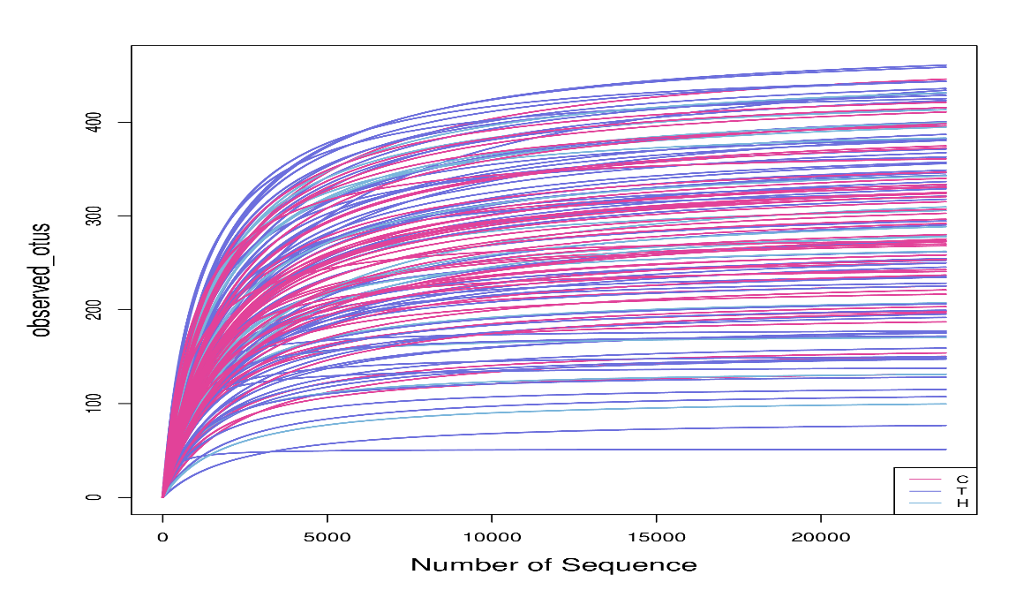

**Supplementary Figure 1.** Rarefaction Curve: The curve directly reflects the rationality of the detected sequencing data and indirectly reflects the richness of species. The curve of each sample tended to be flat, indicating that the amount of measured data was saturated and the sequencing depth reached a very high level.

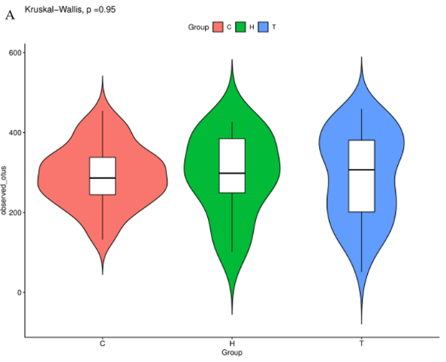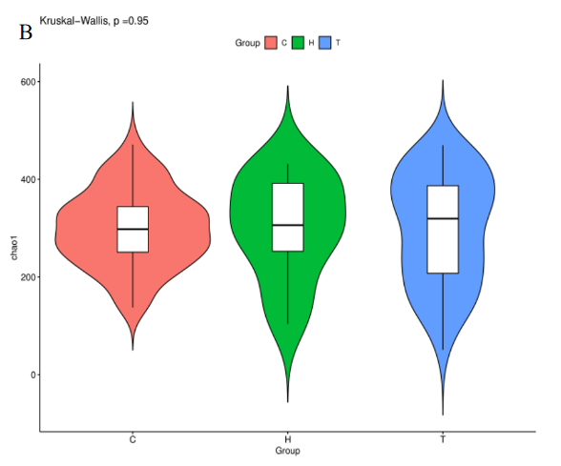

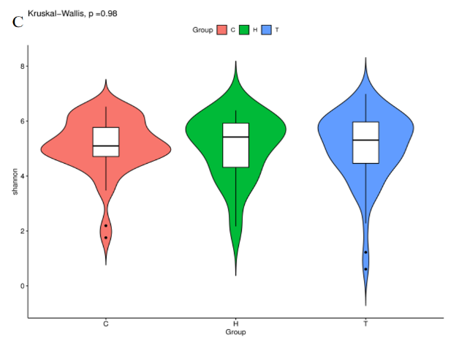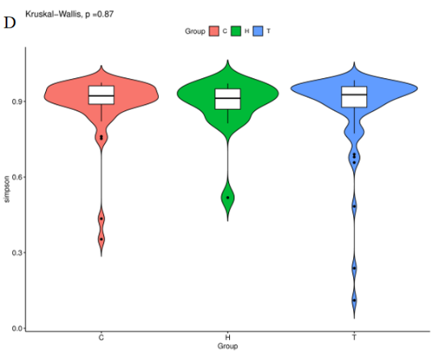

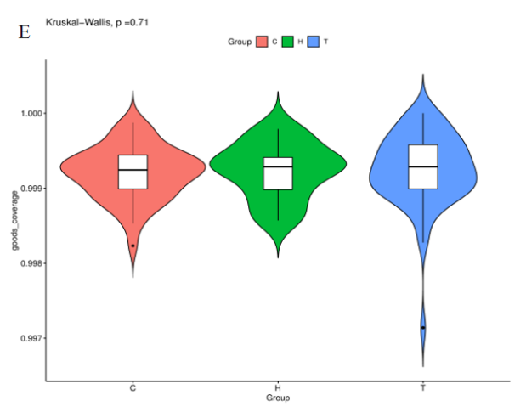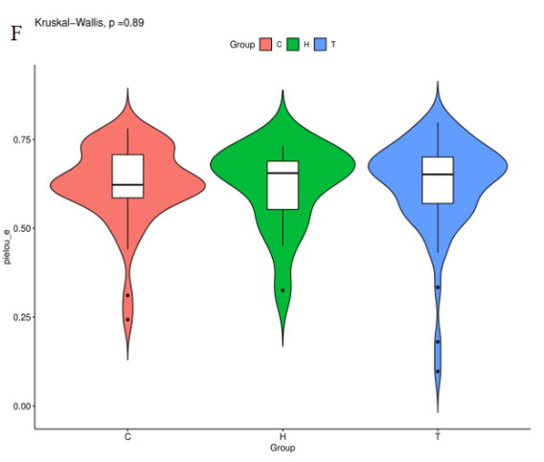

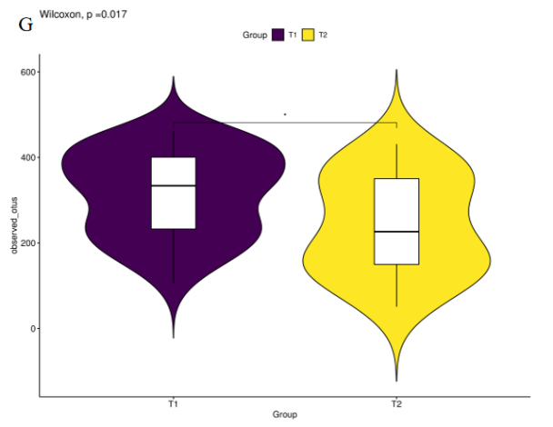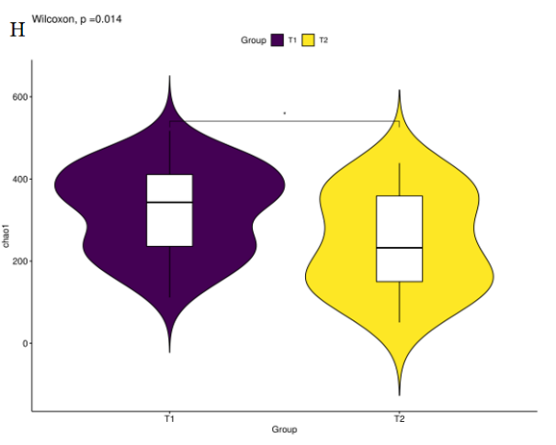

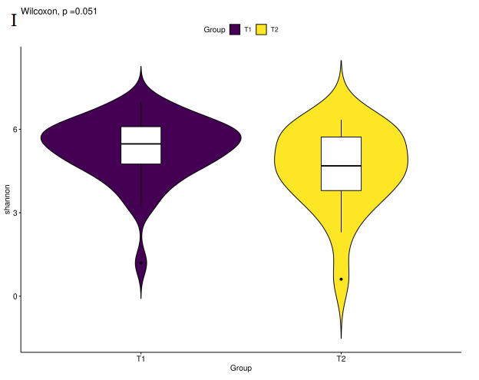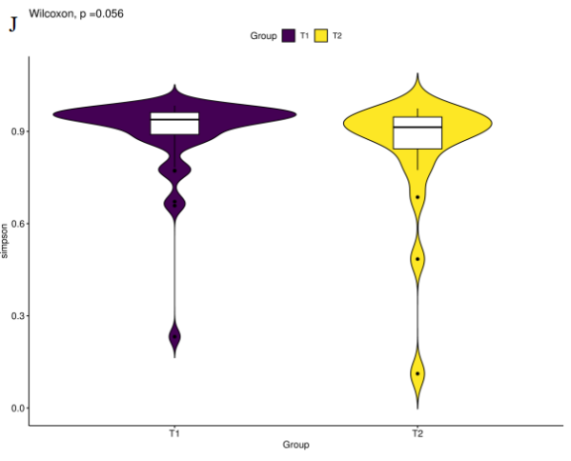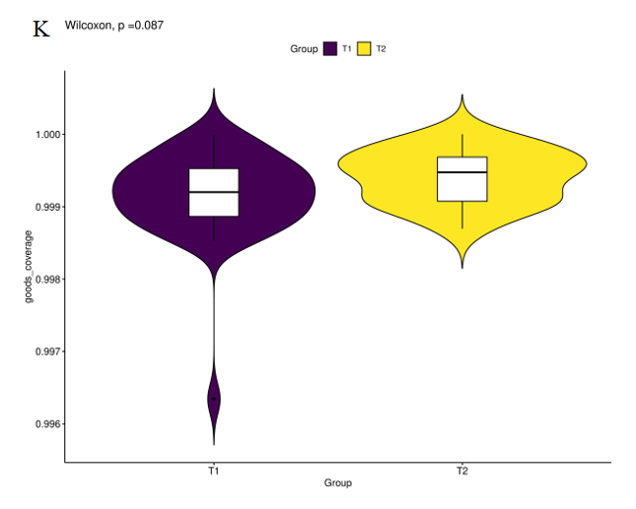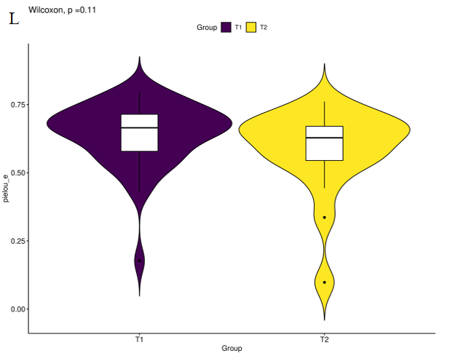

**Supplementary Figure 2.**  Analysis of Alpha diversity.

Note: A-F shows the alpha diversity of groups C, T, and H; G-L shows the alpha diversity of groups T1 and T2; C: control group, T: OSAHS group, H: simple snoring group,T1: mild OSAHS group, T2: moderate to severe OSAHS group; ★：P＜0.05.

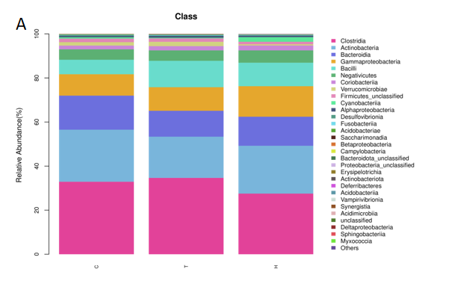

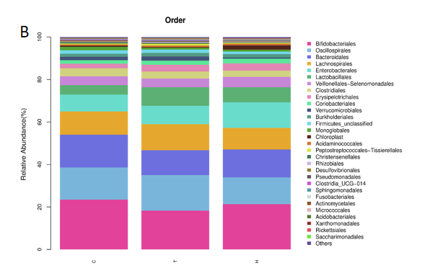

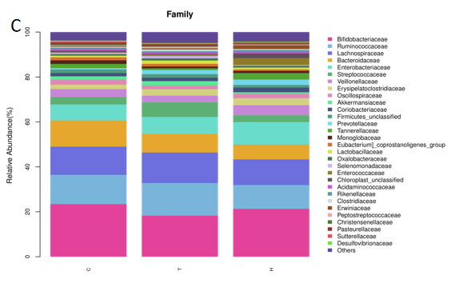

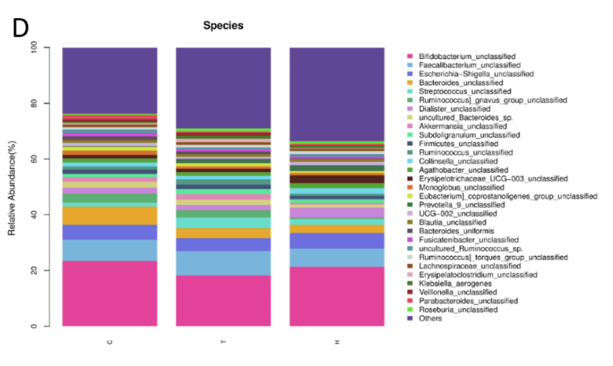

**Supplementary Figure 3.** Histogram of species classification; Class (A), Order (B), Family(C) and Species(D) levels. Note: C: control group, T: OSAHS group, H: simple snoring group; In the figure, the horizontal axis is the grouping, and the vertical axis is the relative abundance of a bacterial group. Different colors correspond to different species at the same level.

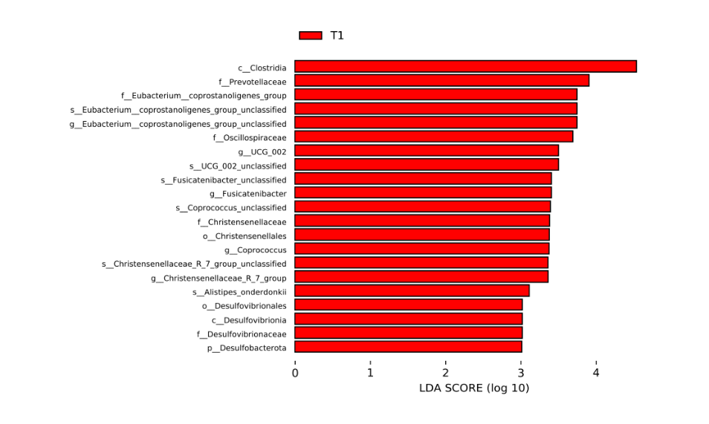

**Supplementary Figure 4.** Histogram of LDA distribution: Comparison of mild OSAHS group and moderate to severe OSAHS group. Note: Relative abundance of the most discriminant fecal metabolites according to LEfSe. T1: mild OSAHS group.