Supplementary Material

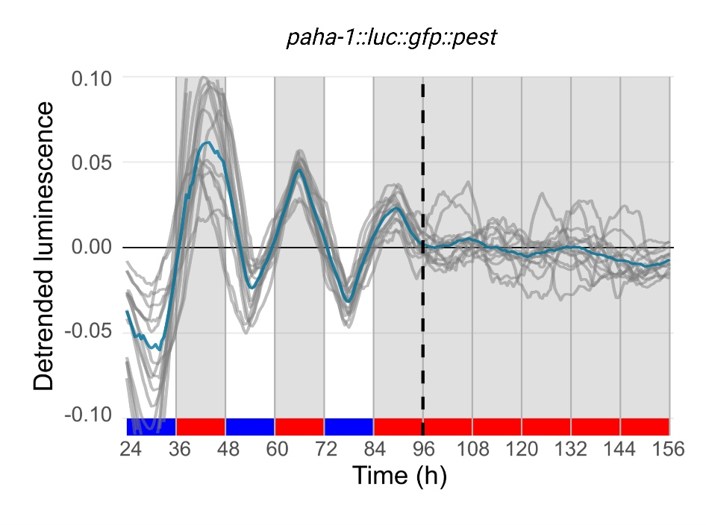
Supplementary Figure 1. Reporter activity of all adult populations under dual cyclic conditions (LD/CW, 15.5/17 °C) and FR conditions (DD/WW, 17 °C). Luminescence signals are shown as mean ± SEM in blue line and all the individual wells are represented in the gray line. VQ1071 qvEx295 [paha-1::luc::gfp::pest] strain, n total = 30. Each population consisted of 50 adult nematodes per well.

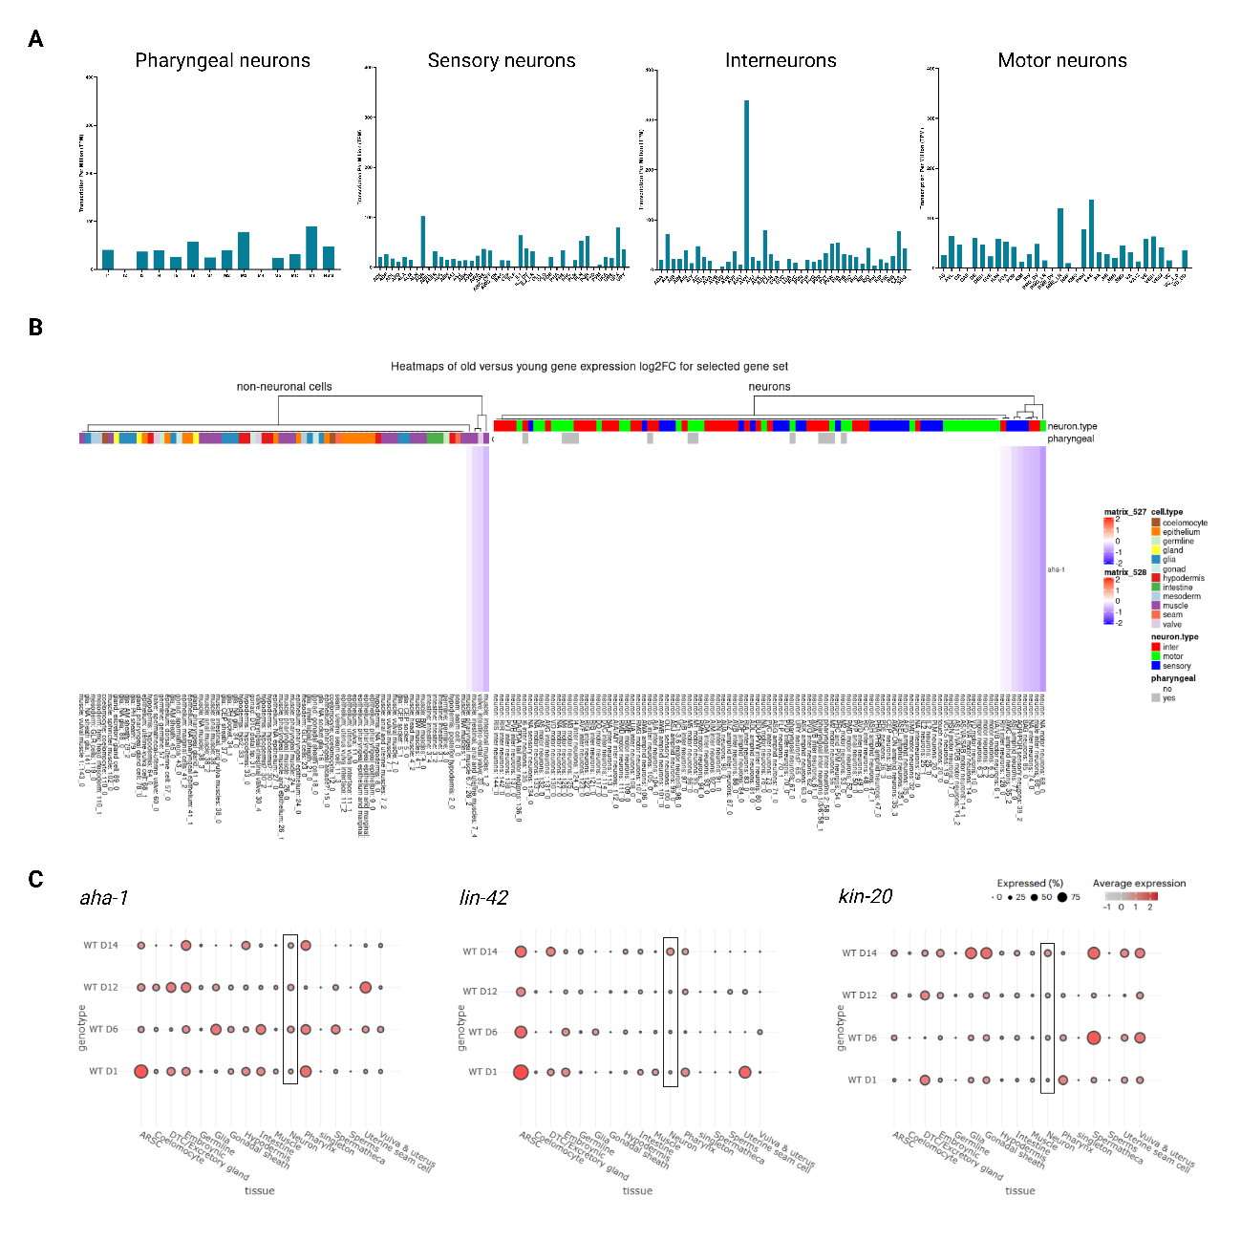

Supplementary Figure 2. Expression of aha-1 by single-cell RNA-seq. (A) Representative expression of aha-1 gene in sensory neurons, interneurons, motor neurons, and pharyngeal neurons. Data obtained from CeNGEN (https://www.cengen.org/). The scale represents the percentage of expression of the genes of interest. TPM stands for transcription per million. Each bar represents a neuron. (B) Heatmap of gene expression changes (log2FC between days 8,11,15 and days 1,3,5) across all cell type clusters for aha-1 gene. The heatmap was from obtained (https://c.elegans.aging.atlas.research.calicolabs.com/embeddings). (C) Dot plot visualizing the cell-type-specific expression patterns of the aha-1, lin-42, and kin-20 genes, based on publicly available RNA-seq data from the C. elegans Aging Atlas (http://mengwanglab.org/atlas). Dot size represents the percentage of cells within a specific tissue expressing the gene, and the color intensity indicates the average expression level of the gene across the tissue. D: day; WT: wild-type strain.

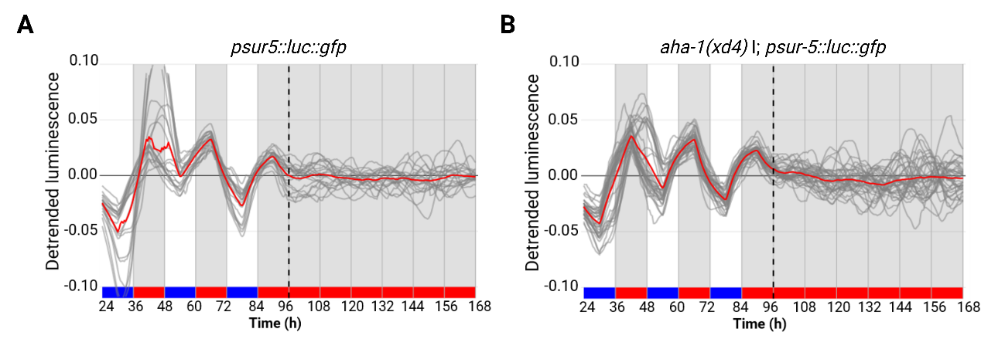
Supplementary Figure 3. Reporter activity of all adult populations under dual cyclic conditions (LD/CW, 15.5/17 °C) and FR conditions (DD/WW, 17 °C). Luminescence signals are shown as mean ± SEM in red line and all the individual wells are represented in the gray line (A) control, n total = 39, (B) aha-1(xd4), n total = 72. Each population consisted of 50 adult nematodes per well.

