Supplementary Material

# Supplementary Figures and Tables

## Supplementary Figures

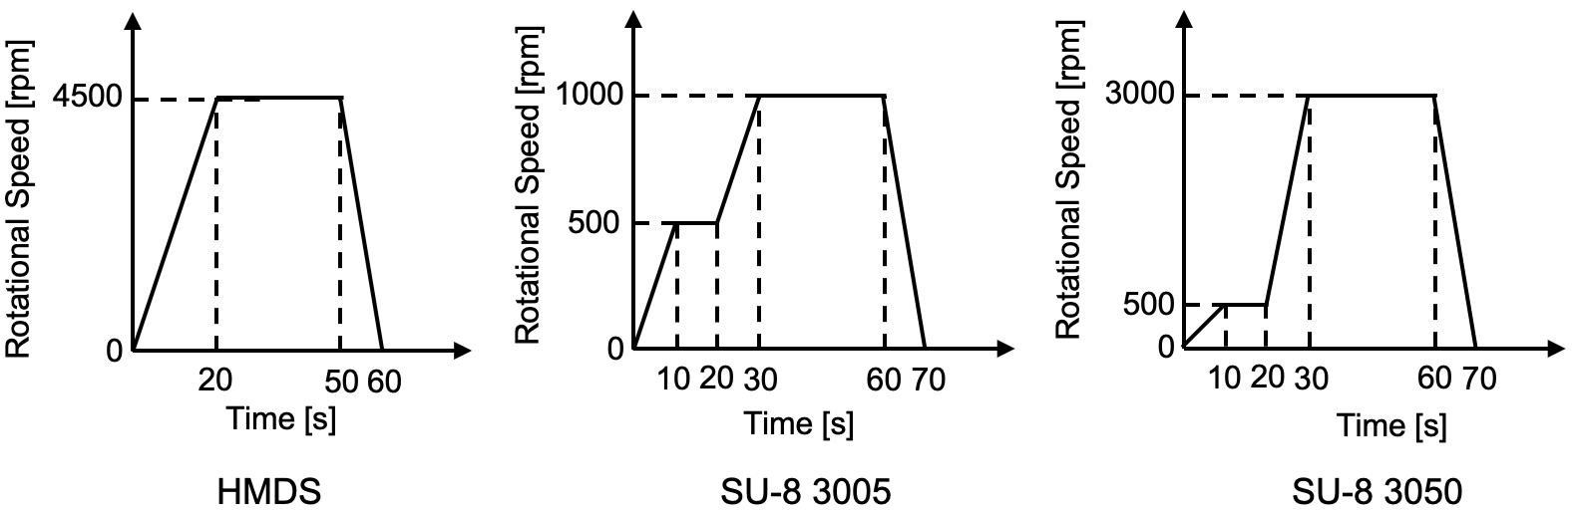

**Supplementary Figure 1.** Parameters of spin-coating.

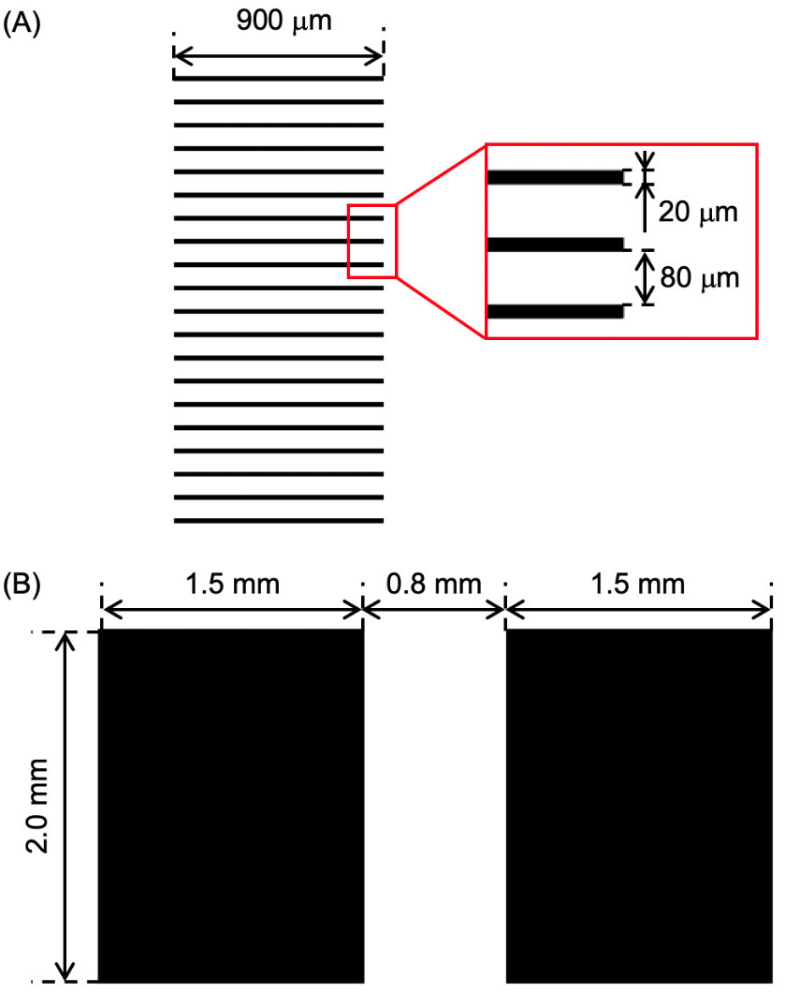

**Supplementary Figure 2.** Exposure patterns of the SU-8 molds. (A) Shape of the microtunnel mold; 20 microtunnels were made in rectangular patterns. (B) Shape of the culture chamber mold; 2 chambers were made in rectangular patterns.

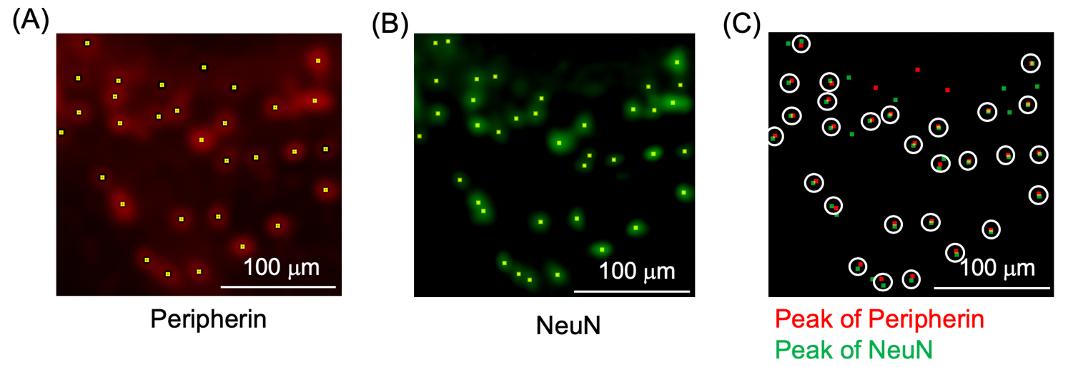

**Supplementary Figure 3.** Peak Detection in Immunofluorescence Staining of DRG Neurons. The Peripherin+ areas are shown in red (A), while the NeuN+ areas are shown in green (B). Brightness peaks are depicted in yellow in both (A) and (B). (C) Identification of Peripherin+/NeuN+ neurons. Peaks in the Peripherin+ regions are indicated in red, and those in the NeuN+ regions are indicated in green. White-circled areas containing both red and green peak points represent Peripherin+/NeuN+ neurons. Peripherin+/NeuN+ neurons were identified based on the distance between the peaks.

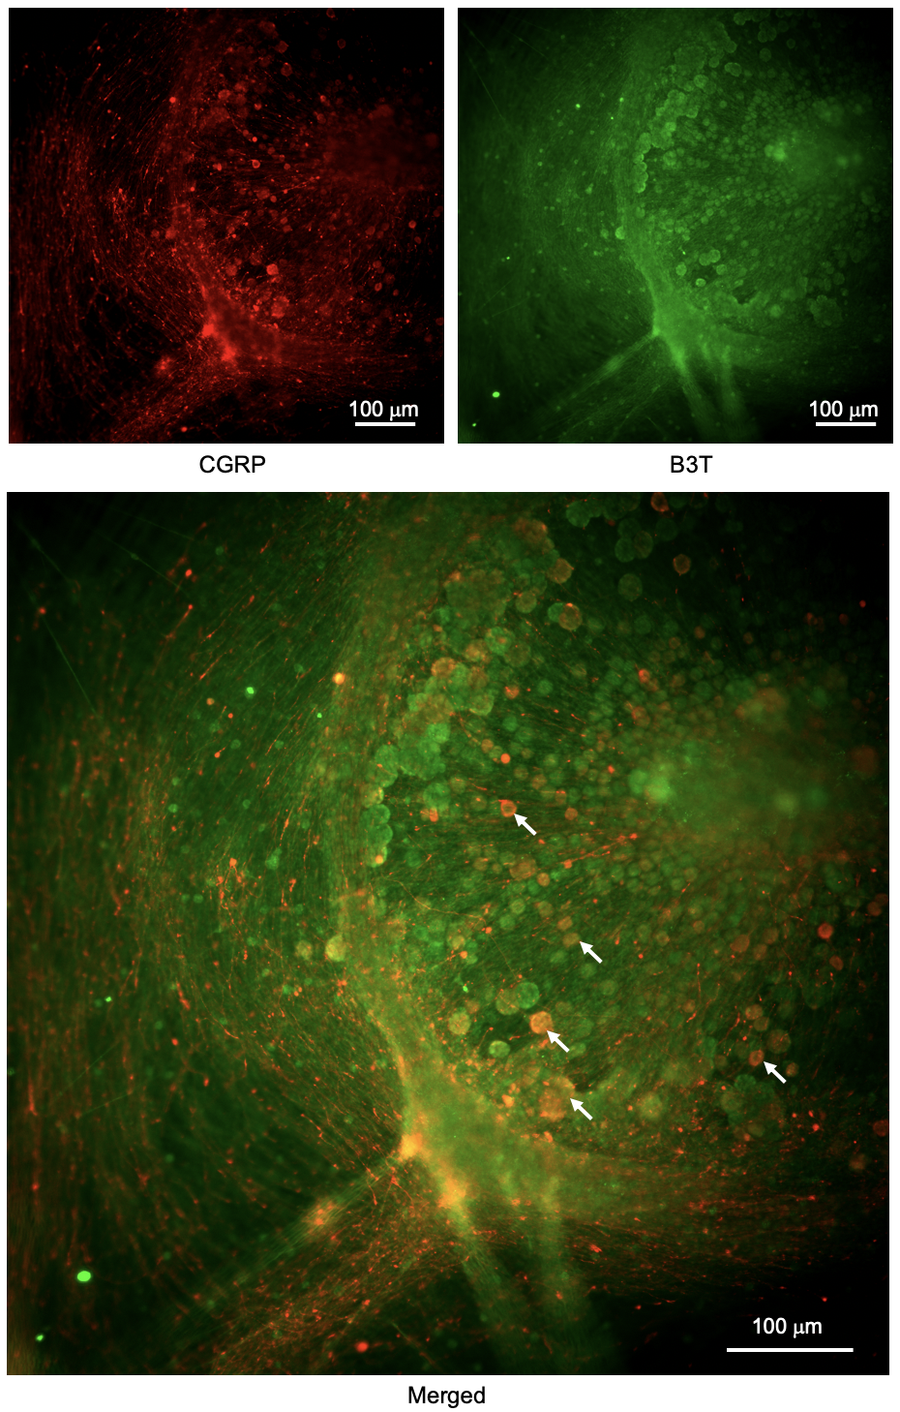

**Supplementary Figure 4.** Immunofluorescence staining of DRG neurons. CGRP+ neurons are indicated in red, and B3T+ neurons are depicted in green. A total of 10.8% of DRG neurons were positive for CGRP.