Supplemental Material
Performance Indicators metrics
To evaluate the performance of fitted models in testing and validation average mean absolute error (MAE), root mean square error (RMSE), and mean bias error (MBE) were used. Additional metrics including R² and Kling Gupta model efficiency (KGE; Gupta et al. 2009) were used to evaluate model testing. Equations, range of values and outcome goals are identified in Table S1.
Table S1. Model performance indices used in this study. $y$ = observed time-series data; $\hat{y}$ = simulated time series data; ε = error or model residuals ($ε=y_{i}-{\hat{y}}_{i}$); σ = dataset standard deviation; µ = dataset mean; RDF = residual degrees of freedom.
Name | Description | Formula | Range | Goal
MAE | Mean absolute error | $$1/n ∙∑\left|\hat{y_{i}}-y_{i}\right|$$ | $$-∞- ∞$$ | Min
RMSE | Root mean square error | $$\sqrt{\frac{∑ε_{i}^{2}}{RDF}}$$ | $$-∞- ∞$$ | Min
MBE | Mean bias error | $$1/n ∙∑\left(\hat{y_{i}}-y_{i}\right)$$ | $$-∞- ∞$$ | Min
r | Correlation coefficient | $${cov(y,\hat{y})}/{\left(σ_{y}∙σ_{\hat{y}}\right)}$$ | -1.0 – 1.0 | 1.0
R² | Coefficient of determination | $$1-\frac{∑{\left(y_{i}-\hat{y_{i}} \right)}^{2}}{∑{\left(\hat{y_{i}}-μ_{y}\right)}^{2}}$$ | 0.0 – 1.0 | 1.0
β | Bias ratio of dataset means | $${μ_{\hat{y}}}/{μ_{y}}$$ | $$-∞- ∞$$ | 1.0
α | Ratio of standard deviation | $${σ_{\hat{y}}}/{σ_{y}}$$ | $$-∞- ∞$$ | 1.0
KGE | Kling-Gupta efficiency | $$1-\sqrt{\left[{\left(β-1\right)}^{2}+{\left(α-1 \right)}^{2}+{\left(r-1\right)}^{2}\right]}$$ | $$-∞- 1.0$$ | 1.0

Table S2. Comparison of Lake Okeechobee System Operating Manual (LOSOM) and Lake Okeechobee Component A Reservoir (LOCAR) alternative and the description or outcome of the various comparisons.
Alternative 1 | Alternative 2 | Description/Outcome
NA25f | PA25 | LORS08 vs LOSOM
NA25f | FWOLL | LORS08 vs LOSOM with EAA Reservoir  (Effect of southern storage)
NA25f | LCR1 | LORS08 vs LOSOM with LOCAR and EAA Reservoir  (Effect of northern and southern storage with LOSOM)
PA25 | FWOLL | Incremental LOSOM  (addition of southern storage within LOSOM)
PA25 | LCR1 | Incremental LOSOM  (combined effect of northern and southern storage within LOSOM)
FWOLL | LCR1 | Incremental LOSOM (LOCAR)  (Effect of the addition of northern storage within LOSOM)

Table S3. Slope and intercept values for each variable and effect for chlorophyll-a (1), frequency of exceeding 20 µg L⁻¹ (2), and frequency of exceeding 20 µg L⁻¹ (3).
Variable | Effects | Ecological Zone | Intercept | Intercept  Std. Error | Slope | Slope  Std. Error
(1) Chl-a Conc. | Fixed |  | 2.70 | 0.25 | 0.18 | 0.09
 | Random | Littoral North | 0.58 | 0.26 | -0.15 | 0.10
 |  | Littoral South | -0.67 | 0.28 | 0.23 | 0.10
 |  | Littoral West | -0.30 | 0.27 | 0.11 | 0.10
 |  | Nearshore | 0.02 | 0.27 | -0.01 | 0.10
 |  | Pelagic | 0.38 | 0.27 | -0.18 | 0.10
(2) ƒ(Chl-a >20 μg/L) | Fixed |  | -0.92 | 0.59 | 0.26 | 0.22
 | Random | Littoral North | 1.27 | 0.61 | -0.35 | 0.23
 |  | Littoral South | -1.99 | 0.64 | 0.79 | 0.24
 |  | Littoral West | -0.06 | 0.62 | -0.04 | 0.23
 |  | Nearshore | -0.11 | 0.60 | -0.03 | 0.23
 |  | Pelagic | 0.89 | 0.60 | -0.37 | 0.23
(3) ƒ(Chl-a >40 μg/L) | Fixed |  | -2.26 | 0.39 | 0.25 | 0.15
 | Random | Littoral North | 0.98 | 0.42 | -0.27 | 0.17
 |  | Littoral South | -1.06 | 0.47 | 0.46 | 0.18
 |  | Littoral West | 0.14 | 0.45 | -0.00 | 0.17
 |  | Nearshore | -0.33 | 0.43 | 0.06 | 0.17
 |  | Pelagic | 0.27 | 0.42 | -0.25 | 0.17

Table S4. Hierarchical generalized additive model results for chlorophyll-a (1) total phosphorus (2) and dissolved inorganic nitrogen concentration within Lake Okeechobee. Minimum selection criteria and method are defined as GCV.Cp (Generalized Cross Validation). Other values provided include effective degrees of freedom (edf), adjusted R2 and deviance explained (Dev. Exp.).
Predicted  Variable | Term | Estimate | Standard  Error | t-value | ρ-value | edf | F-value | ρ-value | Adj R²  (Dev. Exp.) | Smooth  Selection  Criterion | Scale  (n)
(1) Chl-a | Intercept | 2.83 | 0.15 | 19.52 | < 0.01 | --- | --- | --- | 0.70  (0.84) | 300.39  (GCV.Cp) | 0.34  (93)
 | WRT | -0.0003 | 0.0002 | -1.27 | 0.21 | --- | --- | ---
 | TP | 5.79 | 1.61 | 3.60 | < 0.01 | --- | --- | ---
 | DIN | -3.84 | 1.11 | -3.46 | < 0.01 | --- | --- | ---
 | ti(TP,DIN):EcoZone - Lit. North | --- | --- | --- | --- | 2.61 | 1.25 | 0.21
 | ti(TP,DIN):EcoZone - Lit. South | --- | --- | --- | --- | 1.63 | 1.92 | 0.18
 | ti(TP,DIN):EcoZone - Lit. West | --- | --- | --- | --- | 6.24 | 1.48 | 0.24
 | ti(TP,DIN):EcoZone - Nearshore | --- | --- | --- | --- | 2.04 | 1.25 | 0.43
 | ti(TP,DIN):EcoZone - Pelagic | --- | --- | --- | --- | 1.00 | 0.01 | 0.93
 | s(Z):EcoZone - Lit. North | --- | --- | --- | --- | 1.00 | 0.01 | 0.94
 | s(Z):EcoZone - Lit. South | --- | --- | --- | --- | 3.22 | 0.00 | 1.00
 | s(Z):EcoZone - Lit. West | --- | --- | --- | --- | 1.00 | 4.22 | 0.04
 | s(Z):EcoZone - Nearshore | --- | --- | --- | --- | 1.00 | 18.10 | < 0.01
 | s(Z):EcoZone - Pelagic | --- | --- | --- | --- | 2.87 | 0.01 | 1.00
 | s(Inflow Q) | --- | --- | --- | --- | 0.19 | 0.02 | 0.97
 | s(EcoZone) | --- | --- | --- | --- | 2.88 | 4.23 | < 0.01
(2) Total Phosphorus | Intercept | -2.43 | 0.16 | -14.97 | < 0.01 | --- | --- | --- | 0.64  (0.71) | -193.67  (GCV.Cp) | 0.01  (94)
 | s(V):EcoZone - Lit. North | --- | --- | --- | --- | 1.00 | 0.38 | 0.54
 | s(V):EcoZone - Lit. South | --- | --- | --- | --- | 2.17 | 6.42 | < 0.01
 | s(V):EcoZone - Lit. West | --- | --- | --- | --- | 3.02 | 6.23 | < 0.01
 | s(V):EcoZone - Nearshore | --- | --- | --- | --- | 1.00 | 4.05 | 0.05
 | s(V):EcoZone - pelagic | --- | --- | --- | --- | 1.00 | 0.13 | 0.72
 | s(Outflow Q) | --- | --- | --- | --- | 2.67 | 4.31 | < 0.01
 | s(EcoZone) | --- | --- | --- | --- | 3.83 | 24.08 | < 0.01
(3) Dissolved Inorganic N | Intercept | -3.56 | 0.43 | -8.38 | < 0.01 | --- | --- | --- | 0.58  (0.61) | -139.57  (GCV.Cp) | 0.13  (93)
 | Outflow Q | 2x10⁻⁹ | 6x10⁻¹⁰ | 3.51 | < 0.01 | --- | --- | ---
 | V | 0.18 | 0.12 | 1.46 | 0.15 | --- | --- | ---
 | s(WRT):EcoZone - Lit. North | --- | --- | --- | --- | 3.01 | 3.22 | 0.04
 | s(WRT):EcoZone - Lit. South | --- | --- | --- | --- | 1.40 | 0.44 | 0.48
 | s(WRT):EcoZone - Lit. West | --- | --- | --- | --- | 2.60 | 1.26 | 0.25
 | s(WRT):EcoZone - Nearshore | --- | --- | --- | --- | 2.51 | 2.13 | 0.09
 | s(WRT):EcoZone - Pelagic | --- | --- | --- | --- | 2.71 | 1.51 | 0.22
 | s(EcoZone) | --- | --- | --- | --- | 3.43 | 6.74 | < 0.01

Table S5. Summary statistics for observed and simulated stage elevation within Lake Okeechobee during the observed period of record and period of simulation (P.O.S.;1965 – 2016) for all alternatives.
Variable | Area/Region | Period | Alternative | Min. | Mean | St. Dev | Median | Max.
Stage  (m, NGVD29) ¹ | Lake  Okeechobee | P.O.S. ² | OBS ^{A} | 2.69 | 4.31 | 0.57 | 4.38 | 5.65
 |  |  | NA25f ^{B} | 2.49 | 4.03 | 0.57 | 4.09 | 5.37
 |  |  | PA25 ^{B} | 2.61 | 4.21 | 0.63 | 4.28 | 5.40
 |  |  | FWOLL ^{C} | 2.50 | 4.09 | 0.61 | 4.16 | 5.38
 |  |  | LCR1 ^{C} | 2.68 | 4.11 | 0.54 | 4.20 | 5.38
 |  | Summer | OBS ^{A} | 2.69 | 4.08 | 0.55 | 4.15 | 5.18
 |  |  | NA25f ^{B} | 2.49 | 3.79 | 0.54 | 3.81 | 4.84
 |  |  | PA25 ^{B} | 2.61 | 3.98 | 0.63 | 4.02 | 5.13
 |  |  | FWOLL ^{C} | 2.50 | 3.84 | 0.60 | 3.85 | 5.08
 |  |  | LCR1 ^{C} | 2.68 | 3.87 | 0.54 | 3.87 | 4.95
¹ National Geodetic Vertical Datum of 1929
² Period of Simulation (Jan 1965 - Dec 2016)
^{A} Observed data (Oct 1974 - Sept 2023)
^{B} Lake Okeechobee System Operating Manual - Operational Planning Project
^{C} Lake Okeechobee Component A Reservoir - Restoration Planning Project

Table S6. Mean (minimum – maximum) observed (OBS) and simulated chlorophyll concentration (1), frequency of exceeding 20 µg L⁻¹ (2), and frequency of exceeding 40 µg L⁻¹ (3) within Lake Okeechobee during the model fitting period (2000 – 2023) and the period of simulation (P.O.S.;1965 – 2016) for all alternatives.
Variable | Ecological Zone | OBS | NA25f | PA25 | FWOLL | LCR1
(1) Chl-a Conc. (μg L⁻¹) | Littoral North | 26.7  (13.3 - 42.6) | 27.5  (26.6 - 29.3) | 28.0  (26.6 - 30.3) | 27.7  (26.6 - 29.9) | 27.7  (26.6 - 29.5)
 | Littoral South | 18.0  (3.8 - 42.6) | 14.5  (7.6 - 34.4) | 20.2  (7.6 - 55.6) | 16.5  (7.6 - 46.0) | 16.0  (7.6 - 37.4)
 | Littoral West | 19.6  (1.4 - 51.7) | 16.9  (11.0 - 31.7) | 20.9  (11.0 - 44.4) | 18.3  (11.0 - 38.9) | 18.1  (11.0 - 33.6)
 | Nearshore | 20.3  (10.9 - 37.5) | 19.0  (15.1 - 27.5) | 21.2  (15.1 - 33.3) | 19.7  (15.1 - 30.9) | 19.7  (15.1 - 28.4)
 | Pelagic | 21.9  (11.0 - 38.2) | 21.6  (21.5 - 21.7) | 21.6  (21.5 - 21.7) | 21.6  (21.5 - 21.7) | 21.6  (21.5 - 21.7)
 | Lake wide | 21.3  (1.4 - 51.7) | 19.1  (14.9 - 28.5) | 21.5  (14.9 - 35.1) | 19.9  (14.9 - 32.4) | 19.9  (14.9 - 29.6)
(2) ƒ(Chl-a >20 μg L⁻¹) | Littoral North | 0.49  (0.00 - 0.83) | 0.56  (0.50 - 0.59) | 0.54  (0.48 - 0.59) | 0.55  (0.49 - 0.59) | 0.55  (0.50 - 0.59)
 | Littoral South | 0.31  (0.00 - 0.75) | 0.23  (0.05 - 0.71) | 0.34  (0.05 - 0.89) | 0.27  (0.05 - 0.84) | 0.26  (0.05 - 0.76)
 | Littoral West | 0.33  (0.00 - 0.75) | 0.34  (0.27 - 0.46) | 0.36  (0.27 - 0.52) | 0.34  (0.27 - 0.49) | 0.35  (0.27 - 0.47)
 | Nearshore | 0.33  (0.10 - 0.51) | 0.33  (0.26 - 0.45) | 0.36  (0.26 - 0.52) | 0.34  (0.26 - 0.49) | 0.34  (0.26 - 0.46)
 | Pelagic | 0.41  (0.17 - 0.73) | 0.45  (0.39 - 0.49) | 0.44  (0.35 - 0.49) | 0.45  (0.37 - 0.49) | 0.45  (0.38 - 0.49)
 | Lake wide | 0.37  (0.00 - 0.83) | 0.36  (0.29 - 0.50) | 0.39  (0.29 - 0.58) | 0.37  (0.29 - 0.55) | 0.37  (0.29 - 0.52)
(3) ƒ(Chl-a >40 μg L⁻¹) | Littoral North | 0.19  (0.00 - 0.45) | 0.21  (0.21 - 0.22) | 0.21  (0.21 - 0.22) | 0.21  (0.21 - 0.22) | 0.21  (0.21 - 0.22)
 | Littoral South | 0.13  (0.00 - 0.50) | 0.10  (0.03 - 0.33) | 0.17  (0.03 - 0.52) | 0.13  (0.03 - 0.44) | 0.12  (0.03 - 0.36)
 | Littoral West | 0.13  (0.00 - 0.39) | 0.15  (0.11 - 0.23) | 0.17  (0.11 - 0.29) | 0.15  (0.11 - 0.26) | 0.15  (0.11 - 0.24)
 | Nearshore | 0.12  (0.00 - 0.30) | 0.11  (0.07 - 0.19) | 0.13  (0.07 - 0.26) | 0.11  (0.07 - 0.23) | 0.11  (0.07 - 0.20)
 | Pelagic | 0.11  (0.00 - 0.31) | 0.12  (0.12 - 0.12) | 0.12  (0.12 - 0.12) | 0.12  (0.12 - 0.12) | 0.12  (0.12 - 0.12)
 | Lake wide | 0.14  (0.00 - 0.50) | 0.13  (0.09 - 0.21) | 0.15  (0.09 - 0.26) | 0.14  (0.09 - 0.24) | 0.14  (0.09 - 0.22)

Table S7. Wilcoxon pairwise two-sided comparisons between alternatives for fixed-effect model predicted chlorophyll-a concentration (1), frequency of exceedance of 20 µg L⁻¹ (2), and frequency of exceedance of 40 µg L⁻¹ (3).
Variable | Alternative 1 | Alternative 2 | V-statistic | Adjusted  ρ-value ¹
(1) Chl-a Conc. | NA25f | PA25 | 123 | < 0.01
 | NA25f | FWOLL | 323 | < 0.05
 | NA25f | LCR1 | 179 | < 0.01
 | PA25 | FWOLL | 1014 | < 0.01
 | PA25 | LCR1 | 931 | < 0.01
 | FWOLL | LCR1 | 461 | 0.39
(2) ƒ(Chl-a >20 μg/L) | NA25f | PA25 | 123 | < 0.01
 | NA25f | FWOLL | 326 | < 0.05
 | NA25f | LCR1 | 171 | < 0.01
 | PA25 | FWOLL | 1009 | < 0.01
 | PA25 | LCR1 | 928 | < 0.01
 | FWOLL | LCR1 | 448 | 0.31
(3) ƒ(Chl-a >40 μg/L) | NA25f | PA25 | 124 | < 0.01
 | NA25f | FWOLL | 323 | < 0.05
 | NA25f | LCR1 | 179 | < 0.01
 | PA25 | FWOLL | 1014 | < 0.01
 | PA25 | LCR1 | 931 | < 0.01
 | FWOLL | LCR1 | 462 | 0.39
¹ ρ-value adjusted using the Holm-Bonferroni method

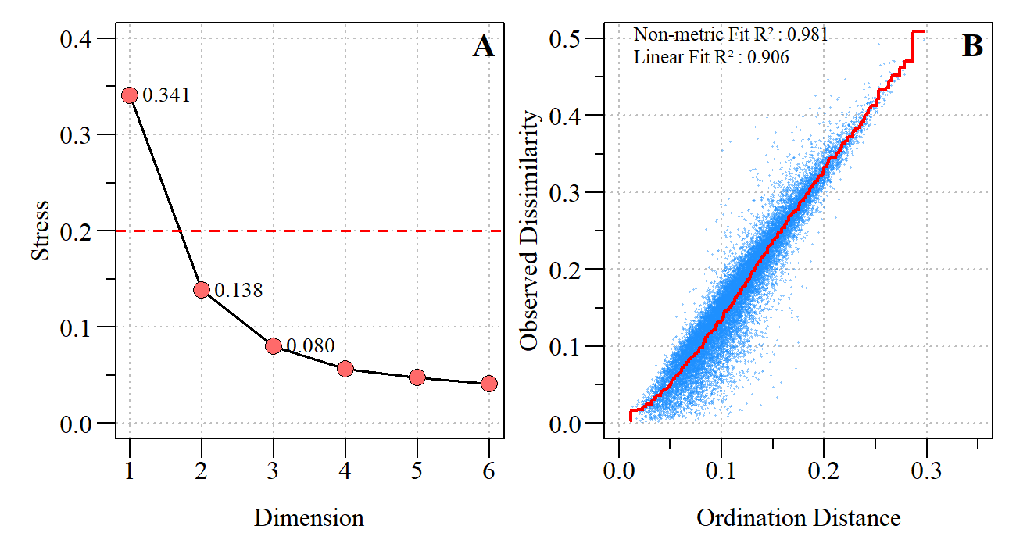
Figure S1. A) Nonmetric Multidimensional Scaling (NMDS) screeplot with the stress values of the first three dimensions identified. B) NMDS shepherds plot to show the relative goodness of fit of observed dissimilarity and distance.

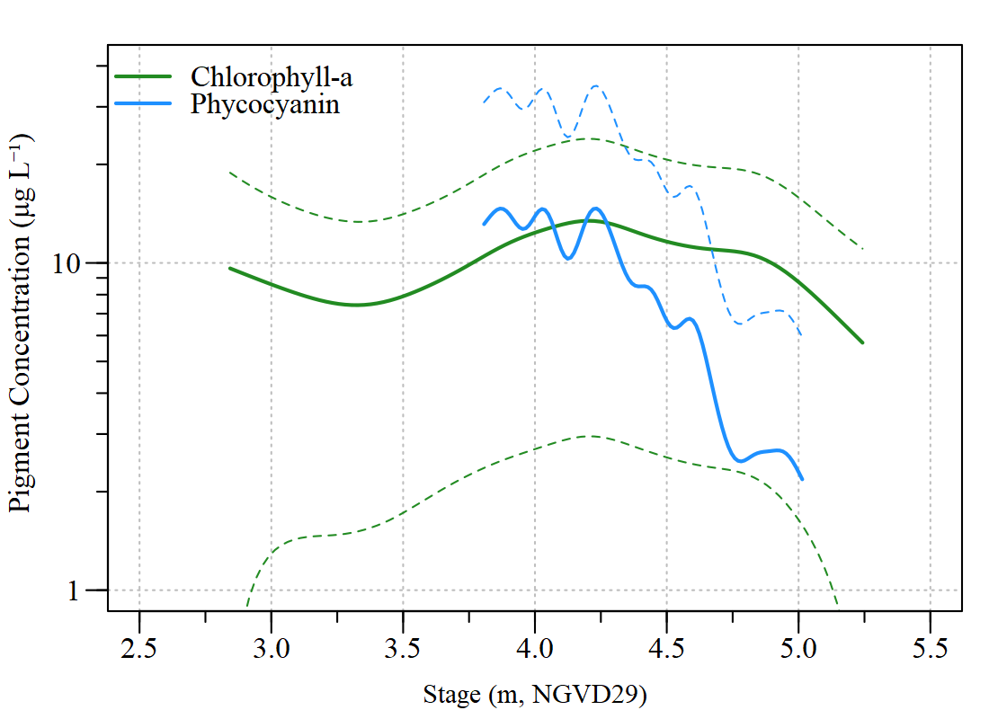
Figure S2. Average (± 95% confidence intervals) response curve for chlorophyll-a and phycocyanin generalized additive models relative to Lake Okeechobee summer average stage elevation.

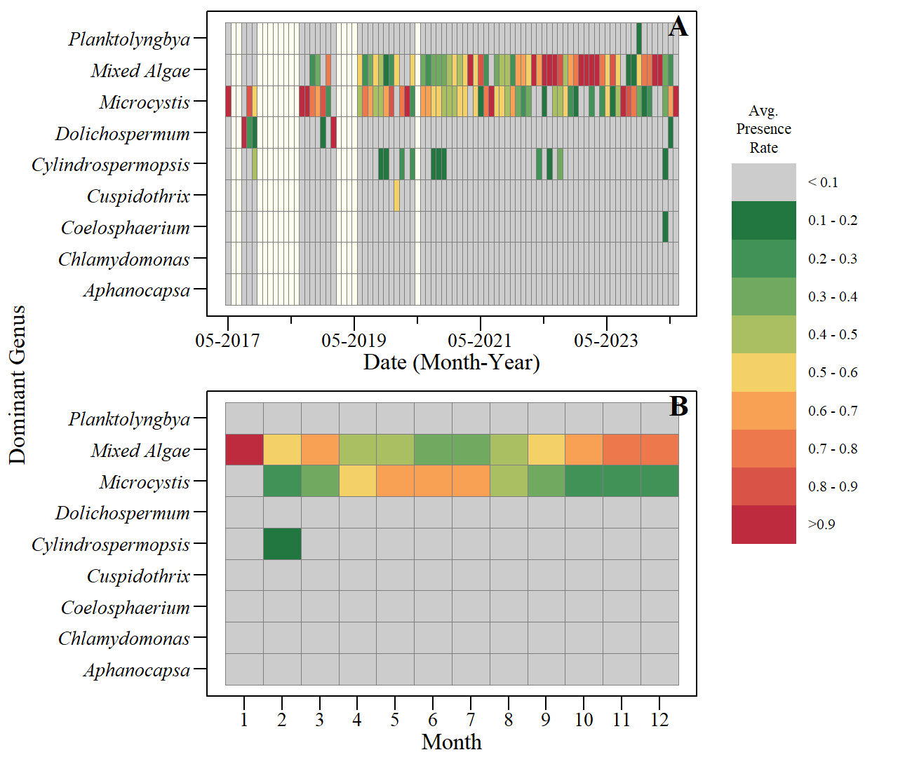
Figure S3. The average presence rate of cyanobacteria and algae genera across Lake Okeechobee observed between May 2017 to April 2024 represented as A) time-series during the period and B) seasonal (monthly) average values for the entire period of record. Data provided by Florida Department of Environmental Protection (https://floridadep.gov/dear/algal-bloom/content/algal-bloom-sampling-results).

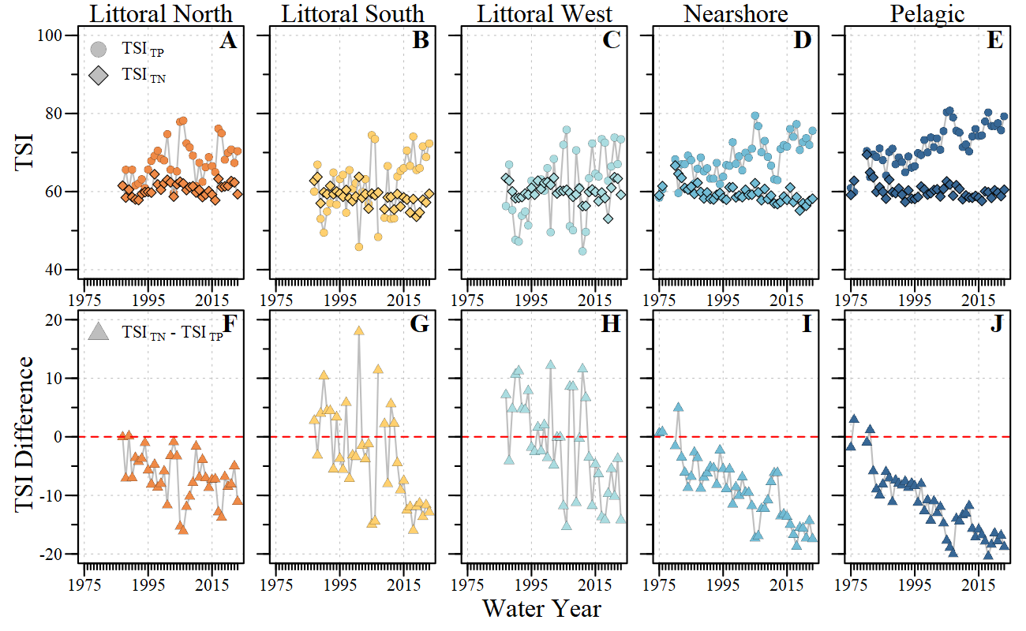
Figure S4. Mean summer trophic state index (TSI) for total phosphorus (TP) and total nitrogen (TN) calculated consistent with Carlson (2007) across Lake Okeechobee ecological regions (A – E) and the difference TSI_{TN} and TSI_{TP} (F – J) between water year 1975 to 2024 (WY; May – April). Negative TSI difference values suggest potential N limitation while positive TSI values suggest potential P limitation as indicated by Havens (1995).

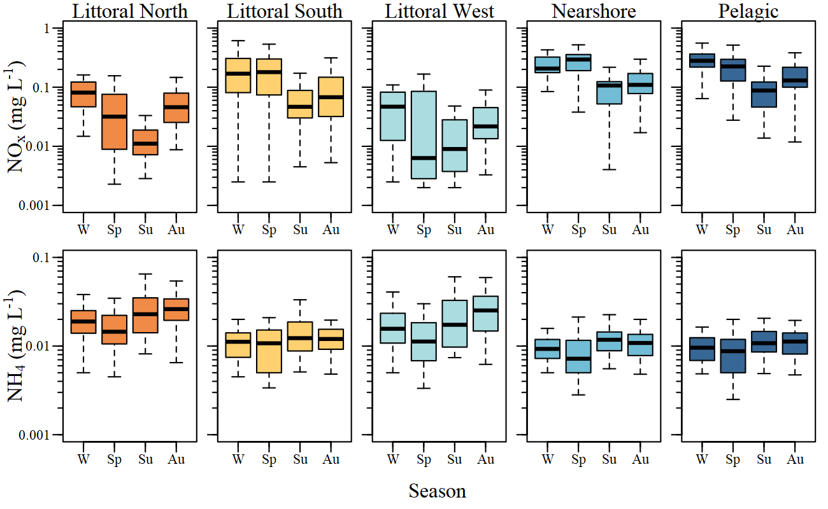
Figure S5. Season mean nitrate-nitrite (NO_{x}) and ammonium (NH₄) concentrations across Lake Okeechobee ecological regions and seasons water year 1975 to 2024 (WY; May – April). Seasons are defined as winter (W) January to March, spring (Sp) April, summer (Su) May to August and autumn (Au) September to December.

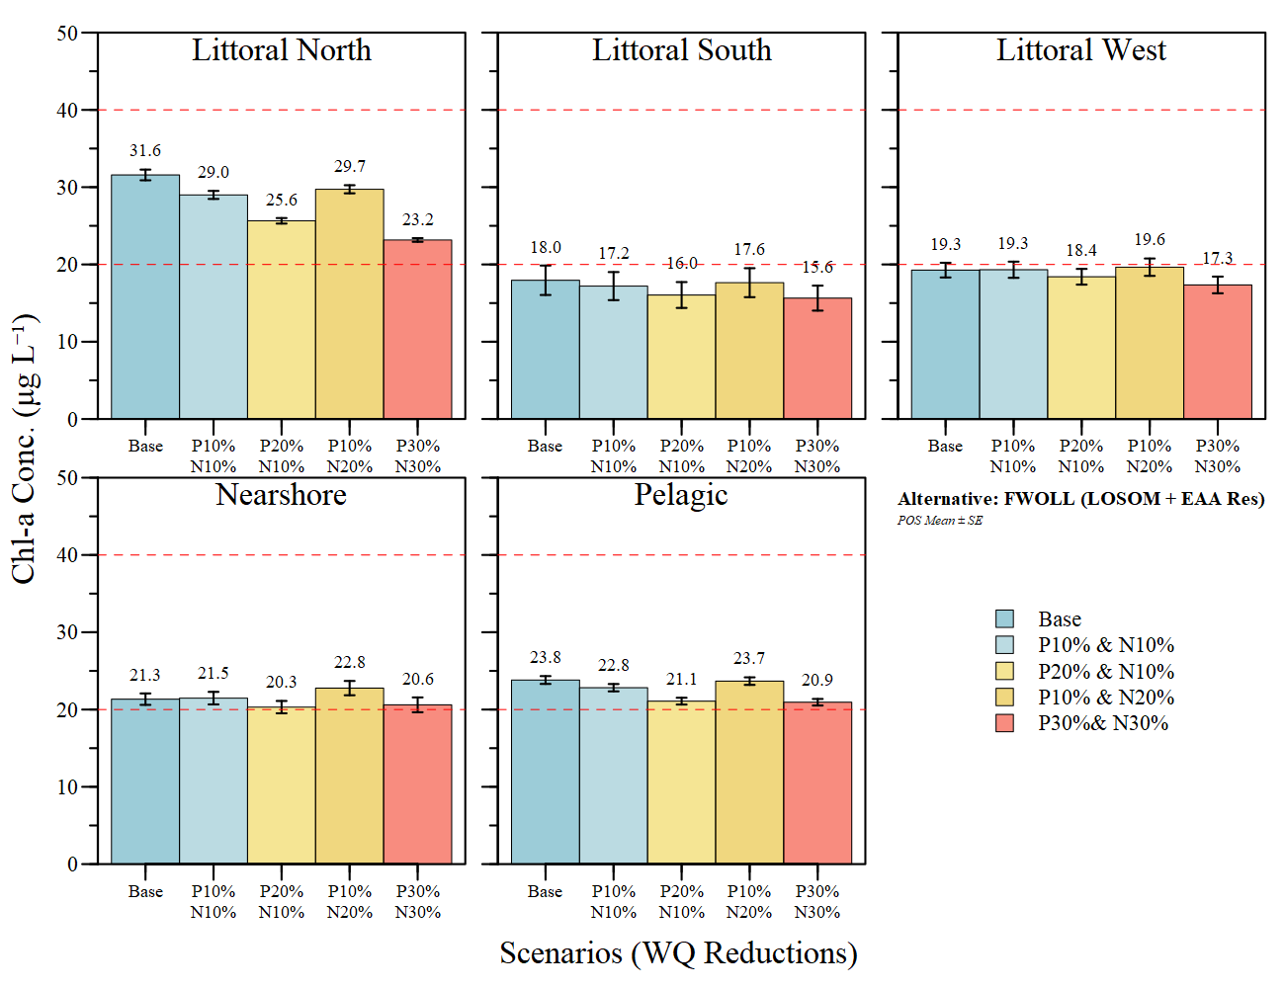
Figure S6. Water quality improvement scenario results using LOK HABAM to evaluate potential changes in mean summer chlorophyll-a concentrations across Lake Okeechobee using the FWOLL (LOSOM with EAA Reservoir) from the Lake Okeechobee Component A Reservoir modeling effort.

