Supplementary Material

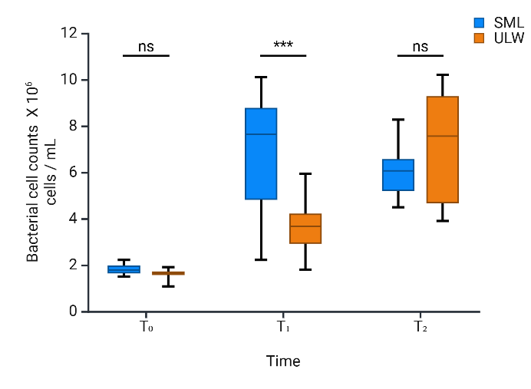
Figure S1. The difference in bacterial cell counts across various time points. The total cell counts of all bacterial species at each concentration of ciprofloxacin. Each box plot displays the median cell count at each time point, allowing for a comparison of the differences observed between the SML and ULW at different time points under different ciprofloxacin concentrations. Asterisks (P < 0.001), “ns" (significant difference).
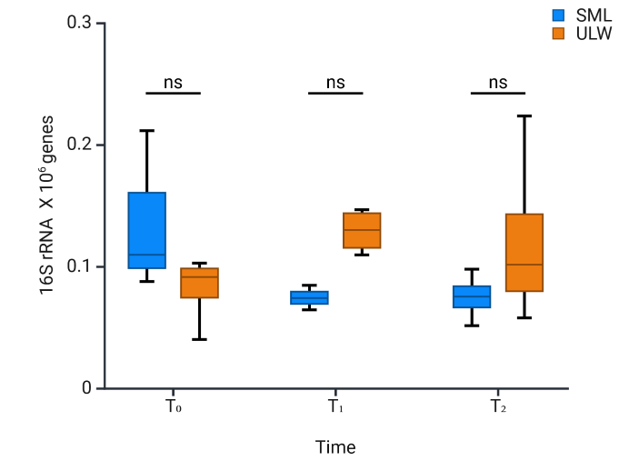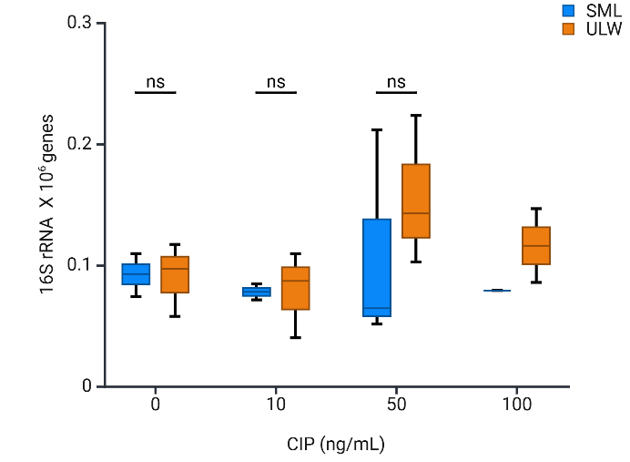
(a)
(b)
Figure S2. (a) Bacterial 16S rRNA amplicon sequence in the SML and ULW at time points. (b)16S rRNA amplicon genes in the SML and ULW samples across different ciprofloxacin concentrations. SML samples treated with 100 ng/mL at T₀ and T₁ were lost during sample processing. “ns" (significant difference).

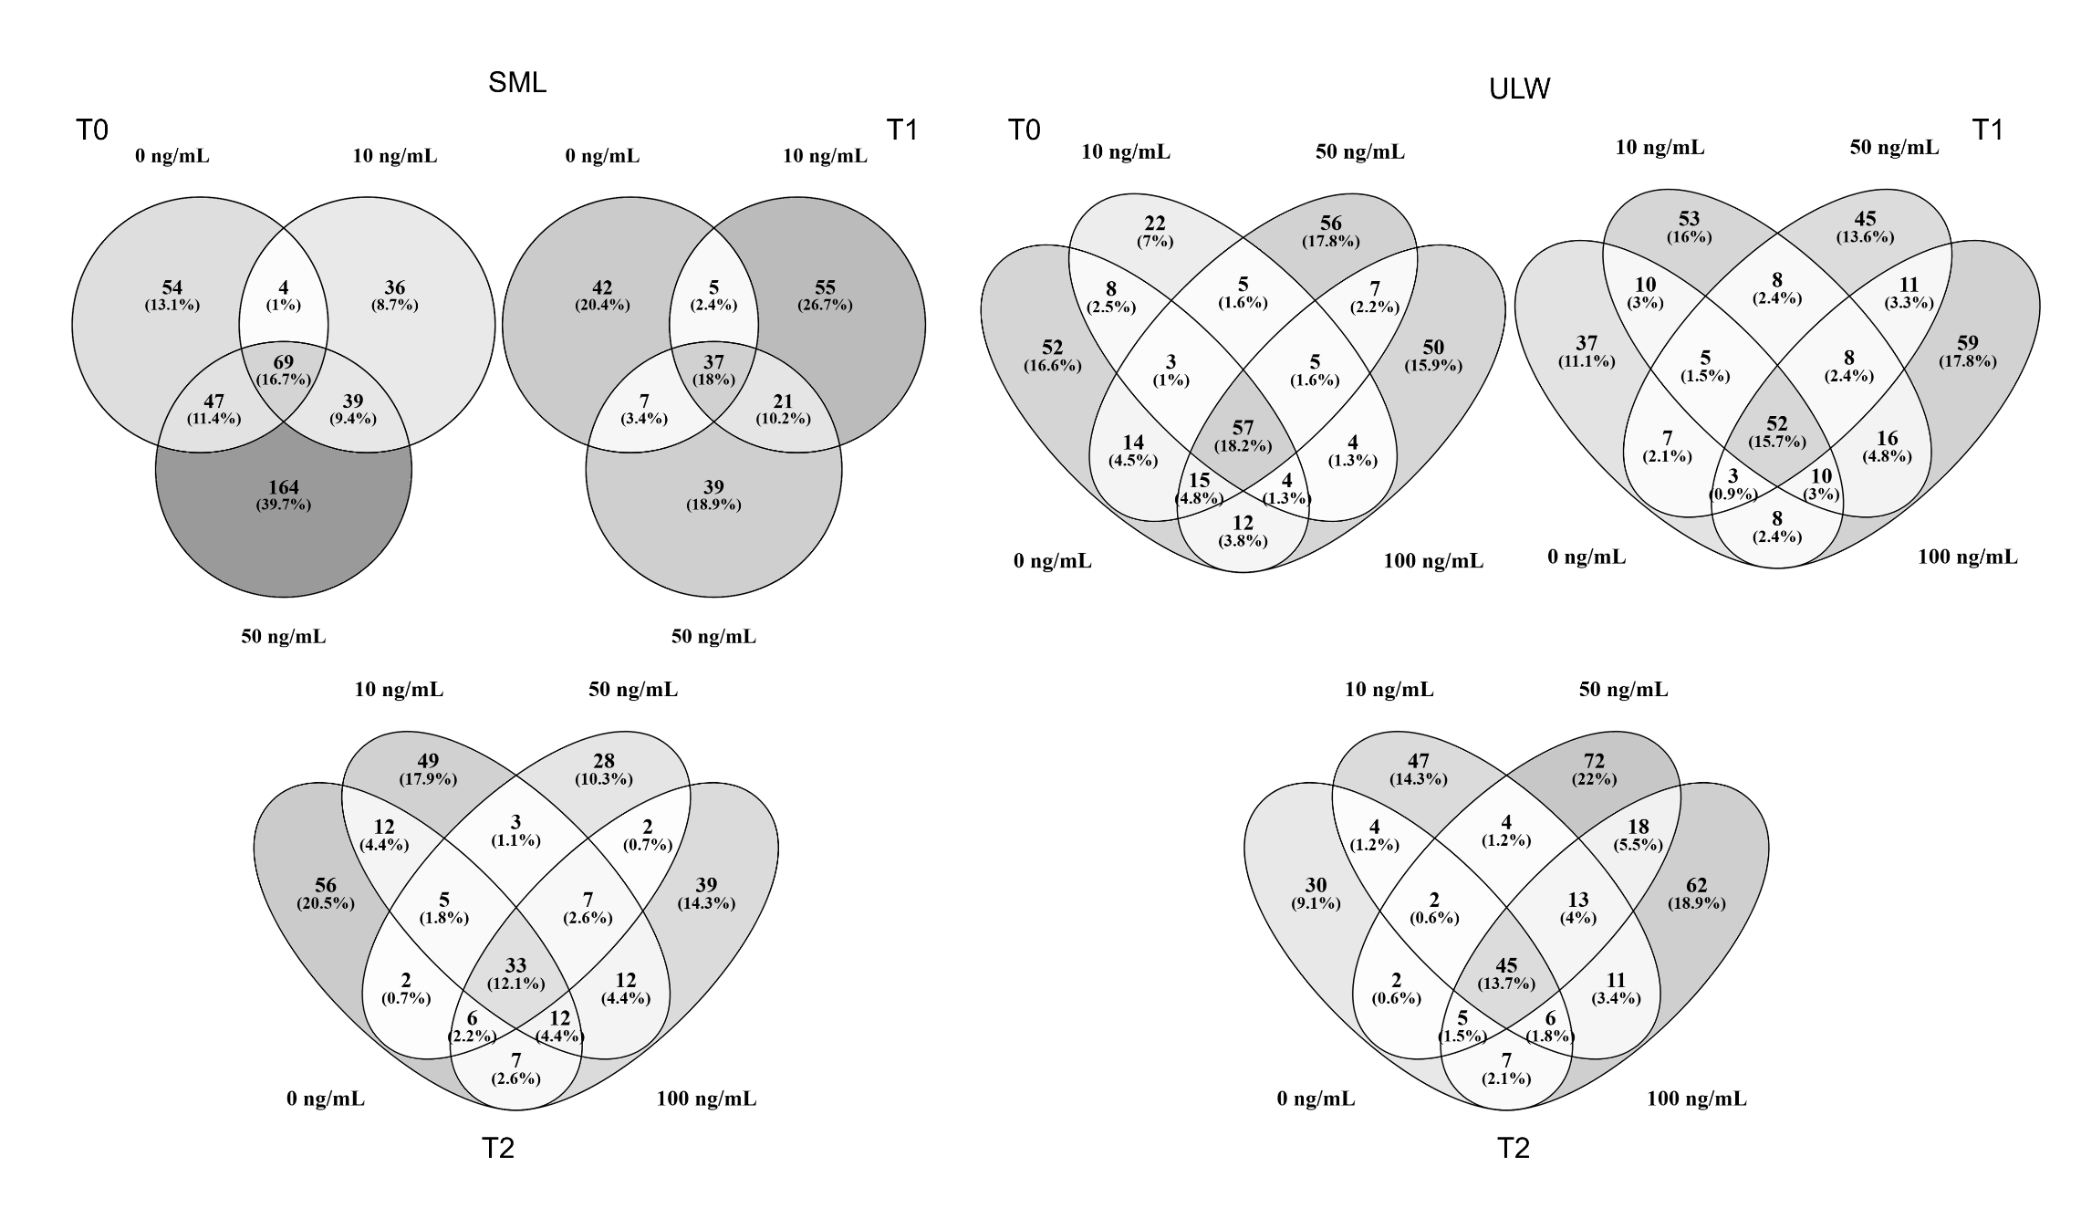Figure S3. Venn diagrams showing individual and shared ASVs across different concentrations at different time points
Table S1. Multiple reaction monitoring (MRM), retention time, limit of detection (LoD), and limit of quantification (LoQ) of targeted compounds (obtained from Adenaya et al. (2024))
Antibiotic class | Antibiotic type | MRM | Retention time | LoD  ng/L | LoQ
 |  |  | (min)
Lincosamides | Lincomycin (+) | 407.20 > 126.00 | 2.90 | 0.02 | 0.08
 | Clindamycin (+) | 425.20 > 126.00 | 4.30 | 0.02 | 0.08
 | Clarithromycin (+) | 748.50 > 158.00 | 5.10 | 0.02 | 0.06
Macrolides | Spiramycin (+) | 422.00 > 174.00 | 3.80 | 0.02 | 0.06
 | Tylosin (+) | 916.50 > 174.00 | 4.80 | 0.02 | 0.06
 | Erythromycin (+) | 734.50 > 158.00 | 4.70 | 0.02 | 0.06
 | Azithromycin (+) | 748.90 > 591.00 | 5.00 | 0.01 | 0.02
Quinolones | Ofloxacin (+) | 362.10 > 318.00 | 3.30 | 0.01 | 0.03
 | Enrofloxacin (+) | 360.10 > 342.00 | 3.40 | 0.01 | 0.03
 | Roxithromycin (+) | 837.50 > 158.00 | 5.10 | 0.00 | 0.01
 | Ciprofloxacin (+) | 362.10 > 318.00 | 3.30 | 0.01 | 0.03
 | Sparfloxacin (+) | 393.20 > 349.00 | 3.80 | 0.01 | 0.03
Phenicol | Chloramphenicol (-) | 152.10 > 257.00 | 4.11 | 0.02 | 0.07
Sulfonamides | Sulfadiazine (+) | 251.10 > 155.20 | 2.70 | 0.03 | 0.11
 | Sulfadimethoxine (+) | 251.10 > 155.20 | 2.70 | 0.03 | 0.11
 | Sulfamethazine (+) | 279.10 > 186.20 | 3.30 | 0.03 | 0.11
 | Sulfamethizole (+) | 271.00 > 156.00 | 3.10 | 0.02 | 0.06
 | Sulfamethoxazole (+) | 254.10 > 156.10 | 3.40 | 0.03 | 0.11
 | Sulfaguanidine (+) | 215.10 > 156.00 | 1.63 | 0.02 | 0.06
 | Sulfathiazole (+) | 256.00 > 156.00 | 2.80 | 0.02 | 0.06
Aminocoumarin | Novobiocin (+) | 613.20 > 189.00 | 5.70 | 0.02 | 0.05
Tetracyclines | Doxycycline (+) | 445.20 > 410.00 | 3.40 | 0.01 | 0.02
 | Chlortetracycline (+) | 479.10 > 444.00 | 4.10 | 0.01 | 0.02
 | Oxytetracycline (+) | 461.10 > 425.00 | 3.60 | 0.01 | 0.02
Other Antibiotics | Trimethoprim (+) | 291.10 > 229.00 | 3.00 | 0.01 | 0.04
 | Rifampicin (+) | 823.40 > 791.00 | 4.90 | 0.00 | 0.01

Table S1. ASVs' distribution across bacterial taxa
Taxonomic | Counts of
rank | taxonomic rank
Phylum | 66
Class | 161
Order | 380
Family | 605
Genus | 1025
Unknown Bacteria | 369

Table S3. The phylogenetic affiliation of bacterial isolates obtained on Mueller-Hinton agar (MHA) containing 100 ng/mL ciprofloxacin. Bacterial strains not identified by MALDI-TOF (not in the database) and those with MALDI-TOF scores < 2.0 were identified by sequencing their 16S rRNA genes. MALDI-TOF scores > 2.0 indicate species-level identification. Only for the isolates for which a 16S rRNA gene sequence was available, NCBI accession numbers are given. The accession numbers of the closest described relatives are also indicated for sequenced isolates.
Sample | Phylum | Bacterial Class/order | Bacterial Isolate | Accession | Closest described relative | Accession No
SML | Bacillota | Bacilli/Bacillales | Alkalihalobacillus sp. AN-7 |  | Alkalihalobacillus clausii
 |  |  | Alkalihalobacillus sp. AN-8 |  | Alkalihalobacillus clausii
 |  |  | Bacillus sp. AN-12 | OR739618 | Bacillus mobilis | MK389421.1
 |  |  | Bacillus sp. AN-16 |  | Bacillus coagulans
 | Actinomycetota | Actinomycetes/ | Brevibacterium sp. AN-14 | OR739619 | Brevibacterium luteolum | CP035810.1
 |  | Micrococcales | Brevibacterium sp. AN-17 | OR739621 | Brevibacterium luteolum strain NEB1784 | CP035810.1
 |  |  | Brevibacterium sp. AN-19 | OR739623 | Brevibacterium luteolum strain CF87 | NR_114872.1
 |  |  | Brevibacterium sp. AN-20 | OR739624 | Brevibacterium luteolum strain NEB1784 | CP035810.1
 |  |  | Brevibacterium sp. AN-22 | OR739626 | Brevibacterium luteolum strain CF87 | NR_114872.1
 |  |  | Brevibacterium sp. AN-24 | OR739628 | Brevibacterium luteolum strain y223 | KF306374.1
 |  |  | Cytobacillus sp. AN-21 | OR739625 | Cytobacillus kochii strain P140 | MZ373183.1
 |  |  | Micrococcus sp. AN-1 |  | Micrococcus luteus
 |  |  | Micrococcus sp. AN-10 |  | Micrococcus luteus
 |  |  | Micrococcus sp. AN-11 |  | Micrococcus luteus
 |  |  | Micrococcus sp. AN-13 |  | Micrococcus luteus
 |  |  | Micrococcus sp. AN-2 |  | Micrococcus luteus
 |  |  | Micrococcus sp. AN-3 |  | Micrococcus luteus
 |  |  | Micrococcus sp. AN-6 |  | Micrococcus luteus
 |  |  | Micrococcus sp. AN-6 |  | Micrococcus luteus
 |  |  | Micrococcus sp. AN-9 |  | Micrococcus luteus
 | Pseudomonadota | Alphaproteobacteria/ | Ochrobactrum sp. AN-15 | OR739620 | Ochrobactrum chromiisoli strain YY2X | OP787966.1
 |  | Hyphomicrobiales | Ochrobactrum sp. AN-18 | OR739622 | Ochrobactrum chromiisoli strain YY2X | OP787966.1
 |  |  | Ochrobactrum sp. AN-23 | OR739627 | Ochrobactrum chromiisoli strain YY2X | OP787966.1
ULW | Bacillota | Bacilli / Bacillales | Bacillus sp. de-13 |  | Bacillus cereus
 |  |  | Bacillus sp. de-15 |  | Bacillus cereus
 |  |  | Bacillus sp. de-29 |  | Bacillus cereus
 |  |  | Bacillus sp. de-32 |  | Bacillus cereus
 |  |  | Virgibacillus sp. de-1 | OR739634 | Virgibacillus proomi | MN620396.1
 |  |  | Virgibacillus sp. de-16 | OR739630 | Virgibacillus proomi | MN620396.1
 |  |  | Virgibacillus sp. de-17 | OR739631 | Virgibacillus proomi | MN620396.1
 |  |  | Virgibacillus sp. de-18 | OR739632 | Virgibacillus proomi | MN620396.1
 |  |  | Virgibacillus sp. de-19 | OR739633 | Virgibacillus proomi | MG309540.1
 |  |  | Virgibacillus sp. de-2 | OR739643 | Virgibacillus proomi | FN397532.1
 |  |  | Virgibacillus sp. de-20 | OR739635 | Virgibacillus proomi | MG309540.1
 |  |  | Virgibacillus sp. de-21 | OR739636 | Virgibacillus proomi | MG309540.1
 |  |  | Virgibacillus sp. de-22 | OR739637 | Virgibacillus proomi | MN620396.1
 |  |  | Virgibacillus sp. de-24 | OR739638 | Virgibacillus proomi | MG309540.1
 |  |  | Virgibacillus sp. de-25 | OR739639 | Virgibacillus proomi | MG309540.1
 |  |  | Virgibacillus sp. de-26 | OR739640 | Virgibacillus proomi | MG309540.1
 |  |  | Virgibacillus sp. de-27 | OR739641 | Virgibacillus proomi | MG309540.1
 |  |  | Virgibacillus sp. de-28 | OR739642 | Virgibacillus proomi | MG309540.1
 |  |  | Virgibacillus sp. de-3 | OR739645 | Virgibacillus proomi | MN620396.1
 |  |  | Virgibacillus sp. de-30 | OR739644 | Virgibacillus proomi
 |  |  | Virgibacillus sp. de-7 |  | Virgibacillus proomi
 |  |  | Virgibacillus sp. de-9 |  | Virgibacillus proomi
 | Actinomycetota | Actinomycetes/ | Micrococcus sp. de-10 |  | Micrococcus luteus
 |  | Micrococcales | Micrococcus sp. de-11 |  | Micrococcus luteus
 |  |  | Micrococcus sp. de-12 |  | Micrococcus luteus
 |  |  | Micrococcus sp. de-14 |  | Micrococcus luteu
 |  |  | Micrococcus sp. de-23 |  | Micrococcus luteus
 |  |  | Micrococcus sp. de-31 |  | Micrococcus luteus
 |  |  | Micrococcus sp. de-4 |  | Micrococcus luteus
 |  |  | Micrococcus sp. de-5 |  | Micrococcus luteus
 |  |  | Micrococcus sp. de-6 |  | Micrococcus luteus
 |  |  | Micrococcus sp. de-8 |  | Micrococcus luteus

