Supplementary Material

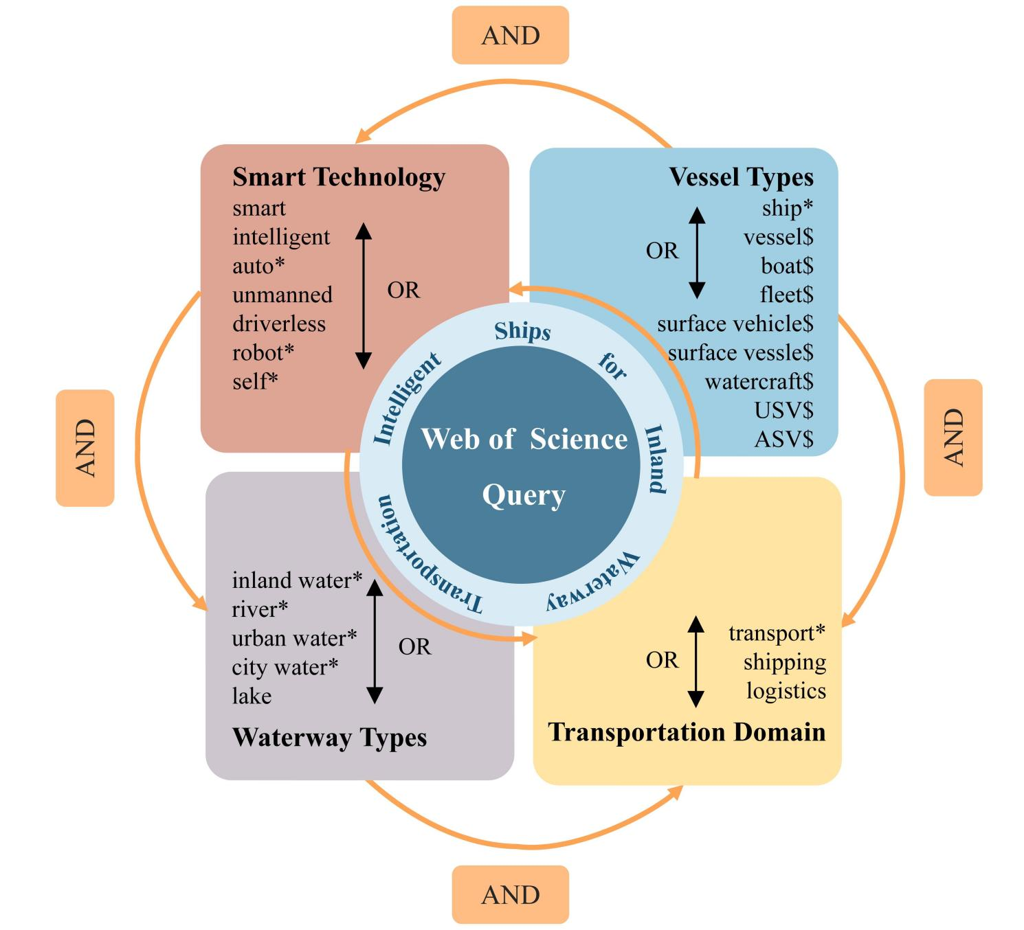

**Figure 3.** Thefour-component research query in the current study.

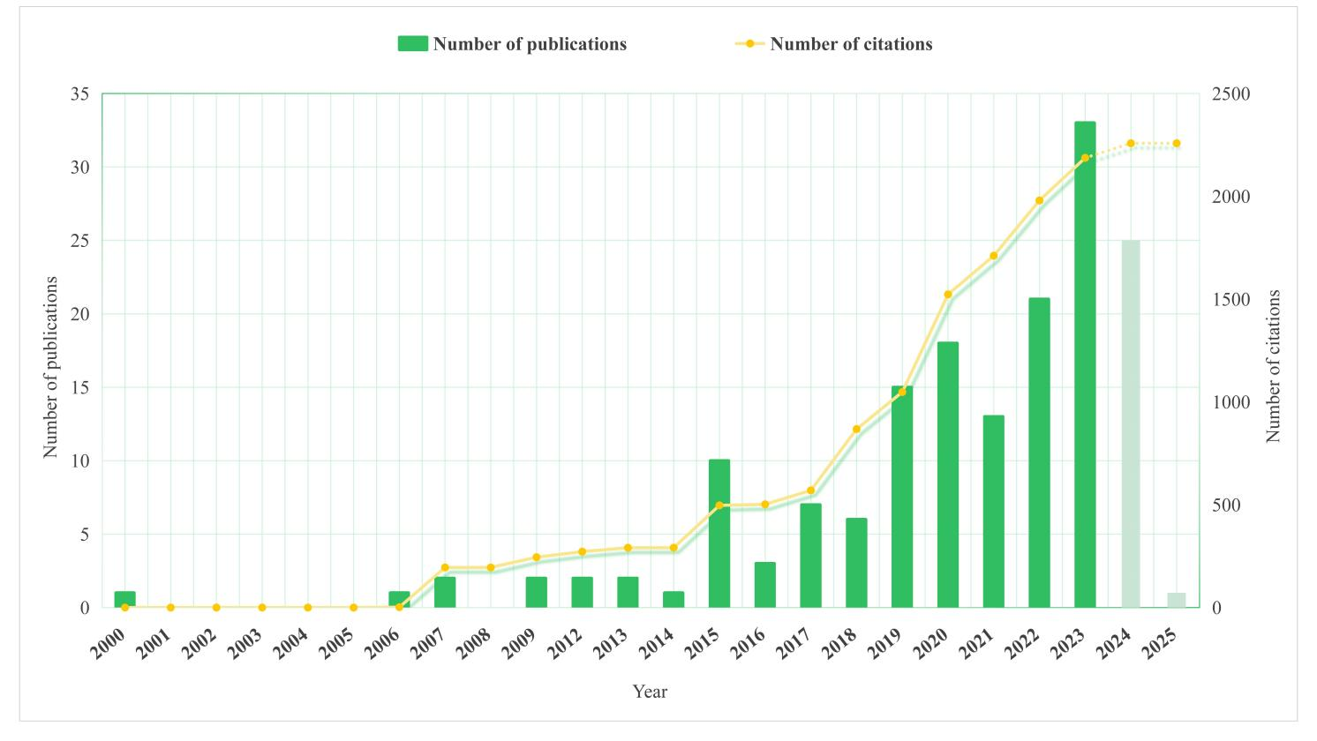

**Figure 4.** Number of publications and citations in the explored domain.

**Table 1.** The top 10 prolific authors in the explored domain and their interests.

|  |  |  |  |  |  |  |  |  |  |
| --- | --- | --- | --- | --- | --- | --- | --- | --- | --- |
| **Rank** | **Author** | **Country** | **Institution** | **NP** | **P (%)** | **TC** | **APY** | **AC** | **Main research interests** |
| 1 | Chu, Xiumin | China | Wuhan University of Technology | 10 | 6.13% | 102 | 2019.60 | 10.20 | Inland Waterway; Automatic Identification System; Waterway Transportation; Simulation; Smart Ship; Waterway Traffic Intelligent System Control |
| 2 | Abel, Dirk | Germany | RWTH Aachen University | 6 | 3.68% | 15 | 2021.83 | 2.50 | Model Predictive Control; Simulation of Dynamic Systems; Rapid Control Prototyping methods; Optimization Problem; Control Performance |
| 3 | Chen, Linying | China | [Wuhan University of Technology](https://www.scopus.com/pages/organization/60022414" \o "https://www.scopus.com/pages/organization/60022414) | 6 | 3.68% | 145 | 2021.83 | 24.17 | Intelligent Ships; Ship Collision; Cooperative Multi-vessel Systems; Water Traffic System Coordinated Control |
| 4 | He, Wei | China | Minjiang University | 6 | 3.68% | 42 | 2021.00 | 7.00 | Intelligent System and Information Fusion; Marine Equipment and New Energy; Transport Management |
| 5 | Bolbot, Victor | Finland | Aalto University | 5 | 3.07% | 122 | 2021.80 | 24.40 | Autonomous Ships; Marine Systems Safety; Ship Propulsion Systems; Cybersecurity |
| 6 | Liu, chenguang | China | Wuhan University of Technology | 5 | 3.07% | 35 | 2021.40 | 7.00 | Ship Intelligent Navigation; Formation Cooperative Control; Path/Motion Planning; Model Predictive Control |
| 7 | Negenborn, Rudy | Netherlands | Delft University of Technology | 5 | 3.07% | 139 | 2019.80 | 27.80 | Automatic Control; Coordination of Transport Technology; Smart Shipping; Smart Logistics Applications |
| 8 | Ratti, Carlo | USA | Massachusetts Institute of Technology | 5 | 3.07% | 161 | 2020.00 | 32.20 | Smart city; Natural Disasters; Human Computer Interfaces; Urban Design; Tsunami |
| 9 | Amro, Ahmed | Norway | Norwegian University of Science and Technology | 4 | 2.45% | 44 | 2022.25 | 11.00 | Communication and Cyber security of Autonomous systems; Cyber Risk Management; Secure System Development; Network traffic analysis; TLS protocol security |
| 10 | Duarte, Fabio | USA | Massachusetts Institute of Technology | 4 | 2.45% | 130 | 2020.00 | 32.50 | Waterway Infrastructure; Urban Technologies, Transportation and Planning; Social Construction of Technologies |

**Note:** NP = Number of publications; P(%) = The proportion of NP/TND; TND = Total number of documents; TC = Total number of citations; APY = Average publications year=Total publication years/NP; AC = Average citations = TC/NP

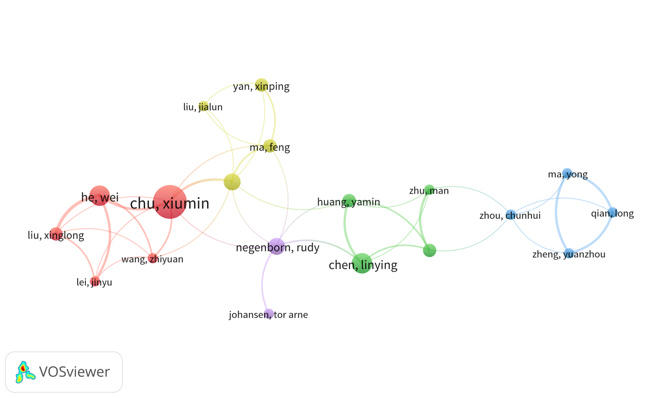

**Figure 5.** Author collaboration network using analysis of co-authorship.

**Table 2.** The top 10 prolific research institutions in the explored domain.

|  |  |  |  |  |  |  |  |  |  |
| --- | --- | --- | --- | --- | --- | --- | --- | --- | --- |
| **Rank** | **Institution** | **Country** | **Links** | **TLS** | **NP** | **P (%)** | **TC** | **APY** | **AC** |
| 1 | Wuhan Univ Technol | China | **50** | **77** | **57** | **34.97%** | **883** | 2020.56 | 15.49 |
| 2 | Minjiang univ | China | 13 | 23 | 10 | 6.13% | 97 | 2021.30 | 9.70 |
| 3 | Natl Engn Res Ctr Water Transport Safety | China | 12 | 21 | 9 | 5.52% | 213 | 2021.00 | 23.67 |
| 4 | Norwegian Univ Sci & Technol | Norway | 9 | 10 | 8 | 4.91% | 232 | 2020.75 | **29.00** |
| 5 | Hubei Key Lab Inland Shipping Technol | China | 4 | 10 | 7 | 4.29% | 68 | **2023.57** | 9.71 |
| 6 | Delft Univ Technol | Netherlands | 3 | 4 | 6 | 3.68% | 154 | 2019.00 | 25.67 |
| 7 | MIT | USA | 4 | 4 | 6 | 3.68% | 161 | 2020.50 | 26.83 |
| 8 | Rhein Westfal Th Aachen | German | 2 | 3 | 6 | 3.68% | 15 | 2021.83 | 2.50 |
| 9 | Shanghai Maritime Univ | China | 10 | 11 | 6 | 3.68% | 45 | 2022.50 | 7.50 |
| 10 | Dalian Maritime Univ | China | 6 | 6 | 5 | 3.07% | 15 | 2018.40 | 3 |

**Note:** TLS = Total link strength; NP = Number of publications; P(%) = The proportion of NP/TND; TND = Total number of documents; TC = Total number of citations; APY = Average publications year; AC = Average citations = TC/NP.

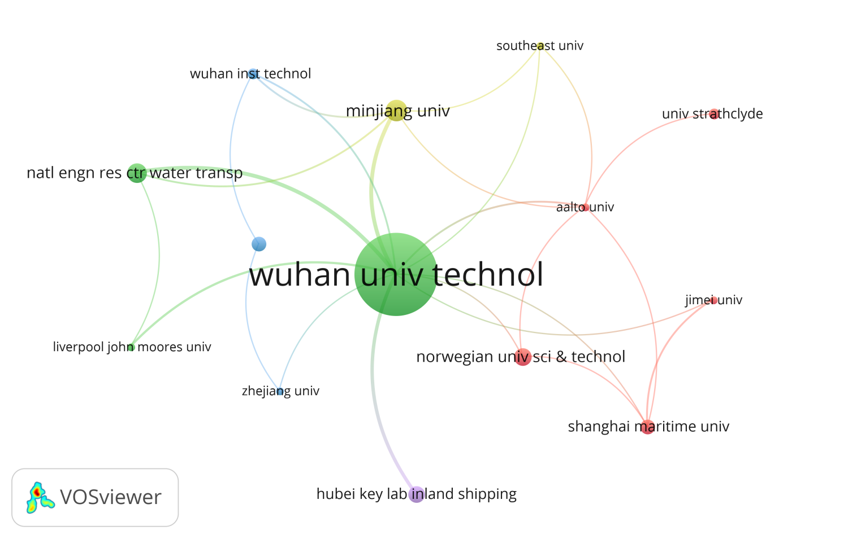

**Figure 6.** Institution collaboration network using analysis of co-authorship.

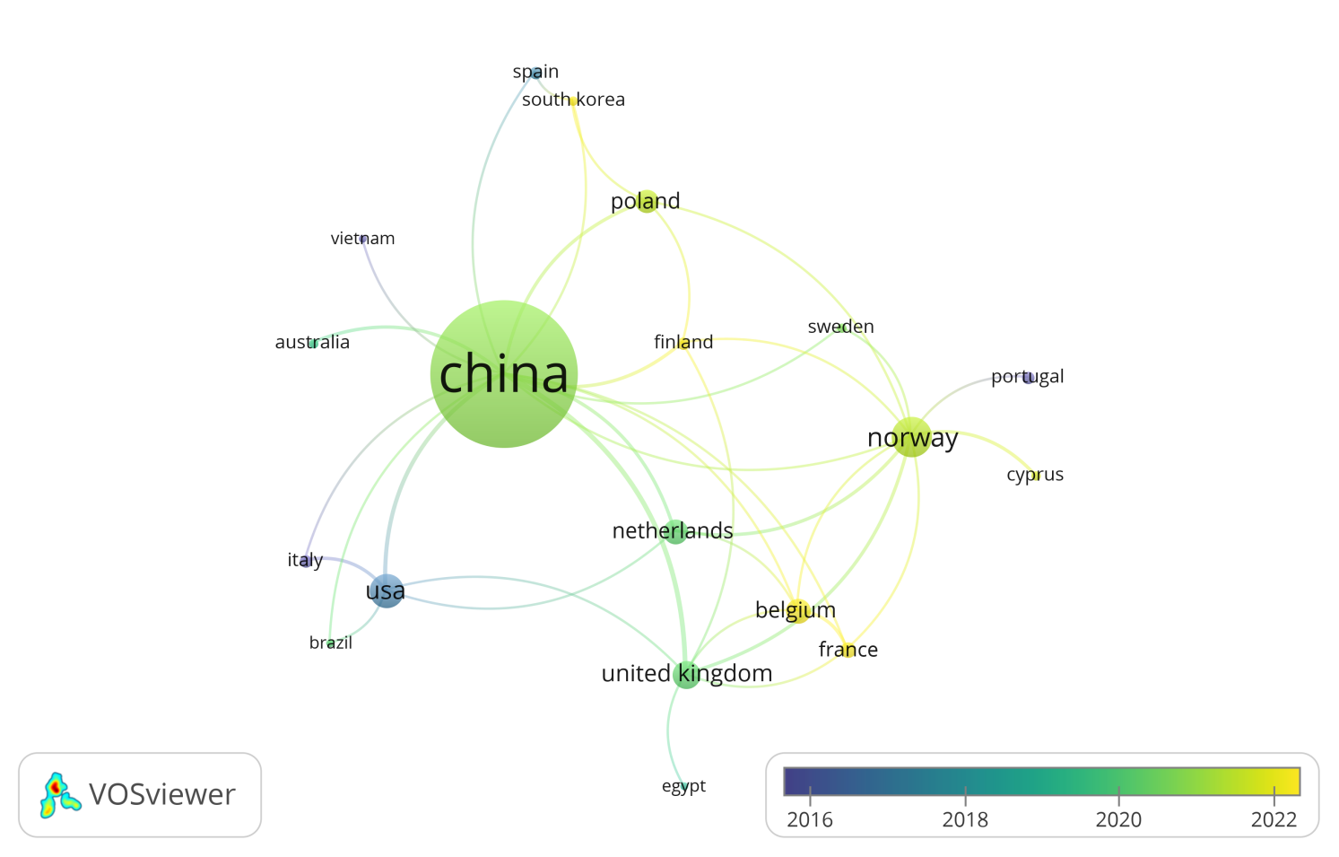

**Figure 7.** Country collaboration network using analysis of co-authorship.

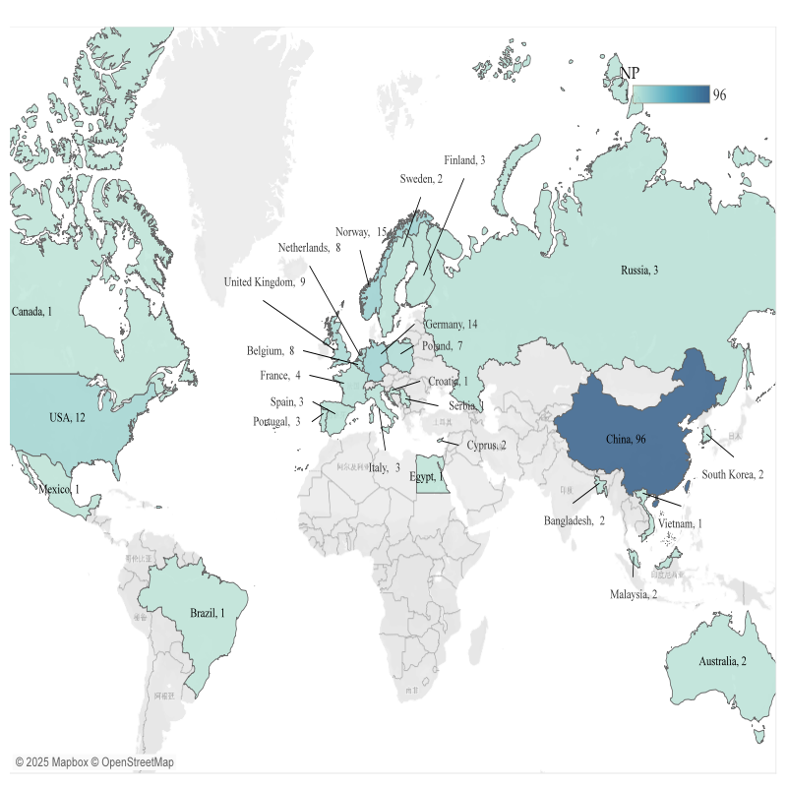

**Figure 8.** The number of publications distributed by countries.

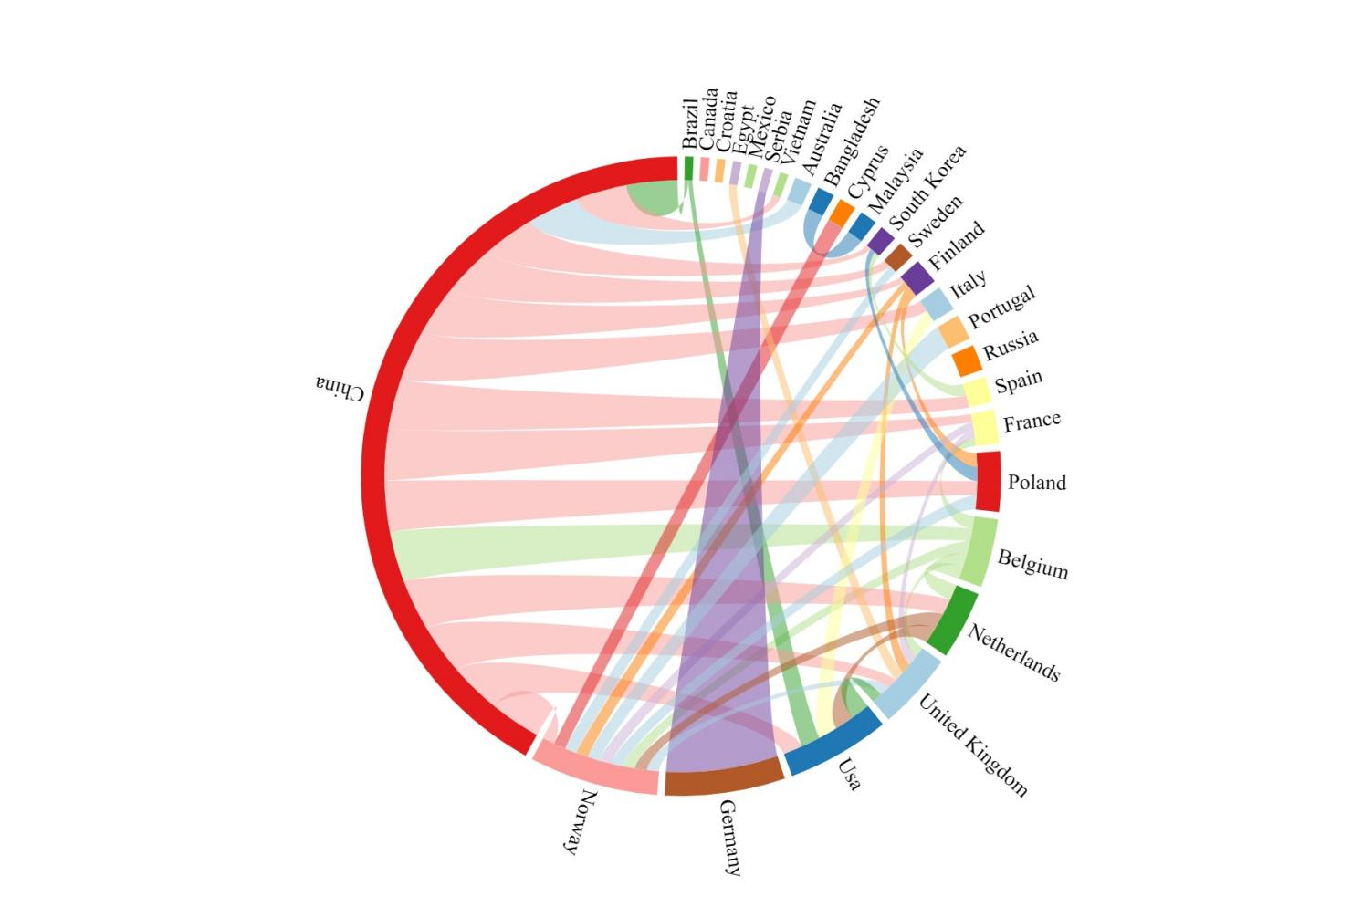

**Figure 9.** Country collaboration network using chord diagram.

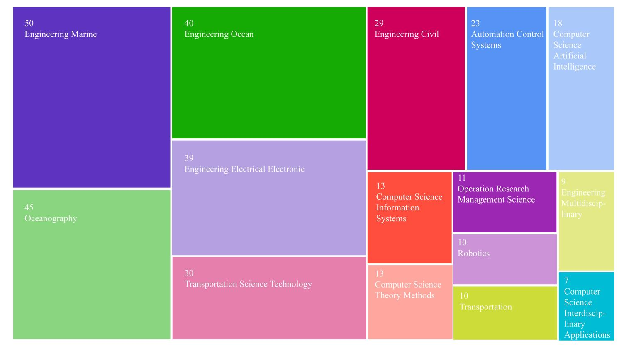

**Figure 10.** Number of publications by subject category.

**Table 3.** The top 10 highly cited publications in explored research domain.

|  |  |  |  |  |  |
| --- | --- | --- | --- | --- | --- |
| **Rank** | **Author** | **Title** | **Year** | **TC** | **ACY** |
| 1 | Moreira et al.(Moreira et al, 2007). | Path following control system for a tanker ship model | 2007 | **177** | 10.41 |
| 2 | Li et al.(Li et al, 2018) | Spatio-Temporal Vessel Trajectory Clustering Based on Data Mapping and Density | 2018 | 120 | 20.00 |
| 3 | Chen et al.(Chen et al, 2018) | Distributed model predictive control for vessel train formations of cooperative multi-vessel systems | 2018 | 92 | 15.33 |
| 4 | Sang et al.(Sang et al, 2015) | A novel method for restoring the trajectory of the inland waterway ship by using AIS data | 2015 | 87 | 9.67 |
| 5 | Qian et al.(Qian et al, 2022) | A New Method of Inland Water Ship Trajectory Prediction Based on Long Short-Term Memory Network Optimized by Genetic Algorithm | 2022 | 86 | **43.00** |
| 6 | Wu et al.(Wu et al, 2020) | Fuzzy logic based dynamic decision-making system for intelligent navigation strategy within inland traffic separation schemes | 2020 | 83 | 20.75 |
| 7 | Bolbot et al.(Bolbot et al, 2020) | A novel cyber-risk assessment method for ship systems | 2020 | 67 | 16.75 |
| 8 | Wang et al.(Wang et al, 2018) | Design, Modeling, and Nonlinear Model Predictive Tracking Control of a Novel Autonomous Surface Vehicle | 2018 | 62 | 10.33 |
| 9 | Wang et al.(Wang et al, 2019) | Roboat: An Autonomous Surface Vehicle for Urban Waterways | 2019 | 59 | 11.80 |
| 10 | Zheng et al.(Zheng et al, 2022) | Recognition and Depth Estimation of Ships Based on Binocular Stereo Vision | 2022 | 57 | 28.50 |

**Note:** TC = Total number of citations; ACY = Average citations per year.

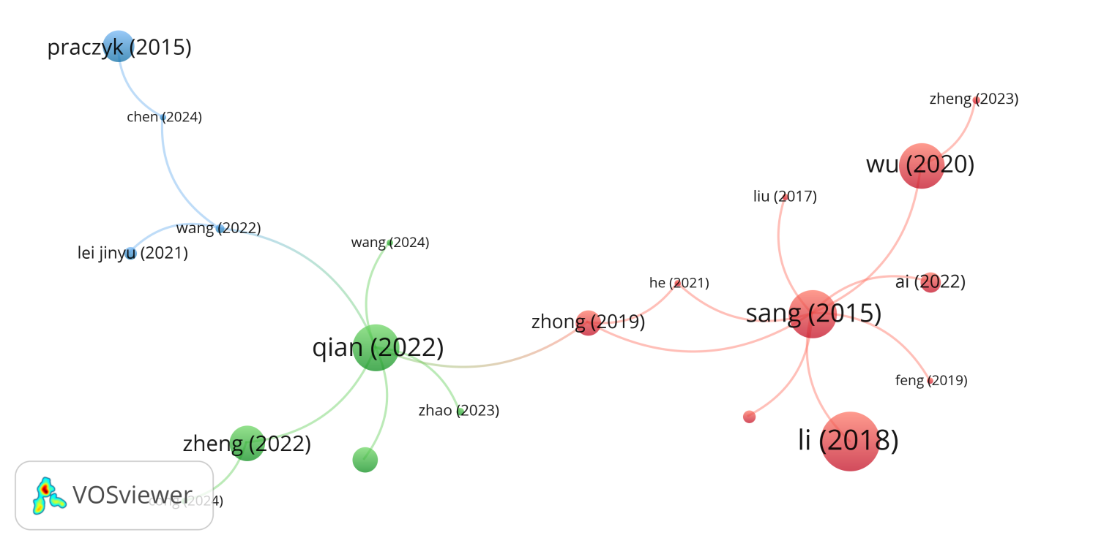

**Figure 11.** Citation map for papers cited more than once.

**Table 4.** The top 10 most prolific journals in explored research domain.

|  |  |  |  |  |  |  |  |
| --- | --- | --- | --- | --- | --- | --- | --- |
| **Rank** | **Source** |  | **NP** | **P%** | **TC** | **CP** | **2023IF** |
| 1 | Journal of Marine Science and Engineering |  | **20** | **12.27%** | 204 | 10.20 | 2.7 |
| 2 | Ocean Engineering |  | 17 | 10.43% | **472** | 27.76 | 4.6 |
| 3 | IEEE Transactions on Intelligent Transportation Systems |  | 6 | 3.68% | 136 | 22.67 | **7.9** |
| 4 | Journal of Navigation |  | 4 | 2.45% | 56 | 14.00 | 1.9 |
| 5 | European Transport Research Review |  | 3 | 1.84% | 18 | 6.00 | 5.1 |
| 6 | Sensors |  | 3 | 1.84% | 49 | 16.33 | 3.4 |
| 7 | Sustainability |  | 3 | 1.84% | 51 | 17.00 | 3.3 |
| 8 | Applied Sciences-Basel |  | 2 | 1.23% | 87 | 43.50 | 2.5 |
| 9 | IEEE Access |  | 2 | 1.23% | 165 | **82.50** | 3.4 |
| 10 | International Journal of Naval Architecture and Ocean Engineering |  | 2 | 1.23% | 17 | 8.50 | 2.3 |

**Note:**  NP = Number of publications; P(%)=The proportion of NP/TND; TC = total number of citations; CP = citations per publication; IF = impact factor.

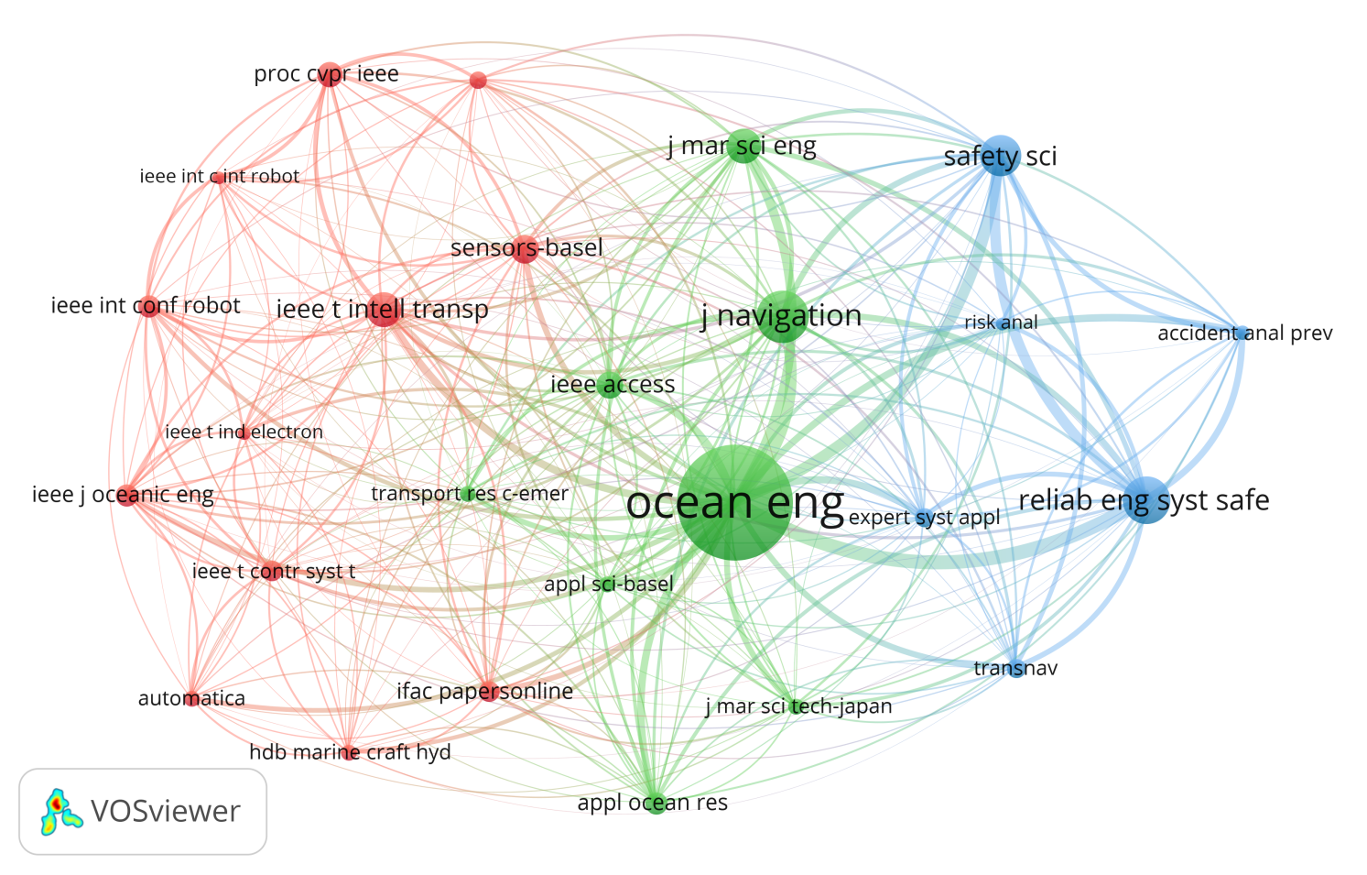

**Figure 12.** Co-citation map for journals cited more than 20 times.

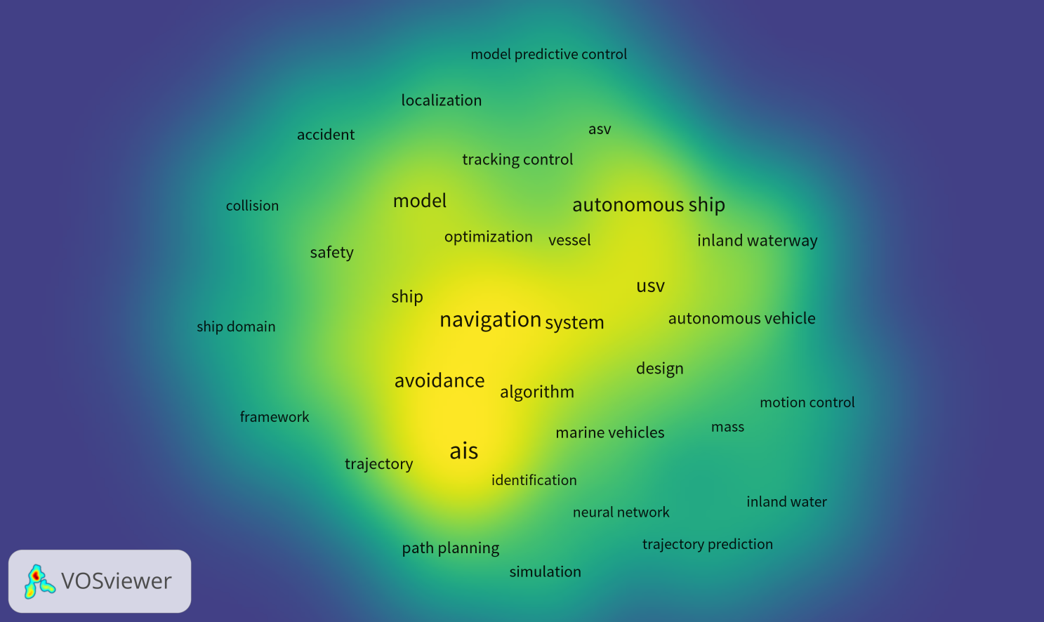

**Figure 13.** Heat map of keywords in the explored domain.

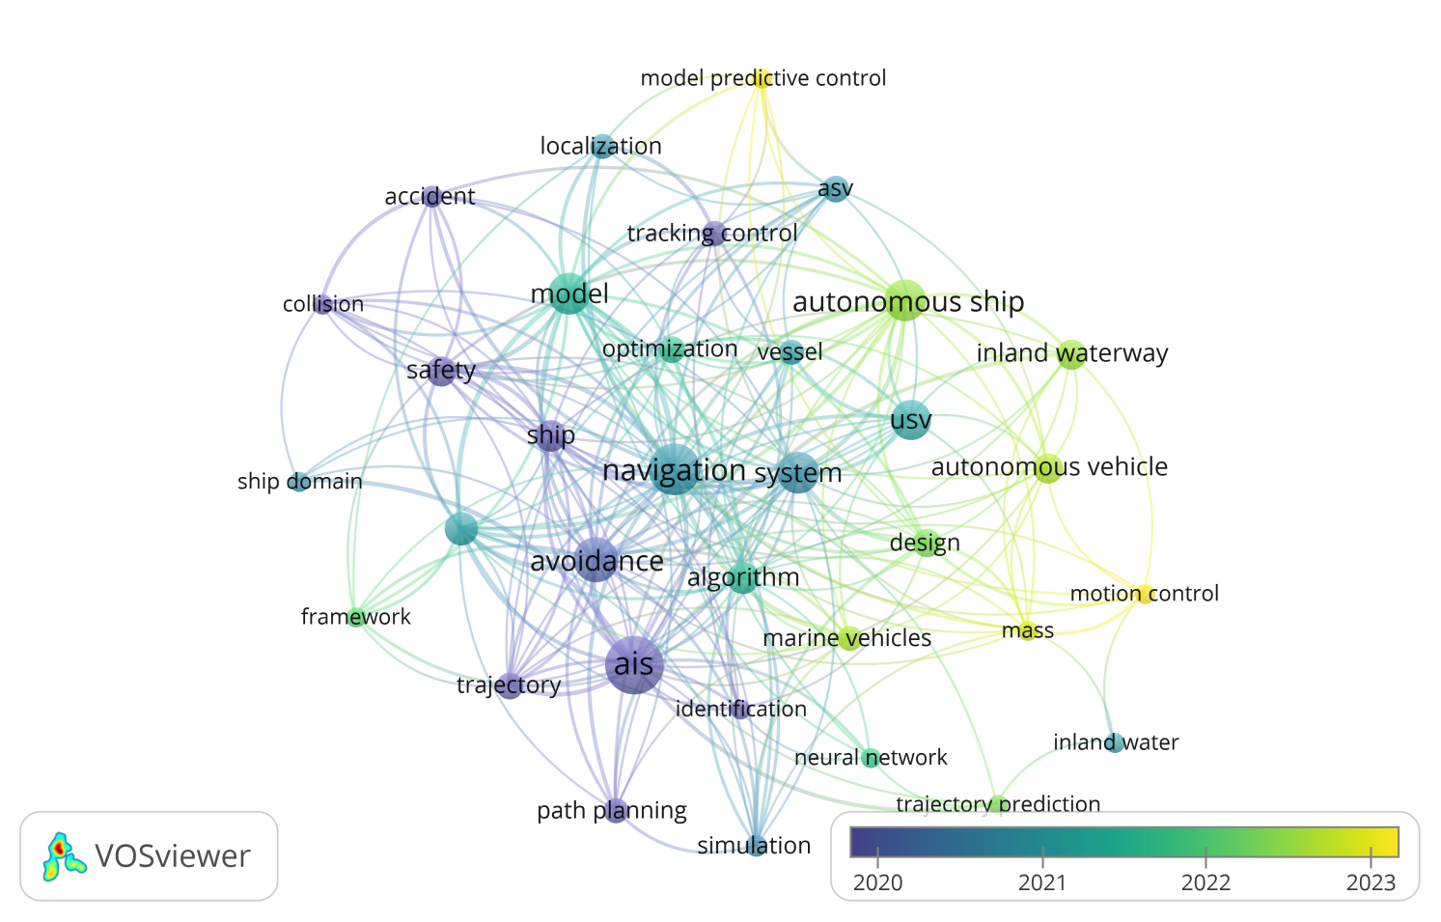

**Figure 14.** Co-occurrence network of keywords in the explored domain.

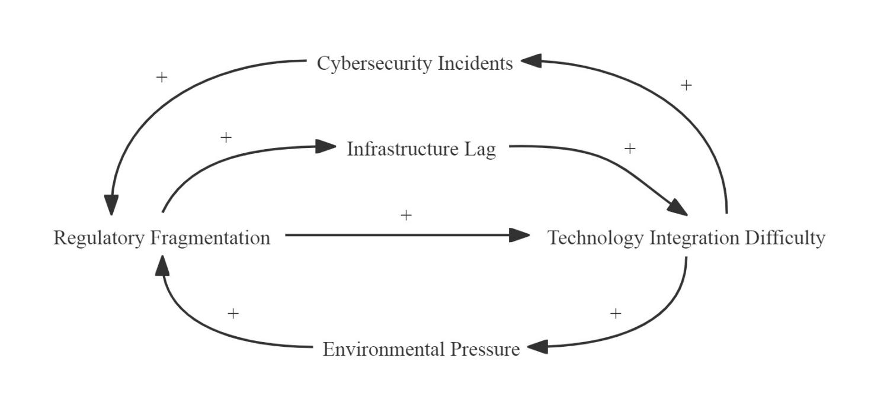

**Figure 15.** Causal loop diagram of challenges.

**Table A.1** Parameter setting for bibliographic mapping.

|  |  |  |  |  |
| --- | --- | --- | --- | --- |
| **Figure** | **Threshold** | **Attr.** | **Repu.** | **Type** |
| Figure 5. Author collaboration network using analysis of co-authorship. | 3 | 5 | -2 | Network |
| Figure 6. Institution collaboration network using analysis of co-authorship. | 3 | 5 | -5 | Network |
| Figure 7. Country collaboration network using analysis of co-authorship. | 1 | 2 | 0 | Overlay |
| Figure 11. Citation map for papers cited more than 1 times | 1 | 4 | -1 | Network |
| Figure 12. Co-citation map for journals cited more than 20 times | 20 | 2 | -2 | Network |
| Figure 13. Heat maps of keywords in explored domain. | 4 | 1 | -1 | Density |
| Figure 14. Co-occurrence network of keywords in explored domain. | 4 | 1 | -1 | Overlay |