Calcium-phosphate biomineralization induced by alkaline phosphatase activity in *Escherichia coli*: localization, kinetics and potential signatures in the fossil record

Julie Cosmidis1†, Karim Benzerara1\*, François Guyot1, Fériel Skouri-Panet1, Elodie Duprat1, Céline Férard1, Jean-Michel Guigner1, Florence Babonneau2, Cristina Coehlo3

1 Institut de Minéralogie, de Physique des Matériaux, et de Cosmochimie (IMPMC), Sorbonne Universités, UMR 7590, CNRS, MNHN, Univ Paris 06, IRD UMR 206, Paris, France.

2 Laboratoire de Chimie de la Matière Condensée de Paris (LCMCP), Université Pierre et Marie Curie, CNRS, Collège de France, UMR 7574, Paris, France.

3Institut des Matériaux de Paris-Centre (IMPC), Université Pierre et Marie Curie, FR CNRS 2482, Paris, France.

**\* Correspondence:** Karim Benzerara, Institut de Minéralogie, de Physique des Matériaux et de Cosmochimie, 4 place Jussieu, 75252 Paris cedex 05, France.

[karim.benzerara@impmc.upmc.fr](mailto:karim.benzerara@impmc.upmc.fr)

**† Current address:** Julie Cosmidis, Geomicrobiology Laboratory, Department of Geological Sciences, University of Colorado, Boulder, CO, USA.

# Supplementary Figures

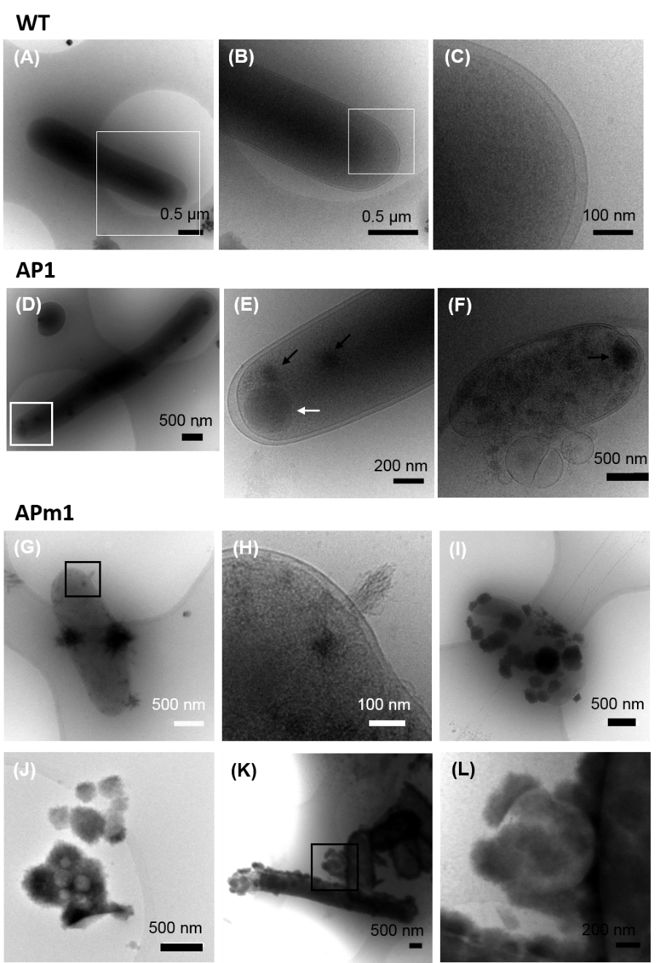

**Supplementary Figure 1 Cryo-TEM images of WT, AP1 and APm1 *E. coli* after 24 in the calcification medium.** (A)-(C) WT *E.coli*. (B) is a close-up of the area depicted by a rectangle in (A), and (C) is a close-up of the area depicted by a rectangle in (B). The periplasm can be observed (electron light space between the cytoplasm and the outer membrane). (D)-(F) AP1. (E) is a close-up of the area depicted by a rectangle on (D) showing intracellular electron dense granules (black arrows) and relatively less electron dense inclusion, possibly a carbon or phosphorus-rich body (white arrow). (F) Cell presenting a disruption of the cell envelope and forming membrane vesicles. The cell contains intracellular electron dense granules (black arrow). (G)-(L) APm1. (H) is a close-up of the area depicted by a rectangle on (G). Ca-phosphate fibers radiating from the outer membrane. (J) Vesicles encrusted by Ca-phosphates and lying away from cells. (L) Close-up of the area depicted by a rectangle on (K). It shows an outer membrane vesicle detaching from a cell on the surface of which Ca-phosphates precipitates are present.



**Supplementary Figure 2** **XANES spectra at the Ca L2,3-edges of the Ca-phosphates precipitated in presence of WT *E. coli* cells (24 hours), AP1 (7 hours), APm1 (7 hours), and PHO A in the presence or the absence of WT *E. coli* cells (24 hours).** Times in the calcification medium are given in parentheses. The spectra of reference Ca-phosphate compounds HA and ACP and are shown for comparison. For all spectra, the energy of the peak corresponding to the Ca L2 edge has been set to 352.5 eV. All spectra have also been normalized to the height of the Ca L2 edge peak. The vertical dotted lines correspond to the energies of the peaks in HA spectrum.



**Supplementary Figure 3** **1H MAS (A) and 31P MAS and 31P CP MAS (B) spectra of the Ca-phosphate precipitates formed in the presence of APm1 and PHO, after two weeks in the calcification medium. Arrows in (A) show the shoulder at 3.8 ppm in both APm1 and PHO A spectra.**

# Supplementary Data

## Enzymatic assays performed on *E. coli* cells during the calcification experiments

Rinsed *E. coli* cells WT, AP1 and APm1 harvested after 2, 24 and 70 hours of experiment in the calcification medium were used for pNPP enzymatic assays. For each condition, the evolution of absorption with time was measured for three out of four initial concentrations of pNPP in order to obtain different values of initial reaction rates *vi* corresponding to different substrate concentrations *[S]*. An example of typical experimental curves is shown in Figure 1 (A). In the Michaelis-Menten kinetic model (Johnson and Goody, 2011), *vi* is linked to *[S]* by the following equation:

$v_{i}=\frac{V_{max}\left[S\right]}{K_{m}+\left[S\right]}$**Equation 1**

Enzymatic assays are generally used to determine the values of the Michaelis constant *Km* and the maximum reaction rate *Vmax*, which give measures of the affinity of the enzyme for its substrate and the efficiency of the enzyme respectively. The catalysis kinetics of PHO A in the periplasm of *E. coli* has been studied by Martinez et al. (1992, 1996, 1999). They showed that a Michaelis-Menten model alone could not explain the kinetic behavior of PHO A *in vivo*, because diffusion across the outer membrane of the cells is, under certain conditions, the rate-limiting step of the enzymatic dynamics. As a result, traditional linearization methods of the Michaelis-Menten equation used for the determination of *Km* and *Vmax* (*e.g.* Lineweaver-Burk linearization; Lineweaver and Burk, 1934) cannot be used. Following Eadie-Hostee linearization, Equation 1 can be modified to obtain Equation 2:

$\frac{v_{i}}{\left[S\right]}=\frac{V_{max}}{K_{m}}-\frac{1}{K_{m}}v_{i}$**Equation 2**

The plot of *vi*,/[S] versus *vi*, called Eadie-Hostee plot (Hofstee, 1959), is shown in Figure 1 (B). Under conditions where a Michaelis -Menten model applies, e.g. for enzyme in the absence of cells, data will fall on a line with a slope equal to *-1/Km*, intersect with the x-the axis at *Vmax,* and intersect with the y-axis at *Vmax/Km*. Martinez et al. (1992) showed that with intact *E. coli* cells, results do not sit on a line but on a curve (see Figure 1 in Martinez et al., 1992). At its extremes, this curve represents two kinds of kinetics. At high substrate concentrations (right part of the plot), equilibrium of substrate between bulk solution and the periplasm is achieved, and the kinetic properties follow a Michaelis-Menten model. As a result, the curve intersects the x-axis at a value corresponding to the Vmax obtained with lysed cells: which means that alkaline phosphatase acts as if the same concentration of enzymes was not contained within cells. On the other hand, at low substrate concentrations (left part of the plot), the curve is almost parallel to the x-axis: the reaction rate is then proportional to the substrate concentration. This is interpreted by the fact that, as there are many unbound enzymes in the periplasm, each substrate molecule that enters the cell through the diffusion barrier of the outer membrane is hydrolyzed. At these low substrate concentrations, the reaction rate will therefore not depend on the concentration of enzymes per cell, but on number of cells present in the assay.

For WT *E. coli* and AP1 we obtained relatively horizontal lines at all times. We are therefore out of the Michaelis-Menten regime of the plot and the kinetic parameters *Km* and *Vmax* cannot be retrieved. For APm1, data do not sit on a horizontal line. However, PHO A for APm1 does not act as a free enzyme either. Indeed, if we had a Michaelis-Menten regime for this assay, Eadie-Hofstee linearization would give a *Km* of 15.5 mM after 2 hours of experiment, which is 1000-fold higher than the Km value of purified PHO A determined by Martinez et al. (~15 μM). Diffusion therefore still plays an important role in the kinetic behavior of the enzyme in the APm1 case and we are likely in the transition zone between Michaelis-Menten and a purely diffusive regime. Determining *Km* and *Vmax* is therefore still impossible in this case.

Altogether, these results show that in WT, AP1 and APm1, PHO A enzymes are mostly still associated with the cells even after 70 hours of experiment and have not all been released in the assay medium.

**C:\Users\Julie\Dropbox\Article coli\Frontiers\Figures\SD Fig1.tif**

**Figure 1 Enzymatic assays performed on *E. coli* cells during the calcification experiments** (A) Evolution of the absorbance at 410 nm for APm1 after 2 hours of experiment and for different initial concentrations of pNPP: 0.67 mM (green), 1.35 mM (blue) and 2.69 mM (purple). (B) Eadie-Hofstee plot obtained for the *E. coli* strains WT (red squares), AP1 (green triangles) and APm1 (blue dots) after 2 hours (solid regression lines), 24 hours (dashed regression lines) and 70 hours (dotted regression lines) of experiment in the mineralization medium (the data for APm1 at 70 hours is missing).

## Determination of the turnover number *kcat* of PHO A using purified enzymes

In order to determine the turnover number *kcat* of the alkaline phosphatase in the experiments, enzymatic assays using pNPP were performed on different concentrations of the purified PHO A. For each concentration of PHO A *[E]0*, initial reaction rates *vi* were determined for different concentrations of pNPP *[S]*. The initial pNPP concentrations were chosen so that *vi* could reach its maximal value, *Vmax*. A representative example of the obtained reaction curves for different pNPP concentrations is shown in Figure 2 (A). The very good linear relationship existing between *Vmax*and *[E]0*(Figure 2 (B)) allowed the determination of *kcat:* *kcat* ~8.9 s-1. This value is consistent with the value of 8.5 s-1 given by Coleman (1992) for the hydrolysis of phosphate monoesters in Tris 0.1 M, pH 8.0.

*kcat*can vary depending on the enzyme substrate and the chemical conditions of the medium. We thus also wanted to determine it in the conditions of calcification experiments, i.e. with glycerophosphate as a substrate of PHO A. For that purpose, we conducted an experiment with purified PHO A (without cells) at different concentrations in the calcification medium and calculated phosphate release rates d[Pi]t/dt (Fig, 2 (C)). Within the first hours of the experiment, d[Pi]t/dt provides a measure of *vi*. The initial glycerophosphate concentration used here (10 mM) is high enough to ensure that at the beginning of the experiment vi is equal to *Vmax*. The values of *Vmax* thus obtained for the different concentrations of PHO A are plotted in Figure 2 (D). The turnover rate obtained from these results is ~8.1 s-1. This value is close to that determined in the enzymatic assay conditions (~8.9 s-1). The similarity of the values of the turnover rate of PHO A obtained using an enzymatic assay and during a calcification experiment shows that: (i) the efficiency of PHO A is not significantly altered in the calcification medium, and (ii) the approach consisting of using calculated phosphate release rates during mineralization to obtain a measure of the concentration of active enzymes *[E]0* in the medium is valid.

C:\Users\Julie\Dropbox\Article coli\Frontiers\Figures\SD_Fig1.tif

**Figure 2 Determination of the turnover number kcat of PHO A** **using enzymatic assays (A)-(B) and using phosphate release rates in the calcification medium (C)-(D).** (A) Evolution of the absorbance at 410 nm for a PHO A concentration of 2.81 10-7 M and for different initial concentrations of pNPP: 0.07 mM (triangles), 0.13 mM (squares), 0.37 mM (crosses) and 1.35 mM (diamonds). The maximal reaction rate Vmax (initial slope) is reached even for the smallest concentrations of pNPP. (B) Maximal reaction rate (*Vmax*) versus enzyme concentration (*[E]0*), determined in the enzymatic assay conditions, pNPP being the substrate of the enzyme. The blue dotted line is a linear regression curve. The equation of the regression line, allowing the determination of *kcat*, and the coefficient of determination (R2) are shown.(C) Phosphate release rate as a function of time for different concentrations of PHO A in the calcification medium: 5.62 10-12 M (green circles), 5.62 10-10 M (blue diamonds) and 5.62 10-8 M (red squares). (D) Values of *Vmax* obtained for the different concentrations of PHO A. The equation of the regression line, allowing the determination of *kcat*, and the coefficient of determination (R2) are shown.

# References

Coleman, J. E. (1992). Structure and mechanism of alkaline phosphatase. *Annu. Rev. Biophys. Biomol. Struct.* 21, 441–483. doi:10.1146/annurev.bb.21.060192.002301.

Hofstee, B. H. J. (1959). Non-Inverted Versus Inverted Plots in Enzyme Kinetics. *Nature* 184, 1296–1298. doi:10.1038/1841296b0.

Lineweaver, H., and Burk, D. (1934). The Determination of Enzyme Dissociation Constants. *J. Am. Chem. Soc.* 56, 658–666.

Martinez, M. B., Flickinger, M. C., and Nelsestuen, G. L. (1996). Accurate kinetic modeling of alkaline phosphatase in the Escherichia coli periplasm: implications for enzyme properties and substrate diffusion. *Biochemistry (Mosc.)* 35, 1179–1186. doi:10.1021/bi951955a.

Martinez, M. B., Flickinger, M. C., and Nelsestuen, G. L. (1999). Steady-state enzyme kinetics in the Escherichia coli periplasm: a model of a whole cell biocatalyst. *J. Biotechnol.* 71, 59–66. doi:10.1016/S0168-1656(99)00015-2.

Martinez, M. B., Schendel, F. J., Flickinger, M. C., and Nelsestuen, G. L. (1992). Kinetic properties of enzyme populations in vivo: alkaline phosphatase of the Escherichia coli periplasm. *Biochemistry (Mosc.)* 31, 11500–11509.