**Supplementary Table 1. Primers used in this study.**

|  |  |  |
| --- | --- | --- |
| Primer | Sequence (5′→3′) | Restriction site |
| P1 | AAATCGAAACCCAGCCGGCT | *Hin*dIII |
| P2 | AAAATGTAGTTCGTGCTACGCACACCAT |  |
| P3 | AAGCACAACCGCGTGCAGAGT |  |
| P4 | ATTTGCTAAAGCGGCGCCAATT | *Eco*RI |

**Supplementary Table 2. Primers used in this study.**

|  |  |  |
| --- | --- | --- |
| Primer | Sequence (5′→3′) | Restriction site |
| P1 | CGCCCTTATTCCCTTTTTTGCGG | *Hin*dIII |
| P2 | TCACCGGCTCCAGATTTATCAGC |  |
| P3 | CCCTTTTTTGCGGCATTTTGCCTTC |  |
| P4 | TTGCCTGACTCCCCGTCGTGTA | *Eco*RI |

**Supplementary Fig 1.**

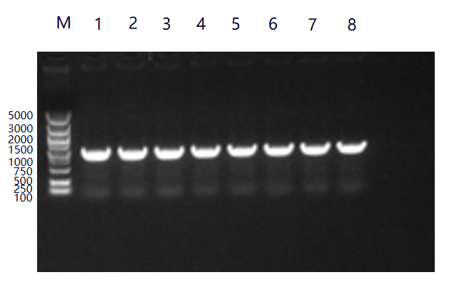

**Supplementary Fig 1.Agarose gel electrophoresis results of Staygold-levE fragments**

**Supplementary Fig 2.**

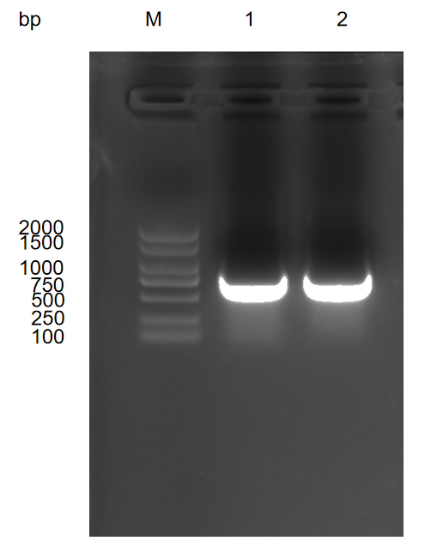

**Supplementary Fig 2.Agarose gel electrophoresis results of Staygold-levE fragments**

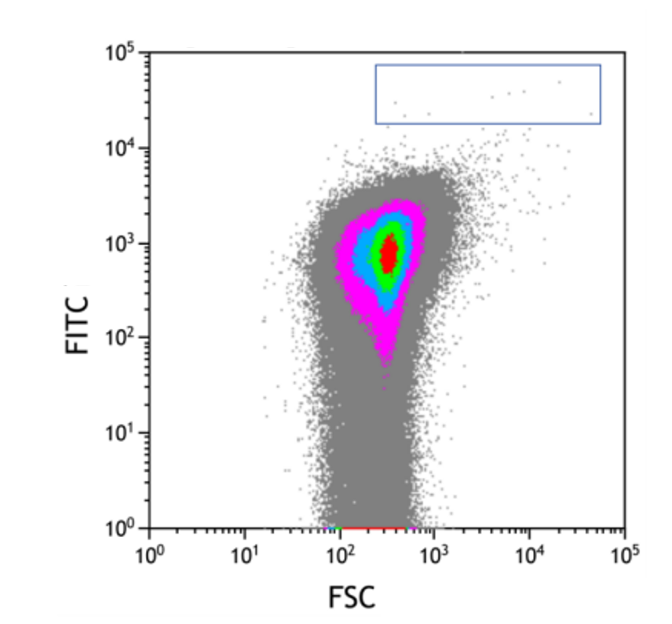

**Supplementary Fig 3.Flow cytometry analysis results.**