**Study on the sources and influencing factors of dissolved organic carbon under high-sediment environments – A case from Wuding River Basin**

Manhong Xia a,b, Nan Xue a,b, Bo Huc, Xinru Gong c, Zhoufeng Wang a,b, Xiaohong Zhao c

*a School of Water and Environment, Chang’an University, PR China*

*b* Key Laboratory of Subsurface Hydrology and Ecological Effect in Arid Region of the Ministry of Education, *Chang’an University*, Xi’an 710054, *PR.China*

*c**School of Civil Engineering, Chang’an University, PR.China*

**\*Corresponding author:**

E-mail address: [wangzf@chd.edu.cn](mailto:wangzf@chd.edu.cn) (Z. Wang); [xzhao@chd.edu.cn](mailto:xzhao@chd.edu.cn) (X. Zhao)

**List of text and table captions**

**Text S1.**

**Text S2.**

**Figure S1.** Spatial distribution of suspended sediment concentrations

**Figure S2.** Relationship between sediment organic carbon content and carbon cycle function genes

**Table S1** Differences in physical and chemical properties of upstream and downstream sediments

**Table S2** The δ13C and δ15N three-endmember mixing model results of sedimentary organic matter

**Text S1.**

Sediment samples were air-dried and sieved through a 200-mesh sieve. The sieved sediment was reacted with 1 mol/L HCl for 24 hours, or until gas evolution ceased, to remove inorganic carbon. The sample was then centrifuged, the supernatant was discarded, and the remaining sediment was oven-dried at 30 °C. The decarbonated sediment was repeatedly rinsed with deionized water until the rinse water tested neutral using pH paper. After each rinse, the sample was centrifuged and the supernatant discarded. The rinsed sediment was oven-dried again at 30 °C. The dried sediment was ground and passed through a 200-mesh sieve. Finally, 20-50 mg of the processed sediment was weighed into a tin boat/capsule for analysis using an elemental analyzer.

**Text S2.**

Sediment available phosphorus (AP) was determined using the Olsen bicarbonate extraction method. Air-dried sediment was extracted with 100 mL 0.5 mol/L NaHCO₃ (pH 8.5) containing 0.5 g activated carbon at 20-21°C for 30 minutes with mechanical shaking. This process facilitates Ca-P dissolution through CaCO₃ precipitation-mediated reduction in Ca²⁺ activity. The extract was filtered through P-free filter paper. A 10 mL aliquot of filtrate was transferred to a volumetric flask, adjusted to faint yellow with dinitrophenol indicator, then mixed with 5 mL molybdenum-antimony-ascorbic acid reagent. After CO₂ venting and dilution to volume, chromogenesis proceeded for 30 minutes. Absorbance was measured at 660 nm (1 cm pathlength) against reagent blanks. AP concentrations were calculated from a phosphate standard curve.

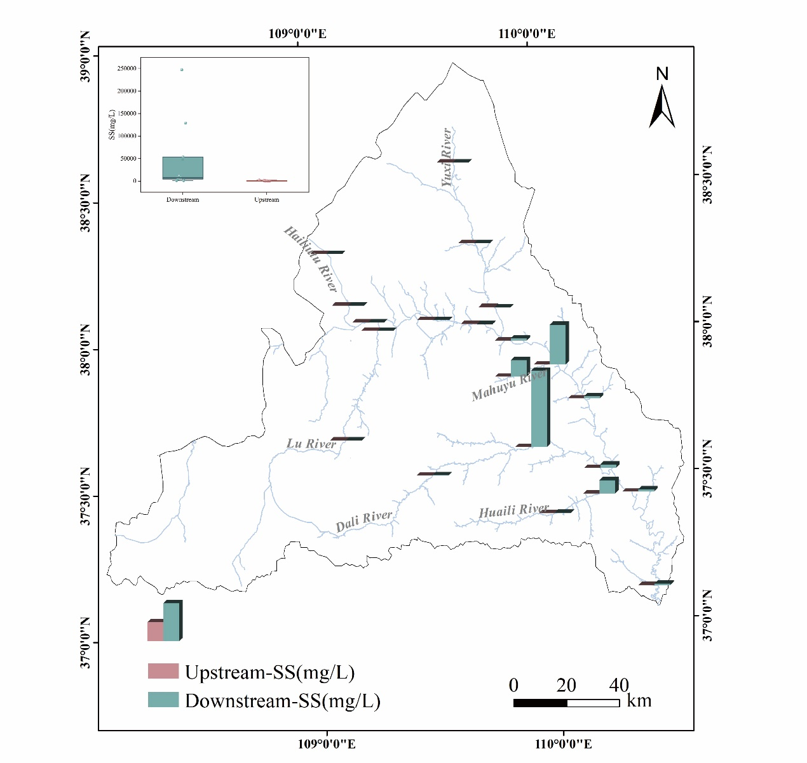

**Figure S1.** Spatial distribution of suspended sediment concentrations

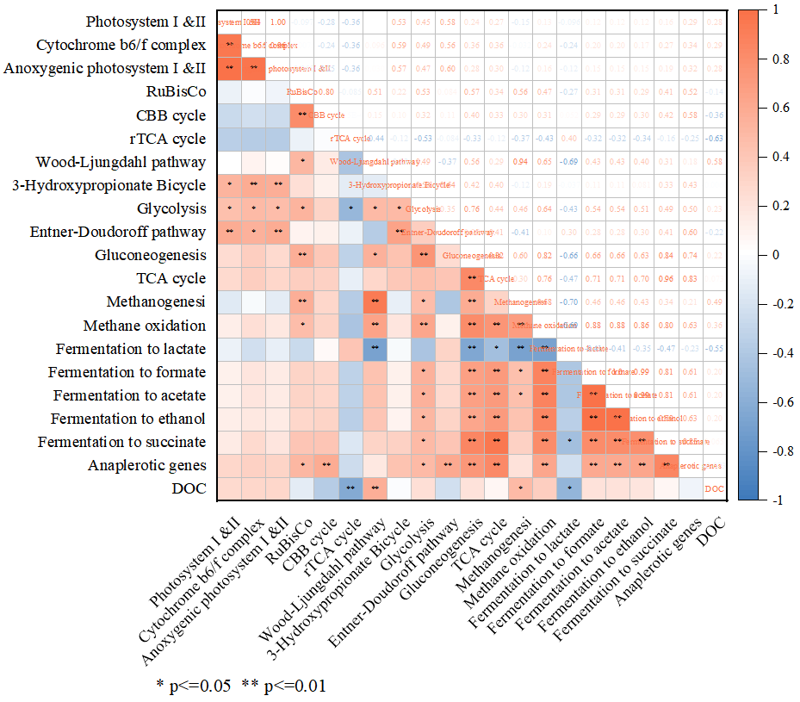

**Figure S2.** Relationship between sediment organic carbon content and carbon cycle function genes

|  |  |  |  |  |  |  |  |  |  |  |  |  |  |  |  |  |
| --- | --- | --- | --- | --- | --- | --- | --- | --- | --- | --- | --- | --- | --- | --- | --- | --- |
| **Table S1** Differences in physical and chemical properties of upstream and downstream sediments | | | | | | | | | | | | | | | | |
| Class | | SS | pH | | TOC | | AP | DOC | | TP | | AN | TN | | C/N | |
| p-value | | 1.45 | 0.15 | | 0.003 | | 0.000 | 0.000 | | 0.08 | | 0.54 | 0.000 | | 0.02 | |
| Notes: p<0.05 is considered a difference; p<0.001 is considered a significant difference. | | | | | | | | | | | | | | | | |
| **Table S2** The δ13C and δ15N three-endmember mixing model results of sedimentary organic matter | | | | | | | | | | | | | | | | |
| ID | mean_ | | | stdev_ | | mean_ | | | stdev_ | | mean_ | | | stdev_ | |
| terrestrial | | | terrestrial | | aquaculture | | | aquaculture | | marine plankton | | | marine plankton | |
| WD1 | 0.46 | | | 0.20 | | 0.33 | | | 0.21 | | 0.22 | | | 0.14 | |
| WD2 | 0.48 | | | 0.26 | | 0.32 | | | 0.26 | | 0.20 | | | 0.18 | |
| WD3 | 0.48 | | | 0.26 | | 0.32 | | | 0.25 | | 0.19 | | | 0.18 | |
| WD4 | 0.49 | | | 0.27 | | 0.32 | | | 0.26 | | 0.19 | | | 0.17 | |
| WD5 | 0.49 | | | 0.28 | | 0.30 | | | 0.26 | | 0.21 | | | 0.19 | |
| WD6 | 0.51 | | | 0.27 | | 0.33 | | | 0.27 | | 0.16 | | | 0.16 | |
| WD7 | 0.49 | | | 0.26 | | 0.30 | | | 0.25 | | 0.21 | | | 0.19 | |
| WD8 | 0.55 | | | 0.28 | | 0.28 | | | 0.26 | | 0.16 | | | 0.16 | |
| WD9 | 0.54 | | | 0.27 | | 0.29 | | | 0.26 | | 0.17 | | | 0.16 | |
| WD10 | 0.51 | | | 0.27 | | 0.30 | | | 0.26 | | 0.20 | | | 0.18 | |
| WD11 | 0.56 | | | 0.28 | | 0.28 | | | 0.26 | | 0.16 | | | 0.15 | |
| Downstream | 0.50 | | | 0.26 | | 0.31 | | | 0.25 | | 0.19 | | | 0.17 | |
| WD12 | 0.40 | | | 0.27 | | 0.33 | | | 0.28 | | 0.28 | | | 0.24 | |
| WD13 | 0.45 | | | 0.26 | | 0.31 | | | 0.25 | | 0.24 | | | 0.20 | |
| WD14 | 0.49 | | | 0.29 | | 0.31 | | | 0.28 | | 0.20 | | | 0.19 | |
| WD15 | 0.42 | | | 0.25 | | 0.32 | | | 0.25 | | 0.26 | | | 0.20 | |
| WD16 | 0.43 | | | 0.25 | | 0.31 | | | 0.25 | | 0.25 | | | 0.21 | |
| WD17 | 0.24 | | | 0.19 | | 0.37 | | | 0.29 | | 0.38 | | | 0.28 | |
| WD18 | 0.31 | | | 0.21 | | 0.33 | | | 0.26 | | 0.36 | | | 0.25 | |
| WD19 | 0.46 | | | 0.26 | | 0.33 | | | 0.26 | | 0.21 | | | 0.19 | |
| WD20 | 0.20 | | | 0.17 | | 0.40 | | | 0.31 | | 0.41 | | | 0.32 | |
| WD21 | 0.18 | | | 0.20 | | 0.48 | | | 0.36 | | 0.34 | | | 0.35 | |
| Upstream | 0.36 | | | 0.24 | | 0.35 | | | 0.28 | | 0.29 | | | 0.24 | |