Supplementary Material

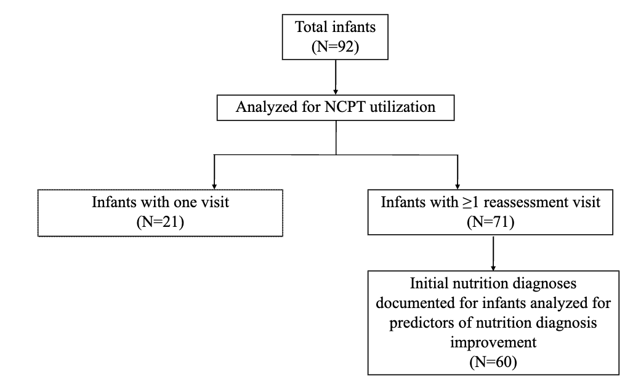
Supplementary Figure 1. Flow chart illustrating the process of analyzing nutrition care data documented in the Academy of Nutrition and Dietetics Health Informatics Infrastructure for infants in the Breastfeeding Registry Study (N=92). NCPT, Nutrition Care Process Terminology⁹

Supplementary Table 1. Registered Dietitian Nutritionist (RDN) and Collaborating Site Characteristics for the Breastfeeding Registry (BFR) Study.
 | N (%)
RDN Race
White or Caucasian | 9 (100)
RDN Education Level
Bachelor’s Degree | 8 (89)
Master’s Degree | 1 (11)
RDN Lactation Certification - Yes | 6 (67)
CLC or CLE | 4 (44)
IBCLC | 2 (22)
Facility Type
Community/Public Health | 7 (78)
Neonatal Intensive Care Unit | 2 (22)
Prior ANDHII Training – Yes | 1 (11)
Prior NCP/T Training - Yes | 7 (78)
NCP/T Utilized at Collaborating Site – Yes | 6 (67)
 | Median (IQR) | Minimum | Maximum
Years of RDN experience | 2 (6) | 0.5 | 15
Years working at collaborating site | 2 (5) | 0.5 | 15
Years working in current position | 2 (6) | 0.5 | 15
Number of RDNs employed at collaborating site | 3 (10) | 1 | 28
Number of RDNs with advanced degrees employed at collaborating site | 1 (3) | 0 | 30
Number of RDNs with lactation credentials at collaborating site | 1 (3) | 0 | 4
_________________________________________________________________________________
Abbreviations: CLC, Certified Lactation Counselor. CLE, Certified Lactation Educator. IBCLC, International Board-Certified Lactation Consultant. ANDHII, Academy of Nutrition and Dietetics Health Informatics Infrastructure. NCP/T, Nutrition Care Process and Terminology.
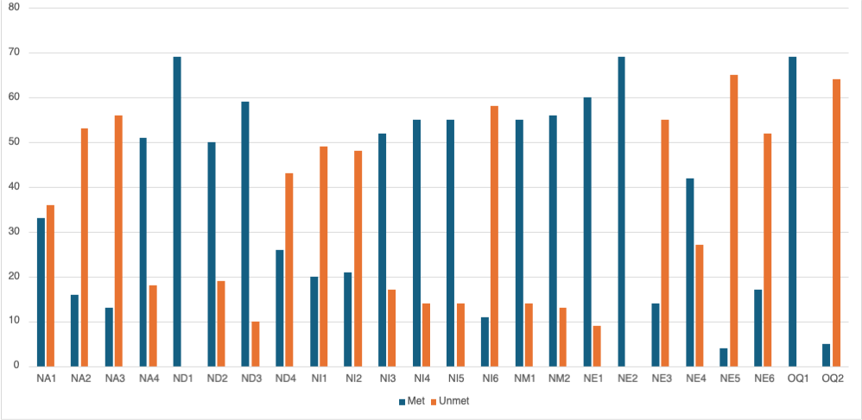
Supplementary Figure 2. Distribution of Nutrition Care Process Quality Evaluation and Standardization Tool (NCP-QUEST)²⁶ indicators from the audit of nutrition care documentation (N=69) in the Breastfeeding Registry (BFR). All encounters in the BFR were documented within the Academy of Nutrition and Dietetics Health Informatics Infrastructure (ANDHII).⁸ This figure includes matched initial and reassessment encounters for infants with at least one documented nutrition diagnosis. Specific indicators correspond to the five NCP chain links: ND2 (evidence-diagnosis link), ND4 (diagnosis-etiology link), NI1 (etiology-intervention link), NI3 (intervention-goal link), and NE2 (diagnosis-outcomes link). NA= nutrition assessment; ND= nutrition diagnosis; NI= nutrition intervention; NM= nutrition monitoring; NE= nutrition evaluation; OQ= overall quality.
Supplementary Table 2. Distribution of the top five most frequently documented Nutrition Care Process Terminology (NCPT)⁹ for infants (N=92) in the Breastfeeding Registry (BFR) Study.
 | Domain/ Category | NCPT Term | N (%)
Nutrition Assessment
Assessment NCPT  (N=2,229 terms) | Client History | Age | 184 (8.2)
Assessment NCPT  (N=2,229 terms) | Food or Nutrition-Related History | Mothers expressed breastmilk intake | 179 (8.0)
Assessment NCPT  (N=2,229 terms) | Client History | Gender | 163 (7.3)
Assessment NCPT  (N=2,229 terms) | Food or Nutrition-Related History | Exclusive breastfeeding | 145 (6.5)
Assessment NCPT  (N=2,229 terms) | Anthropometric Measurements | Weight | 138 (6.2)
Assessment NCPT  (N=2,229 terms) | Other NCPT documented |  | 1420 (63.7)
Nutrition Diagnosis
Problem NCPT  (N=180 terms) | Clinical | Breastfeeding difficulty | 56 (31.1)
Problem NCPT  (N=180 terms) | Intake | Inadequate oral intake | 29 (16.1)
Problem NCPT  (N=180 terms) | Clinical | Predicted breastfeeding difficulty | 18 (10)
Problem NCPT  (N=180 terms) | Intake | Inadequate energy intake | 15 (8.3)
Problem NCPT  (N=180 terms) | Intake | Inadequate vitamin D intake | 14 (7.8)
Problem NCPT  (N=180 terms) | Other NCPT documented |  | 48 (26.7)
Etiology NCPT*  (N=160 terms) | Physical-Function | Breastfeeding difficulty | 28 (17.5)
Etiology NCPT*  (N=160 terms) | Knowledge | Food and nutrition related knowledge deficit | 25 (15.6)
Etiology NCPT*  (N=160 terms) | Behavior | Disordered eating pattern | 14 (8.8)
Etiology NCPT*  (N=160 terms) | Physiologic-Metabolic | Inadequate energy intake | 14 (8.8)
Etiology NCPT*  (N=160 terms) | Physiologic-Metabolic | Increased nutrient needs | 13 (7.2)
Etiology NCPT*  (N=160 terms) | Physical-Function | Predicted breastfeeding difficulty | 13 (7.2)
Etiology NCPT*  (N=160 terms) | Other NCPT documented |  | 53 (33.1)
Signs/Symptoms NCPT  (N=292 terms) | Food or Nutrition-Related History | Energy estimated intake from oral nutrition in 24 hours | 50 (17.1)
Signs/Symptoms NCPT  (N=292 terms) | Food or Nutrition-Related History | Breastmilk feeding attempts in 24 hours | 35 (12)
Signs/Symptoms NCPT  (N=292 terms) | Food or Nutrition-Related History | Adequacy of infant formula intake | 22 (7.5)
Signs/Symptoms NCPT  (N=292 terms) | Food or Nutrition-Related History | Breastfeeding difficulties | 19 (6.5)
Signs/Symptoms NCPT  (N=292 terms) | Food or Nutrition-Related History | Difficulty latching onto breast for feeding | 15 (5.1)
Signs/Symptoms NCPT  (N=292 terms) | Other NCPT documented |  | 151 (51.7)
Nutrition Intervention
Intervention NCPT  (N=237 terms) | Food and/or Nutrient Delivery | Modify breastfeeding attempts | 32 (13.5)
Intervention NCPT  (N=237 terms) | Coordination of Nutrition Care | Collaboration by nutrition professional with other providers | 22 (9.3)
Intervention NCPT  (N=237 terms) | Coordination of Nutrition Care | Referral by nutrition professional to community agencies and programs | 21 (8.9)
Intervention NCPT  (N=237 terms) | Nutrition Education | Education on nutrition's influence on health | 19 (8)
Intervention NCPT  (N=237 terms) | Food and/or Nutrient Delivery | Evaluation of breastfeeding | 14 (5.9)
Intervention NCPT  (N=237 terms) | Other NCPT documented |  | 129 (54.4)
Nutrition Monitoring and Evaluation
Reassessment NCPT  (N=227 terms) | Food or Nutrition-Related History | Breastmilk feeding attempts in 24 hours | 31 (13.7)
Reassessment NCPT  (N=227 terms) | Food or Nutrition-Related History | Difficulty latching onto breast for feeding | 19 (8.4)
Reassessment NCPT  (N=227 terms) | Food or Nutrition-Related History | Energy estimated intake from oral nutrition in 24 hours | 15 (6.6)
Reassessment NCPT  (N=227 terms) | Food or Nutrition-Related History | Inadequate flow of breastmilk | 14 (6.2)
Reassessment NCPT  (N=227 terms) | Food or Nutrition-Related History | Breastfeeding difficulties | 10 (4.4)
Reassessment NCPT  (N=227 terms) | Food or Nutrition-Related History | Infant formula intake | 10 (4.4)
Reassessment NCPT  (N=227 terms) | Comparative Standards | Vitamin D needs | 10 (4.4)
Reassessment NCPT  (N=227 terms) | Other NCPT documented |  | 118 (52.0)
Nutrition care encounter documentation was analyzed from the Academy of Nutrition and Dietetics Health Informatics Infrastructure (ANDHII).⁸ This table reflects NCPT from a total of 197 initial and reassessment encounters, with RDNs documenting multiple terms across Nutrition Care Process⁹ steps. The five most frequently documented NCPT terms are listed; in case of a tie, terms appear in alphabetical order. *There are no nutrition etiology NCPT terms. Nutrition etiologies were free texted in ANDHII.

