## Appendix A. Supplementary material

**Deciphering Drought Response Mechanism in Tibetan Qingke through Comprehensive Transcriptomic and Physiological Analysis**

Deyuan Jiang1,2\*, Shuaihao Chen2,3,4, Zhongmengyi Qin2,3,4, La Bo2,3,4, Liping Niu2,3,4, Hongkang Zhou2,3, Jing Wang2,3,4, Dawa Dondup2 and Xin Hou2,3,4\*

1 School of Life Science and Technology, Wuhan Polytechnic University, Wuhan, Hubei, China.

2 State Key Laboratory of Hulless Barley and Yak Germplasm Resources and Genetic Improvement, Tibet Academy of Agricultural and Animal Husbandry Sciences, Lhasa, Tibet, China.

3 Hubei Hongshan Laboratory, College of Life Sciences, Wuhan University, Wuhan, Hubei, China.

4 School of Ecology and Environment, Tibet University, Lhasa, Tibet, China.

\* Author for correspondence:

*Deyuan Jiang*

*Email:* [dyjiang@whpu.edu.cn](mailto:dyjiang@whpu.edu.cn)

*Xin Hou*

*Email:* [xinhou@whu.edu.cn](mailto:xinhou@whu.edu.cn)

**Supplementary Figure S1.** FPKM Distribution of Transcriptomic Data.

**Supplementary Figure S2.** Co-expression correlation-based network of genes with a connectivity greater than 75 in the Coral2 module.

**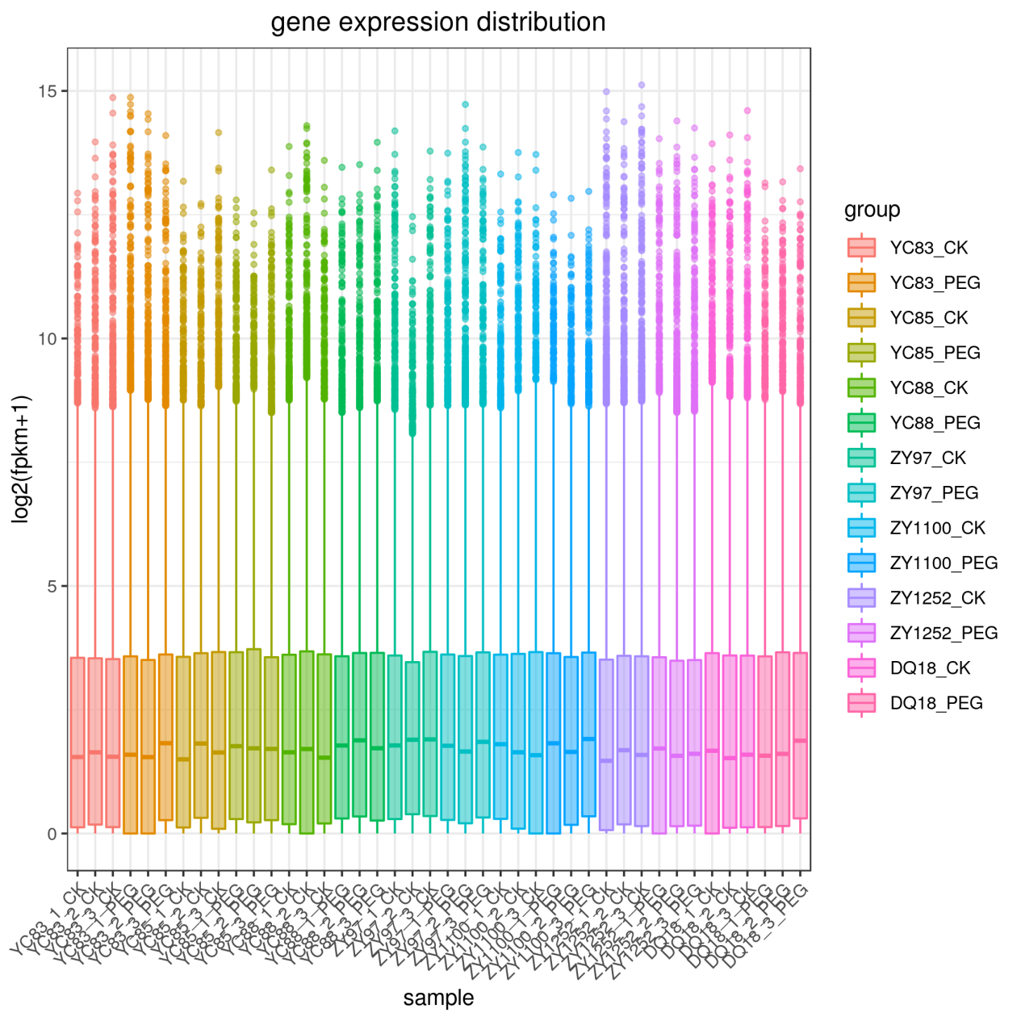**

**Supplementary Figure S1.** FPKM Distribution of Transcriptomic Data.

**Figure S2. coral2_up75_ForFigS**

**Supplementary Figure S2.** Co-expression correlation-based network of genes with a connectivity greater than 75 in the Coral2 module.