Supplementary Material

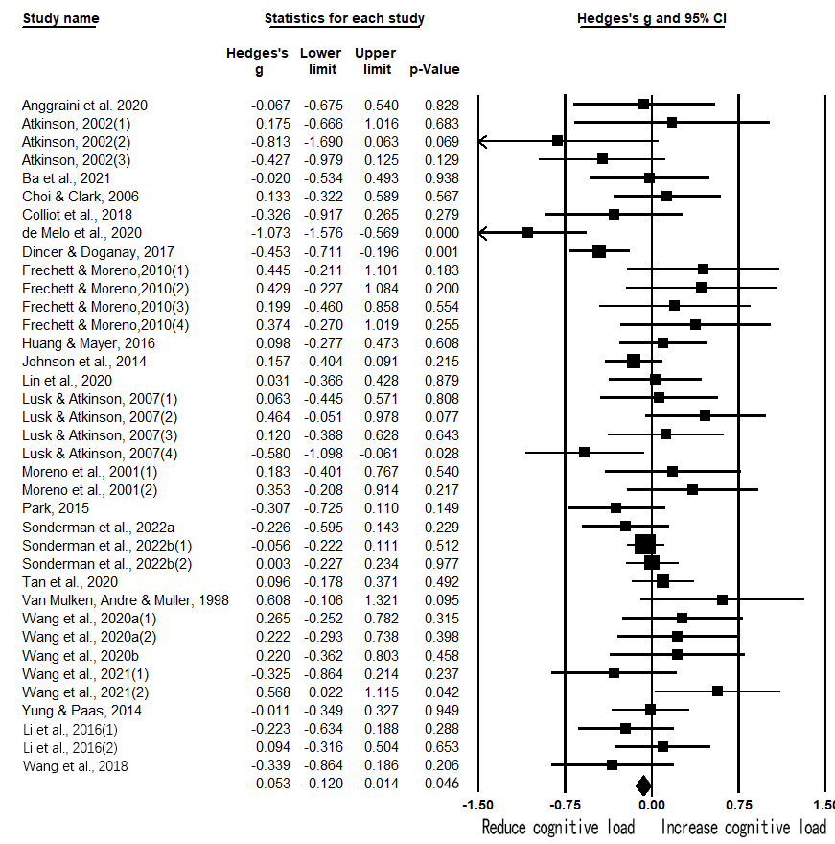

**Supplementary Figure 1.** Forest Plot of All Included Studies (fixed effects model)