**Dose-dependent effects of testosterone on proteins related to nitric oxide signaling pathway and trophic factors in the spinal cord of adolescent trained rats.**

**Katarzyna Nierwińska1, Konstancja Grabowska1, Małgorzata Chalimoniuk2, Sławomir Jagsz3, Józef Langfort4,Andrzej Małecki1, Marta Nowacka-Chmielewska1**

1 Laboratory of Molecular Biology, Institute of Physiotherapy and Health Sciences, Academy of Physical Education in Katowice, Mikolowska 72a, 40-065 Katowice, Poland

2 Faculty in Biala Podlaska, Jozef Pilsudski University of Physical Education in Warsaw, 21-500 Warszawa, Poland.

3 Department of Biochemistry, The Jerzy Kukuczka Academy of Physical Education, Katowice, Poland.

4 Department of Sports Nutrition, The Jerzy Kukuczka Academy of Physical Education in Katowice, Mikolowska 72a, 40-065 Katowice, Poland. j.langfort@awf.katowice.pl.

Correspondence: Katarzyna Nierwińska; e-mail: k.nierwinska@awf.katowice.pl

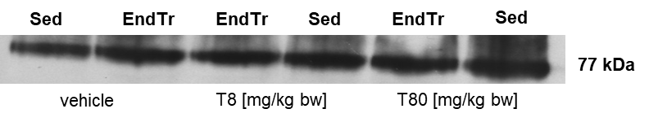

**Fig. 1** Visualization of PKC bands.

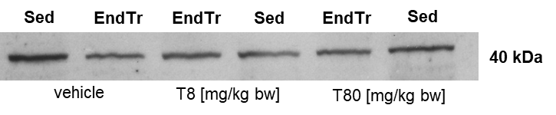

**Fig. 2** Visualization of p-p38 bands.

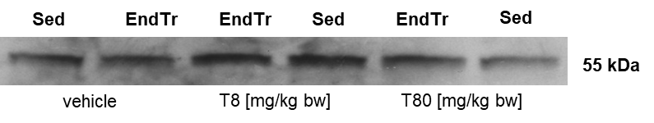

**Fig. 3** Visualization of pAKT bands.

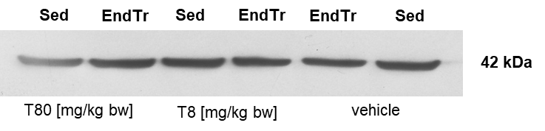

**Fig. 4** Visualization of β-actin bands as a loading control to PKC, p-p38, and pAKT.

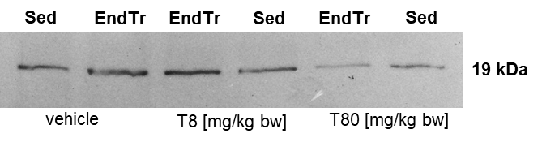

**Fig. 5** Visualization of VEGF-A bands.

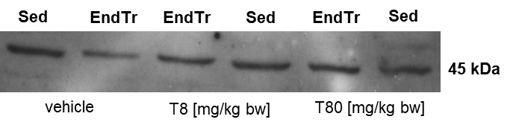

**Fig. 6** Visualization of VEGF-C bands.

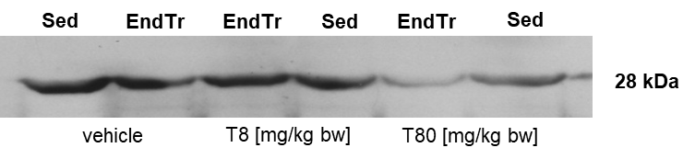

**Fig. 7** Visualization of BDNF bands.

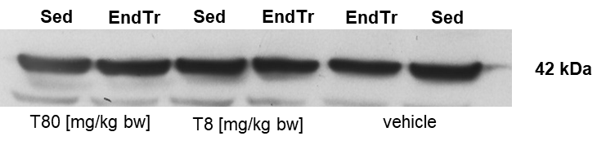

**Fig. 8** Visualization of β-actin bands as a loading control to VEGF-A, VEGF-C, and BDNF.

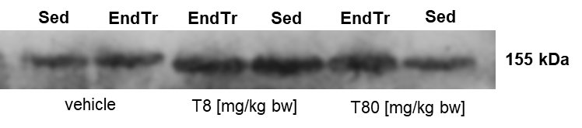

**Fig. 9** Visualization of nNOS bands.

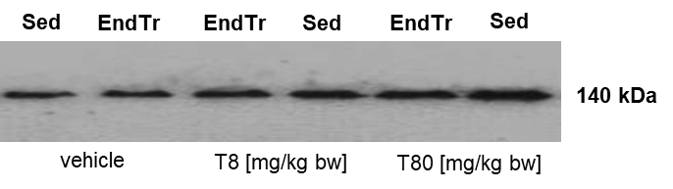

**Fig. 10** Visualization of eNOS bands

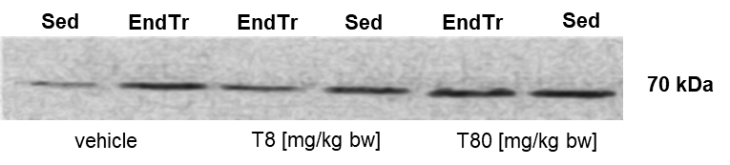

**Fig. 11** Visualization of CGβ1 bands.

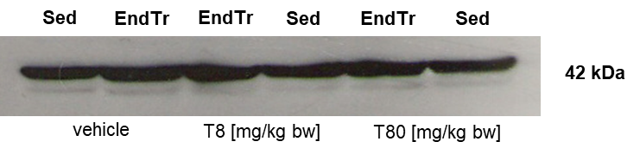

**Fig. 12** Visualization of β-actin bands as a loading control to nNOS, eNOS, and CGβ1.