Supplementary Material

## Supplementary Tables

**Table 1 Baseline characteristics of 1791 IgAN patients.**

|  |  |  |  |  |  |
| --- | --- | --- | --- | --- | --- |
| **Variables** | **Total**  **(n=1791)** | **Tertile1**  **(n=597)**  **<5.08** | **Tertile2**  **(n=597)**  **≥5.08,≤5.34** | **Tertile3**  **(n=597)**  **>5.34** | **P**  **value** |
| Age,years | 43(36-53) | 40(34-48) | 44(36-53) | 46(38-57) | **<0.001** |
| Male,n(%) | 760(42.4) | 163(27.3) | 255(42.7) | 342(57.3) | **<0.001** |
| BMI,(kg/m2) | 23.05(20.85-25.35) | 21.19(19.48-23.27) | 23.12(21.11-24.13) | 24.77(22.67-26.84) | **<0.001** |
| Hypertension,n(%) | 195(10.9) | 64(10.7) | 57(9.5) | 74(12.4) | 0.284 |
| Smoking,n(%) | 172(9.6) | 27(4.5) | 63(10.6) | 82(13.7) | **<0.001** |
| Hemoglobin,g/L | 126.0(113.0-139.0) | 122.0(111.0-134.0) | 125.5(112.5-138) | 132.0(117.0-144.0) | **<0.001** |
| Albumin,g/L | 38.50(35.80-41.00) | 39.00(36.50-41.40) | 38.40(35.70-40.80) | 38.30(34.50-40.90) | **0.002** |
| TC, mmol/L | 4.65(4.05-5.37) | 4.23(3.72-4.87) | 4.63(4.11-5.30) | 5.10(4.53-5.96) | **<0.001** |
| TG, mmol/L | 1.29(0.90-1.97) | 0.88(0.69-1.19) | 1.29(0.95-1.82) | 2.02(1.48-2.72) | **<0.001** |
| LDL, mmol/L | 2.84(2.34-3.42) | 2.39(1.96-2.83) | 2.87(2.48-3.38) | 3.29(2.81-4.00) | **<0.001** |
| HDL, mmol/L | 1.08(0.92-1.30) | 1.26(1.07-1.47) | 1.07(0.92-1.25) | 0.97(0.85-1.14) | **<0.001** |
| FBG, mmol/L | 4.67(4.30-5.11) | 4.35(4.05-4.68) | 4.63(4.31-4.99) | 5.13(4.76-5.66) | **<0.001** |
| H-CRP,mg/L | 1.03(0.51-2.38) | 0.68(0.38-1.60) | 0.99(0.51-2.11) | 1.50(0.77-3.18) | **<0.001** |
| UA,umol/L | 365(300-437) | 321(263-385) | 369(305-437) | 408(347-478) | **<0.001** |
| Scr,umol/L | 80(62-109) | 76(60-99) | 81(62-110) | 84(64-127) | **<0.001** |
| 24h Upro,g/L | 0.91(0.45-1.80) | 0.62(0.33-1.13) | 0.93(0.47-1.80) | 1.35(0.66-2.94) | **<0.001** |
| eGFR,ml/min/1.73m2 | 85.20(61.00-106.60) | 97.45(73.80-115.05) | 84.00(61.75-104.15) | 72.60(49.70-96.90) | **<0.001** |
| Mesangial cellularity, n(%) | | | | | |
| M0 | 22(1.2) | 5(0.8) | 6(1.0) | 11(1.8) | 0.240 |
| M1 | 1769(98.8） | 592(99.2) | 591(99.0) | 586(98.2) |  |
| Endocapillary hypercellularity, n(%) | | | | | |
| E0 | 1232(68.8) | 419(70.2) | 401(67.2) | 412(69.0) | 0.526 |
| E1 | 559(31.2) | 178(29.8) | 196(32.8) | 185(31.0) |  |
| Segmental sclerosis, n(%) | | | | | |
| S0 | 345(19.3) | 112(18.8) | 105(17.6) | 128(21.4) | 0.224 |
| S1 | 1446(80.7) | 485(81.2) | 492(82.4) | 469(78.6) |  |
| Tubular atrophy/interstitial fibrosis, n(%) | | | | | |
| T0 | 1255(70.1) | 483(80.9) | 409(68.5) | 363(60.8) | **<0.001** |
| T1 | 414(23.1) | 105(17.6) | 140(23.5) | 169(28.3) |  |
| T2 | 122(6.8) | 9(1.5) | 48(8.0) | 65(10.9) |  |
| Crescents, n(%) | | | | | |
| C0 | 642(35.8) | 232(39.0) | 185(31.0) | 224(37.5) | **0.044** |
| C1 | 1004(56.1) | 321(53.8) | 359(60.1) | 324(54.3) |  |
| C2 | 145(8.1) | 43(7.2) | 53(8.9) | 49(8.2) |  |
| Using SGLT2i drugs,n(%) | 383(21.4) | 125(20.9) | 119(20.0) | 139(23.3) | 0.350 |
| Using ACEI/ARB drugs,n(%) | 1401(78.2) | 453(75.9) | 471(78.9) | 477(79.9) | 0.216 |
| Using lipid-lowering drugs | 151(8.4) | 45(7.5) | 54(9.0) | 52(8.7) | 0.612 |
| Steroid with/without  immunosuppressants treatment,n(%) | 512(28.6) | 138(23.1) | 184(30.8) | 190(31.8) | **0.001** |
| Composite event,n(%) | 130(7.3) | 23(3.9) | 41(6.9) | 66(11.1) | **<0.001** |

**Notes:** Continuous variables are expressed as median(interquartile range); Categorical variables are expressed as frequency(%);Bold values was that the differences were significant(P<0.05).

**Abbreviations:**BMI,body mass index;TC,total cholesterol;TG, triglyceride;LDL,low-density lipoprotein;HDL,high-density lipoprotein;FBG,fasting blood glucose;UA, uric acid;Scr,serum creatinine;24h Upro:24-hour urine protein; eGFR, estimated glomerular filtration rate; SGLT2i, sodium-glucose cotransporter-2 inhibitors; ACEI/ARB, angiotensin-converting enzyme inhibitors/angiotensin II receptor blockers.

**Table 2 Correlation between CHG index and potential risk factors.**

|  |  |  |  |
| --- | --- | --- | --- |
|  | **Variables** | **Correlation coefficient(r)** | **P value** |
| CHG | sex | 0.258 | **<0.001** |
|  | age | 0.223 | **<0.001** |
|  | BMI | 0.431 | **<0.001** |
|  | Hb | 0.202 | **<0.001** |
|  | ALB | -0.090 | **<0.001** |
|  | UA | 0.370 | **<0.001** |
|  | Scr | 0.297 | **<0.001** |
|  | 24h Upro | 0.341 | **<0.001** |
|  | eGFR | -0.306 | **<0.001** |

**Notes:** Bold values was that the differences were significant(P<0.05).

**Abbreviations:**CHG,the Cholesterol,High-Density Lipoprotein,and Glucose(CHG) index;BMI,body mass index;Hb,hemoglobin;ALB,albumin;UA,uric acid;Scr,serum creatinine;24h Upro,24-hour urine protein; eGFR, estimated glomerular filtration rate.

**Table 3 Logistic Regression Models for the relationship between CHG index and renal pathological lesions and clinical manifestation.**

|  |  |  |  |
| --- | --- | --- | --- |
| **Pathological lesions** | **OR** | **95%CI** | **P value** |
| M1/M0 | 0.338 | 0.099-1.151 | 0.083 |
| E1/E0 | 1.183 | 0.860-1.629 | 0.302 |
| S1/S0 | 0.861 | 0.592-1.253 | 0.435 |
| T1-2/T0 | 3.489 | 2.494-4.882 | **<0.001** |
| C1-2/C0 | 1.062 | 0.779-1.448 | 0.705 |
| Intimal thickening of artery | 2.486 | 1.795-3.443 | **<0.001** |
| Hyaline degeneration | 4.513 | 3.231-6.305 | **<0.001** |
| Smoking | 3.527 | 2.179-5.708 | **<0.001** |
| Hypertension | 1.176 | 0.733-1.887 | 0.502 |
| eGFR<45  ml/min/1.73m2 | 4.593 | 3.050-6.916 | **<0.001** |

**Notes:** Bold values was that the differences were significant(P<0.05).

**Abbreviations:**M,mesangial proliferation; E, endocapillary proliferation; S, segmental glomerulosclerosis; T, tubular atrophy or interstitial fibrosis; C, crescents.

**TABLE 4** Baseline characteristics of 1791 IgAN patients according to the Cut-off value of CHG.

|  |  |  |  |  |  |  |
| --- | --- | --- | --- | --- | --- | --- |
| **Variables** | **Total** | **Low CHG group**  **(≤5.29)** | | **High CHG group**  **(>5.29)** | | **P value** |
| **Participants**,(n) | 1791 | 1096 | | 695 | |  |
| Age,years | 43(36-53) | 41(35-50) | | 47(38-57) | | **<0.001** |
| Male,n(%) | 760(42.4) | 367(33.5) | | 393(56.5) | | **<0.001** |
| BMI,(kg/m2) | 23.05(20.85-25.35) | 22.05(20.07-24.14) | | 24.61(22.49-26.70) | | **<0.001** |
| Hypertension,n(%) | 195(10.5) | 112(10.2) | | 83(11.9) | | 0.254 |
| Smoking,n(%) | 172(9.6) | 76(6.9) | | 96(13.8) | | **<0.001** |
| Hemoglobin,g/L | 126(113-139) | 123(112-135) | | 131(117-144) | | **<0.001** |
| Albumin,g/L | 38.5(35.8-41.0) | 38.7(36.2-41.2) | | 38.4(34.6-40.9) | | **0.011** |
| TC, mmol/L | 4.65(4.05-5.37) | 4.39(3.86-5.05) | | 5.07(4.49-5.93) | | **<0.001** |
| TG, mmol/L | 1.29(0.90-1.97) | 1.02(0.77-1.41) | | 1.96(1.43-2.64) | | **<0.001** |
| LDL, mmol/L | 2.84(2.34-3.42) | 2.58(2.16-3.03) | | 3.25(2.79-3.96) | | **<0.001** |
| HDL, mmol/L | 1.08(0.92-1.30) | 1.16(0.98-1.38) | | 0.98(0.85-1.16) | | **<0.001** |
| FBG, mmol/L | 4.67(4.30-5.11) | 4.45(4.14-4.81) | | 5.07(4.74-5.58) | | **<0.001** |
| H-CRP,mg/L | 1.03(0.51-2.38) | 0.83(0.42-1.85) | | 1.43(0.73-3.02) | | **<0.001** |
| UA,umol/L | 365(300-437) | 336(280-408) | | 406(345-476) | | **<0.001** |
| Scr,umol/L | 80(62-109) | 73.0(59.0-96.7) | | 95(71-131) | | **<0.001** |
| 24h Upro, g/L | 0.91(0.45-1.80) | 0.69(0.37-1.30) | | 1.39(0.69-2.82) | | **<0.001** |
| eGFR,ml/min/1.73m2 | 85.2(61.0-106.6) | 92.7(70.7-111.0) | | 71.5(49.6-94.1) | | **<0.001** |
| Mesangial cellularity,n(%) | | | | | | |
| M0 | 22(1.2) | 9(0.8) | | 13(1.9) | | **0.049** |
| M1 | 1769(98.8) | 1087(99.2) | | 682(98.1) | |  |
| Endocapillary hypercellularity, n(%) | | | | | | |
| E0 | 1232(68.8) | 754(68.8) | 478(68.8) | | 0.993 | |
| E1 | 559(31.2) | 342(31.2) | 217(31.2) | |  | |
| Segmental sclerosis, n(%) | | | | | | |
| S0 | 345(19.3) | 200(18.2) | 145(20.9) | | 0.171 | |
| S1 | 1446(80.7) | 896(81.8) | 550(79.1) | |  | |
| Tubular atrophy/interstitial fibrosis, n(%) | | | | | | |
| T0 | 1225(70.1) | 844(77.0) | 411(59.1) | | **<0.001** | |
| T1-2 | 536(29.9) | 252(23.0) | 284(40.9) | |  | |
| Crescents, n(%) | | | | | | |
| C0 | 642(35.8) | 386(35.2) | 256(36.8) | | 0.487 | |
| C1-2 | 1149(64.2) | 710(64.8) | 439(63.2) | |  | |
| Steroid with/without immunosuppressants treatment,n(%) | 512(28.6) | 288(26.3) | 224(32.2) | | **0.007** | |
| Composite event,n(%) | 130(7.3) | 49(4.5) | 81(11.7) | | **<0.001** | |

**Notes:** Continuous variables are expressed as median(interquartile range); Categorical variables are expressed as frequency(%);Bold values was that the differences were significant(P<0.05).

**Abbreviations:**BMI,body mass index;TC,total cholesterol;TG, triglyceride;LDL,low-density lipoprotein;HDL,high-density lipoprotein;FBG,fasting blood glucose;UA, uric acid;Scr,serum creatinine;24h Upro:24-hour urine protein; eGFR, estimated glomerular filtration rate.

**TABLE 5** Multivariate Cox regression analysis CHG according to Cut-off value and renal outcomes.

|  |  |  |  |
| --- | --- | --- | --- |
|  | **Low CHG group(≤5.29)** | **High CHG group(>5.29)** | **P**  **value** |
| Number of participants with events/n | 49/1096 | 81/695 |  |
| Crude Model | 1.00(reference) | 2.666  (1.868-3.804) | **<0.001** |
| Model 1 | 1.00(reference) | 1.986  (1.142-3.454) | **0.015** |
| Model 2 | 1.00(reference) | 1.853  (1.047-3.280) | **0.034** |
| Model3 | 1.00(reference) | 1.842  (1.044-3.249) | **0.035** |

**Notes:** Model 1: was adjusted for age, gender,BMI+ clinic factors (hemoglobin, albumin,uric acid, 24h Upro and eGFR ). Model 2: was adjusted for Model 1 +Oxford(MEST-C). Model 3: was adjusted for Model 2 + treatment(Steroid with/without immunosuppressants). albumin was transformed into a binary variable with a cutoff of 35.uric acid was transformed into a binary variable with a cutoff of 420.eGFR was transformed into a binary variable with a cutoff of 45. Tubulointerstitial atrophy/interstitial fibrosis (T)was transformed into a binary variable of T0 and T1+T2. Crescent(C) was transformed into a binary variable of C0 and C1+C2. CI, confidence intervals; HR, hazard ratios. Bold values was that the differences were significant.

## Supplementary Figures

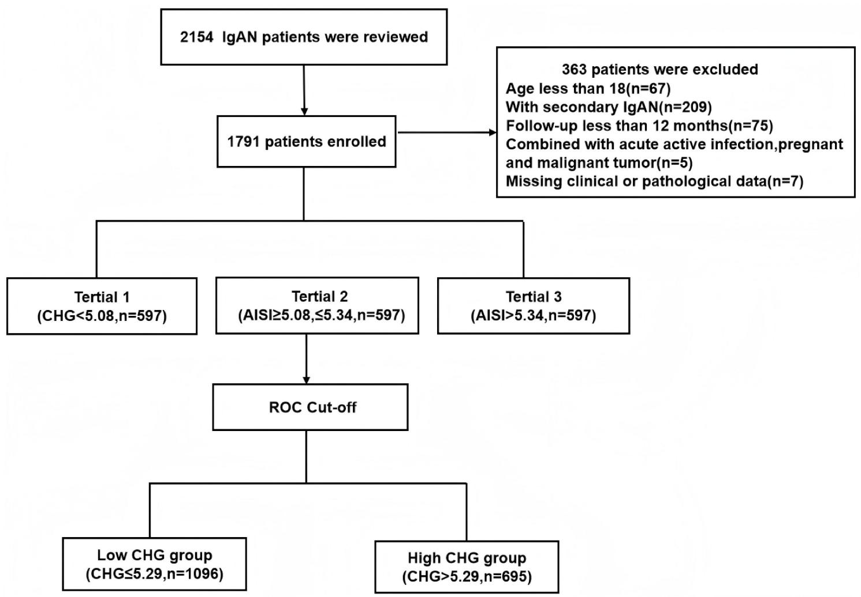

**Figure 1 Flowchart of excluded patients.**

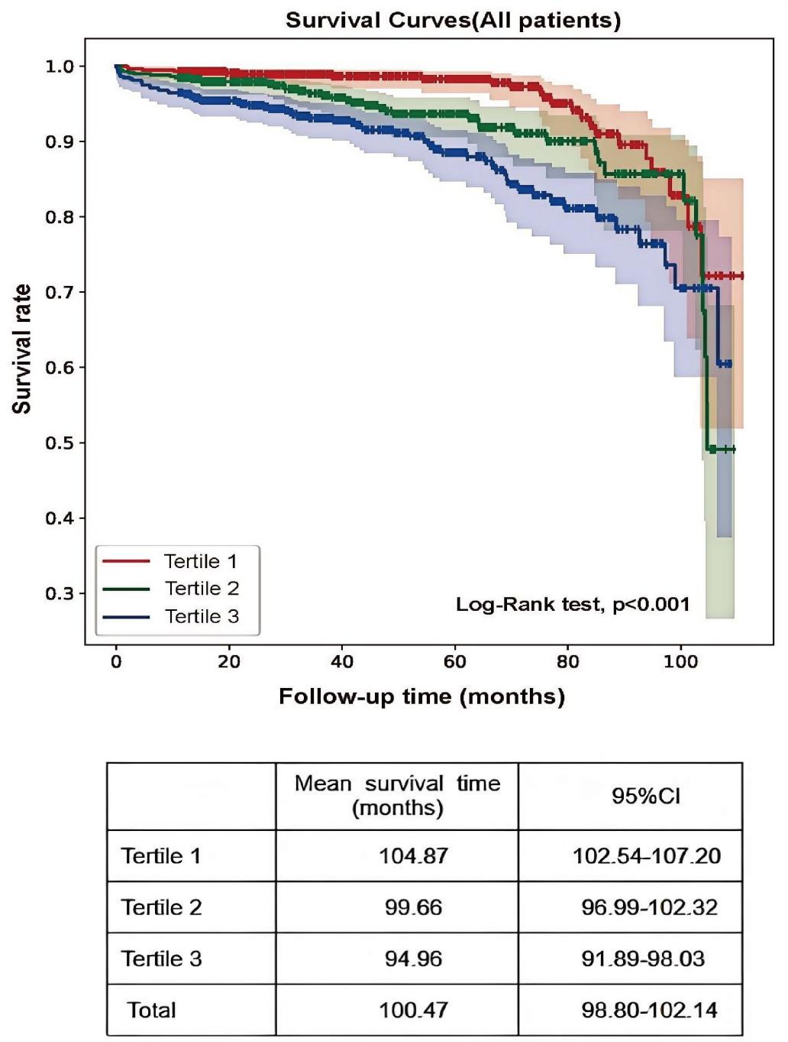

**Figure 2 Kaplan–Meier curves of renal outcomes in different CHG groups.**

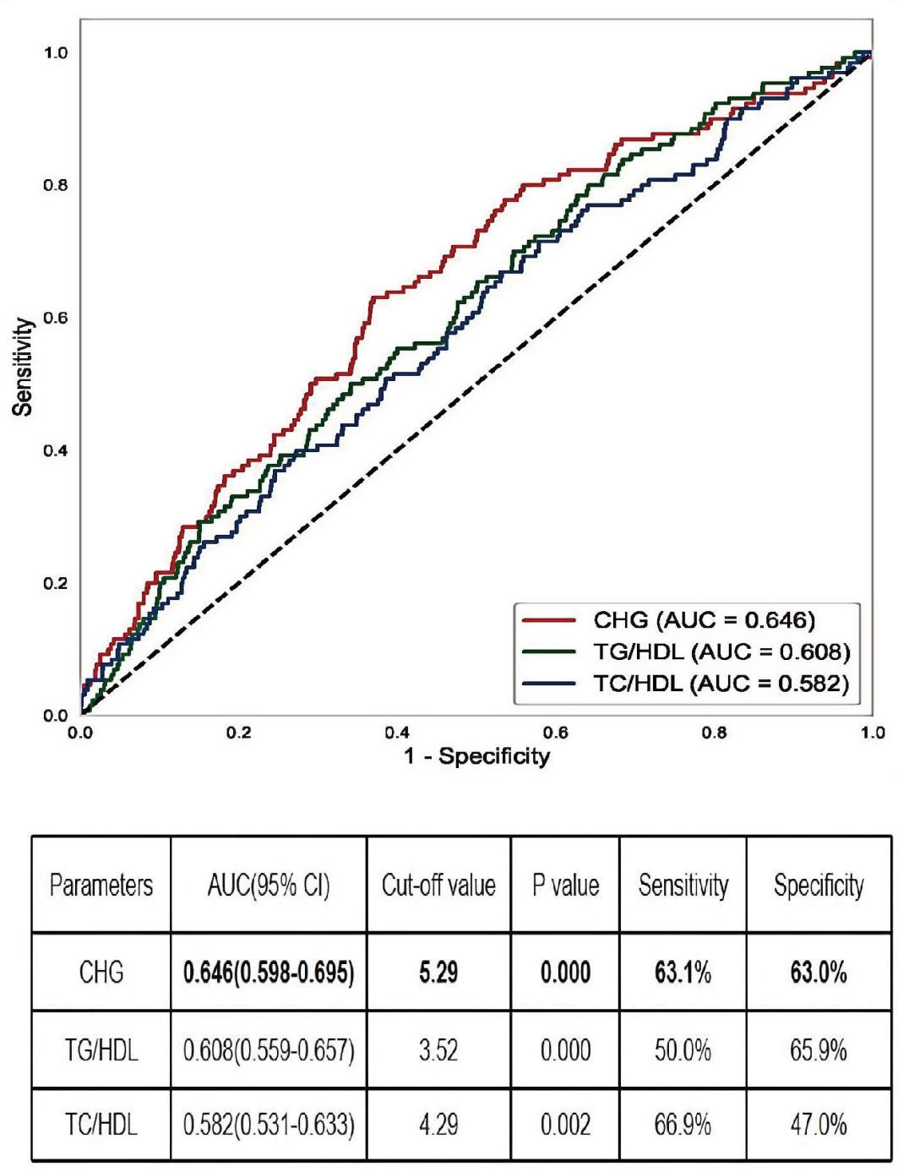

**Figure 3 The AUC of CHG,TG/HDL, and TC/HDL for IgAN renal outcomes.**

**Abbreviations**:AUC,the area under the receiver operating characteristic curve; CHG, the Cholesterol, High-Density Lipoprotein, and Glucose =Ln[TC (mg/dL)× FBG (mg/dL)/2×HDL (mg/dL).

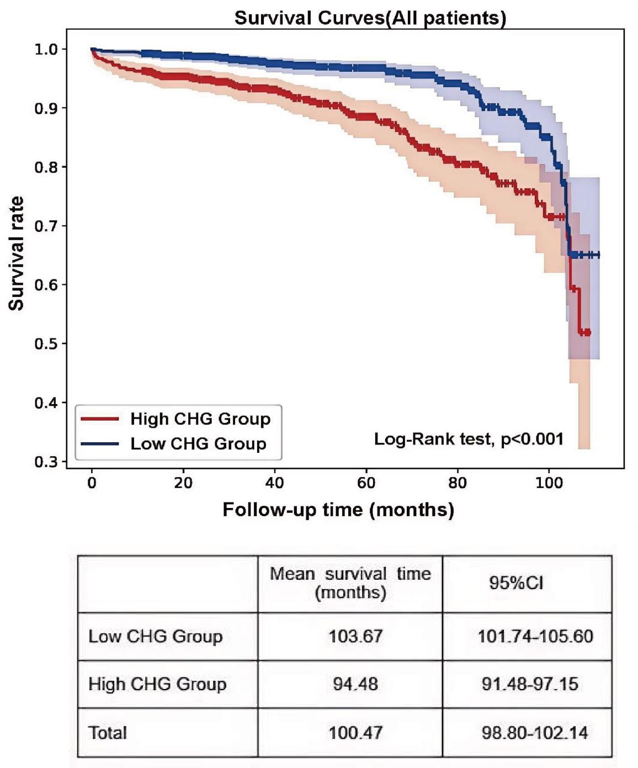

**Figure 4 Kaplan–Meier curves of renal outcomes in two CHG groups.**

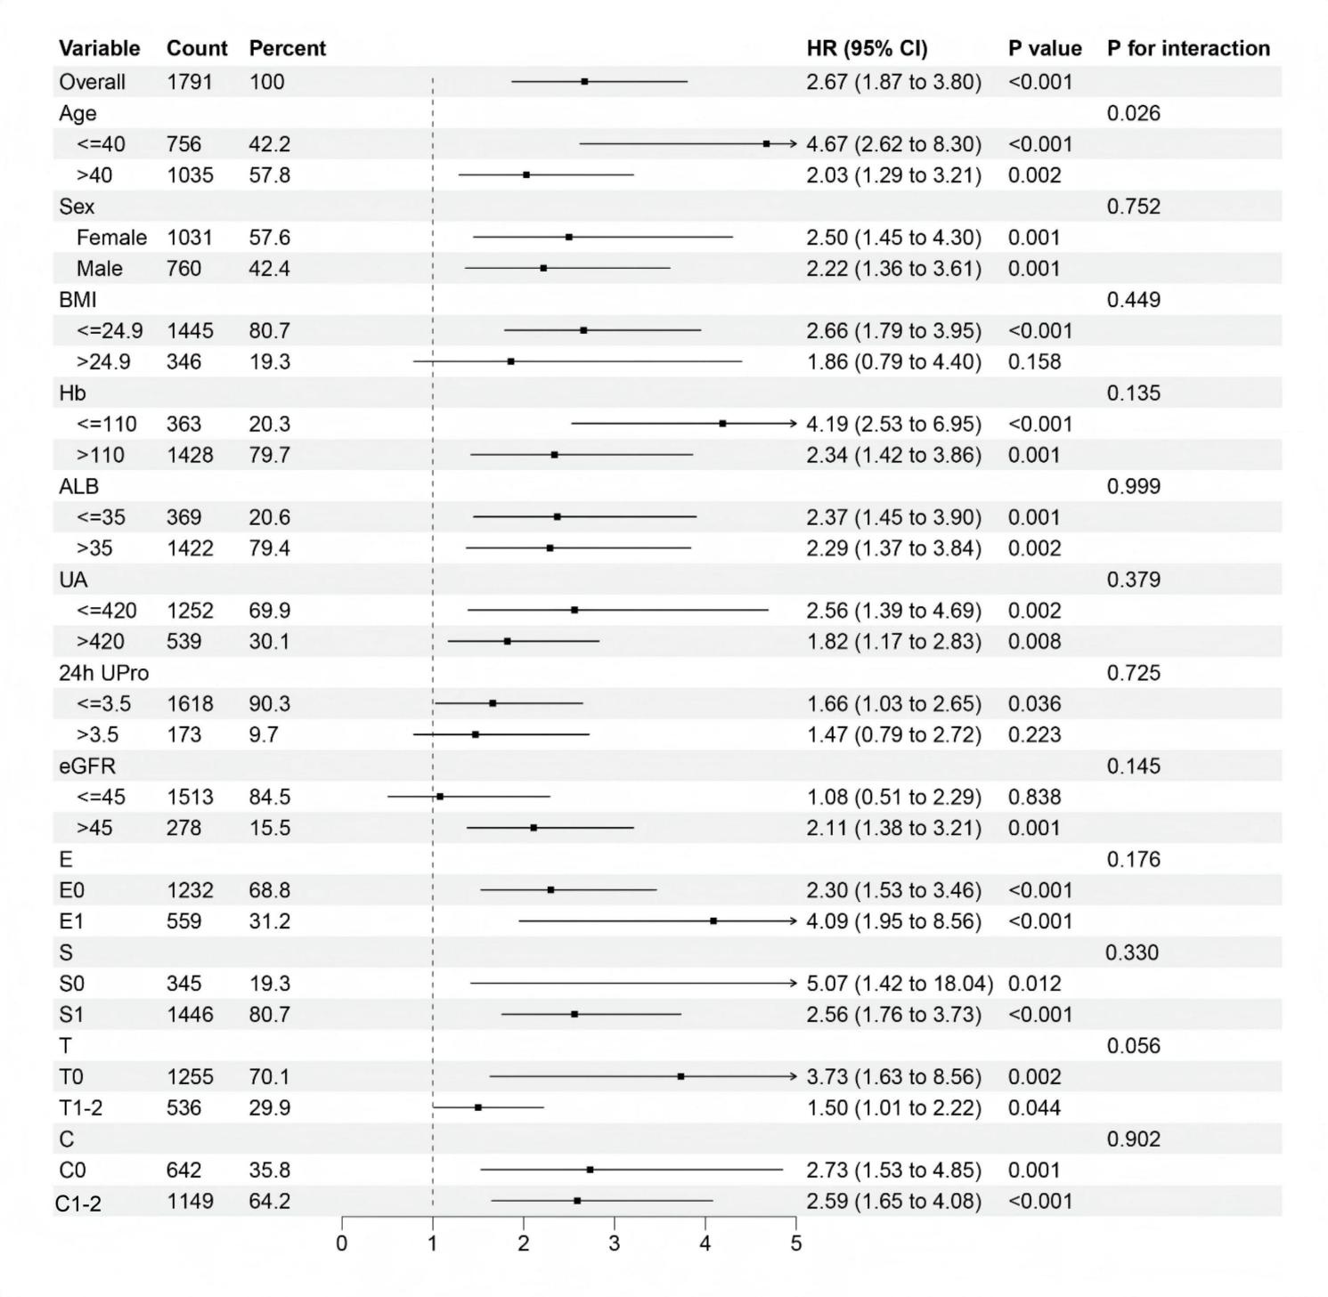

**Figure 5 Forest plot of subgroup and interaction effects analyses.**

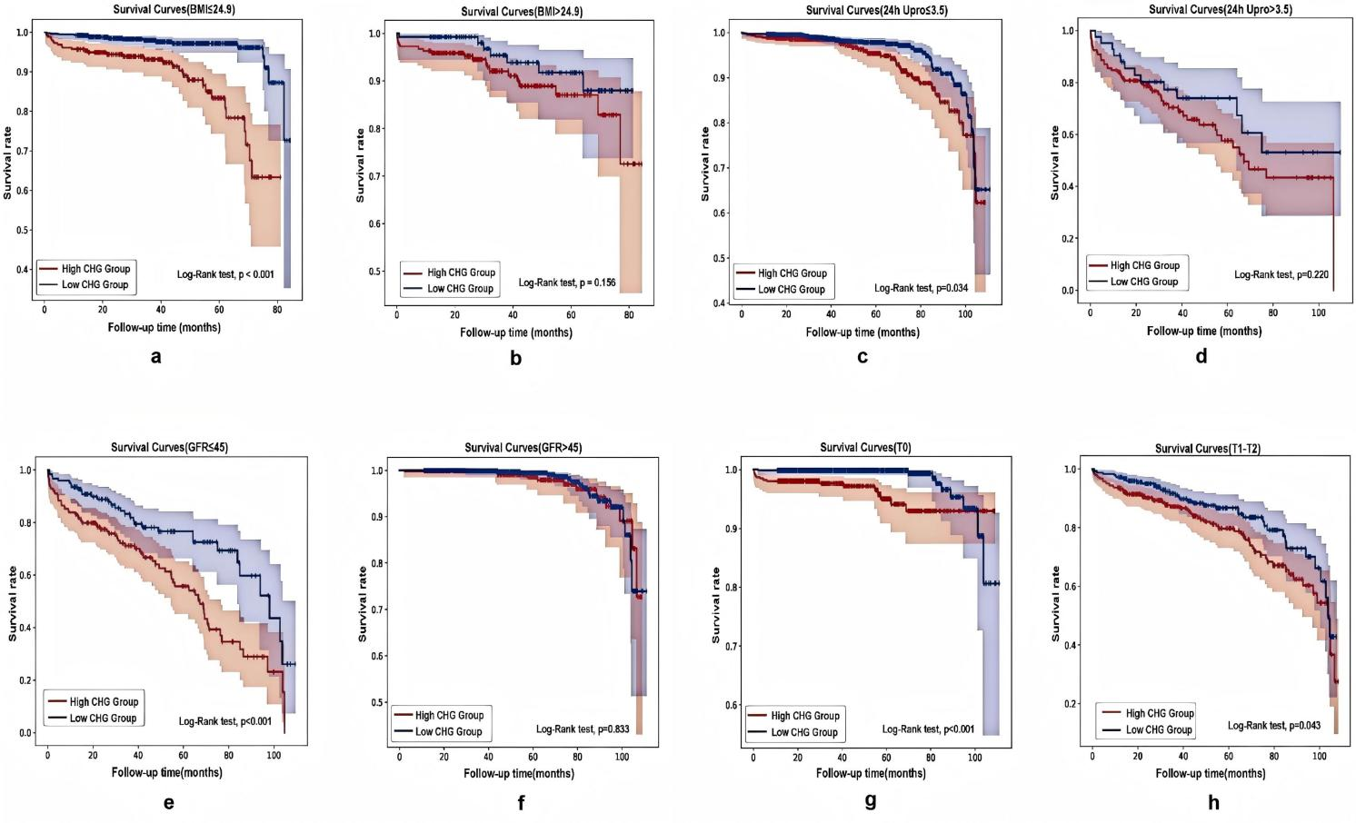

**Figure 6 Different types of Kaplan-Meier analysis for the renal endpoint. (a-b) Kaplan-Meier analysis for with different BMI. (c-d)Kaplan-Meier analysis for patients with different 24-hour urine protein. (e-f)Kaplan-Meier analysis for patients with different eGFR. (g-h)Kaplan-Meier analysis for patients with differenttubulointerstitial atrophy/interstitial fibrosis(T).**

**Abbreviations**: BMI,body mass index;24h Upro,24h urine protein;eGFR, estimated glomerular filtration rate;T,Tubular atrophy/interstitial fibrosis.

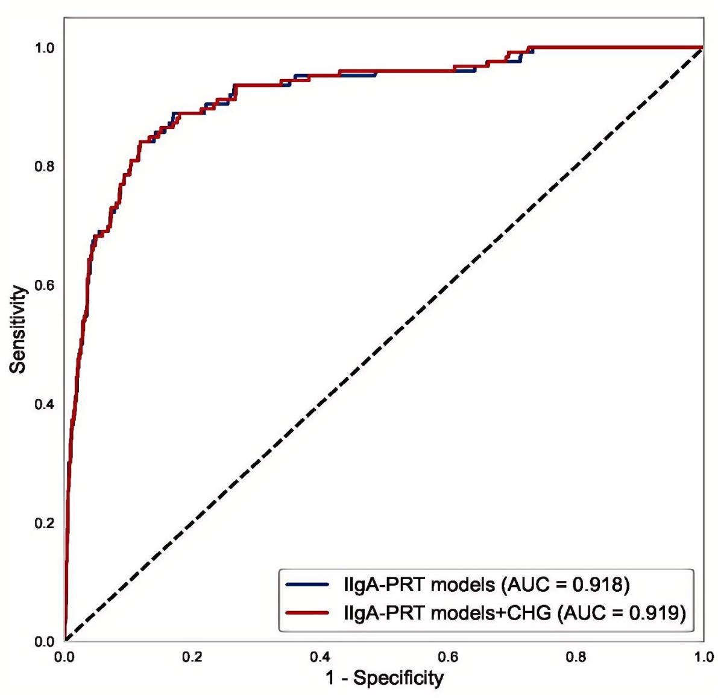

**Figure 7 The ROC of IIgAN-PRT models with and without CHG.**