**Supplementary Materials**

**Table of Contents**

**Tables**

* **Table SM1.** Multi-database validation between Scopus and Web of Science: AI, ML, and DL in Mg-alloys
* **Table SM2** AZ31 and AZ31B alloys
* **Table SM3** Al-Mg and Al-based alloys
* **Table SM4** Advanced models (CNN, GBT, Graph-based)
* **Table SM5** Cluster 2: Alloy composition and mechanical property optimization
* **Table SM6** Cluster 2: corrosion, microstructure, and phase prediction
* **Table SM7** Cluster 9: alloy composition and design strategies
* **Table SM8** Cluster 3: atomic-scale simulations and ML potentials
* **Table SM9** Cluster 6: first-principles and active learning approaches
* **Table SM10** Cluster 4: AI in welding and advanced processing techniques
* **Table SM11** Cluster 5: biomaterials and microstructural optimization
* **Table SM12** Cluster 6: corrosion modeling
* **Table SM13** Cluster 7: data-driven design and optimization techniques
* **Table SM14.** Actionable AI strategies and deployment challenges across key Mg alloy application dmains

**Figures**

* **Figure SM1.** CNN-based microstructure-to-strength prediction workflow
* **Figure SM2.** ML-based prediction framework for heat treatment effects on mechanical properties in Mg alloys
* **Figure SM3.** SHAP summary plot for biodegradation rate prediction in Mg alloys
* **Figure SM4.** Time-series deep learning framework for grain growth prediction in Mg alloys
* **Figure SM5.** Data-driven optimization workflow for Mg alloy design

**Table SM1.** Multi-database validation between Scopus and Web of Science: AI, ML, and DL in Mg-alloys

|  |  |  |  |  |
| --- | --- | --- | --- | --- |
| **Validation Element** | **Database 1: Scopus** | **Database 2: Web of Science** | **Overlap** | **Similarity (%)** |
| Author Keywords (Top 20) | Machine Learning, Magnesium Alloys, Alloy Design, Magnesium Alloy, Mechanical Properties, Magnesium, Deep Learning, Corrosion, DFT, Mg Alloys, Molecular Dynamics, ANN, Aluminum Alloy, AI, Genetic Algorithm, Active Learning, Mg Alloy, Corrosion Behavior, DFT, Corrosion Resistance | Machine Learning, Magnesium Alloys, Magnesium, Magnesium Alloy, Mechanical Properties, Corrosion, DFT, Mg Alloys, Molecular Dynamics, ANN, Deep Learning, Aluminum Alloy, AI, Genetic Algorithm, Active Learning, Microstructure, Alloy Design, Friction Stir Welding, Prediction, Wear | 17 out of 20 | 85% |
| Index Keywords (Top 20) | Magnesium Alloys, Machine-Learning, Aluminum Alloys, Forecasting, Zinc Alloys, Binary Alloys, Copper Alloys, Learning Systems, Tensile Strength, Ternary Alloys, Mg Alloy, Machine Learning Models, Property, DFT, Neural Networks, Corrosion Resistance, Corrosive Effects, Deep Learning, Article, Density Functional Theory | Microstructure, Mechanical-Properties, Behavior, Magnesium, Magnesium Alloy, Strength, Ductility, Mg, Alloys, Evolution, Design, Prediction, Deformation, Temperature, Texture, Al, Aluminum, Corrosion, AI, DL | 16 out of 20 | 80% |
| Authors (Top 20) | Pan Fusheng, Tang Aitao, Zeng Xiaoqin, Lamaka Sviatlana V., Lee Taekyung, Wang Han, Wang Li, Würger Tim, Yu Jinyeong, Zheludkevich Mikhail L., Fu Huadong, Jiang Lei, Li Yuanyuan, Lu Guimin, Mi Xiaoxi, Mishra Akshansh, Wang Leyun, Xie Jianxin, Zhu Gaoming, Shaban Mahmoud | Pan Fusheng, Feiler Christian, Zheludkevich Mikhail L., Tang Aitao, Lamaka Sviatlana V., Wuerger Tim, Zeng Xiaoqin, Alsunaydih Fahad Nasser, Hoeche Daniel, Lee Taekyung, Meissner Robert H., Yu Jinyeong, Chen Ding, Vaghefinazari Bahram, Alawad Majed O., Wang Li, Mi Xiaoxi, Li Yuanyuan, Mishra Akshansh, Moses Atwakyire | 14 out of 20 | 70% |
| Sources (Top 20) | Materials Today Communications, Journal of Magnesium and Alloys, Computational Materials Science, Acta Materialia, Materials Letters, Journal of Materials Research and Technology, Journal of Alloys and Compounds, Materials and Design, Physical Review Materials, JOM, Journal of Materials Science and Technology, Materials, Materials Transactions, npj Computational Materials, Advanced Engineering Materials, Computers, Materials and Continua, Corrosion Science, npj Computational Materials, Journal of Applied Physics, Materials Characterization | Materials Today Communications, Journal of Magnesium and Alloys, Computational Materials Science, Journal of Materials Research and Technology-JMR&T, Journal of Materials Science & Technology, International Journal of Hydrogen Energy, Acta Materialia, Journal of Materials Science & Technology, Journal of Materials Informatics, Crystals, npj Materials Degradation, Applied Sciences-Basel, Corrosion Science, Advanced Engineering Materials, npj Computational Materials, Energy Storage Materials, International Journal of Interactive Design and Manufacturing, JOM, Scientific Reports, Mechanics of Materials | 16 out of 20 | 80% |
| Countries (Top 20) | China, USA, India, South Korea, Germany, Japan, United Kingdom, Australia, Switzerland, Canada, Saudi Arabia, Iran, Turkey, Russia, Spain, Taiwan, Egypt, Italy, Austria, Belgium | China, India, USA, Germany, South Korea, Australia, Saudi Arabia, Canada, Egypt, England, Iran, Russia, Taiwan, Turkey, France, Japan, Spain, Switzerland, Norway, Malaysia | 17 out of 20 | 85% |

**Table SM2** Cluster 1: AZ31 and AZ31B alloys

|  |  |  |  |  |
| --- | --- | --- | --- | --- |
| **Ref.** | **Material/**  **Alloy** | **Target Property** | **ML/ANN**  **Approach** | **Key Highlights/**  **Findings** |
| (Yu et al., 2024) | * AZ31   Mg alloy | * Low-cycle fatigue life | * Hybrid * ML/Energy-based model | * Outperformed traditional   fatigue models   * Accurate in multiple   loading directions |
| (Wang et al., 2024a) | * Maximum thinning rate | * Hybrid BPNN-RF * with GA and DBO | * Best formability at 250Â°C * Resistance coefficient   had the most substantial  impact   * 0.32% prediction error |
| (Zhang et al., 2023b) | * Tensile properties vs texture | * Artificial Neural Network | * ANN-linked texture features * (Imax, D, PLD, PTD)   to yield strength and elongation |
| (Murugesan et al., 2023) | * AZ31B Mg   alloy | * Flow stress | * BP-ANN * GABP-ANN * CFBP-ANN | * CFBP-ANN had the   best prediction   * Models trained on strain   temp, and strain rate data |
| (Yadav and Khurana, 2022) | * Tensile strength * Elongation * Hardness * Grain size | * ANN + Genetic Algorithm | * Validated optimum joint   performance (<3% error)   * GA used for   multi-objective optimization |
| (Jaafreh et al., 2022) | * Pure Mg   and AZ31 | * Stress concentration (KAM) | * ERT, RF * MLP, LR * DT, KNN * NBC | * ERT best accuracy * Grain size was most important * SC lower in fine-grain sizes |

**Table SM3** Cluster 1: Al-Mg and Al-based alloys

|  |  |  |  |  |
| --- | --- | --- | --- | --- |
| **Ref.** | **Material/**  **Alloy** | **Target Property** | **ML/ANN**  **Approach** | **Key Highlights/**  **Findings** |
| (Jain et al., 2024) | * Al-Mg-X alloys | * Hardness | * CatBoost * Ensemble ML   models | * CatBoost showed superior   hardness prediction   * Compiled composition * Aging, and property data |
| (Chandana and Kamesh, 2024) | * Mg-based alloys | * Hydrogen storage/   release capacity | * ANN with Bayesian | * R² of 0.86 to 0.93 * Key factors included   particle size  Mg content and pressure |
| (Yu et al., 2024) | * AZ31 Mg alloy | * Low-cycle   fatigue life | * Hybrid ML/   Energy-based model | * Outperformed traditional   fatigue models   * Accurate in multiple   loading directions |
| (El-Garaihy et al., 2024) | * ZX30 Mg alloy | * Grain size * Corrosion rate * Yield strength | * ANN * Gaussian Process   Regression   * Simulated Annealing | * Route Bc and pass   number crucial   * Strong correlation with   yield strength  and corrosion resistance |
| (Zhu et al., 2025b) | * Cu-Cr-Zr-Mg-Ti   alloy | * Tensile strength * Electrical   conductivity | * BP neural network * GA | * 668 MPa tensile strength   achieved   * Micro-alloying effects   captured via ANN. |
| (Bai et al., 2024) | * Al-Zn-Mg-Cu-Zr   alloy | * Flow stress * Dislocation density | * BP-ANN * Correlation   K-means clustering | * R² = 98.67% for stress * Linked energy dissipation   with microstructure  (DRX, grain boundaries) |
| (Efa, 2024) | * AA7075 * AZ61A with   Ti-interlayer | * Residual stress * Equivalent strain * Peak temperature | * BP neural network   with gradient descent | * Ti-interlayer reduced   residual stress   * ANN predicted optimal   process settings accurately |
| (Gurugubelli et al., 2023) | * Al-Mg alloys * (5000 series) | * Tensile strength | * AI with Python * Ansys simulations | * Simulated tensile test   equivalent to experiments   * AI as an alternative   to lab testing |
| (Li et al., 2024d) | * Mg-2Ho alloy | * Flow stress | * PSO-BP ANN | * PSO-BP ANN outperformed   the Arrhenius model  (R² = 0.99948)   * Captured DRX mechanisms |
| (Xue et al., 2023) | * Al-Mg alloy | * Corrosion resistance   (NAMLT) | * ML framework   (unspecified) | * Predicted corrosion resistance   from limited data   * Mg% * Annealing temp/time critical |
| (Mishra, 2024a) | * Mg alloys * FSW | * Ultimate tensile   strength | * Decision Trees * XGBoost, ANN * RF * Gradient Boosting * AdaBoost | * XGBoost had the highest   R² = 0.81   * Mg alloy type was   the most important feature |
| (Jiang et al., 2024a) | * Advanced * Al-Zn-Mg-Cu-Ti   -Cr-Zr alloy | * UTS * Toughness * Corrosion resistance | * Interpretable ML | * Ti, Cr, Zr enhanced all   properties   * Explained elemental   impact using ML. |
| (Troncoso et al., 2023) | * Mg-10%Al alloy | * Twinning interface   recognition | * Advanced ML | * Used stress fields   to identify interfaces   * Prismatic interfaces   drive twin growth |
| (Wang et al., 2023a) | * Al-Li alloys | * Tensile strength * Yield strength | * RBF and BP neural   networks | * RBF outperformed BP * Validated with experiments * Improved efficiency |
| (Byun et al., 2024) | * ZK60 Mg alloy | * Anisotropic   deformation  behavior | * GAN-aided GRU   model | * Excellent generalization   in flow prediction   * Effective with small   datasets and multiple  directions |
| (Medghalchi et al., 2023) | * Mg-4.65Al-2.82Ca   alloy | * Damage   mechanism  (microcracks,  decohesion) | * YOLOv5 DL   (object detection) | * Damage mechanisms   vary with strain rate   * DL detected crack   evolution  and orientation changes |
| (Pei et al., 2024b) | * Mg-Gd-Y-Zr alloy | * Stress-strain   behavior  (hot-forming) | * ANN * ISV model * Arrhenius | * ANN best fits the   original data   * ISV model is effective * under   complex loading  and embedded in ABAQUS. |
| (Li et al., 2023) | * 7075 Al alloy | * Slurry temp * Uniformity   (ECP process) | * GA-BPNN | * R² = 0.9988 for average temp * Excellent fit for temp prediction |
| (Mokhtari et al., 2024) | * Al-Mg alloys | * Tensile strength * Stiffness | * ANN, GRU * LSTM, RNN   (DNNs) | * RNN and LSTM   outperformed other  models   * DNNs with memory   were best  for predicting tensile  properties |
| (Sun and Liu, 2023) | * Mg alloys | * Uncertainty   quantification  (performance) | * Deep Neural Network   classifier  + SGD | * Used DNN to * optimize performance bounds * Helped in safety design   for Mg alloys |
| (Shaban et al., 2023) | * ZK30 Mg   alloy | * Grain size * Hardness * Corrosion | * Linear regression * Gaussian process * SVR | * Route Bc with four   passes optimal   * The model showed   that the die angle had  little effect on  grain refinement. |
| (Jagadeesh and Setti, 2023) | * Mg Ze41A   alloy | * Wear rate * Tribological   behavior | * ANN | * Wear maps built * Predicted wear   characteristics  with a 3.4% error. |
| (Ma et al., 2022) | * Cast Al * Mg-based   alloys | * Grain size | * Various ML   methods (review) | * ML was highlighted   as effective for data-driven  grain size prediction  across compositions  and conditions |

**Table SM4** Cluster 1: Advanced models (CNN, GBT, Graph-based)

|  |  |  |  |  |
| --- | --- | --- | --- | --- |
| **Ref.** | **Material/Alloy** | **Target Property** | **ML/ANN**  **Approach** | **Key Highlights/**  **Findings** |
| (Kim et al., 2024) | * Al-Ti-Cr * Al-/Mg-based alloys | * Specific hardness | * Ensemble ML   (ANN, CNN, RF, etc.) | * New high-hardness   alloys   * Explainable AI   to interpret results |
| (Lopes Marinho et al., 2024) | * Mg-based biodegradable   implants | * Degradation * Osseointegration   (image segmentation) | * CNNs   (U-Net, HR-Net,  nnU-Net) | * 2D nnU-Net had the   best segmentation  performance on images   * Degradation layer   most challenging to predict |
| (Nithin et al., 2022) | * Al-Si-Mg alloy | * Grain prediction   (a-Al grains) | * CNN | * CNN predicted a-Al   grains with >90% accuracy   * Extrusion ratio = 2   showed the best properties |
| (Masood Chaudry et al., 2021) | * Al-Cu-Mg-x * alloys | * Hardness | * Gradient Boosted   Trees (GBT) | * GBT predicted the   hardness of the unexplored  Al alloys effectively  using literature data |
| (Shu et al., 2022) | * Polycrystalline   Mg alloys | * Microstructure-   property prediction | * HGGAT   (graph attention  network) | * HGGAT outperformed   ML baselines   * Proposed grain   knowledge graph for  performance prediction. |

**Table SM5** Cluster 2: Alloy composition and mechanical property optimization

|  |  |  |  |  |
| --- | --- | --- | --- | --- |
| **Ref.** | **AI/ML Technique**  **Used** | **Target Material/**  **System** | **Predicted Property/**  **Output** | **Key**  **Findings** |
| (Wang et al., 2025) | * Interpretable ML   (Data Augmentation  + Reconstruction) | * Low-alloyed   Mg Alloys | * Ultimate tensile strength * Elongation-to-failure | * High accuracy   (R² > 95%)   * New Mg alloy   (MZAX2000)  shows excellent  strength-ductility |
| (Li et al., 2024a) | * DL Potential | * Al2CuMg Phases   in Al-Cu-Mg Alloy | * Crystal structure * Mechanical/thermal   properties | * Highest rigidity   and tensile strength   * Highest thermal * conductivity |
| (Yang et al., 2024) | * RF   Regression  (RFReg) | * SiCp/Al   Composites with Cu | * Mechanical properties   (tensile strength) | * ML-designed   composite  achieved 561 MPa  after processing |
| (Mo et al., 2025) | * Active Learning   with Bagging | * Al-Mg-Zn Alloys | * Strength-ductility balance * (UTS and EL) | * New alloy * 602 MPa UTS   and 15.1% EL   * Validated via   Microstructural  analysis |
| (Anne et al., 2024) | * Decision Tree * Multi-Layer Perceptron   (MLP) | * Mg/Al-Ce   Hybrid Composite | * Structure-property   relationships | * Strength and   hardness improved  2.36x   * ML captures   deformation-property  trends |
| (Mi et al., 2024) | * Regression-based Bayesian   Optimization Active  Learning Model  (RBOALM) | * Mg-Mn-based   Wrought Alloys | * Mechanical properties   (UTS, YS, EL) | * New alloys * High strength * Elongation revealed |
| (Peng et al., 2023) | * Active Learning * Revised LAsou Method | * Mg3Bi2-xSbx Alloy | * Atomic configurations | * 90-atom unit cells   yield realistic structures   * XRD matches   experiment |
| (Juan et al., 2024) | * ML-based   Property Optimization | * Al-Zn-Mg-Cu   Alloys | * Strength and toughness | * Trace Hf addition   improves strength   * Alloy validated with   superior properties |
| (Jiang et al., 2021) | * Deep Potential * DP-GEN | * Al-Cu-Mg   Alloy System | * Potential Energy Surface   (PES) | * Model consistent   with first-principles   * Suitable for full-range   atomistic modeling |

**Table SM6** Cluster 2: Corrosion, microstructure, and phase prediction

|  |  |  |  |  |  |
| --- | --- | --- | --- | --- | --- |
| **Ref.** | **AI/ML**  **Technique**  **Used** | **Target Material/**  **System** | **Predicted Property/**  **Output** | **Methodology/**  **Model Details** | **Key Findings** |
| (Kuriki et al., 2024) | * Multimodal   Deep  Learning (MDL) | * As-cast Mg/   LPSO two-  phase alloys | * 3D local   strain distribution | * 3D microstructure   descriptors + DL   * Occlusion sensitivity * Correlation analysis for * feature importance | * High strain   occurs where the hard  LPSO phase is elongated   * Multimodal DL * improves prediction accuracy |
| (Liu et al., 2025b) | * MDL | * Thermal Barrier   Coatings  (TBCs)   * Turbine blades | * TBC failure/ * lifetime prediction | * DL network   modeling corrosion effects  with microscale stress  and damage models | * DL model accurately   predicts TBC spalling  Lifetime within 20% of  observed data |
| (Chen et al., 2024b) | * GA | * AZ61 Mg   Alloy | * Rheological behavior * DRX grain growth | * GA-optimized Arrhenius   Model + 3D Cellular  Automata  for microstructure  evolution | * GA-Arrhenius   accurately predicts  material behavior   * CA simulates   DRX morphology |
| (Dai et al., 2024) | * ML | * WE43 Mg   Alloy | * Corrosion behavior   under protein  adsorption  and shear stress | * ML model to explore   intrinsic  corrosion mechanism  under BSA and WSS | * BSA and WSS   competitively accelerate  corrosion   * ML models * intrinsic mechanisms |
| (Chen et al., 2024a) | * ML | * Biodegradable   Zn Alloys | * UTS * Corrosion rate | * ML models for UTS * CR with real-time   visualization interface | * UTS prediction error 0.95% * CR 5.5% * Enables efficient Z * n-Mn alloy design |
| (Qi et al., 2025) | * Spatiotemporal   DL  (PredRNN,  ConvLSTM) | * MAO-coated   Mg Alloys | * Corrosion progression | * FEM-generated dataset * DL models trained   to predict corrosion  evolution | * PredRNN model   outperforms in stability  detail for long-term prediction |
| (Davydzenka et al., 2022) | * ML   + Stochastic  Augmentation | * Mg-based   Alloy | * Image * segmentation accuracy | * Stochastic data * augmentation   improved model  training with limited data | * Segmentation accuracy   improved from  81.1% to 90%  with augmented data |
| (Li et al., 2025) | * Wasserstein   Autoencoder  + Property Predictor | * Fe-based   Metallic  Glasses | * Saturation magnetic   flux density (Bs) | * Joint-WAE model   for inverse design  high-dimensional  optimization | * Predicted unreported   Fe-based MGs with  Bs > 1.5 T  validated experimentally |

**Table SM7** Cluster 2: Alloy composition and design strategies

|  |  |  |  |  |  |
| --- | --- | --- | --- | --- | --- |
| **Ref.** | **Alloy System /**  **Base Alloy** | **Design Strategy/**  **Method Used** | **Target**  **Properties** | **Key**  **Alloying**  **Elements** | **Main Findings/**  **Outcome** |
| (Zhang et al., 2025c) | * Al-Zn-Mg-Cu   (7075) | * Kriging-assisted   Two  Archive algorithm  (KTA2) | * Strength * Plasticity * Grain refinement | * Ca * Y | * Improved joint   properties in  4 iterations   * Reduced grain   size  and eliminated  columnar grains |
| (Zhang et al., 2024a) | * Cu-Ni-Co-Si-Mg | * SHAP analysis   + physicochemical  screening | * Strength * Conductivity * Sustainability | * Cr   (substitution  for Co) | * 64% Co   reduction   * Retained high   UTS and  conductivity |
| (Feng et al., 2023) | * Al-Mg-Si | * NSGA-II   GA | * Strength * Corrosion   resistance | * Mn * Cr * Fe * Zr * Ti | * Improved YS/UTS * Corrosion   resistance with low  Cu/Mg/Si |
| (Zhang et al., 2023a) | * Al-Si-Mg-Sr-Ti | * Bayesian   optimization  + thermodynamics | * Strength * Ductility | * Sr * Ti | * Designed   Ti-modified  alloy   * Validated   Composition  -property  relation |
| (Cheng et al., 2024) | * Mg-Al | * Generative   model  + automatic  differentiation | * Structure   prediction | * Mg * Al | * Predicted five   stable Mg-Al  structures with  application  potential |
| (Jiang et al., 2022) | * Al-Mg-Zn   (Cu, Cr,  Mn, Ti, Zr) | * Property-oriented   MLDS | * UTS * Ductility * Toughness | * Mg * Zn * Cr * Mn * Ti * Zr | * Discovered novel   alloys with UTS  up to 736 MPa |
| (Yanase et al., 2022) | * Al-Si-Mg | * SLM   + ML  analysis | * Relative density * Microstructure | * Si * Mg | * Double scanning   improved density   * ML identified key   parameters |
| (Liu et al., 2020) | * AlSi10Mg | * GPR | * Density * Strength * Ductility | * Si * Mg | * Optimized   LPBF window   * Improved   Mechanical  properties |

**Table SM8** Cluster 3: Atomic-scale simulations and ML potentials

|  |  |  |  |  |  |
| --- | --- | --- | --- | --- | --- |
| **Ref.** | **Material/**  **System Studied** | **Simulation**  **Method(s)** | **ML Technique/**  **Model** | **Key Focus/**  **Target Property** | **Key Findings/**  **Outcomes** |
| (Jiang et al., 2024b) | * NLi4-BGra/   MgH2  Heterojunction | * DFT * MD | * DFT + ML   for material  prediction | * Hydrogen   storage   * Desorption   temperature | * ML-assisted DFT   predicted improved  Mg-alloy hydrides   * Modulation of   H-desorption via  heterojunction  substitution validated |
| (Geng et al., 2025) | * MgCu alloys   (monocrystal/  polycrystalline) | * DFT * MD | * ML Force Field   (MLFF) | * Strength-   concentration  relation   * Yield strength | * MLFF enables   accurate mechanical  property prediction at  low Cu concentrations   * Refined strength   understanding |
| (Deng, 2024) | * Mg-Fe-O system | * Large-scale   simulations  with ML  potential | * DL Interatomic * Potential | * MgO exsolution   processes   * Geodynamo   energy source | * Unified DL   potential predicts  MgO exsolution  phase and rate   * Refining geodynamic   models |
| (Fang et al., 2025) | * 1155 binary alloy   catalysts for glucose  hydrogenation | * DFT * Microkinetic   simulation | * Light Gradient   Boosting Machine  (LGBM) | * Adsorption energies * Catalytic activity | * LGBM accurately   predicts adsorption  energies   * Identified 9 high-activity   catalysts |
| (Zhang et al., 2025b) | * BCC Mg-Li-Al   alloys  (single crystal  and polycrystalline) | * DFT * ML-based   atomistic  simulations | * ML Potential   Energy Surface | * Plastic deformation * Phase transition * Twin strengthening | * Revealed   BCC-FCC-BCC-HCP  phase transition  in single crystal  Mg-Li-Al   * Twin strengthening   absent in polycrystalline |
| (Chen et al., 2025) | * Dual-site   M-COFs  MgFe-S-COF  MgZn-S-COF | * DFT | * ML   screening  of 136 candidates | * CO2 reduction to C2   products   * Charge distribution | * DFT & ML   identified  catalysts |
| (Menon et al., 2024) | * Micro-scale   Polycrystalline  Mg-Y alloys | * MS * MD * DFT | * Surrogate model   with stacking cross-  validation | * Grain boundary   segregation  thermodynamics | * Predicted Y   segregation free  energies with  uncertainty   * Model agrees   with experimental results |
| (Feng and Lu, 2024) | * Hydrated   MgCl2-NaCl-KCl  (MNK) molten salt | * AIMD * DPMD | * Deep Potential   (DP)   * DP-GEN | * Thermophysical   properties   * Diffusion * Viscosity * Conductivity | * Efficient ML   potential development   * Accurately predicts   temperature-dependent  properties of MNK s  ystem |
| (Wang et al., 2024b) | * Binary   Mg intermetallics | * DFT * HER kinetics   model | * Regression model   using Wf  and WFIE | * Corrosion resistance * Hydrogen adsorption   energy | * ML predicts   corrosion-resistant  intermetallics   * Model validated   with low RMSE  on new alloys |
| (Motamedi et al., 2023) | * Al-Mg-Zn alloy | * MD   simulation | * GLM * ANN * DT * RF | * Tensile   properties  under different  conditions | * ANN best for   predictions   * Parameter tuning   improved DT  and RF accuracy |
| (Wang et al., 2021) | * Ternary   Mg alloys  (RE-free) | * DFT | * Non-linear   regression model | * Stacking fault   energy   * Ductility | * ML predicted low   SFE alloys validated  by DFT   * RE-free ductile alloys |
| (Tian and Yu, 2021) | * Mg-Cd binary   alloy | * DFT * Cluster   Expansion   * Monte Carlo | * Semi-automated   phase detection  algorithm | * Phase diagram   prediction   * Transition behavior | * First quantification   of uncertainty in  DFT-based phase  diagrams   * Detected   configurational  disorder |
| (Álvarez-Zapatero et al., 2021) | * ZnMg nanoalloys | * DFT * Basin-hopping | * Neural Network   (NN) potential | * Energy landscape * Stability | * NN predicts   stable structures  accurately   * Structural/electronic   traits of nanoalloys |
| (Xue et al., 2022) | * Al-Mg-Zn-Er-Zr   alloys | * EBSD * Experimental   validation | * ANN   vs.  Arrhenius  model | * Hot   deformation  behavior | * ANN outperforms   traditional models   * Accurately predicts   deformation  and  dislocation trends |
| (Messina et al., 2021) | * Mg-Al alloys   (grain boundaries) | * Atomistic   simulations | * ML for   segregation  energetics | * Grain boundary   segregation   * Corrosion   resistance | * Al segregation varies   with GB structure   * ML quantifies energetics   for better alloy design |

**Table SM9** Cluster 3: First-principles and active learning approaches

|  |  |  |  |  |
| --- | --- | --- | --- | --- |
| **Ref.** | **Materials/**  **System Studied** | **ML/**  **Computational**  **Approach** | **Key Features/**  **Variables** | **Main**  **Findings** |
| (Zhu et al., 2025a) | * Comprehensive   database of  various Mg alloys | * GBR * A-SMOTE   algorithm | * 28 features * Key ones:   ultimate tensile  strength,  yield strength,  Ce, La | * GBR: 89% accuracy * Inverse design   of Mg alloys  with optimal  properties |
| (Ling et al., 2024) | * Binary   Mg alloys  (e.g., Mg-Ca,  Mg-Zn, Mg-Al) | * XGB | * Cell voltage * Utilization efficiency * Specific capacity * Specific energy | * Identified Mg-Ca   as best anode   * Good agreement   between predicted  and experimental  results |
| (Zhang et al., 2025a) | * Mg-Ca-Zn   alloys  with different  aging treatments | * RF * AL | * Alloy composition * Aging time   and temperature | * Peak hardness:   71.10 Hv predicted  and validated   * RF outperformed   other models |
| (Liang et al., 2024) | * 29 Mg-based   binary alloys | * First-principles   (DFT) +  ML analysis | * Valence difference * Electron configuration * Solubility * Electronegativity | * Alloys with   s/p-block elements  showed higher  conductivity |
| (Jain et al., 2025a) | * Mg-based   rare earth  alloys with  different  thermomechanical  treatments | * KNN * Performance   evaluation  (R², MAE,  RMSE) | * Ultimate tensile   strength   * Yield strength * Elongation. | * KNN: R² = 0.955 * Effective in   predicting  mechanical  behavior |
| (Ghorbani et al., 2024) | * Various   Mg alloys | * GPR * AL * Bayesian   optimization | * Prediction   and uncertainty  balance via upper  confidence  bound acquisition  function | * Overcame prediction   error dependency   * Validated strategy   via regret analysis   * Web tool developed |
| (Zhang et al., 2024c) | * 38 binary   Mg solid  solutions | * First-principles   + ML feature  screening | * DOS variance * Valence difference * Electronic   structure descriptors | * Phonon   contribution <10%   * Key descriptors   identified  for thermal  conductivity |
| (Wu et al., 2025b) | * Electrolyte additives   for Mg-0.2Ca anodes | * ML-based   adaptive design | * Additive properties   impacting voltage   * Efficiency * Specific energy | * Discovered   2,3-dihydroxynaphthalene  with highest  specific energy  (3.37 kWh/kg) |
| (Mo et al., 2025) | * Al-5.27Mg-2.8Zn   based multi-element  alloy | * Bagging + AL * Pareto front   optimization | * UTS * EL * Alloy composition | * Designed alloy   achieved 602 MPa UTS  and 15.1% EL   * Microstructure   analysis confirmed  findings |
| (Menon et al., 2024) | * Y in   polycrystalline  Mg  (symmetric tilt  grain boundaries) | * Spectral model * Stacking CV   regressors with  physics-informed  features | * Per-site segregation   energy/  free energy spectra | * Predicted Y   segregation tendencies  aligned with experiments |
| (Ji et al., 2024) | * Al-Sc-Cu   based alloys | * Reinforcement   self-learning ML   * Work function   prediction | * Stress-strain * Corrosion resistance * H-trapping | * Elongation reached   ~30%   * Verified experimentally |
| (He et al., 2023) | * Mg alloy   dataset from  high-throughput  DFT | * KRR * DeePMD * (DL) | * Atomic descriptors * Formation energy | * DeePMD is more accurate * KRR more efficient * RMSE down to   0.43 meV/atom |
| (Wang et al., 2023c) | * Binary   Mg intermetallics | * Active learning * DFT * Voronoi-based   H adsorption  modeling | * H adsorption energy * Electron transfer * Surface stability | * Identified intermetallics   that suppress HER   * MAE = 0.196 eV   with <1% dataset |
| (Chen et al., 2022a) | * Various   solutes in  Mg matrix | * RF * Decision Tree | * Formation energy * Electronegativity * Work function * Atomic radius | * Identified 4 key   features for  solubility classification |
| (Wang et al., 2021) | * 300 ternary   RE-free  Mg alloy systems | * ML regression   on DFT SFE data | * Volume * Oonization energy * Bulk modulus | * Predicted novel   ductile alloys   * Validated by DFT   and experiments |
| (Chen et al., 2022b) | * 24 binary   and 88 ternary  Mg alloys | * ML on DFT   derived features | * Atomic substitution * Volume diff.   c/a ratio,  formation energy | * Strong correlations   between interaction  features and  elemental properties |
| (Choudhuri, 2021) | * Precipitate in   Mg matrix | * DFT-based   modeling of precipitate/  matrix structure | * Phonon DOS * Covalent bonding * Template-nucleus   stability | * Nucleation starts   with substructures  stabilized in Mg |
| (Chen et al., 2020) | * ZE62   Mg alloy  (Mg-Zn-RE) | * Iterative   multi-objective  ML optimization | * Aging treatment   parameters | * 27% strength * 13.5% ductility   improvement in  4 experiments |
| (Jaafreh et al., 2023) | * MgBe13 * MgPd2   and related  IMCs | * ML with   moduli-based  proxies +  DFT validation | * G/B ratio * Charge density * ELF | * DB behavior   predictions aligned  with DFT   * Guides IMC   screening |
| (Batalović et al., 2022) | * Mg-Ni-M   intermetallics | * MEGNet * Transfer learning | * Crystal structure * Formation enthalpy | * Fast accurate   prediction of  hydride enthalpy  for hydrogen  storage |
| (Pei and Yin, 2019) | * Various solutes   in Mg matrix | * Gaussian   Process  Classification | * Solute properties * Ductility mechanism   proxies | * Clarified   competing ductility  mechanisms  via solute screening |

**Table SM10** Cluster 4: AI in welding and advanced processing techniques

|  |  |  |  |  |  |
| --- | --- | --- | --- | --- | --- |
| **Ref.** | **Focus**  **Area** | **Material/**  **System Studied** | **AI/ML**  **Technique**  **Used** | **Application/**  **Outcome** | **Key Findings** |
| (Jiang et al., 2024b) | * Hydrogen   Storage  Materials | * NLi4-BGra/MgH2   heterojunctions   * Mg1-XMeXH2 | * ML with   DFT and MD | * Tuning hydrogen * desorption temperature | * ML-guided   substitution modulates  hydrogen-desorption  temperature   * Validated via MD and   electronic structure  analysis |
| (B et al., 2025) | * FSW | * AZ31B Mg Alloy   Yttrium Oxide | * DNN * 1D-CNN * Gaussian Process   Regression | * Prediction of   Mechanical  properties | * FSP improves   hardness   * Wear and corrosion   resistance   * ML models predict   performance effectively |
| (Athul et al., 2025) | * Hydrogen   Storage  Prediction | * Intermetallic   Hydrides  (Mg, Li, Ge based) | * RF | * Prediction of   hydrogen  storage capacity  and properties | * Identified stable   compounds with high  HSC   * ML reduces discovery   time using elemental  attributes. |
| (Österreicher et al., 2024) | * Thermo-   mechanical  Processing | * Al-Mg-Si Alloys | * Feedforward   Neural Network | * Prediction of grain   structures during  extrusion | * In-situ conductometry   + ML enables prediction  of extrudate structure |
| (Mishra, 2024a) | * FSW | * Mg Alloys * (AM20, AZ61A,   AZ31B, AZ31) | * Decision Trees * XGBoost * ANN * RF * Gradient Boosting * AdaBoost | * Prediction of * Ultimate Tensile   Strength | * XGBoost achieved   highest R² (0.81)   * Alloy type most   significant feature |
| (Menze et al., 2024) | * Biodegradable * Mg Implants | * Resoloy   Mg scaffolds in  coronary arteries | * U-Net   (Convolutional  Neural Network) | * Segmentation of   images for  degradation analysis | * DL-aided image   analysis reveals  slower  degradation with  thinner struts  and paclitaxel   * Correlated with lumen   loss and recoil |
| (Bahari-Sambran et al., 2024) | * Superplastic   Deformation  Analysis | * ZK30 Mg Alloy | * RF * ANN | * Prediction of high   temperature flow  stress | * ANN accurately   predicts flow stress   * Grain size affects   superplastic  behavior significantly |
| (Maqbool et al., 2024) | * Corrosion   Rate  Prediction | * WE43 Mg Alloy | * ML with PSO   generated synthetic  data   * SHAP analysis | * Corrosion rate   prediction based  on FSP parameters | * Shoulder diameter   most significant   * GUI developed * Improved prediction   using virtual data. |
| (Mishra, 2024b) | * Text   Summarization  in Welding  Research | * FSW   Mg Alloy  Abstracts | * Text Rank * Lex Rank * LSA * Luhn * KL-SUM * ROUGE | * Performance   comparison of  NLP summarization  methods | * Luhn performed best   based on F1 score   * NLP useful for   structuring  welding literature |
| (Wiese et al., 2023) | * Material Design   Optimization | * Mg-Gd Alloys | * Shallow ANN * Hyperparameter   Optimization | * Prediction of   mechanical properties  from alloy content  and process | * Accurate predictions of   anisotropic behavior   * ML model better than * linear regression. |
| (Díaz-Romero et al., 2023) | * Al Scrap   Sorting | * Post-consumer   Al Scrap | * UNet * DenseNet * DL Fusion | * Scrap classification   by alloy type | * Fusion model achieves   high accuracy  (F1 up to 99%)   * Enables efficient   alloy-based sorting |
| (Rahnama and Sridhar, 2019) | * Hydride   Clustering  Analysis | * DOE   Hydride  Database | * K-means Clustering * Kernel Density * Estimation | * Cluster analysis   for hydrogen  storage materials | * 3 optimal clusters   identified   * Mg-based   complex hydrides  and A2B group together  parameter removal  impacts clustering |

**Table SM11** Cluster 5: Biomaterials and microstructural optimization

|  |  |  |  |  |
| --- | --- | --- | --- | --- |
| **Ref.** | **Focus Area/**  **Alloy System** | **ML/DL**  **Method** | **Key**  **Findings/Application**  **Area** | **Application**  **Area** |
| (Huang et al., 2024) | * Effect of   ECAP and  reinforcement  on properties   * AZ61 Mg +   composites | * ML | * ECAP and reinforcement   improved  hardness   * YS, and modulus * Microstructure-phase   homogeneity positively  correlated with  strength | * Structural   materials |
| (Chen et al., 2020) | * Multi-objective   optimization of  aging treatment   * ZE62 Mg alloy | * ML-assisted * Experiment   Planning | * Optimized strength * (+27%) * Ductility   (+13.5%) with  just 4 experiments   * Method accelerated   design of aging  parameters | * Alloy   design  methodology |
| (Li et al., 2021) | * SPD and implant   mechanical behavior  prediction   * UFG biodegradable   Mg alloys | * ANFIS * SVM * GEP * GP | * ANFIS and SVM   accurately predicted  fracture and  implant behavior   * SPD parameters   critical for  implant design | * Orthopedic   implants |
| (Suh et al., 2022) | * Aging and precipitation   property prediction   * AZ61, AZ91 | * ANN +   Decision Tree | * Mg17Al12   precipitation  behavior   * Yield strength   predicted with  >98% accuracy   * SEM-only   data extended  dataset by 9x | * Aged structural   alloys |
| (Zhang et al., 2020) | * SPD effect on   implant alloy  performance   * ZK60 Mg   (biodegradable) | * GEP * GP | * SPD via PTCAP   improved mechanical  performance   * ML predicted   optimal pass  numbers and  property trends | * Bone   implants |
| (Yanase et al., 2022) | * SLM densification   analysis   * Al-10Si-0.35Mg | * ML | * ML identified   scan pitch and  speed as dominant  parameters  for densification   * Double scan   improved relative  density >95% | * Additive   manufacturing |
| (Liu et al., 2020) | * LPBF process   window optimization   * AlSi10Mg | * Gaussian   Process Regression | * Optimized LPBF   parameters for  99%+ density   * Subtle cell morphology   differences explained  property variation | * Additive   manufacturing |
| (Ma et al., 2025) | * Corrosion behavior   of coated Mg alloys   * PEO-coated WE43   Mg alloy | * CNN | * CNN predicted   corrosion curve/  interface with  ~1% error   * Coating microstructure   critical to corrosion  resistance | * Biomedical   implants |
| (Jain et al., 2025a) | * Property prediction   under thermo-mechanical  processing   * Mg-RE alloys | * KNN | * KNN   (R² = 0.955)   * UTS * YS * Elongation predicted   under various  treatments | * Lightweight   materials |
| (Wu et al., 2025a) | * Microstructure   evolution with  RE addition   * A356 + Y   aluminum alloy | * AIMD +   DPMD Simulations | * Y refined microstructure * Removed MgSi * Reduced defects * Improved mechanical   properties by  up to 19.02% | * Automotive/   Aerospace |
| (Otieno et al., 2024) | * Phase and property   prediction   * Mg-Al-Cu-Mn-Zn   alloys | * ANN * KNN * LDA * RF | * ANN: 98.7%   accuracy   * Predicted   strengthening  phases  (e.g., Mg17Al12)   * Verified by   SEM/EDS and MatCalc | * Vehicle/   Aerospace |
| (Geng et al., 2025) | * Strength prediction   at low Cu content   * Mg-Cu solid   solutions | * MLFF | * MLFF accurately   predicted strength  trends   * Ductility and   YS improved  <0.43 at% Cu   * Grain refinement   the effect was minor | * Orthopedic   biomaterials |
| (Farooq et al., 2025) | * Combustion behavior   and ignition resistance   * AZ31 * AZ91 * WE43 * Mg-Gd-Y-Zn-Zr | * Supervised/   Unsupervised ML | * Image processing +   ML revealed  ignition phases  and morphologies   * REEs formed   protective oxides   * Key for fire-resilient   alloys | * Aerospace/   industrial |
| (Jain et al., 2025b) | * Generalized   mechanical property  prediction | * ET * RF * XGB | * Extra Trees gave   best performance  (R² = 97.2% for YS)   * ML models   accelerated alloy  design with  minimal intervention | * Tailored   applications |
| (Raguraman et al., 2024) | * Microstructure-   property-degradation  relation   * Multicomponent * Mg alloys * ZX10 (Mg-Zn-Ca-Mn) * alloy | * LASSO +   Pearson correlation | * Grain size   and Ca₂Mg₆Zn₃  phase dominated  strength and corrosion   * Highlights thermal   processing role  in biodegradable  implant performance | * Orthopedic   implant |
| (Zhu et al., 2025a) | * Mechanical property   prediction   * Mg alloys | * GBR | * GBR: 89% accuracy * Key features:   UTS, YS, Ce, La   * Inverse design   using A-SMOTE   * Low prediction   error (0.5–9.6%) | * Structural   materials |

**Table SM12** Cluster 6: Corrosion modeling

|  |  |  |  |  |  |
| --- | --- | --- | --- | --- | --- |
| **Ref.** | **Material/**  **Corrosion**  **Context** | **AI/ML**  **Method Used** | **Key Inputs/**  **Target Outputs** | **Model**  **Performance** | **Highlights/**  **Applications** |
| (Ma et al., 2025) | * PEO-coated   WE43  Mg Alloy   * Pitting corrosion   under  mechano-chemical  loading | * CNN * Encoder * Decoder | * Coating   microstructure  (phase field data)   * Corrosion curve * Interface evolution | * Avg. error ~1% * Multi-input   CNN superior | * Fast evaluation   of biodegradable  coatings |
| (Liu et al., 2025a) | * Mg   Fracturing  Balls   * Corrosion * Strength   balance | * Multi-objective * ML   + Genetic Algorithm | * Element ratios   from  corrosion   * Strength DB * Corrosion rate * Compressive   strength | * Accuracy:   0.93  on test set | * Discovered   new  Mg alloy  with optimal  properties |
| (Dargusch et al., 2024) | * Biodegradable   WE43  Mg Alloy   * In vivo   corrosion   * Hydrogen   evolution | * ML-based image   analysis  + Atom  Probe Tomography | * CT scan images * Nanophase data * In vivo hydrogen   evolution   * Corrosion rate | * Latent gas   evolution found  despite decreasing  corrosion rate | * Revealed   passivation  mechanisms   * Corrosion   trends |
| (Chen et al., 2024a) | * Zn-Mn   Based  Biodegradable  Alloy   * Corrosion rate   Strength prediction | * ML Models with   real-time  visualization interface | * Alloy composition * Mechanical   test data   * UTS * Corrosion Rate | * UTS error:   0.95%   * CR error:   5.5% | * Dual-model   strategy  for alloy design |
| (Pei et al., 2024a) | * Mg-RE-Ni   Alloys   * Corrosion   mechanism  modeling | * ML | * Microstructure   parameters  of LPSO phase   * Corrosion   behavior | * Prediction   accuracy  > 93% | * Quantified   Composition  -structure-corrosion  relationship |
| (Gu et al., 2024) | * AZ80 Mg Alloy * High-temp   mechanical   * prediction | * TCMSSA-ELM   (Improved ELM) | * Temp, strain rate * Strain * Stress under   hot deformation | * MAPE: 85.4% * R²: 0.99956 | * Optimized ML   model for  forming stage  prediction |
| (Qi et al., 2025) | * MAO-coated   Mg Alloys   * Electrochemical   corrosion behavior | * FEM + Spatiotemporal   DL  (PredRNN,  ConvLSTM) | * Simulated   corrosion  data from FEM   * Corrosion evolution   (spatiotemporal) | * PredRNN   outperformed  ConvLSTM in  stability/detail | * Accurate   long-term  corrosion  forecasting tool |
| (Jiang et al., 2024a) | * Advanced   Al Alloy   * Stress corrosion * Strength   Toughness | * Interpretable ML   design strategy | * Intrinsic atomic/ * electronic factors * UTS * KIC * ISSRT | * Designed alloy   met multiple  property targets | * Selected   Ti, Cr, Zr  for improved  corrosion  resistance |
| (Gao et al., 2024) | * ZM6 Mg Alloy * Fatigue life under * internal defects | * XGBoost +   Damage  Mechanics Model | * Stress * Stress ratio * Defect coeff. * High cycle   fatigue life | * High prediction   accuracy   * Tested with   real defects | * Linked defect   geometry with  corrosion-fatigue |
| (Mondal et al., 2024) | * Mg Alloys   for Implants   * Review on   ML-based  corrosion  modeling | * Multiscale   ML models   * ANN * RFR * LASSO, etc. | * Model structures * Alloy data * Implant physiology * Corrosion behavior   prediction | * RFR best   performer   * LASSO/ANN   less effective | * Comprehensive   critical review  for implant  alloys |
| (Feng et al., 2024) | * Medical Mg   Alloys  (Anticorrosion  Coatings)   * Electroactive   anticorrosion  protection | * Thermodynamic   Equilibrium  Calculations | * TA/pH ratio * Chemical   composition   * Corrosion   resistance  improvement | * Validated by   empirical  corrosion trends | * New   TA/pH-based  coating design  framework |
| (Feng et al., 2023) | * Al-Mg-Si   Alloys   * Strength vs.   corrosion  trade-off | * NSGA-II   (Genetic ML  Algorithm) | * Alloying elements   (Cu, Mg, Si, etc.)   * UTS * YS * Elongation * Corrosion resistance | * Developed 3   high-performance  alloys | * Simultaneous   strength   * Corrosion   optimization |
| (Li et al., 2024c) | * Light   High-Entropy  Alloys  (LHEAs)   * Phase prediction | * Gradient Boosting   Classifier | * Elemental features * Solid solution   phase type | * Accuracy:   91.7%   * F1: 89.2% | * LHEA   prediction  framework  validated |
| (Pagadala et al., 2023) | * Mg-Sn Alloy * (Implants) * Corrosion rate | * XGBoost | * EIS and Tafel   data   * Corrosion rate   prediction | * R2: 0.961 (EIS),   0.6145 (Tafel) | * Accurate   prediction in  bio-environment |
| (Ghorbani et al., 2023) | * Mg Alloys   (General)   * Composition   -property  modeling | * RF * NN * Cross-validation | * Atomic & thermo   features   * UTS, ductility | * RF: 80% * NN: 70%   accuracy | * Created GUI   for property  prediction |
| (Suh et al., 2023) | * ZMJX Alloys   (Implants)   * Corrosion   UCS | * Cascade Neural   Network + RF | * Zn, Mn, Sr, Ca   content   * UCS * Corrosion rate | * Accuracy   > 0.95 | * Compositional   window proposed |
| (Zhang et al., 2024b) | * AZ80 Mg   Alloy   * Thermodynamic   stress prediction | * TCMSSA-ELM | * Temp * Strain * Strain rate * Stress | * RMSE: 61.96% * R²: 1.43% | * Improved   prediction with  TCM-SSA |
| (Radha, 2024) | * Mg Alloy   Battery  Anodes  Corrosion behavior | * XGBoost | * Corrosion current   density   * Corrosion rate | * R²: 0.9931 | * Strong correlation * Explained by   Spearman  & Kendall |
| (Mukunda et al., 2023) | * AZ31-MWCNT   Composite   * Wear resistance   Corrosion | * XGBoost | * Load * Speed * MWCNT % * Wear loss * Hardness | * R²: 0.999 (train)   0.908 (test) | * Hardness with   MWCNT   * Less surface   damage |
| (Würger et al., 2019) | * Corrosion inhibition * modeling | * ML + DFT   + Molecular  Dynamics | * Corrosion   inhibition data   * Inhibitor   performance | * Virtual screening   success | * Simulated new   inhibitor molecules |
| (Wei et al., 2022) | * Mg Second   Phases   * Work function   prediction | * SVR * GBT * MLR * XGBoost | * DFT data * (150 samples) * Work function | * SVR best   prediction | * Predicted   Mg7Zn3  phase well |
| (Wang et al., 2020) | * Al-Mg   Intermetallics   * Crystal structure   prediction | * Deep Potential * + PSO | * Formation energy * DFT data * Stable crystal   structures | * Identified   ductile/hard  phases | * Efficient convex   hull screening |
| (Zhang et al., 2022) | * 6xxx   Al-Mg-Si  Alloys   * Corrosion   morphology | * CNN * + Fractal analysis | * Corrosion images * Morphology match * with field data | * CNN >70%   match with  field images | * Identified   acidified tests  as a best fit |

**Table SM13** Cluster 7: Data-driven design and optimization techniques

|  |  |  |  |  |  |
| --- | --- | --- | --- | --- | --- |
| **Ref.** | **Alloy System /**  **Material Focus** | **ML Technique/**  **Optimization**  **Approach** | **Target**  **Properties** | **Validation**  **Method** | **Key Findings/**  **Contribution** |
| (Ling et al., 2024) | * Binary Mg alloys   (Mg-Ca,  Mg-Zn, etc.) | * XGB * Feature-based   Screening | * Cell voltage * Specific energy * Capacity * Efficiency | * SEM * PDP curves * Hydrogen evolution | * Identified top   5 anode materials   * Mg-Ca showed   highest specific  energy |
| (Çolak, 2025) | * High-entropy   Mg-Y-Ni-Cu | * ANN | * Discharge   capacity   * Potential * Retention ratio | * Prediction accuracy   (0.26% deviation) | * ML reduces   trial cost   * Optimized energy   storage alloys |
| (Liu et al., 2025a) | * Mg alloy fracturing   balls | * Multi-objective ML   with GA | * Corrosion rate * Compressive   strength | * Train/Test split   accuracy (0.98/0.93) | * Designed   Mg-6.4Al-3.4Zn-4.6Cu  with optimized  strength/corrosion |
| (Cheng et al., 2025) | * Bulk Metallic   Glasses  (Zr-Cu-Al-Ag) | * Stacking Ensemble * SHAP * Bayesian Optimization   (BOA) | * Glass-Forming   Ability  (GFA) | * R2 score (0.79) * SHAP analysis | * Revealed formation   law   * Verified MLS in   Cu-Mg-Ca alloys |
| (Ouyang et al., 2025) | * Mg-Gd   based alloys | * ML-integrated design * Composition   optimization | * Creep resistance | * Literature review * and discussion | * Guidelines for   creep-resistant  Mg alloys using  ML |
| (El-Sanabary et al., 2024) | * Mg-Zn-Ca alloys   (ECAP-processed) | * Regression models * ANOVA * DOE * GA * MOGA | * Wear behavior * (VL, COF) | * Wear testing * XRD * Response surfaces | * Optimized ECAP   process for wear  resistance  using ML |
| (Singh et al., 2024) | * Spray-coated   AZ91D Mg alloys | * ASO-RF * (Seagull Optimization   +RF)   * Parameter tuning | * Attrition loss | * Prediction   performance  comparison | * Optimized coating   conditions for wear  resistance |
| (Maqbool et al., 2024) | * WE43 Mg alloy   (FSP-processed) | * ML +   Virtual Sample  Generation  (PSO)   * DOE * Sensitivity Analysis | * Corrosion rate | * GUI * SHAP analysis | * Created GUI to   predict corrosion   * Highlighted shoulder   diameter impact |
| (Wang et al., 2023b) | * Mg-Al-Ca-Mn   (AXM100) | * SVR * Hot-processing   map-based  optimization | * Flow behavior * DRX kinetics * Strength-Ductility | * Experimental   validation   * DRX analysis | * SVR improved   prediction accuracy   * Identified optimal   extrusion parameters |
| (Li et al., 2024b) | * Al Li alloys | * Compositional   ML model   * Virtual search space   & compositional  optimization | * Specific modulus * Tensile strength | * Experimental   Validation of 6 alloys | * 0.96 wt.% Ga alloy   showed best  performance   * Solid solubility &   microstructure  considered |
| (Dong et al., 2023) | * Mg-based binary   and ternary alloys | * GBR (Ab_max) * MLP (De_max) * SHAP * Descriptor-based   screening | * Hydrogen   absorption  and release | * R2 scores   (0.947, 0.922)   * SHAP interpretation | * Identified   high-performing  hydrogen storage  alloys  (e.g., 96Mg-4Sm) |
| (Zhang et al., 2021) | * Precipitation-   strengthened  Cu alloys | * Correlation screening   + Bayesian Optimization   * Iterative   alloy design | * Hardness (HV) * Electrical   conductivity  (EC) | * Experimental   validation | * Designed   Cu-Ni-Co-Si-Mg  alloy with superior  combined  HV and EC |
| (Gupta et al., 2021) | * A380 Al alloy   (Pressure die casting) | * Fuzzy Logic Methodology   (FLM),   * Taguchi DOE   + GA | * Casting defects   (flash, cold-shut,  porosity) | * Regression analysis * ANOVA * R² validation | * Reduced defects   through  optimized PDC  parameters  using FLM-GA |
| (Jafari et al., 2015) | * L-bending Al   sheet metal | * ANFIS +   Teaching Learning  Based Optimization   * Taguchi DOE   + FE model validation | * Springback * minimization | * FE simulation * Experimental   validation | * ANFIS model   successfully  predicted and minimized  springback |
| (Shimanek et al., 2022) | * Ni-based and   Mg-based alloys | * Correlation analysis * Atomic descriptor   screening | * Ideal shear   strength | * First-principles   calculations | * Identified atomic * properties   influencing shear  strength   * Useful for ML   applications |
| (Song et al., 2019) | * 7075-T6 Al /   AZ31B Mg  (FSW) | * BPNN +   Gray Wolf Optimization  (GWOA)   * Hybrid AI   optimization | * Tensile   shear load | * Experimental   validation  (9.05 kN load) | * Optimized joint   strength  11.8% higher than  previous   * Hybrid AI model * effective |

**Table SM14.** Actionable AI strategies and deployment challenges across key Mg alloy application domains

|  |  |  |  |
| --- | --- | --- | --- |
| **Application Domain** | **Recommended AI Strategy** | **Deployment Challenge** | **Proposed Solution** |
| Automotive Alloys | CNN for image-based strength prediction | Generalization across casting routes | Data augmentation + transfer learning |
| Biomedical Implants | RF for biodegradation rate prediction | Model interpretability | SHAP + multi-output regression |
| High-Temp Alloys | GNNs for phase stability | Training data scarcity | Physics-informed generative models |
| Corrosion Simulation | Ensemble models for multi-factor interaction | Dynamic environmental modeling | Time-series DL + feedback coupling |

A schematic representation of a CNN framework trained to predict tensile strength from electron backscatter diffraction (EBSD) or microstructure images is presented in Figure SM1. This framework enables the automated extraction of features related to grain boundaries and texture patterns, thereby capturing complex structure property relationships that typically surpass the analytical capabilities of conventional methods. Such an approach facilitates more accurate and efficient characterization of material behavior directly from high-dimensional microstructural data.

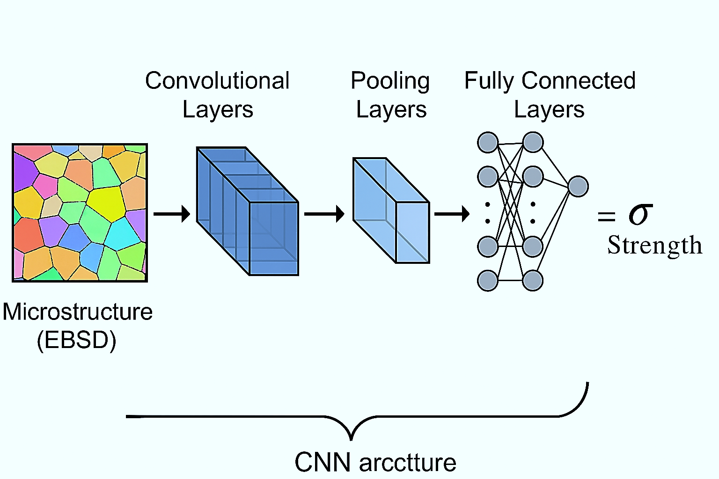

**Figure SM1.** CNN-based microstructure-to-strength prediction workflow

The ML framework for predicting post-treatment mechanical properties from thermal parameters namely, solutionizing temperature, aging time, and cooling rate is depicted in Figure SM2. The developed model effectively captures the complex nonlinear interactions induced by heat treatment on hardness, strength, and ductility.

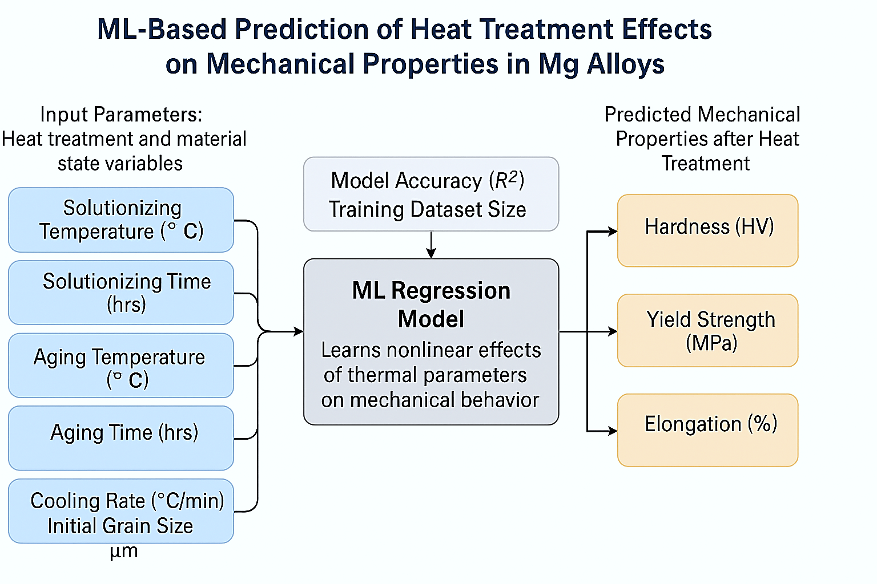

**Figure SM2.** ML-based prediction framework for heat treatment effects on mechanical properties in Mg alloys

The SHAP summary plot illustrates the relative contributions of individual features toward predicting the biodegradation rates of magnesium-based implants, as depicted in Figure SM3. The analysis indicates that higher concentrations of Zn and Ca positively influence degradation rates, whereas reduced immersion times exert a detrimental effect.

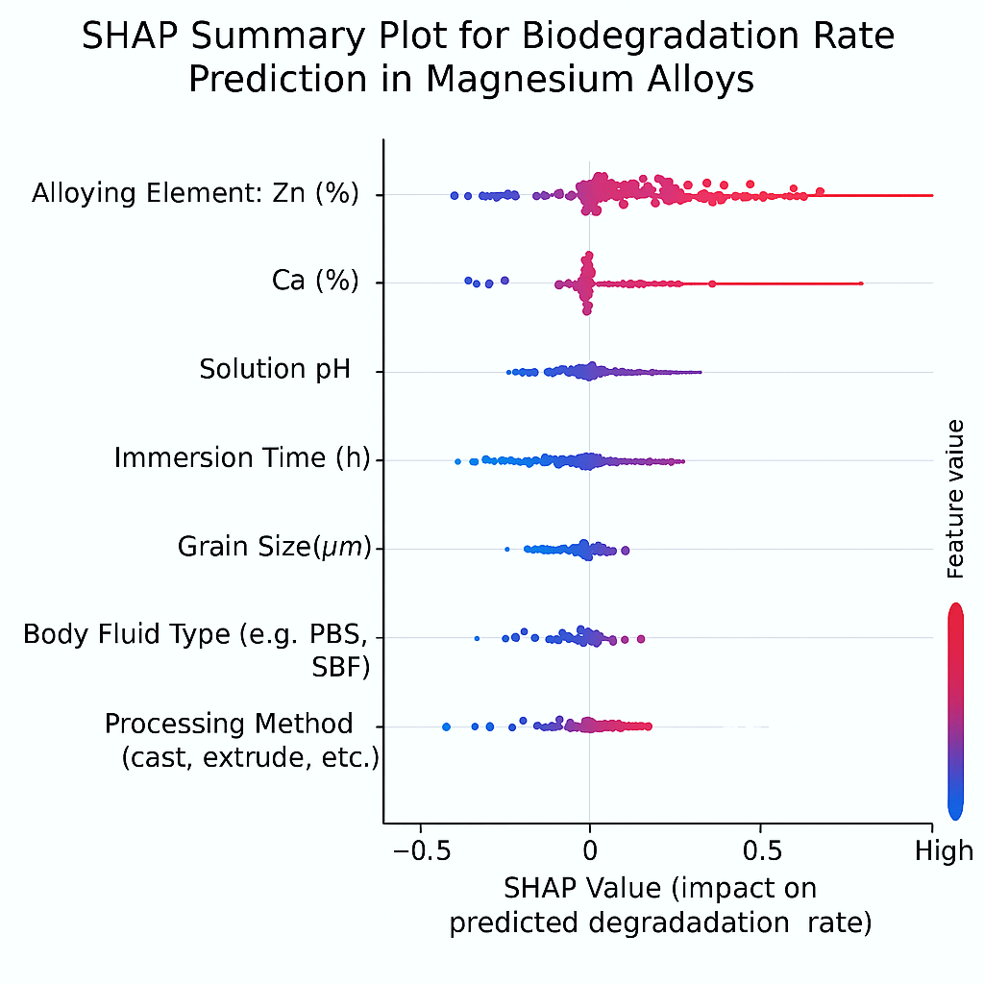

**Figure SM3.** SHAP summary plot for biodegradation rate prediction in Mg alloys

An LSTM-based time-series model for predicting the evolution of grain size in magnesium alloys under dynamic thermal conditions is illustrated in Figure SM4. The model effectively captures temporal dependencies related to variables such as temperature, duration, and cooling rate by processing these sequential inputs, thereby addressing limitations inherent in conventional predictive approaches, particularly concerning microstructural transformation. This enables accurate forecasting of ultimate recrystallization outcomes, facilitating process optimization and precise microstructural control in magnesium alloy engineering.

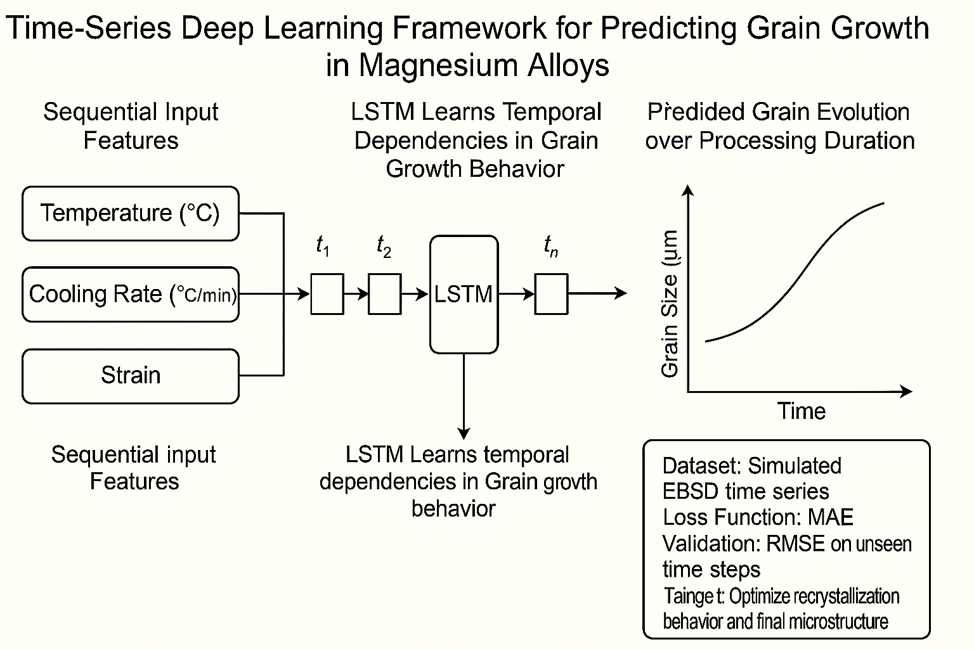

**Figure SM4.** Time-series deep learning framework for grain growth prediction in Mg alloys

Figure SM5 illustrates a data-driven optimization framework combining experimental data, simulation outputs, and literature sources with machine learning and optimization algorithms. The workflow predicts alloy properties and recommends optimal compositions and processing parameters. This closed-loop system supports efficient exploration of design space, accelerating the development of high-performance magnesium alloys for structural and biomedical applications.

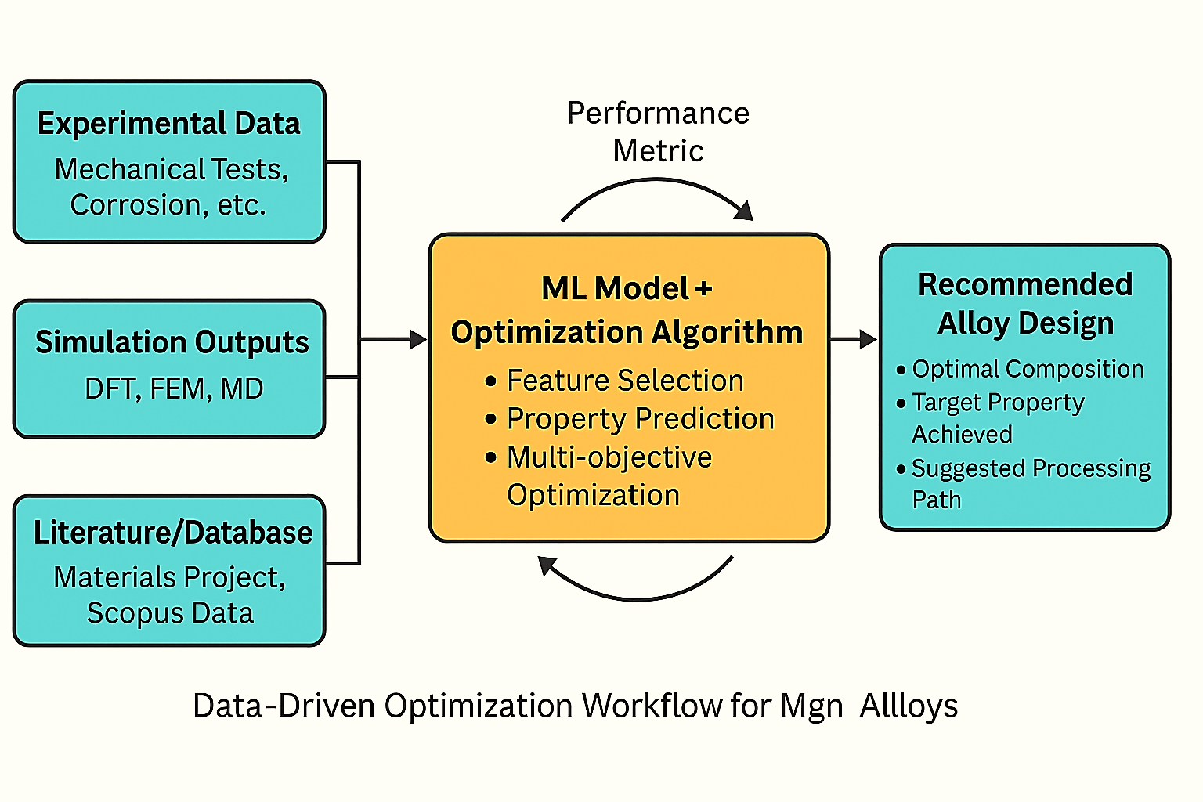

**Figure SM5.** Data-driven optimization workflow for Mg alloy design

**References**

Álvarez-Zapatero, P., Vega, A., and Aguado, A. (2021). A neural network potential for searching the atomic structures of pure and mixed nanoparticles. Application to ZnMg nanoalloys with an eye on their anticorrosive properties. *Acta Materialia* 220. doi: 10.1016/j.actamat.2021.117341.

Anne, G., Bhat, N., Vishwanatha, H.M., Ramesh, S., Maruthi Prashanth, B.H., Sharma, P., et al. (2024). Effect of addition of Ce and accumulative roll bonding on structure-property of the Mg-Ce-Al hybrid composite and its prediction and comparison using artificial neural network (ANN) approach. *Materials Research Express* 11(9). doi: 10.1088/2053-1591/ad7449.

Athul, A.S., Muthachikavil, A.V., Buddhiraju, V.S., Premraj, K., and Runkana, V. (2025). Identification of Stable Intermetallic Compounds for Hydrogen Storage via Machine Learning. *Energy Storage* 7(1). doi: 10.1002/est2.70115.

B, S., Ramasamy, P., Vignesh R, V., and V, B. (2025). Yttrium oxide reinforced AZ31B processed by FSP: Predictive modeling of mechanical, tribological, and corrosion properties. *Materials Science and Technology (United Kingdom)*. doi: 10.1177/02670836251316550.

Bahari-Sambran, F., Carreño, F., Cepeda-Jiménez, C.M., and Orozco-Caballero, A. (2024). Predicting grain size-dependent superplastic properties in friction stir processed ZK30 magnesium alloy with machine learning methods. *Journal of Magnesium and Alloys* 12(5)**,** 1931-1943. doi: 10.1016/j.jma.2024.05.019.

Bai, M., Wu, X., Tang, S., Lin, X., Yang, Y., Cao, L., et al. (2024). Study on hot deformation behavior and recrystallization mechanism of an Al-6.3Zn-2.5Mg-2.6Cu-0.11Zr alloy based on machine learning. *Journal of Alloys and Compounds* 1000. doi: 10.1016/j.jallcom.2024.175086.

Batalović, K., Radaković, J., Paskaš Mamula, B., Kuzmanović, B., and Medić Ilić, M. (2022). Predicting the Heat of Hydride Formation by Graph Neural Network - Exploring the Structure–Property Relation for Metal Hydrides. *Advanced Theory and Simulations* 5(9). doi: 10.1002/adts.202200293.

Byun, S., Yu, J., Cheon, S., Lee, S.H., Park, S.H., and Lee, T. (2024). Enhanced prediction of anisotropic deformation behavior using machine learning with data augmentation. *Journal of Magnesium and Alloys* 12(1)**,** 186-196. doi: 10.1016/j.jma.2023.12.007.

Chandana, K.S., and Kamesh, R. (2024). Machine learning insights into prediction of H2 gravimetric capacity in Mg-based pure metal alloys. *International Journal of Hydrogen Energy* 77**,** 695-711. doi: 10.1016/j.ijhydene.2024.06.186.

Chen, K.X., Wang, Y., Dong, Y.Q., Zhao, Z.H., Zang, Y., Zhang, G.L., et al. (2025). Theoretical design of dual-site metallo-covalent organic frameworks for efficient CO2 photoreduction into C2H4. *Applied Catalysis B: Environmental* 365. doi: 10.1016/j.apcatb.2024.124933.

Chen, T., Gao, Q., Yuan, Y., Li, T., Xi, Q., Liu, T., et al. (2022a). Coupling physics in machine learning to investigate the solution behavior of binary Mg alloys. *Journal of Magnesium and Alloys* 10(10)**,** 2817-2832. doi: 10.1016/j.jma.2021.06.014.

Chen, T., Yuan, Y., Mi, X., Wu, J., Tang, A., Wang, J., et al. (2022b). Interaction of elements in dilute Mg alloys: A DFT and machine learning study. *Journal of Materials Research and Technology* 21**,** 4512-4525. doi: 10.1016/j.jmrt.2022.11.071.

Chen, W., Gou, W., Li, Y., Li, X., Li, M., Hou, J., et al. (2024a). Machine learning design of 400 MPa grade biodegradable Zn-Mn based alloys with appropriate corrosion rates. *International Journal of Minerals, Metallurgy and Materials* 31(12)**,** 2727-2736. doi: 10.1007/s12613-024-2995-4.

Chen, Y., Li, Q., Chen, X., Tan, J., and He, H. (2024b). Simulation of recrystallization grain growth in AZ61 magnesium alloy based on GA and 3D CA. *Materials Letters* 377. doi: 10.1016/j.matlet.2024.137452.

Chen, Y., Tian, Y., Zhou, Y., Fang, D., Ding, X., Sun, J., et al. (2020). Machine learning assisted multi-objective optimization for materials processing parameters: A case study in Mg alloy. *Journal of Alloys and Compounds* 844. doi: 10.1016/j.jallcom.2020.156159.

Cheng, D.J., Liang, Y.C., Pu, Y.W., and Chen, Q. (2025). Ensemble learning predicts glass-forming ability under imbalanced datasets. *Computational Materials Science* 248. doi: 10.1016/j.commatsci.2024.113601.

Cheng, S., Li, Z., Zhang, H., Yan, X., and Chu, S. (2024). Discovery of magnesium-aluminum alloys by generative model and automatic differentiation approach. *Modelling and Simulation in Materials Science and Engineering* 32(4). doi: 10.1088/1361-651X/ad38d0.

Choudhuri, D. (2021). Local structure and bonding environment of intermetallic β1 precipitate phase nucleus in binary Mg-Nd. *Computational Materials Science* 187. doi: 10.1016/j.commatsci.2020.110111.

Çolak, A.B. (2025). An innovative study on high entropy energy storage mg-Y-Ni-cu systems: Machine learning-driven optimization of electrical cycling in Ni-MH battery alloys. *Journal of Energy Storage* 107. doi: 10.1016/j.est.2024.114958.

Dai, J., Yang, J., Zhang, X., Zhang, L., Sun, B., Li, X., et al. (2024). Synergistic effects of BSA adsorption and shear stress on corrosion behaviors of WE43 alloy under simulated physiological flow field. *Corrosion Science* 237. doi: 10.1016/j.corsci.2024.112317.

Dargusch, M., Wang, Y., Sha, C., Yang, N., Chen, X., Venezuela, J., et al. (2024). Insights into heat treatments of biodegradable Mg-Y-Nd-Zr alloys in clinical settings: Unveiling roles of β' and β1 nanophases and latent in vivo hydrogen evolution. *Acta Biomaterialia* 190**,** 605-622. doi: 10.1016/j.actbio.2024.10.047.

Davydzenka, T., Sinclair, D., Chawla, N., and Tahmasebi, P. (2022). Deep-layers-assisted machine learning for accurate image segmentation of complex materials. *Materials Characterization* 192. doi: 10.1016/j.matchar.2022.112175.

Deng, J. (2024). Large-Scale Atomistic Simulations of Magnesium Oxide Exsolution Driven by Machine Learning Potentials: Implications for the Early Geodynamo. *Geophysical Research Letters* 51(16). doi: 10.1029/2024GL109793.

Díaz-Romero, D., Van den Eynde, S., Zaplana, I., Zhou, C., Sterkens, W., Goedemé, T., et al. (2023). Classification of aluminum scrap by laser induced breakdown spectroscopy (LIBS) and RGB + D image fusion using deep learning approaches. *Resources, Conservation and Recycling* 190. doi: 10.1016/j.resconrec.2023.106865.

Dong, S., Wang, Y., Li, J., Li, Y., Wang, L., and Zhang, J. (2023). Exploration and design of Mg alloys for hydrogen storage with supervised machine learning. *International Journal of Hydrogen Energy* 48(97)**,** 38412-38424. doi: 10.1016/j.ijhydene.2023.06.108.

Efa, D.A. (2024). Computational modeling and virtual analysis using a moving heat source to join AZ61A and AA7075 alloys with the application of a titanium alloy interlayer. *Infrared Physics and Technology* 141. doi: 10.1016/j.infrared.2024.105501.

El-Garaihy, W.H., Alateyah, A.I., Alawad, M.O., Alsunaydih, F.N., El-Sanabary, S., El-Asfoury, M.S., et al. (2024). Optimization of ECAP parameters of ZX30 alloy using feature engineering assisted machine learning and response surface approaches. *Materials Today Communications* 40. doi: 10.1016/j.mtcomm.2024.109560.

El-Sanabary, S., Kouta, H., Shaban, M., Alrumayh, A., Alateyah, A.I., Alsunaydih, F.N., et al. (2024). A comparative study of machine learning and response surface methodologies for optimizing wear parameters of ECAP-processed ZX30 alloy. *Heliyon* 10(13). doi: 10.1016/j.heliyon.2024.e33967.

Fang, Z., Wang, S., Fan, H., Zhao, X., Ji, H., Li, B., et al. (2025). Machine-learning-assisted catalytic performance predictions of binary alloy catalysts for glucose hydrogenation. *Applied Catalysis A: General* 691. doi: 10.1016/j.apcata.2024.120086.

Farooq, M.Z., Wu, Y., Zheng, M., and Lu, L. (2025). Ignition-proof magnesium alloys with rare earth elements: A novel framework to predict combustion phases, surface morphologies, and hidden features using heating rates. *Journal of Magnesium and Alloys*. doi: 10.1016/j.jma.2025.01.014.

Feng, T., and Lu, G. (2024). Hydration MgCl2-NaCl-KCl molten salt using a novel approach for training machine learning potential. *Journal of Molecular Liquids* 394. doi: 10.1016/j.molliq.2023.123533.

Feng, X., Wang, Z., Jiang, L., Zhao, F., and Zhang, Z. (2023). Simultaneous enhancement in mechanical and corrosion properties of Al-Mg-Si alloys using machine learning. *Journal of Materials Science and Technology* 167**,** 1-13. doi: 10.1016/j.jmst.2023.04.072.

Feng, Y., Tian, Y., Yang, Y., Zhang, Y., Guo, H., and Li, J. (2024). Analyze the Performance of Electroactive Anticorrosion Coating of Medical Magnesium Alloy Using Deep Learning. *Computers, Materials and Continua* 79(1)**,** 263-278. doi: 10.32604/cmc.2024.047004.

Gao, T., Zhan, Z., Hu, W., and Meng, Q. (2024). A novel damage mechanics and XGBoost based approach for HCF life prediction of cast magnesium alloy considering internal defect characteristics. *International Journal of Fatigue* 182. doi: 10.1016/j.ijfatigue.2024.108220.

Geng, X., Wang, L.W., and Meng, X. (2025). Exploring the strength-concentration relationship of MgCu bioalloys at low copper content using machine learning force fields. *Computational Materials Science* 246. doi: 10.1016/j.commatsci.2024.113486.

Ghorbani, M., Boley, M., Nakashima, P.N.H., and Birbilis, N. (2023). A machine learning approach for accelerated design of magnesium alloys. Part B: Regression and property prediction. *Journal of Magnesium and Alloys* 11(11)**,** 4197-4205. doi: 10.1016/j.jma.2023.09.010.

Ghorbani, M., Boley, M., Nakashima, P.N.H., and Birbilis, N. (2024). An active machine learning approach for optimal design of magnesium alloys using Bayesian optimisation. *Scientific Reports* 14(1). doi: 10.1038/s41598-024-59100-9.

Gu, J., Jiang, S., Guo, W., Wang, L., and Zhang, J. (2024). An improved extreme learning machine model for predicting the mechanical property of AZ80 magnesium alloy. *Applied Physics A: Materials Science and Processing* 130(8). doi: 10.1007/s00339-024-07740-z.

Gupta, A.K., Kumar, S., Chandna, P., and Bhushan, G. (2021). Optimization of Process Parameters during Pressure Die Casting of A380: a Silicon-Based Aluminium Alloy Using GA & Fuzzy Methodology. *Silicon* 13(8)**,** 2429-2443. doi: 10.1007/s12633-020-00594-z.

Gurugubelli, S., Chintada, V.B., and Chekuri, R.B.R. (2023). Investigation on Mechanical Properties of Fabricated Aluminium 5000 Series using Finite Element and Artificial Intelligence Methods. *International Journal of Vehicle Structures and Systems* 15(2)**,** 183-186. doi: 10.4273/ijvss.15.2.07.

He, X., Liu, J., Yang, C., and Jiang, G. (2023). Predicting thermodynamic stability of magnesium alloys in machine learning. *Computational Materials Science* 223. doi: 10.1016/j.commatsci.2023.112111.

Huang, S.J., Sanjaya, J., Adityawardhana, Y., and Kannaiyan, S. (2024). Enhancing the Mechanical Properties of AM60B Magnesium Alloys through Graphene Addition: Characterization and Regression Analysis. *Materials* 17(18). doi: 10.3390/ma17184673.

Jaafreh, R., Kang, Y.S., and Hamad, K. (2023). Brittle and ductile characteristics of intermetallic compounds in magnesium alloys: A large-scale screening guided by machine learning. *Journal of Magnesium and Alloys* 11(1)**,** 392-404. doi: 10.1016/j.jma.2022.05.006.

Jaafreh, R., Kim, J.G., and Hamad, K. (2022). Interpretable Machine Learning Analysis of Stress Concentration in Magnesium: An Insight beyond the Black Box of Predictive Modeling. *Crystals* 12(9). doi: 10.3390/cryst12091247.

Jafari, M., Lotfi, M., Ghaseminejad, P., Roodi, M., and Teimouria, R. (2015). Numerical control and optimization of springback in L-bending of magnesium alloy through FE analysis and artificial intelligence. *Transactions of the Indian Institute of Metals* 68(5)**,** 969-979. doi: 10.1007/s12666-015-0535-7.

Jagadeesh, G.V., and Setti, S.G. (2023). Tribological Characterization of Ball Burnished Magnesium Alloy by Wear-Burnishing Maps, Wear Maps and Artificial Intelligence Technique. *Arabian Journal for Science and Engineering* 48(3)**,** 3111-3131. doi: 10.1007/s13369-022-07025-8.

Jain, S., Bhowmik, A., and Lee, J. (2025a). Machine learning approaches for predicting and validating mechanical properties of Mg rare earth alloys for light weight applications. *Science and Technology of Advanced Materials* 26(1). doi: 10.1080/14686996.2025.2449811.

Jain, S., Jain, R., Dewangan, S., and Bhowmik, A. (2024). A Machine learning perspective on hardness prediction in multicomponent Al-Mg based lightweight alloys. *Materials Letters* 365. doi: 10.1016/j.matlet.2024.136473.

Jain, S., Jain, R., Patel, M., Sahoo, B., and Bhowmik, A. (2025b). Harnessing machine learning for predicting mechanical properties of lightweight Mg alloys. *Materials Letters* 378. doi: 10.1016/j.matlet.2024.137597.

Ji, Y., Fu, X., Ding, F., Xu, Y., He, Y., Ao, M., et al. (2024). Artificial intelligence combined with high-throughput calculations to improve the corrosion resistance of AlMgZn alloy. *Corrosion Science* 233. doi: 10.1016/j.corsci.2024.112062.

Jiang, L., Fu, H., Zhang, Z., Zhang, H., Zhang, X., Feng, X., et al. (2024a). Synchronously enhancing the strength, toughness, and stress corrosion resistance of high-end aluminum alloys via interpretable machine learning. *Acta Materialia* 270. doi: 10.1016/j.actamat.2024.119873.

Jiang, L., Wang, C., Fu, H., Shen, J., Zhang, Z., and Xie, J. (2022). Discovery of aluminum alloys with ultra-strength and high-toughness via a property-oriented design strategy. *Journal of Materials Science and Technology* 98**,** 33-43. doi: 10.1016/j.jmst.2021.05.011.

Jiang, Q., Jia, Z., Lu, S., Song, P., Gao, Z., Wang, Z., et al. (2024b). Novel NLi4-BGra/MgH2-based heterojunctions for efficient hydrogen storage and modulation of hydrogen-desorption temperature ranges. *Ceramics International* 50(13)**,** 23058-23069. doi: 10.1016/j.ceramint.2024.04.028.

Jiang, W., Zhang, Y., Zhang, L., and Wang, H. (2021). Accurate Deep Potential model for the Al-Cu-Mg alloy in the full concentration space. *Chinese Physics B* 30(5). doi: 10.1088/1674-1056/abf134.

Juan, Y., Niu, G., Yang, Y., Dai, Y., Yang, J., and Zhang, J. (2024). Machine learning-based identification method of new strengthening element and the study on Al-Zn-Mg-Cu-Zr-Hf alloy. *Materials Today Communications* 38. doi: 10.1016/j.mtcomm.2024.108359.

Kim, T., Ryu, W.H., Yoo, G.H., Park, D., Kim, J.Y., Park, E.S., et al. (2024). Data-driven discovery of ultrahigh specific hardness alloys. *Journal of Materials Research and Technology* 33**,** 7753-7760. doi: 10.1016/j.jmrt.2024.11.153.

Kuriki, D., Briffod, F., Shiraiwa, T., and Enoki, M. (2024). Multimodal deep learning framework to predict strain localization of Mg/LPSO two-phase alloys. *Acta Materialia* 281. doi: 10.1016/j.actamat.2024.120398.

Li, C., Zhang, H., Guo, D., and Zeng, W. (2024a). Crystal Structure Prediction and Property Calculation of Al2CuMg by Deep Learning Potential. *Journal of Materials Engineering and Performance* 33(24)**,** 13721-13730. doi: 10.1007/s11665-023-08944-9.

Li, G., Cheng, L., Yue, Q., Hu, X., Lu, H., and Zhu, Q. (2023). Predicting temperature of semi-solid 7075 aluminum alloy slurry prepared by a novel rheocasting route via neural network. *Materials Letters* 349. doi: 10.1016/j.matlet.2023.134753.

Li, H., Li, X., Li, Y., Gao, G., Wen, K., Li, Z., et al. (2024b). Exploration of Alloying Elements of High Specific Modulus Al–Li Alloy Based on Machine Learning. *Materials* 17(1). doi: 10.3390/ma17010092.

Li, K.Y., Liu, L.C., Shao, L.L., Zhou, J., Ke, H.B., Li, M.Z., et al. (2025). Generative model-based inverse design of Fe-based metallic glasses with high saturation magnetic flux density. *Journal of Alloys and Compounds* 1010. doi: 10.1016/j.jallcom.2024.178325.

Li, M., Mesbah, M., Fallahpour, A., Nasiri-Tabrizi, B., and Liu, B. (2021). Mechanical strength estimation of ultrafine-grained magnesium implant by neural-based predictive machine learning. *Materials Letters* 305. doi: 10.1016/j.matlet.2021.130627.

Li, S., Liu, R., Yan, H., Li, Z., Li, Y., Li, X., et al. (2024c). Machine Learning Phase Prediction of Light-Weight High-Entropy Alloys Containing Aluminum, Magnesium, and Lithium. *Metals* 14(4). doi: 10.3390/met14040400.

Li, X., Liu, Y., Luan, S., Ma, D., Liu, X., Liu, Q., et al. (2024d). Investigation of deformation behavior of Mg-2Ho alloy based on hyperbolic sine constitutive equation and PSO-BP neural network. *Materials Today Communications* 38. doi: 10.1016/j.mtcomm.2023.107613.

Liang, T., Yuan, Y., Chen, T., Wang, J., Zhang, L., Wu, L., et al. (2024). Electrical conductivity of binary magnesium alloys: Integrating first-principles and machine learning studies. *Materials Today Communications* 40. doi: 10.1016/j.mtcomm.2024.110021.

Ling, N., Wang, Y., Song, S., Liu, C., Yang, F., Qi, X., et al. (2024). Experimentally validated screening strategy for alloys as anode in Mg-air battery with multi-target machine learning predictions. *Chemical Engineering Journal* 496. doi: 10.1016/j.cej.2024.153824.

Liu, Q., Wu, H., Paul, M.J., He, P., Peng, Z., Gludovatz, B., et al. (2020). Machine-learning assisted laser powder bed fusion process optimization for AlSi10Mg: New microstructure description indices and fracture mechanisms. *Acta Materialia* 201**,** 316-328. doi: 10.1016/j.actamat.2020.10.010.

Liu, X., Yang, J., Yi, L., Li, D., Wang, Q., Du, H., et al. (2025a). Multi-objective optimization of fracturing ball strength and corrosion rate with genetic algorithms and interpretable machine learning. *Advanced Composites and Hybrid Materials* 8(1). doi: 10.1007/s42114-024-01199-5.

Liu, Z., Xiao, Y., Yang, L., Liu, W., Yan, G., Sun, Y., et al. (2025b). Failure prediction of thermal barrier coatings on turbine blades under calcium-magnesium-alumina-silicate corrosion and thermal shock. *Acta Mechanica Sinica/Lixue Xuebao* 41(5). doi: 10.1007/s10409-024-24285-x.

Lopes Marinho, A., Kazimi, B., Ćwieka, H., Marek, R., Beckmann, F., Willumeit-Römer, R., et al. (2024). A comparison of deep learning segmentation models for synchrotron radiation based tomograms of biodegradable bone implants. *Frontiers in Physics* 12. doi: 10.3389/fphy.2024.1257512.

Ma, S., Zhang, D., Zhang, P., and Markert, B. (2025). Rapid prediction of the corrosion behaviour of coated biodegradable magnesium alloys using phase field simulation and machine learning. *Computational Materials Science* 247. doi: 10.1016/j.commatsci.2024.113546.

Ma, S., Zhang, Z., Huang, Z., Song, D., Jia, Y., Zhou, N., et al. (2022). Prediction of Grain Size in Cast Aluminum Alloys. *Crystals* 12(4). doi: 10.3390/cryst12040474.

Maqbool, A., Khalad, A., and Khan, N.Z. (2024). Prediction of corrosion rate for friction stir processed WE43 alloy by combining PSO-based virtual sample generation and machine learning. *Journal of Magnesium and Alloys* 12(4)**,** 1518-1528. doi: 10.1016/j.jma.2024.04.012.

Masood Chaudry, U., Hamad, K., and Abuhmed, T. (2021). Machine learning-aided design of aluminum alloys with high performance. *Materials Today Communications* 26. doi: 10.1016/j.mtcomm.2020.101897.

Medghalchi, S., Zubair, M., Karimi, E., Sandlöbes-Haut, S., Kerzel, U., and Korte-Kerzel, S. (2023). Determination of the Rate Dependence of Damage Formation in Metallic-Intermetallic Mg–Al–Ca Composites at Elevated Temperature using Panoramic Image Analysis. *Advanced Engineering Materials* 25(21). doi: 10.1002/adem.202300956.

Menon, V., Das, S., Gavini, V., and Qi, L. (2024). Atomistic simulations and machine learning of solute grain boundary segregation in Mg alloys at finite temperatures. *Acta Materialia* 264. doi: 10.1016/j.actamat.2023.119515.

Menze, R., Hesse, B., Kusmierczuk, M., Chen, D., Weitkamp, T., Bettink, S., et al. (2024). Synchrotron microtomography reveals insights into the degradation kinetics of bio-degradable coronary magnesium scaffolds. *Bioactive Materials* 32**,** 1-11. doi: 10.1016/j.bioactmat.2023.09.008.

Messina, J., Luo, R., Xu, K., Lu, G., Deng, H., Tschopp, M.A., et al. (2021). Machine learning to predict aluminum segregation to magnesium grain boundaries. *Scripta Materialia* 204. doi: 10.1016/j.scriptamat.2021.114150.

Mi, X., Dai, L., Jing, X., She, J., Holmedal, B., Tang, A., et al. (2024). Accelerated design of high-performance Mg-Mn-based magnesium alloys based on novel bayesian optimization. *Journal of Magnesium and Alloys* 12(2)**,** 750-766. doi: 10.1016/j.jma.2024.01.005.

Mishra, A. (2024a). Artificial intelligence algorithms for prediction of the ultimate tensile strength of the friction stir welded magnesium alloys. *International Journal on Interactive Design and Manufacturing* 18(3)**,** 1779-1787. doi: 10.1007/s12008-022-01180-w.

Mishra, A. (2024b). Data driven knowledge summarization of friction stir welded magnesium alloys literature by using natural language processing algorithms. *International Journal on Interactive Design and Manufacturing* 18(3)**,** 1113-1119. doi: 10.1007/s12008-022-01118-2.

Mo, W., Xiao, Y., Huang, Y., Sun, P., Li, Y., Zheng, X., et al. (2025). Active learning-based alloy design strategy for improving the strength-ductility balance of Al-Mg-Zn alloys. *Materials and Design* 252. doi: 10.1016/j.matdes.2025.113772.

Mokhtari, M.A., Nikzad, M.H., and Jalalvand, M. (2024). Competition of systematically optimized deep neural networks for the estimation of tensile behavior of aluminum-magnesium alloy. *Physica Scripta* 99(6). doi: 10.1088/1402-4896/ad4218.

Mondal, S., Samanta, R., Shit, S., Biswas, A., Bandyopadhyay, A., Dhar, R.S., et al. (2024). CORROSION PREDICTION OF MAGNESIUM IMPLANT USING MULTISCALE MODELING BASED ON MACHINE LEARNING ALGORITHMS. *International Journal for Multiscale Computational Engineering* 22(4)**,** 125-141. doi: 10.1615/IntJMultCompEng.2023050288.

Motamedi, M., Nikzad, M.H., and Nasri, M.R. (2023). Mixture design optimization and machine learning-based prediction of Al-Mg alloy composite reinforced by Zn nanoparticles: A molecular dynamics study. *Materials Today Communications* 37. doi: 10.1016/j.mtcomm.2023.107473.

Mukunda, S.G., Srivastava, A., Boppana, S.B., Dayanand, S., and Yeshwanth, D. (2023). Wear Performance Prediction of MWCNT-Reinforced AZ31 Composite Using Machine Learning Technique. *Journal of Bio- and Tribo-Corrosion* 9(2). doi: 10.1007/s40735-023-00745-w.

Murugesan, M., Yu, J.H., Chung, W., and Lee, C.W. (2023). Hybrid Artificial Neural Network-Based Models to Investigate Deformation Behavior of AZ31B Magnesium Alloy at Warm Tensile Deformation. *Materials* 16(15). doi: 10.3390/ma16155308.

Nithin, A.M., Davidson, M.J., and Rao, C.S.P. (2022). Effect of Various Mg/Si Ratios on Microstructure and Structural Properties of Thixoextruded Al-Si-Mg Alloys. *Silicon* 14(17)**,** 11675-11686. doi: 10.1007/s12633-022-01689-5.

Österreicher, J.A., Živanović, D., Walenta, W., Maimone, S., Hofbauer, M., Hovden, S., et al. (2024). In situ conductometry for studying the homogenization of Al-Mg-Si alloys and predicting extrudate grain structure through machine learning. *Materials and Design* 243. doi: 10.1016/j.matdes.2024.113070.

Otieno, R., Odhong, E.V., and Ondieki, C. (2024). Prediction of phases and mechanical properties of magnesium-based high-entropy alloys using machine learning. *Journal of King Saud University - Science* 36(10). doi: 10.1016/j.jksus.2024.103456.

Ouyang, S., Wu, Q., Kim, R.E., Lee, J.H., Lee, J.A., and Kim, H.S. (2025). Recent Progress in Developing Creep-Resistant Mg-Gd-Based Alloys. *Metals and Materials International*. doi: 10.1007/s12540-025-01918-7.

Pagadala, N.D., jaiswal, J., and R, R. (2023). Machine learning based corrosion prediction of as cast Mg-Sn alloys for biomedical applications. *Materials Today Communications* 35. doi: 10.1016/j.mtcomm.2023.106108.

Pei, S., Dai, C., Yang, X., Zhang, L., Wang, H., Zhang, S., et al. (2024a). Quantitative prediction of Mg-RE-Ni alloy corrosion behavior by machine learning. *Corrosion Science* 237. doi: 10.1016/j.corsci.2024.112324.

Pei, Y., Li, L., Yu, M., Wei, E., Zhao, M., and Teng, B. (2024b). Comparison and evaluation of different constitutive models for predicting the hot deformation behavior of Mg-Gd-Y-Zr alloy. *Journal of Magnesium and Alloys*. doi: 10.1016/j.jma.2024.08.004.

Pei, Z., and Yin, J. (2019). Machine learning as a contributor to physics: Understanding Mg alloys. *Materials and Design* 172. doi: 10.1016/j.matdes.2019.107759.

Peng, Q., Yuan, X., Zhao, S., Zhou, Y., Wen, X., and Chen, X.J. (2023). Active-learning search for unitcell structures: A case study on Mg3Bi2-xSbx. *Computational Materials Science* 226. doi: 10.1016/j.commatsci.2023.112260.

Qi, X., Liu, A., Li, Y., Dang, L., Zhang, J., and Wang, L. (2025). Deep learning and finite element simulation of spatiotemporal multiscale fusion: Real time prediction of magnesium alloys corrosion covered with MAO coatings. *Materials Today Communications* 44. doi: 10.1016/j.mtcomm.2025.111915.

Radha, R. (2024). Predicting corrosion current density in magnesium alloy battery anodes: machine learning approach using rapid miner. *Canadian Metallurgical Quarterly*. doi: 10.1080/00084433.2024.2425497.

Raguraman, S., Priyadarshini, M.S., Nguyen, T., McGovern, R., Kim, A., Griebel, A.J., et al. (2024). Machine learning-guided accelerated discovery of structure-property correlations in lean magnesium alloys for biomedical applications. *Journal of Magnesium and Alloys* 12(6)**,** 2267-2283. doi: 10.1016/j.jma.2024.06.008.

Rahnama, A., and Sridhar, S. (2019). Application of data science tools to determine feature correlation and cluster metal hydrides for hydrogen storage. *Materialia* 7. doi: 10.1016/j.mtla.2019.100366.

Shaban, M., Alateyah, A.I., Alsharekh, M.F., Alawad, M.O., BaQais, A., Kamel, M., et al. (2023). Influence of ECAP Parameters on the Structural, Electrochemical and Mechanical Behavior of ZK30: A Combination of Experimental and Machine Learning Approaches. *Journal of Manufacturing and Materials Processing* 7(2). doi: 10.3390/jmmp7020052.

Shimanek, J.D., Shang, S.L., Beese, A.M., and Liu, Z.K. (2022). Insight into ideal shear strength of Ni-based dilute alloys using first-principles calculations and correlational analysis. *Computational Materials Science* 212. doi: 10.1016/j.commatsci.2022.111564.

Shu, C., He, J., Xue, G., and Xie, C. (2022). Grain Knowledge Graph Representation Learning: A New Paradigm for Microstructure-Property Prediction. *Crystals* 12(2). doi: 10.3390/cryst12020280.

Singh, A., Agarwal, T., Gambhir, V., and Harinaiha, A. (2024). Estimation of Attrition Loss Due to Spray-On Coatings for Mg Alloys Using a Novel Machine Learning Approach. *Nanotechnology Perceptions* 20(S3)**,** 291-303. doi: 10.62441/nano-ntp.v20iS3.22.

Song, Q., Ren, Z., Ji, S., Niu, S., Qi, W., and Chen, M. (2019). Improving the Mechanical Property of Dissimilar Al/Mg Zn-Added Ultrasound-Assisted Friction Stir Lap Welding Joint by Back Propagation Neural Network–Gray Wolf Optimization Algorithm. *Advanced Engineering Materials* 21(12). doi: 10.1002/adem.201900973.

Suh, J.S., Suh, B.C., Bae, J.H., and Kim, Y.M. (2023). Machine learning-based design of biodegradable Mg alloys for load-bearing implants. *Materials and Design* 225. doi: 10.1016/j.matdes.2022.111442.

Suh, J.S., Suh, B.C., Lee, S.E., Bae, J.H., and Moon, B.G. (2022). Quantitative analysis of mechanical properties associated with aging treatment and microstructure in Mg-Al-Zn alloys through machine learning. *Journal of Materials Science and Technology* 107**,** 52-63. doi: 10.1016/j.jmst.2021.07.045.

Sun, X., and Liu, B. (2023). A learning-based optimal uncertainty quantification method and its application to ballistic impact problems. *Mechanics of Materials* 184. doi: 10.1016/j.mechmat.2023.104727.

Tian, L., and Yu, W. (2021). Effects of cluster expansion on the locations of phase transition boundary as a first step to quantify uncertainty in first principles statistical mechanics framework. *Computational Materials Science* 186. doi: 10.1016/j.commatsci.2020.110050.

Troncoso, J.F., Hu, Y., della Ventura, N.M., Sharma, A., Maeder, X., and Turlo, V. (2023). Machine learning of twin/matrix interfaces from local stress field. *Computational Materials Science* 228. doi: 10.1016/j.commatsci.2023.112322.

Wang, H., Duan, Z., Guo, Q., Zhang, Y., and Zhao, Y. (2023a). Machine Learning Design of Aluminum-Lithium Alloys with High Strength. *Computers, Materials and Continua* 77**,** 1393-1409. doi: 10.32604/cmc.2023.045871.

Wang, H., Zhang, Y., Zhang, L., and Wang, H. (2020). Crystal Structure Prediction of Binary Alloys via Deep Potential. *Frontiers in Chemistry* 8. doi: 10.3389/fchem.2020.589795.

Wang, M., Yu, H.L., Chen, Y., and Huang, M.X. (2021). Machine learning assisted screening of non-rare-earth elements for Mg alloys with low stacking fault energy. *Computational Materials Science* 196. doi: 10.1016/j.commatsci.2021.110544.

Wang, Q., Qin, X., Xia, S., Wang, L., Wang, W., Huang, W., et al. (2025). Interpretable machine learning excavates a low-alloyed magnesium alloy with strength-ductility synergy based on data augmentation and reconstruction. *Journal of Magnesium and Alloys*. doi: 10.1016/j.jma.2025.01.003.

Wang, Q., Zhai, H., Jin, Z., He, J., Yang, Q., Liu, W., et al. (2023b). Hot-deformation kinetics analysis and extrusion parameter optimization of a dilute rare-earth free magnesium alloy. *Journal of Magnesium and Alloys* 11(9)**,** 3302-3322. doi: 10.1016/j.jma.2022.07.013.

Wang, S., Wu, Y., Xu, Q., Ma, Y., and Wang, T. (2024a). Research on stamping formability and process simulation of AZ31 magnesium alloy based on deep learning. *Materials Today Communications* 40. doi: 10.1016/j.mtcomm.2024.109807.

Wang, Y., Tang, Q., Xu, X., Weng, P., Ying, T., Yang, Y., et al. (2023c). Accelerated discovery of magnesium intermetallic compounds with sluggish corrosion cathodic reactions through active learning and DFT calculations. *Acta Materialia* 255. doi: 10.1016/j.actamat.2023.119063.

Wang, Y., Xie, T., Tang, Q., Wang, M., Ying, T., Zhu, H., et al. (2024b). High-throughput calculations combining machine learning to investigate the corrosion properties of binary Mg alloys. *Journal of Magnesium and Alloys* 12(4)**,** 1406-1418. doi: 10.1016/j.jma.2021.12.007.

Wei, X., Wang, J., Wang, C., Zhu, S., Wang, L., and Guan, S. (2022). Prediction of electronic work function of the second phase in binary magnesium alloy based on machine learning method. *Journal of Materials Research* 37(21)**,** 3792-3802. doi: 10.1557/s43578-022-00752-6.

Wiese, B., Berger, S., Bohlen, J., Nienaber, M., and Höche, D. (2023). Property design of extruded magnesium-gadolinium alloys through machine learning. *Materials Today Communications* 36. doi: 10.1016/j.mtcomm.2023.106566.

Wu, H., Chen, X., Yang, L., Zheng, D., Zhou, J., Zhang, E., et al. (2025a). Mechanism study of rare earth Y enhancing A356 tensile performance: Deep learning potential and Ab initio molecular dynamics. *Materials Today Communications* 44. doi: 10.1016/j.mtcomm.2025.111868.

Wu, Y., Snihirova, D., Würger, T., Wang, L., Feiler, C., Höche, D., et al. (2025b). Machine learning-guided discovery of high-efficiency electrolyte additives for aqueous magnesium-air batteries. *Energy Storage Materials* 76. doi: 10.1016/j.ensm.2025.104120.

Würger, T., Feiler, C., Musil, F., Feldbauer, G.B.V., Höche, D., Lamaka, S.V., et al. (2019). Data science based mg corrosion engineering. *Frontiers in Materials* 6**,** 1-9. doi: 10.3389/fmats.2019.00053.

Xue, D., Wei, W., Shi, W., Zhou, X., Rong, L., Wen, S., et al. (2022). Microstructural evolution and constitutive analysis of Al-Mg-Zn-Er-Zr based on arrhenius-type and machine-learning algorithm. *Materials Today Communications* 32. doi: 10.1016/j.mtcomm.2022.104076.

Xue, D., Wei, W., Shi, W., Zhou, X.R., Qi, J.T., Wen, S.P., et al. (2023). Optimization of stabilized annealing of Al-Mg alloys utilizing machine learning algorithms. *Materials Today Communications* 35. doi: 10.1016/j.mtcomm.2023.106177.

Yadav, P.K., and Khurana, M.K. (2022). Experimental investigation and optimization of quality characteristics during friction stir welding of Al- and Zn-based magnesium alloy using artificial intelligence. *Proceedings of the Institution of Mechanical Engineers, Part L: Journal of Materials: Design and Applications* 236(2)**,** 345-360. doi: 10.1177/14644207211044805.

Yanase, Y., Miyauchi, H., Matsumoto, H., and Yokota, K. (2022). Densification Behavior and Microstructures of the Al-10%Si-0.35Mg Alloy Fabricated by Selective Laser Melting: From Experimental Observation to Machine Learning. *Materials Transactions* 63(2)**,** 176-184. doi: 10.2320/matertrans.MT-M2021215.

Yang, W., Wang, Y., Huang, X., Liu, S., Wang, P., and Du, Y. (2024). Effects of Cu content and Sintering temperature on microstructure and mechanical properties of SiCp/Al-Cu-Mg composites through experimental study, CALPHAD-type simulation and machine learning. *Journal of Materials Research and Technology* 33**,** 2216-2225. doi: 10.1016/j.jmrt.2024.09.202.

Yu, J., Lee, S.H., Cheon, S., Park, S.H., and Lee, T. (2024). Alternative predictive approach for low-cycle fatigue life based on machine learning and energy-based modeling. *Journal of Magnesium and Alloys* 12(10)**,** 4075-4084. doi: 10.1016/j.jma.2024.10.014.

Zhang, C., Zhang, Y., Ren, B., Wu, Y., Hu, Y., Chai, Y., et al. (2025a). Accelerated design of age-hardened Mg-Ca-Zn alloys with enhanced mechanical properties via machine learning. *Computational Materials Science* 249. doi: 10.1016/j.commatsci.2025.113665.

Zhang, D., Srinivasan, J., and Locke, J.S. (2022). Quantitative Evaluation of the Ability of Accelerated Tests to Simulate On-Road Corrosion Morphology of Automotive Aluminum Alloys. *Corrosion* 78(12)**,** 1229-1249. doi: 10.5006/4174.

Zhang, G., Mei, W., Zhang, W., and Yu, K. (2025b). Exploring the mechanism of plastic deformation in BCC Mg-Li-Al alloys via Machine learning Molecular dynamics simulations. *Computational Materials Science* 246. doi: 10.1016/j.commatsci.2024.113396.

Zhang, H., Fu, H., Li, W., Jiang, L., Yong, W., Sun, J., et al. (2024a). Empowering the Sustainable Development of High-End Alloys via Interpretive Machine Learning. *Advanced Materials* 36(48). doi: 10.1002/adma.202404478.

Zhang, H., Fu, H., Zhu, S., Yong, W., and Xie, J. (2021). Machine learning assisted composition effective design for precipitation strengthened copper alloys. *Acta Materialia* 215. doi: 10.1016/j.actamat.2021.117118.

Zhang, P., Zhang, J., Fu, J., Guo, W., Zhao, D., and Wang, L. (2024b). Property prediction of AZ80 magnesium alloy: an extreme learning machine model optimized by a new improved sparrow search algorithm. *Revista Materia* 29(3). doi: 10.1590/1517-7076-RMAT-2024-0296.

Zhang, S., Yi, W., Zhong, J., Gao, J., Lu, Z., and Zhang, L. (2023a). Computer Alloy Design of Ti Modified Al-Si-Mg-Sr Casting Alloys for Achieving Simultaneous Enhancement in Strength and Ductility. *Materials* 16(1). doi: 10.3390/ma16010306.

Zhang, X., Wang, A., Shao, C., and Bao, H. (2024c). Understanding thermal transport in magnesium solid solutions through first-principles approaches and machine learning feature screening. *Acta Materialia* 276. doi: 10.1016/j.actamat.2024.120160.

Zhang, Y., Bai, S., Jiang, B., Li, K., Dong, Z., and Pan, F. (2023b). Modeling the correlation between texture characteristics and tensile properties of AZ31 magnesium alloy based on the artificial neural networks. *Journal of Materials Research and Technology* 24**,** 5286-5297. doi: 10.1016/j.jmrt.2023.04.079.

Zhang, Y., Tu, X., Deng, A., Wu, D., Hu, Y., Yan, B., et al. (2025c). Machine learning-assisted design of filler for laser welding of Al-Zn-Mg-Cu alloy. *Materials Letters* 383. doi: 10.1016/j.matlet.2025.137974.

Zhang, Y., Wang, N., Li, J., Mesbah, M., Wong, K.Y., Fallahpour, A., et al. (2020). Mechanical properties modeling of severely plastically deformed biodegradable zk60 magnesium alloy for bone implants. *Latin American Journal of Solids and Structures* 17(5)**,** 1-23. doi: 10.1590/1679-78256151.

Zhu, G., Du, X., and Sun, D. (2025a). Machine learning accelerated design of magnesium alloys with high strength and high ductility. *Materials Today Communications* 44. doi: 10.1016/j.mtcomm.2025.111894.

Zhu, Y., Cao, Y., Peng, L., Yu, Q., Yang, Z., Li, Z., et al. (2025b). Design of a novel Cu-Cr-X alloy with high strength and high electrical conductivity based on mechanical learning. *Materials and Design* 250. doi: 10.1016/j.matdes.2025.113599.