# Supporting Documents - 1

# Methods

## Development of Assessment Model

An age-structured population dynamics model with monthly time-steps was developed using the Template Model Builder R package (TMB; Kristensen et al., 2016). The populations dynamics model is initialized in an unfished state, assuming a monthly recruitment pattern and no process error on the recruitment deviations (Equations 1-3, Table S1-1). The age-structure of the unfished population in the initial time-step (month = 1) is generated by assigning the expected relative recruitment for the first month (e.g., January; $R_{m=1}^{0}$) to the initial age-0 age-class. The remaining age-classes (1 to maximum age (*a*max)) are then populated by applying the cumulative natural mortality (*M*) and the product of the cumulative post-spawning mortality ( $φ)$ to the original expected recruitment ( $R_{m}^{0})$ for each age-class (Equation 1, Table S1-1), where $R_{m}^{0}$ is the expected fraction of mean annual recruitment for month *m*, where *m* is the index corresponding with the calendar month (1 – 12) for the initial recruitment for each age-class (Equation 2; see Table S1-3 for a definition of all symbols). Then the unfished population in the remaining 11 months of the unfished initial year were populated with the usual recursive equation (Equation 3; Table S1-1).

An equilibrium fished population was then generated by applying an initial equilibrium fishing mortality (*F*init) to the equilibrium unfished population (Equations 5-7, Table S1-1). This was done by iterating the model over 48 time-steps (enough to reach equilibrium for a short-lived species) using a recursive equation where the expected recruitment to age-0 for each month ( $R_{m})$ was calculated from a Beverton-Holt stock recruitment function, and the spawning biomass calculated in the middle of each time-step (Equations 8 -12, Table S1-1). *F*init is calculated as the mean of the time-series of estimated fishing mortality. This assumes that the initial fished population is an equilibrium state with respect to fishing mortality.

Next, the population dynamics were calculated for the fished population for all the time-steps in the model (Equations 13 -15, Table S1-1). Catch-at-age was calculated in the middle of each time-step, assuming half of the natural- and post-spawning mortality for that month had occurred, and then summed over ages and multiplied by mean weight-at-age to generate a time-series of catch biomass by month (Equations 16 -17, Table S1-1). Total and vulnerable biomass were calculated for each month (Equations 18 -19, Table S1-1). The spawning potential rate was calculated for each monthly time-step by dividing the eggs-per-recruit expected lifetime egg production of a fished cohort in a given time-step by the expected lifetime egg production for an unfished cohort (Equations 20 – 22, Table S1-1).

The predicted proportion of catch (in numbers) in each weight class in each time-step was calculated assuming weight-at-age was log-normally distributed with a constant standard deviation for all ages and months (Equations 23 – 25, Table S1-1). Finally, the predicted index of fishing effort $\left(E_{t}^{\text{pred}}\right)$, predicted index of abundance $\left(I_{t}^{\text{pred}}\right)$, and predicted index of catch $\left({CB}_{t}^{\text{pred}}\right)$ were calculated by dividing the monthly fishing mortality, monthly vulnerable biomass, and monthly catch biomass by their respective mean values over the entire time-series (Equations 25 – 27, Table S1-1).

The joint negative log-likelihood $\left({NLL}_{\text{total}}\right)$ was calculated as the sum of the negative log-likelihoods of the weight composition data (multinomial with a user-defined effective sample size; Equation 29, Table S1-2) and the negative log-likelihoods of the effort, catch, and abundance indices, if they exist (log-normal; Equations 30 – 32, Table S1-2), plus the negative log-likelihood of the recruitment deviations (log-normal; Equation 33, Table S1-2) and the optional penalty terms (described below; Equations 34 – 35, Table S1-2).

The recruitment deviations in each time-step can be treated as random effects, with the standard deviation of the distribution estimated as a fixed effect. However, this can lead to model instability and poor estimation performance, and consequently the default behavior of the model is to estimate the recruitment deviations using a penalized likelihood with a user-specified standard deviation.

An option was included for random-walk penalties for both the monthly estimates of fishing mortality $\left(F_{t}\right)$, and the fraction of expected annual recruitment in each calendar month $\left(R_{m}^{0}\right)$. These penalties shrink estimates of *F* in month *t*+1towards the estimate in month *t*, and the estimate of $R_{m}^{0}$ in month *m+1* to the estimate in month *m* (for *m=*1 the random walk penalty is calculated from *m=*12), and prevent large inter-monthly changes in these values.

A HARA (hyperbolic absolute risk aversion) model (Mendelssohn, 1982) was used to calculate the pattern in monthly fishing mortality that results in the highest utility. This model follows the same structure as the assessment model, with the exception that there was no process error on recruitment $\left(σ_{R}^{2}=0\right)$, and the model was run until the population was in equilibrium.

Relative annual utility $\left(U_{y}\right)$ was calculated using the HARA model of the form $U_{y}=\sum_{m=1}^{12}{{{CB}_{m}}^{λ}}$, where $λ$ is a measure of the relative degree of risk aversion, and *m* is the calendar month (i.e., 1 – 12) in year *y*.

The optimization model predicts the average fishing mortality for each calendar month that corresponds with the highest utility $\left({\text{F}}_{m}^{\text{opt}}\right)$; analogous to the *F*MSY metric often used as a reference point. Using this information together with the estimated selectivity-at-age schedule, and the user-defined life-history parameters, the optimal spawning potential ratio $\left({\text{SPR}}_{m}^{\text{opt}}\right)$ was calculated for each calendar month.

If there is no seasonal pattern in recruitment, the HARA model will recommend the same average fishing mortality for each month of the year. However, if there is a seasonal recruitment pattern, the recommended monthly pattern in fishing effort from the HARA model will depend on the value of the $λ$ parameter. When $λ=1$, the utility is the same whether catch is all taken in one month or spread out evenly throughout the year, and $U$ is simply the total annual catch corresponding with conventional maximum sustainable yield. When $0<λ<1$, the marginal utility of each unit of catch decreases as the total catch increases, and utility is higher when the catches are more evenly distributed throughout the year.

For example, with a seasonal recruitment pattern where most of the recruitment occurs in the middle of the year (Figure 2‑1 or Figure S1-1), the HARA model will recommend two discrete pulses in fishing effort, and a corresponding pattern in catch, when $λ=1$ (Figure 2‑2 or Figure S1-2, right column). As the value of the $λ$ parameter decreases (i.e., increased risk aversion), the HARA model recommends a more stable pattern in fishing effort throughout the year (Figure 2‑2 or Figure S1-2). In this example at least, the total annual catch with $λ<1$ are only marginally lower than the maximum sustainable yield ($λ=1)$, but there is considerably less variation in fishing effort and catches throughout the year (Figure 2‑2 or Figure S1-2).

The appropriate value for $λ$ can be determined by interviews with fishers and other stakeholders in the fishery. The HARA model can also be modified to account for other aspects of the fishery system. For example, if the value of the catch is not linearly related to total catch weight (e.g., value is a function of size) the equation for $U$ can be modified to include the relative value of the size classes of the catch. Additionally, if fishers choose not to operate in certain months of the year, due to weather conditions or other constraints, the HARA model can be modified to account for this in the calculation of the optimal monthly pattern in fishing effort.

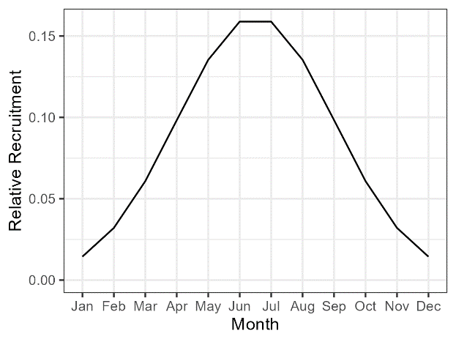

Figure 2‑1. or Figure S1-1. An example of a seasonal recruitment pattern.

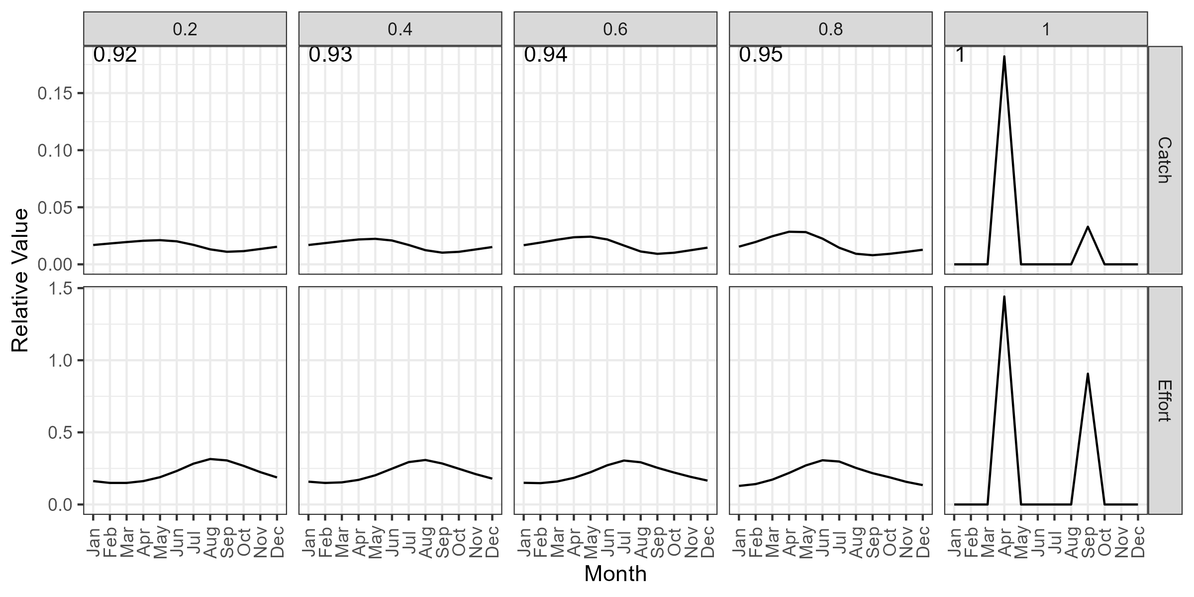

Figure 2‑2. or Figure S1-2. The HARA model prediction for the optimal relative monthly catch (top row) and fishing effort (bottom row) for five values of the risk aversion parameter (columns). The values in the top row indicate the catch relative to the catch with a risk aversion value of 1, equivalent to a conventional maximum sustainable yield calculation (right column).

Table S1‑1. Equations for the population dynamics of the unfished and the fished populations.

| **Equation** | **Description** |  |
| --- | --- | --- |
| *Equilibrium Unfished Population Dynamics* |  |  |
| $$N_{a,t=1}^{\text{unfished_eq}}=\left\{\begin{matrix}R_{t=1}^{0} & a=0 \\ R_{m}^{0}e^{\left(-\sum_{i=o}^{a-1}{M_{i}}\right)}\prod_{i=0}^{a-1}{\left(1-φ_{i}\right)} & 0<a\end{matrix} \right.$$ | Unfished age-structure for first time-step in initialized model | 1 |
| $$m=\left\{\begin{matrix}-\left(a \text{mod} 12\right)+1 & a \text{mod} 12=0 \\ -\left(a \text{mod} 12\right)+13 & 0<a \text{mod} 12\end{matrix} \right.$$ | Calendar month index for the initial time-step (month 1) for the unfished population | 2 |
| $$N_{a,t}^{\text{unfished_eq}}=\left\{\begin{matrix}R_{t}^{0} & a=0, 1<t≤12 \\ N_{a-1,t-1}^{\text{unfished_eq}}e^{-M_{a-1}}\left(1-φ_{a-1}\right) & a>1, 1<t≤12\end{matrix} \right.$$ | Age-structure of unfished population in months 2-12 for the initialized population | 3 |
| *Equilibrium Fished Population Dynamics* |  |  |
| $$S_{a}=\frac{1}{1+e^{\left(-\log\left(19\right)\frac{a-s_{50}}{s_{95}-s_{50}}\right)}}$$ | Logistic selectivity-at-age schedule | 4 |
| $$Z_{a}^{\text{init}}={M_{a}+S}_{a}F^{\text{init}}$$ | Total mortality-at-age before the initial fished time-step | 5 |
| $$N_{a,t=1}^{\text{fished_eq}}=\left\{\begin{matrix}R_{m=1}^{0} & a=0 \\ N_{a-1,m=12}^{\text{unfished_eq}}e^{\left(-Z_{a-1}^{\text{init}}\right)}\left(1-φ_{a-1}\right) & a>0\end{matrix}\right.$$ | Equilibrium fished age-structure for first time-step in initialized model | 6 |
| $$N_{a,t}^{\text{fished_eq}}=\left\{\begin{matrix}R_{m} & a=0, 1<t≤12 \\ N_{a-1,t-1}^{\text{fished_eq}}e^{\left(-Z_{a-1}^{\text{init}}\right)}\left(1-φ_{a-1}\right) & a>1, 1<t≤12\end{matrix} \right.$$ | Age-structure of fished population for months 2-12 for the initialized population | 7 |
|  |  |  |
| *Recruitment Dynamics* |  |  |
| $$R_{t}=\frac{4R_{m}^{0}h{\text{SB}}_{t}}{E_{0}R_{m}^{0}\left(1-h\right)+\left(5h-1\right){\text{SB}}_{t}}$$ | Beverton-Holt stock-recruit relationship for recruits to age-0 in timestep *t* | 8 |
| $${SB}_{t}^{\text{fished_eq}}=\left(\sum_{a}{N_{a,t}^{\text{fished_eq}}W_{a}ρ_{a}}\right)e^{-\frac{F^{\text{init}}}{2}}$$ | Spawning biomass in the middle of time-step *t* for initial equilibrium fished population | 9 |
| $$ρ_{a}=\frac{1}{1+e^{\left(-\log\left(19\right)\frac{a-A_{50}}{A_{95}-A_{50}}\right)}}$$ | Logistic maturity-at-age schedule | 10 |
| $$E_{0}=\sum_{a}{θ_{a}ρ_{a}W_{a}}$$ | Unfished spawning output per-recruit | 11 |
| $$θ_{a}=\left\{\begin{matrix}1 & a=0 \\ θ_{a-1}e^{-M_{a-1}}\left(1-φ_{a-1}\right) & 0<a\end{matrix}\right.$$ | Survival to age *a* for unfished cohort | 12 |
| *Fished Population Dynamics* |  |  |
| $$N_{a,t}=\left\{\begin{matrix}R_{t}ε_{t} & a=0 \\ N_{a-1,m=12}^{\text{fished_eq}}e^{\left(-Z_{a-1}^{\text{init}}\right)}\left(1-φ_{a-1}\right) & a>0, t=1 \\ {N_{a-1,t-1}e}^{\left(-Z_{a-1},t-1\right)}\left(1-φ_{a-1}\right) & 0<a, t>1\end{matrix}\right.$$ | Population dynamics for fished population | 13 |
| $$Z_{a,t}={M_{a}+S}_{a}F_{t}$$ | Total mortality-at-age in the fished time-steps | 14 |
| $${SB}_{t}=\left(\sum_{a}{N_{a,t}W_{a}ρ_{a}}\right)e^{-\frac{F_{t}}{2}}$$ | Spawning biomass in the middle of time-step *t* | 15 |
|  |  |  |
| $$C_{a,t}=N_{a,t}\left(\left(1-ρ_{a}\right)e^{-M_{a}/2}+ρ_{a}e^{-φ_{a}/2}\right)\left(1-e^{-S_{a}F_{t}}\right)$$ | Catch-at-age *a* in middle of time-step *t* | 16 |
| $${CB}_{t}=\sum_{a}^{a_{\text{max}}}{C_{a,t}W_{a}}$$ | Total catch biomass in time-step *t* | 17 |
| $$B_{t}=\sum_{a}^{a_{\text{max}}}{N_{a,t}}W_{a}$$ | Total biomass in time-step *t* | 18 |
| $${VB}_{t}=\sum_{a}^{a_{\text{max}}}{N_{a,t}}W_{a}S_{a}$$ | Vulnerable biomass in time-step *t* | 19 |
| $${\text{SPR}}_{t}=\frac{E_{F,t}}{E_{0}}$$ | Spawning potential ratio in time-step *t* | 20 |
| $$E_{F,t}=\sum_{a}{θ_{a,t}^{F}ρ_{a}W_{a}}$$ | Expected lifetime egg production of a fished cohort | 21 |
| $$θ_{a,t}^{F}=\left\{\begin{matrix}1 & a=0 \\ θ_{a-1}e^{-Z_{a-1,t}}\left(1-φ_{a-1}\right) & 0<a\end{matrix}\right.$$ | Survival to age *a* for fished cohort | 22 |
|  |  |  |
|  |  |  |
| $$p_{t,w}^{\text{pred}}=\frac{\sum_{a}{C_{a,t}}ω_{a,w}}{\sum_{w}{\sum_{a}{C_{a,t}}ω_{a,w}}}$$ | Predicted proportion of the catch (in numbers) in weight class *w* in time-step *t* | 23 |
| $$ω_{a,w_{i}}=\left\{\begin{matrix}∅\left(\frac{\log\left(w_{i}\right)-μ_{a}}{σ_{a}^{w}}\right) & i=1 \\ ∅\left(\frac{\log\left(w_{i}\right)-μ_{a}}{σ_{a}^{w}}\right)-∅\left(\frac{\log\left(w_{i-1}\right)-μ_{a}}{σ_{a}^{w}}\right) & 1<i<I \\ 1-∅\left(\frac{\log\left(w_{i-1}\right)-μ_{a}}{σ_{a}^{w}}\right) & i=I\end{matrix}\right.$$ | Probability of animals at age *a* to be in weight class *w* | 24 |
| $$E_{t}^{\text{pred}}=\frac{F_{t}}{{\overline{F}}_{t}}$$ | The predicted index of fishing effort | 25 |
| $$I_{t}^{\text{pred}}=\frac{{VB}_{t}}{{\overline{VB}}_{t}}$$ | The predicted index of abundance | 26 |
| $${CB}_{t}^{\text{pred}}=\frac{{CB}_{t}}{{\overline{CB}}_{t}}$$ | The predicted index of catch | 27 |

Table S1-2 The equations used to calculate the negative log-likelihood in the assessment model.

| **Equation** | **Description** |  |
| --- | --- | --- |
| $${NLL}_{\text{total}}={NLL}_{\text{CAW}}+ {NLL}_{\text{Effort}}+ {NLL}_{\text{Catch}}+ {NLL}_{\text{Ind}}+{NLL}_{\text{rec}}+{NLL}_{F_{t}}+{NLL}_{R_{m}^{0}}$$ | Total joint negative log-likelihood | 28 |
| $${NLL}_{\text{CAW}}=-\sum_{t}{{ESS}_{t}^{\text{CAW}}\sum_{w}{p_{t,w}^{\text{obs}}\log\left(p_{t,w}^{\text{pred}}\right)}}$$ | Negative likelihood for the catch-at-weight data | 29 |
| $${NLL}_{\text{Effort}}=\sum_{t}{\left(-\log\left(σ_{t}^{\text{Eff}}\right)-\frac{{\left(\log\left(E_{t}^{\text{obs}}\right)-\log\left(E_{t}^{\text{pred}}\right)\right)}^{2}}{2{σ_{t}^{\text{Eff}}}^{2}}\right) }$$ | Negative log-likelihood for the effort data | 30 |
| $${NLL}_{\text{Catch}}=\sum_{t}{\left(-\log\left(σ_{t}^{\text{Catch}}\right)-\frac{{\left(\log\left({CB}_{t}^{\text{obs}}\right)-\log\left({CB}_{t}^{\text{pred}}\right)\right)}^{2}}{2{σ_{t}^{\text{Catch}}}^{2}}\right) }$$ | Negative log-likelihood for the catch data | 31 |
| $${NLL}_{\text{Ind}}=\sum_{t}{\left(-\log\left(σ_{t}^{\text{Ind}}\right)-\frac{{\left(\log\left(I_{t}^{\text{obs}}\right)-\log\left(I_{t}^{\text{pred}}\right)\right)}^{2}}{2{σ_{t}^{\text{Ind}}}^{2}}\right) }$$ | Negative log-likelihood for the index of abundance | 32 |
| $${NLL}_{\text{rec}}= \sum_{t}{\left(-\log\left(σ_{R}\right)-\frac{δ_{t}^{2}}{2σ_{R}^{2}}\right)}$$ | Negative log-likelihood for recruitment deviations assuming normal error on the log deviations | 33 |
| $${NLL}_{F_{t}}=-\sum_{t}{\log\left(∅\left(\frac{\log\left(F_{t}\right)-\log\left(F_{t-1}\right)}{σ_{F_{t}}}\right)\right)} \text{for }t>1$$ | Random walk penalty on the monthly estimates of log fishing mortality | 34 |
| $${NLL}_{R_{m}^{0}}=-\sum_{m=1}^{12}{\left\{\begin{matrix}∅\left(\frac{\log\left(R_{0}^{m}\right)-\log\left(R_{0}^{m-1}\right)}{σ_{R}^{m}}\right) & 1<m≤12 \\ ∅\left(\frac{\log\left(R_{0}^{m}\right)-\log\left(R_{0}^{m=12}\right)}{σ_{R}^{m}}\right) & m=1\end{matrix} \right.}$$ | Random walk penalty on the difference in the log fraction of recruitment between each calendar month | 35 |

Table S1-3. Definition of symbols used in Table S1-1 and values used the simulation testing and application of the assessment model to the case studies.

| **Symbol** | **Definition** | **Simulation Testing** | | **Case Studies** |
| --- | --- | --- | --- | --- |
| $$a_{\text{max}}$$ | Maximum age class (months) | $$14$$ | | |
| $$R_{m}^{0}$$ | Relative proportion of mean annual recruitment in calendar month *m* | See Figure S1-8 | | Estimated |
| $$M_{a}$$ | Instantaneous natural mortality rate for age class *a* | 0.15 (all age classes) | | |
| $$ρ_{a}$$ | Probability of spawning at age ­*a* | See Figure S1-4 | | |
| $$φ_{a}$$ | Proportion of animals in age class *a* that are subject to post-spawning mortality | Equal to $ρ_{a}$ | | |
| $$W_{a}$$ | Mean weight-at-age *a* (kg) | See Table S1-4 | | |
| $$σ_{a}^{w}$$ | Standard deviation of log-normal distributed weight-at-age | See Table S1-4 | | |
| $$L_{a}$$ | Mean weight-at-age *a* | Not used in this analysis | | |
| $$σ_{a}^{l}$$ | Standard deviation of normal distributed length-at-age | Not used in this analysis | | |
| *h* | Steepness of Beverton-Holt stock-recruit relationship | 0.85 | | |
|  |  |  | |  |
| $$s_{50}$$ | Age corresponding to 50% probability of selection | 5.5 | | Estimated |
| $$s_{95}$$ | Age corresponding to 95% probability of selection | 6.5 | | Estimated |
| $${ESS}_{t}^{\text{CAW}}$$ | Effective sample size of catch-at-weight data in time-step t | 416 for all time-steps | | Monthly sample size (with maximum value of 200) |
| $$σ_{R}$$ | Standard deviation of the log-normal recruitment process error | 0.4 | | |
| $$σ_{t}^{\text{Eff}}$$ | Standard deviation of $E_{t}^{\text{obs}}$ | 0.15 | Estimated from data | |
| $$σ_{t}^{\text{Ind}}$$ | Standard deviation of $I_{t}^{\text{obs}}$ | 0.15 | | Estimated from data |
| $$σ_{t}^{\text{Ind}}$$ | Standard deviation of $I_{t}^{\text{obs}}$ | 0.15 | | Estimated from data |
| $$σ_{F_{t}}$$ | Standard deviation for in random walk penalty for monthly fishing mortality | 0.4 | | |
| $$σ_{R}^{m}$$ | Standard deviation for in random walk penalty for log relative fraction of monthly expected recruitment | 0.6 | | |
| *Other Symbols* | |  | |  |
| $$E_{t}^{\text{obs}}$$ | Observed index of fishing effort in time-step i, standardized to mean 1 and NAs for time-steps with missing data | | | |
| $$E_{t}^{\text{pred}}$$ | Predicted index of fishing effort in time-step i, calculated by standardizing $F_{t}$ to mean 1 across time-steps where $E_{t}^{\text{obs}}$ is not missing data | | | |
| $${CB}_{t}^{\text{obs}}$$ | Observed index of catch biomass in time-step i, standardized to mean 1 and NAs for time-steps with missing data | | | |
| $${CB}_{t}^{\text{pred}}$$ | Predicted index of catch biomass in time-step i, calculated by standardizing predicted catches to mean 1 across time-steps where ${CB}_{t}^{\text{obs}}$ is not missing data | | | |
| $$I_{t}^{\text{obs}}$$ | Observed index of abundance in time-step i, standardized to mean 1 and NAs for time-steps with missing data | | | |
| $$I_{t}^{\text{pred}}$$ | Predicted index of abundance time-step i, calculated by standardizing $\frac{{CB}_{t}}{E_{t}^{\text{pred}}}$ to mean 1 across time-steps where $I_{t}^{\text{obs}}$ is not missing data | | | |
| $$δ$$ | Recruitment deviations in log-space | | | |
| $$ε_{m}$$ | Log-normal error for recruitment process error with mean 1 and standard deviation $σ_{R}$ | | | |
| *M* | Index for calendar month (1 - 12) corresponding to time-step *t* | | | |
| $$F_{t}$$ | Fishing mortality in time-step *t* | | | |
| $$F^{\text{init}}$$ | Equilibrium fishing mortality before initial fished time-step | | | |
| $$∅$$ | Cumulative normal probability distribution | | | |
| $$μ_{a}$$ | Bias-corrected log mean weight-at-age calculated as $μ_{a}=\log\left(W_{a}\right)-0.5{σ_{a}^{w}}^{2}$ | | | |

## Summary of Life-History Information

This section summarizes the available information on the life-history of *O. cyanea* and describes the estimates of the life-history parameters used for the simulation testing and the application to the case studies.

There are few studies on the biology of *O. cyanea* in Indonesia, with most recent studies from the West Indian Ocean (Madagascar and Tanzania). Herwig et al. (2012) published a study from Ningaloo reef, Western Australia, which is closer to Indonesia and used as basis for many of the assumed biological values in this study.

### Longevity and Natural Mortality

Herwig et al. (2012) used stylet increment analysis to age 102 individual octopus, and found a maximum age of 314 days for females and 295 days for males. This estimate of an approximately 1 year life-span corresponds well with a longevity of 12 – 15 months reported by earlier studies from other regions (Van Heukelem, 1973).

Like most octopus species, female *O. cyanea* are known to die soon after spawning, and male octopus appear to have a similar life-span to females (Van Heukelem, 1973). The assessment model requires information on the natural mortality rate for the pre-spawning octopus. There appears to be few published studies on this background level of natural mortality for *O. cyanea* or other octopus species.

Herwig et al. (2012) used Hoenig’s (1983) method based on the maximum age (in days) observed in their study and reported a daily mortality rate of 2.9%. Assuming an average of 30.4 days in a month, this corresponds to a natural mortality rate of 0.88 month-1. This value appears too high for a species that has a longevity of at least 12 months, likely because it represents the average mortality over the whole adult lifespan rather than only the before-spawning mortality. Furthermore, it’s not clear if the Hoenig method is appropriate for short-lived semelparous species such as cephalopods. Roa-Ureta et al., (2020) estimated average natural mortality for pre-spawning red octopus (*Enteroctopus megalocyathus*) in Chile and reported a value of 0.017495 week-1, which corresponds to about 0.075 month-1. However, there is some evidence that deep-sea species like *E. megalocyathus* have longer life-spans than shallow water cephalopods.

An alternative logic to illuminate this issue is supplied by concept of optimum size that is widely applied in fisheries biology. This concept being that the process of natural selection that drives each species towards optimizing their evolutionary fitness ensures that in each species their cohorts achieve their maximum biomass coincidentally with their maturation, ensuring species optimize their reproductive output (Beverton & Holt 1957). This phenomenon underlies the inter-relationship of the Beverton-Holt life history ratios in species for which Von Bertalanffy growth curve can be applied, upon which the LBSPR technique is based upon (Hordyk et al. 2015). Applying the same principal, that species will achieve maximum cohort biomass at the size of maturation, to octopus, in order to optimize evolutionary fitness, allows us to evaluate alternative likely rates of natural mortality in octopus. In Figure 2-7 or Figure S1-3 we plot potential trajectories of relative biomass with age (months) assuming varying rates of natural mortality (0.05 – 0.45 month-1) and observe that with a natural mortality rate of 0.15 month-1 the biomass of each cohort will be maximized at the age of maturation in *O. cyanea*; around 12-14 months of age. On this basis, we assumed this to be the natural mortality rate for all pre-spawning age-classes for the simulation testing application to the case studies.

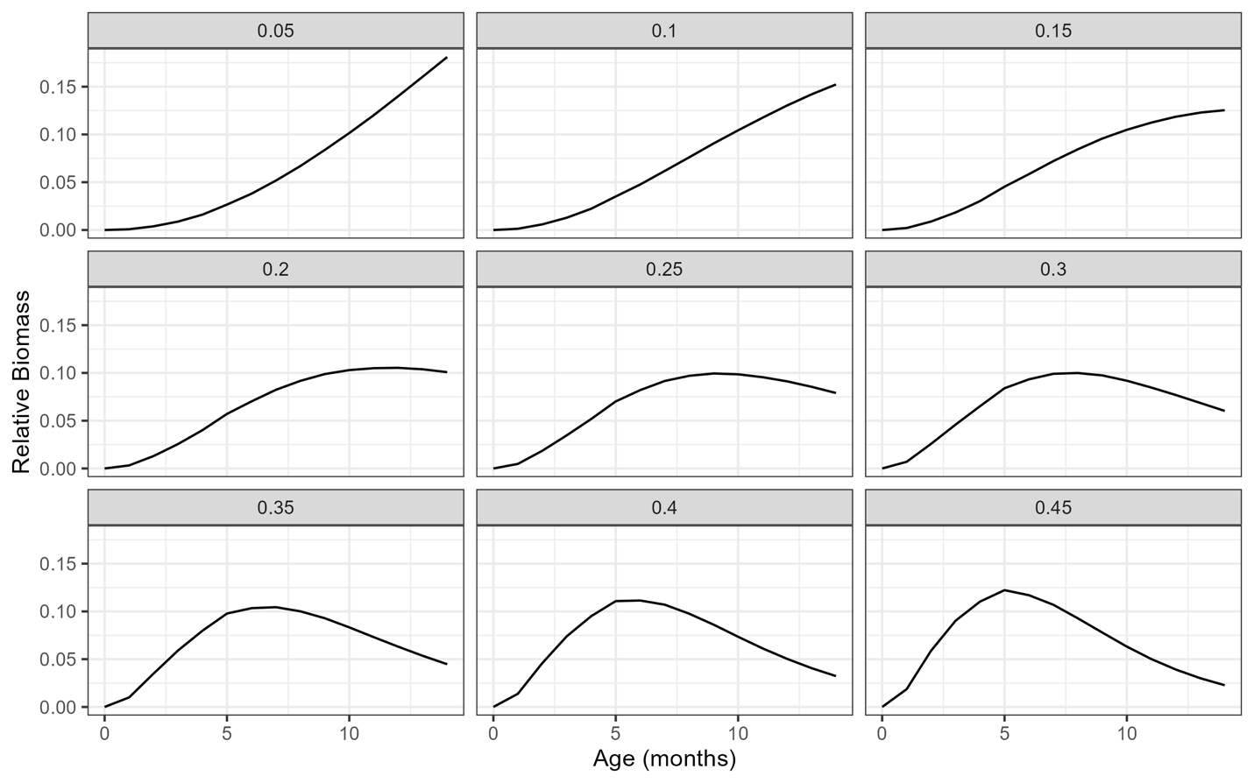

Figure 2‑7 or Figure S1-3. Potential trajectories of cohort relative biomass with age (months) assuming a range of rates of natural mortality (0.05 – 0.45 month-1).

### Probability Spawning-at-Age

Octopus populations in tropical regions typically reproduce year round, though sometimes with pronounced peaks in recruitment in certain months (Guard & Mgaya, 2002; Herwig et al., 2012; Raberinary & Benbow, 2012; Silas et al., 2021). Given that *O. cyanea* are simultaneous terminal spawners (Rocha et al., 2001) and the assumption that recruitment is a function of spawning biomass, in order to maintain a consistent annual seasonal pattern, reproduction must occur when most animals are around 12 months of age. Consequently, we assume an almost knife-edge spawning-at-age schedule $\left(ρ_{a}\right)$, with almost all individuals spawning at the end of their first year of life (Figure 2‑8 or Figure S1-4). Reproduction occurred in the middle of the monthly time-step, and all spawning individuals were assumed to die at the end of the same month; i.e., $φ_{a}=ρ_{a}$ (Table S1-4).

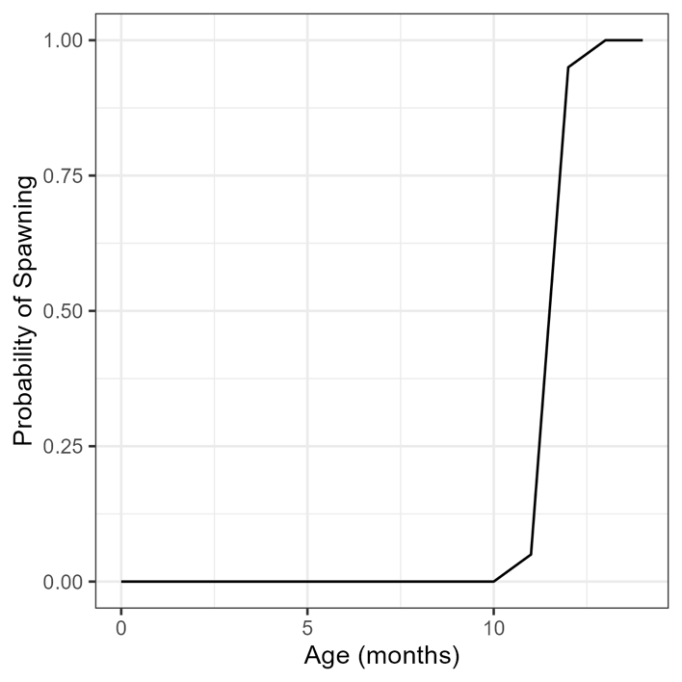

Figure 2‑8 or Figure S1-4. Assumed probability of spawning-at-age for the simulation testing and application to the case study data.

### Weight-at-Age

Herwig et al. (2012) fitted five growth models (exponential, linear, logarithmic, power, and von Bertalanffy) to weight-at-age data and found the power function provided the best fit. They also found no significant difference in growth between female and male octopus.

The coefficients of the power function reported in Table 1 of Herwig et al. (2012) did not reproduce the mean weight-at-age curve shown in their Figure 1 (which reported different values for the coefficients that also did not reproduce the curve). We digitized the data shown in their Figure 1 and fitted a power function to the resulting data. This resulted in slightly different coefficients than reported those reported by Herwig et al. (2012), but showed a similar line of best fit to the data (Figure 2‑9 or Figure S1-5). The standard deviation of the log-normally distributed weight-at-age was estimated in the Herwig et al. (2012) study to be 0.48.

To account for the differences in water temperature between the location of the Herwig et al. (2012) study in Ningaloo reef, Western Australia, and the more northern waters of Indonesia with higher water temperature, we scaled the estimated mean weight-at-age schedule using a local estimate of weight-at-maturity.

At data set of weight of 575 octopus and their maturity stage (Immature or Mature), collected from throughout Indonesia, was provided by Blue Ventures. The probability of maturity-at-weight was estimated from these data using logistic regression with a general linear model (Figure 2‑10 or Figure S1-6). For a given mean weight-at-age schedule, and this estimated maturity-at-weight schedule, the corresponding maturity-at-age schedule can be calculated. We optimized the weight-at-age schedule by scaling the mean weight-at-age estimated by Herwig et al. (2012) until the predicted maturity-at-age schedule matched the assumed schedule described above. This resulted in a smaller assumed mean weight-at-age schedule for Indonesia compared to that estimated by Herwig et al. (2012) (Figure 2‑11 or Figure S1-7).

We assumed a maximum age of 14 months, and used these results to calculate the mean weight-at-age and standard deviation used in the assessment model and simulation testing (Figure 2‑11 or Figure S1-7; Table S1-4).

### Stock-Recruit Relationship

The stock assessment and the monthly fishing optimization models require an estimate of the steepness of the Beverton-Holt stock-recruit relationship. The assessment model could be run assuming a per-recruit model, i.e., $h=1$, however, using this assumption in the fishing mortality optimization routine is likely to result in very high estimates of optimal fishing mortality, as the model will assume eggs will continue to be produced even if the spawning biomass is reduced to very low levels.

Steepness is difficult to estimate for most species, and there appears to be no published studies of steepness for octopus species. Given that octopus populations are often considered to be highly productive, we assumed a relatively high value of 0.85 for steepness of the stock-recruit relationship. Likely values for the recruitment process error $\left(σ_{R}^{2}\right)$ are unknown, and a value of 0.4 was assumed for the simulation testing and application to the case studies.

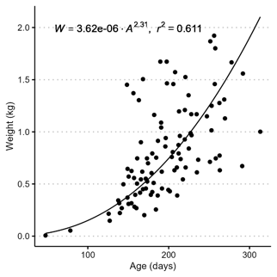

Figure 2‑9 or Figure S1-5. The digitized data points from Herwig et al. (2012) showing the weight-at-age for the octopus from Ningaloo reef, and the line of best fit for the power function fitted to the data.

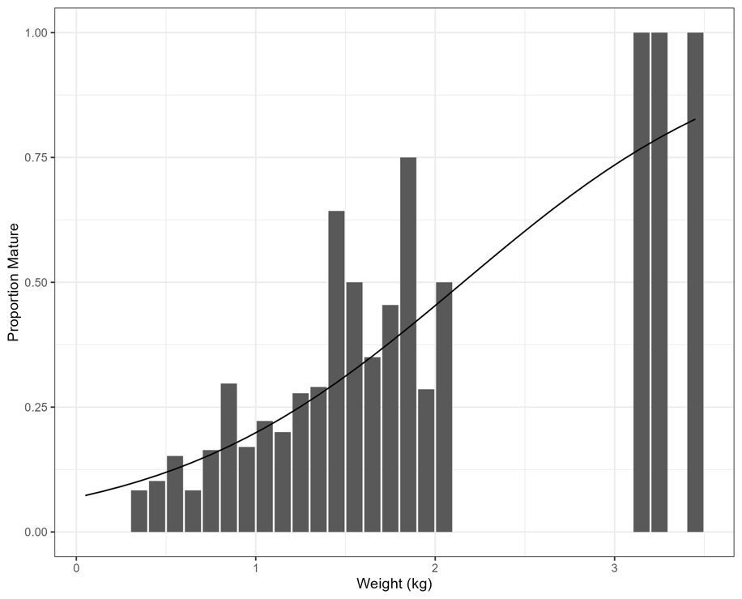

Figure 2‑10 or Figure S1-6. The observed proportion of animals mature in each weight class (bars) and the predicted maturity-at-weight curve (line) for a dataset of 575 individual octopus.

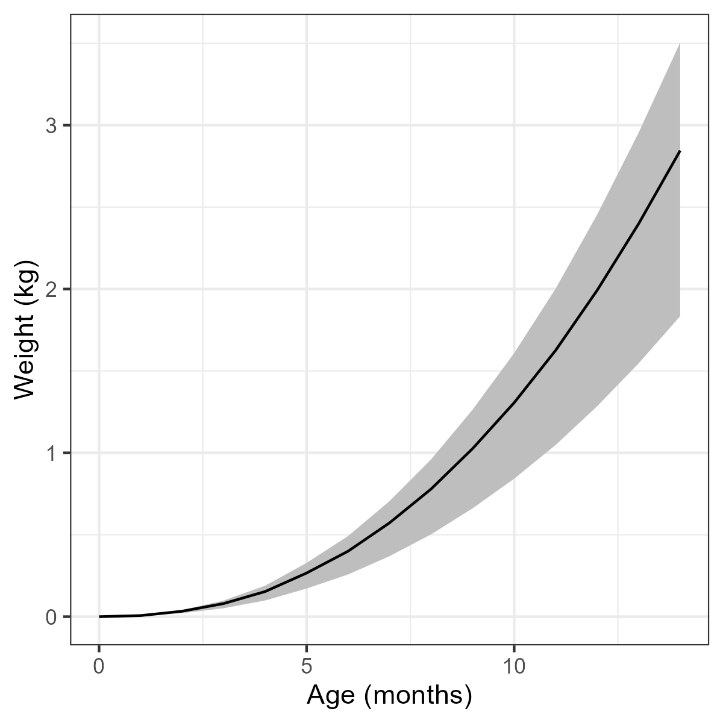

Figure 2‑11 or Figure S1-7. The assumed mean (and 25th and 75th percentiles) weight-at-age schedule used for the simulation testing and application to case study data.

Table S1-4. The mean weight-at-age and standard deviation schedules used in the simulation testing and assessment of the case study data.

|  |  |  |
| --- | --- | --- |
| **Age (months)** | **Mean Weight (kg)** | **Standard Deviation (log-space)** |
| 0 | 0.00 | 0.48 |
| 1 | 0.01 | 0.48 |
| 2 | 0.03 | 0.48 |
| 3 | 0.08 | 0.48 |
| 4 | 0.15 | 0.48 |
| 5 | 0.27 | 0.48 |
| 6 | 0.40 | 0.48 |
| 7 | 0.57 | 0.48 |
| 8 | 0.78 | 0.48 |
| 9 | 1.03 | 0.48 |
| 10 | 1.31 | 0.48 |
| 11 | 1.63 | 0.48 |
| 12 | 1.99 | 0.48 |
| 13 | 2.40 | 0.48 |
| 14 | 2.85 | 0.48 |

## Simulation Testing

A set of simulation tests were run to evaluate the assessment model’s ability to estimate fishing mortality, the spawning potential ratio (SPR), and the seasonal recruitment pattern under a range of different data scenarios.

An operating model (OM) was developed, following the same structure as the assessment model described above, but coded separately from the assessment model using the R statistical computing environment (R Core Team, 2022).

Two seasonal patterns in recruitment were considered (Constant and Pulse; Figure 2‑3). Each recruitment scenario had 100 individual simulations, with stochastic samples of the recruitment process error and observation processes in each simulation.

The simulated fishery was initialized in an equilibrium unfished state and then fished for a 30-year period, nominally referred to as January 1994 to December 2023. The fishing effort was assumed to linearly increase from 0 in the first month to a maximum value of 100 units after 10-years, and then remained on average at this maximum level with log-normally distributed monthly deviations (coefficient of variation (CV) of 10%). Fishing mortality was calculated from the fishing effort, assuming a stationary catchability coefficient *q* of 0.003. For the Pulse recruitment scenario, the pattern in fishing effort in each year was calculated from the HARA model assuming a HARA coefficient of 0.3 (Figure 2‑4). The selectivity-at-age parameters were set to 5.5 and 6.5 for *S50* and *S95* respectively (Table S1-3). The life-history parameters used for the simulation testing and application to the case studies are described in the next section below.

For each iteration, fishery data was generated from the simulated population assuming an effective sample size of 400 for the monthly samples of catch-at-weight, and a 15% CV for the observed indices of catch, effort, and index of abundance (Table S1-3).

Five data scenarios were considered (Table S1-5. For each data scenario, the model was fit assuming 12, 24, 36, 48, and 60 months of recent data were available. This resulted in a total of 50 scenarios: 5 different data series, available for 5 different time-periods, and 2 seasonal recruitment patterns. The model was not fit to indices of effort, catch, and abundance, because the index of abundance was generated from the catch and effort data.

The assessment model was applied to each simulation in each scenario and the results were summarized as the median relative error (MRE) in estimated *F* and SPR for each run. The estimated seasonal recruitment pattern was also compared to the true seasonal pattern in the operating model.

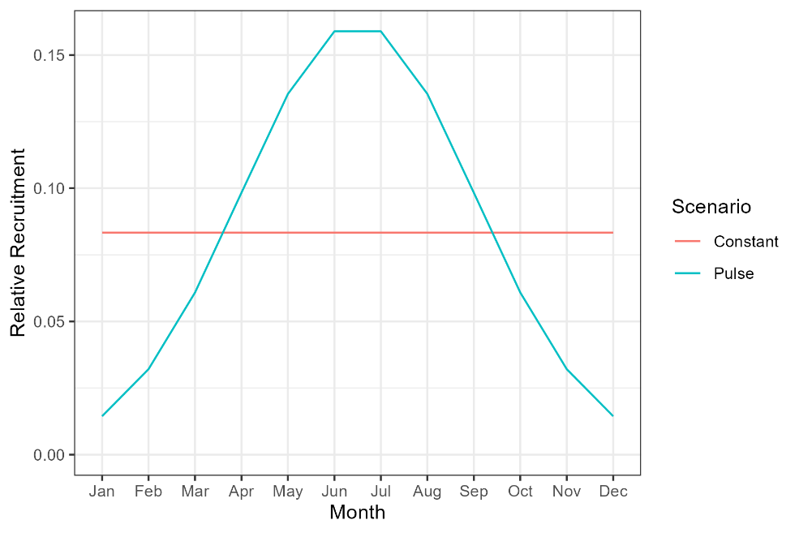

Figure 2‑3 or Figure S1-8. The two patterns in seasonal recruitment evaluated in the simulation tests of the short-lived assessment model.

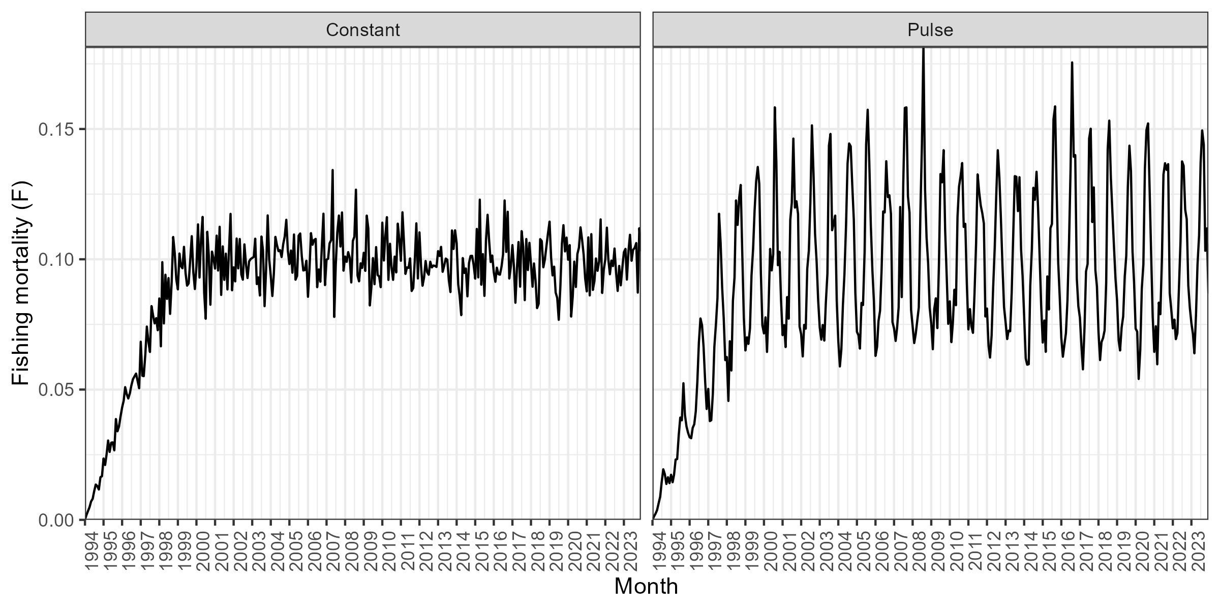

Figure 2‑4 or Figure S1-8. An example of the pattern in fishing mortality for the Constant and Pulse recruitment scenarios. This figure shows a single simulation. Each of the 100 simulations had stochastic process error in fishing effort drawn from a log-normal distribution with CV of 10%.

Table S1-5. The Data Scenarios considered in the Simulation Testing.

|  |  |  |
| --- | --- | --- |
| **Scenario Number** | **Scenario Name** | **Description** |
| 1 | CAW Only | Assessment model fit only to catch-at-weight (CAW) data |
| 2 | CAW + Catch | Assessment model fit only to CAW data and an index of catch |
| 3 | CAW + Catch + Index | Assessment model fit only to CAW data, an index of catch, and an index of abundance (CPUE) |
| 4 | CAW + Effort | Assessment model fit only to CAW data and an index of effort |
| 5 | CAW + Effort + Index | Assessment model fit only to CAW data, an index of effort, and an index of abundance (CPUE) |

## Application to Case Studies

Fishery data was available from 45 villages throughout Indonesia. Villages that were close together were considered to be fishing the same local stock of octopus, and the data from these villages were aggregated into a single case study site. This resulted in 29 individual case study sites. The data were filter to only include catch composition data where at least 50 individuals were sampled in each month. Two sites (Maurongga & Mola) had less than 50 individuals sampled in all months, and were excluded from the study. This resulted in data from 43 villages and a total of 27 case study sites.

The assessment model requires at least 12 continuous months of weight composition data. Cases where weight composition data was missing for a single month where interpolated as the mean of the sampled weight composition data from the month prior and after the month with missing data. The data sets were filtered to only include the longest time period that had at least 12 months of continuous weight composition data (including interpolated data for a missing single month). Nine sites had less than 12 continuous months of weight composition data and were removed from the analysis. The weight composition data for one site (Tetandara (Arubura)) was recorded in 0.5 kg increments, too coarse for this analysis, and therefore this data was removed from the analysis.

This resulted in 17 sites, consisting of data from 33 villages, where the assessment model was applied to the octopus data (Figure 2‑5, Table S1-6) The data was collected on a daily basis and included information on the time spent fishing, the fishing method used, and the weight (kg), mantle length (cm), and sex of the individual octopus caught by each fisher. Effort data was not available for the majority of fishers in each site, and was not available for all months in each data set (Table S1-6).

The observed catch-at-weight data were aggregated into monthly samples, and then binned into discrete weight classes of 100 grams, with a maximum weight class of 4 kg. All observations greater than 4 kg were aggregated into the maximum weight class. The weight frequency data was calculated for both male and female octopus combined together. The effective sample size of the CAW data was set to the monthly sample size of catch-at-weight observations, with a maximum value of 200 individuals. Figure 2‑6 shows the overall weight composition data, summed across all available months, for each case study site.

A time-series of the monthly catch was generated by summing the observed weight-at-age data for each month. Effort data was not recorded for each observation of catch-at-weight, with the majority of fishers not reporting the fishing effort corresponding with each catch-at-weight observation. Consequently, the assessment model was fit to the index of catch for each case study site.

The mean monthly catch-per-unit effort (CPUE) was calculated using a linear model of log-CPUE with individual fishers (where available) and Year:Month as covariate factors, and calculating the mean and standard deviation for the monthly CPUE.

Reference points where calculated using the HARA model with an assumed exponent value of 0.4.

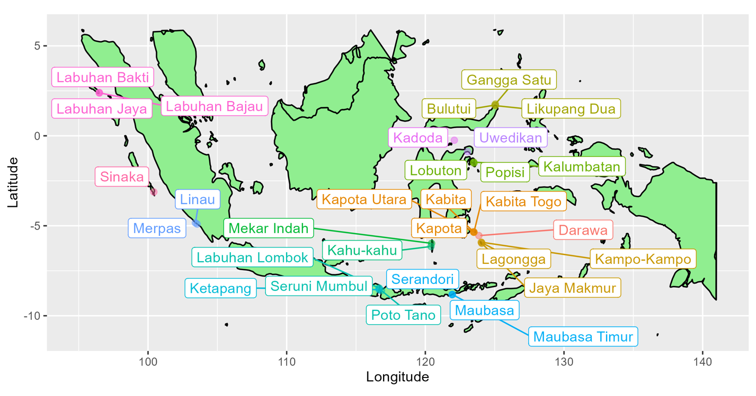

Figure 2‑5 or Figure S1-9. Map of villages in Indonesia where the stock assessment model was applied to the octopus fishery data. Location data for two villages (Grogos and Torosiaje) was not available and these villages are not shown on the map. Adjacent villages where data was combined are shown in the same color (17 sites in total).

Table S1-6. Summary table of the 17 case study sites where the stock assessment model was applied to the octopus data.

| **Site Number** | **Villages** | **Data Date Range** | **N. Months** | **N. Months CAW Data** | **N. Months Effort Data** | **N. Months Catch Data** |
| --- | --- | --- | --- | --- | --- | --- |
| 1 | Bulutui, Gangga Satu, Likupang Dua | 2019-04 – 2023-05 | 50 | 50 | 41 | 50 |
| 2 | Darawa | 2020-11 – 2023-04 | 30 | 28 | 0 | 28 |
| 3 | Grogos | 2020-08 – 2022-04 | 21 | 19 | 0 | 19 |
| 4 | Jaya Makmur, Kampo-Kampo, Lagongga | 2018-04 – 2019-04 | 13 | 12 | 0 | 12 |
| 5 | Kabita, Kabita Togo, Kapota, Kapota Utara | 2021-03 – 2022-12 | 22 | 18 | 0 | 18 |
| 6 | Kadoda | 2021-06 – 2023-03 | 22 | 22 | 1 | 22 |
| 7 | Kahu-kahu | 2020-09 – 2023-03 | 31 | 29 | 0 | 29 |
| 8 | Kalumbatan, Lobuton, Popisi | 2017-01 – 2023-05 | 77 | 77 | 0 | 77 |
| 9 | Ketapang | 2022-01 – 2022-12 | 12 | 12 | 11 | 12 |
| 10 | Labuhan Bajau, Labuhan Bakti, Labuhan Jaya | 2022-04 – 2023-12 | 21 | 20 | 11 | 20 |
| 11 | Labuhan Lombok, Poto Tano, Seruni Mumbul | 2019-10 – 2023-04 | 43 | 43 | 40 | 43 |
| 12 | Linau, Merpas | 2021-06 – 2023-03 | 22 | 22 | 3 | 22 |
| 13 | Maubasa, Maubasa Timur, Serandori | 2021-09 – 2023-06 | 22 | 22 | 19 | 22 |
| 14 | Mekar Indah | 2021-02 – 2023-03 | 26 | 25 | 0 | 25 |
| 15 | Sinaka | 2022-03 – 2023-12 | 22 | 22 | 10 | 22 |
| 16 | Torosiaje | 2021-06 – 2023-10 | 29 | 28 | 21 | 28 |
| 17 | Uwedikan | 2020-09 – 2022-10 | 26 | 24 | 2 | 24 |

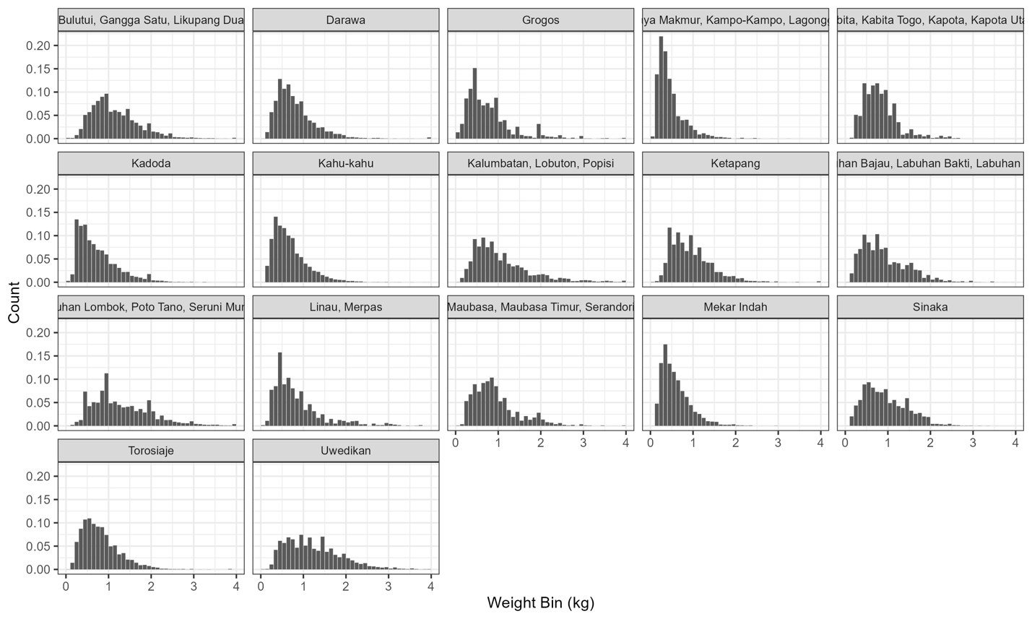

Figure 2‑6 or Figure S1-10. The overall weight composition data from each of the 17 case study sites. The weight composition data for each site is summed over all months of data, and standardized to sum to 1 across the weight bins.