**Table S1.** Self-reported food frequency before and after control beverage or orange juice intake.

|  |  |  |  |
| --- | --- | --- | --- |
| Foods | Time | Control beverage | Orange juice |
| Bread a | Baseline | 1.53 ± 0.16 | 1.68 ± 0.19 |
| Week 5 | 1.63 ± 0.16 | 1.63 ± 0.14 |
| Week 10 | 1.74 ± 0.17 | 1.47 ± 0.14 |
| Vegetables a | Baseline | 2.53 ± 0.14 | 2.63 ± 0.14 |
| Week 5 | 2.37 ± 0.16 | 2.42 ± 0.14 |
| Week 10 | 2.42 ± 0.14 | 2.47 ± 0.16 |
| Fruit a | Baseline | 2.21 ± 0.18 | 1.89 ± 0.19 |
| Week 5 | 2.16 ± 0.21 | 2.05 ± 0.16 |
| Week 10 | 2.05 ± 0.18 | 1.89 ± 0.19 |
| Milk or Yogurt a | Baseline | 1.47 ± 0.16 | 1.58 ± 0.14 |
| Week 5 | 1.53 ± 0.14 | 1.53 ± 0.14 |
| Week 10 | 1.63 ± 0.19 | 1.63 ± 0.18 |
| Rice or Pasta a | Baseline | 1.58 ± 0.16 | 1.53 ± 0.12 |
| Week 5 | 1.47 ± 0.12 | 1.47 ± 0.14 |
| Week 10 | 1.37 ± 0.11 | 1.42 ± 0.12 |
| Vegetable oils a | Baseline | 1.68 ± 0.17 | 1.55 ± 0.14 |
| Week 5 | 1.47 ± 0.14 | 1.58 ± 0.14 |
| Week 10 | 1.58 ± 0.16 | 1.68 ± 0.15 |
| Alcoholic beverages a | Baseline | 1.05 ± 0.05 | 1.05 ± 0.05 |
| Week 5 | 1.05 ± 0.05 | 1.00 ± 0.00 |
| Week 10 | 1.00 ± 0.00 | 1.11 ± 0.07 |
| Breakfast cereals a | Baseline | 1.11 ± 0.07 | 1.11 ± 0.07 |
| Week 5 | 1.16 ± 0.12 | 1.16 ± 0.09 |
| Week 10 | 1.21 ± 0.12 | 1.11 ± 0.07 |
| Meat b | Baseline | 1.74 ± 0.19 | 1.68 ± 0.15 |
| Week 5 | 1.74 ± 0.19 | 1.68 ± 0.19 |
| Week 10 | 1.63 ± 0.18 | 1.68 ± 0.19 |
| Sausages b | Baseline | 1.00 ± 0.00 | 1.00 ± 0.00 |
| Week 5 | 1.00 ± 0.00 | 1.00 ± 0.00 |
| Week 10 | 1.00 ± 0.00 | 1.00 ± 0.00 |
| Cheese b | Baseline | 1.53 ± 0.14 | 1.58 ± 0.16 |
| Week 5 | 1.68 ± 0.15 | 1.68 ± 0.15 |
| Week 10 | 1.58 ± 0.16 | 1.68 ± 0.15 |
| Animal fat (butter, lard) b | Baseline | 1.74 ± 0.19 | 1.47 ± 0.16 |
| Week 5 | 1.58 ± 0.16 | 1.47 ± 0.16 |
| Week 10 | 1.37 ± 0.14 | 1.37 ± 0.16 |
| Vegetable oil b | Baseline | 1.42 ± 0.16 | 1.47 ± 0.12 |
| Week 5 | 1.37 ± 0.11 | 1.53 ± 0.16 |
| Week 10 | 1.26 ± 0.10 | 1.42 ± 0.16 |
| Fast food b | Baseline | 1.00 ± 0.00 | 1.00 ± 0.00 |
| Week 5 | 1.05 ± 0.05 | 1.00 ± 0.00 |
| Week 10 | 1.00 ± 0.00 | 1.00 ± 0.00 |
| Fish c | Baseline | 1.32 ± 0.13 | 1.37 ± 0.14 |
| Week 5 | 1.32 ± 0.13 | 1.32 ± 0.13 |
| Week 10 | 1.26 ± 0.10 | 1.32 ± 0.11 |
| Legumes c | Baseline | 1.58 ± 0.18 | 1.84 ± 0.16 |
| Week 5 | 1.58 ± 0.18 | 1.68 ± 0.17 |
| Week 10 | 1.68 ± 0.17 | 1.63 ± 0.16 |
| Nuts c | Baseline | 1.84 ± 0.21 | 1.63 ± 0.16 |
| Week 5 | 1.79 ± 0.16 | 1.74 ± 0.17 |
| Week 10 | 1.47 ± 0.16 | 1.74 ± 0.19 |

Data are expressed as means ± SEM (n = 19). Results are based on a validated self-reported semi-quantitative food frequency questionnaire that participants filled out before and after each study visit. a 1: <1 time per day, 2: 1 time per day, 3: ≥2 times per day. b 1: <4 times per week, 2: 4-6 times per week, 3: ≥7 times per week. c 1: <2 times per day, 2: 2-3 times per day, 3: ≥4 times per day. The variations in food frequency were analyzed using a Friedman test.

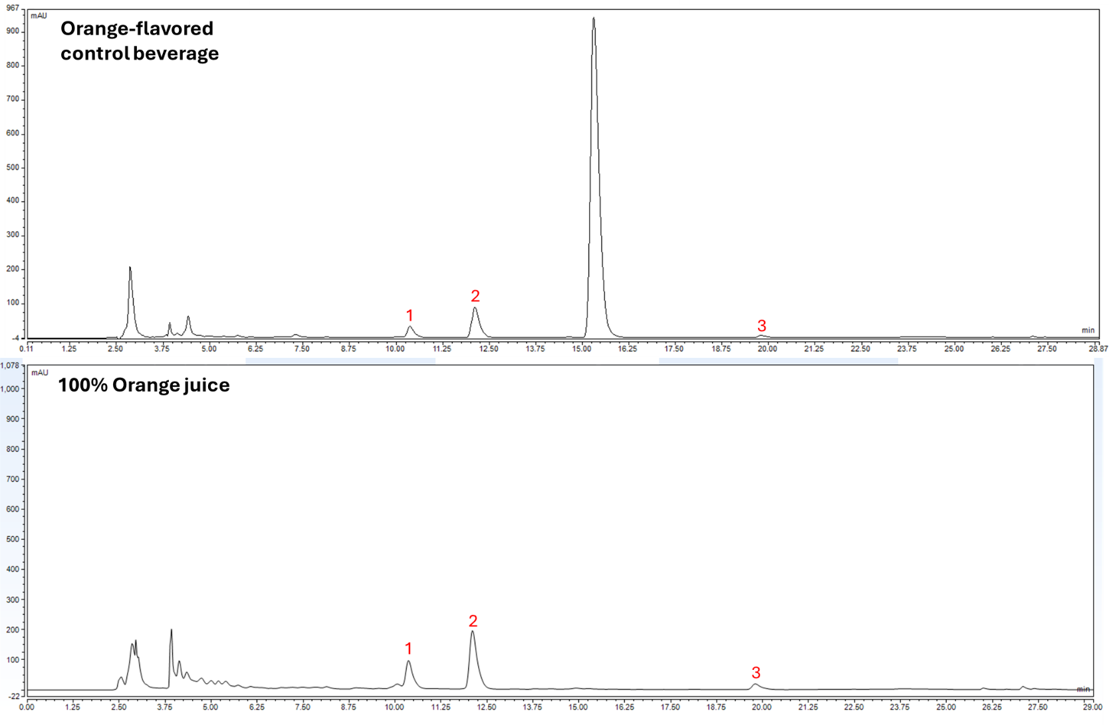

Figure S1. HPLC chromatograms of the orange-flavored control beverage and 100% orange juice. Peaks 1–3 correspond to narirutin, hesperidin, and didymin, respectively.