Supplementary Table 1. Comparison table between PopPK final model and Bootstrap parameters
 | Final model |  | Bootstrap*
 | Estimates(RSE%) | 95%CI | Estimates(RSE%) | 95%CI
PK parameters
K_{a}, 1/h | 0.01086(8.49) | 0.009047~0.01267 | 0.01102 | 0.009160~0.01403
V₁/F, L | 2.387(15.54) | 1.6591~3.1155 | 2.431 | 1.734~3.441
V₂/F, L | 21.42(20.48) | 12.81~30.04 | 20.83 | 11.15~43.07
K_{m}, μg/L | 70.08(13.78) | 51.13~89.03 | 71.45 | 45.26~106.7
V_{max}, μg/h | 80.13(7.82) | 67.83~92.44 | 80.84 | 63.33~107.7
CL₂/F, L/h | 0.05575(10.15) | 0.04464~0.06686 | 0.06058 | 0.02881~0.09989
WEIGHT on V_{max} | 2.202(18.05) | 1.422~2.982 | 2.194 | 0.6494~3.461
AGE on K_{a} | -0.6957 (28.49) | -1.085~-0.3066 | -0.7091 | -0.9709~-0.4449
AGE on V₁/F | 1.470 (24.69) | 0.7574~2.182 | 1.398 | 0.5416~2.275
AGE on V_{max} | 0.7989 (18.37) | 0.5109~1.087 | 0.7819 | 0.3734~1.186
Inter-individual
ω(V₁/F), % | 97.08(24.30) | 50.84~143.3 | 94.35(26.82) | 44.75~143.9
ω(K_{a}), % | 54.77 | - | 54.77 | -
ω(K_{m}), % | 54.77 | - | 54.77 | -
Residual error
σ (prop), % | 28.94 (2.88) | 27.30~30.57 | 28.61 | 24.65~32.28
*OFV：4722.9

Supplementary Table 2. Comparison table between the final PD model and Bootstrap parameters for the elderly
 | PD model for the elderly |  | Bootstrap*
 | Estimates (RSE%) | 95%CI | Estimates | 95%CI
PK parameters
K_{in}, ng/(mL·h) | 0.023(14.79) | 0.01615~0.02938 | 0.02347 | 0.01824~0.03798
K_{out}, 1/h | 0.023(15.50) | 0.01603~0.03006 | 0.02395 | 0.01809~0.03935
E_{max} | 2.245(21.80) | 1.283~3.207 | 2.146 | 1.213~3.092
EC₅₀, ng/mL | 50.74(37.68) | 13.16~88.32 | 46.14 | 19.86~83.51
Inter-individual
ω(EC₅₀), % | 78.76(30.66) | 31.43~126.1 | 81.95(45.38) | 9.055~154.8
ω(K_{out}), % | 10.27(3.901) | 9.485~11.06 | 9.549(4.827) | 8.646~10.45
Residual error
σ(add), ng/mL | 13.20(6.13) | 11.61~14.79 | 13.14 | 11.52~14.64
*OFV：-440.5

Supplementary Table 3. Clinical studies included in the analysis
Study No. | Study design | Dose regimen | Subjects | PK sampling design | IGF-1 sampling design
TB2208GH | Phase I,  single-center,  open and non-randomized  study | 30 μg/kg/2 weeks of YPEG-rhGH injection for 23 consecutive weeks | Healthy elderly subjects,n = 16 | Before (0 h) and 8, 24, 72, 96, 120, 168, 336 h after the first dose; before the third dose; before and 8, 24, 72, 96, 120, 168, 336 h after the seventh dose; before and 8 h and 96 h after the twelfth dose (follow-up until 5 weeks after discontinuation) | Before (0 h) and 8, 24, 72, 96, 120, 168, 336 h after the first dose; before the third, fourth, fifth, and sixth doses; before and 8, 24, 72, 96, 120, 168, and 336 h after the seventh dose; before the ninth, tenth, and eleventh doses; and before and 8 and 96 h after the twelfth dose (follow-up until 5 weeks after discontinuation)
TB1010GH | Phase I,  single-center,  open and randomized study | First stage:0.1 IU/kg or 0.15 IU/kg of Saizen® for 7 consecutive days  Second stage: a single dose of 10 μg/kg, 30 μg/kg, 60 μg/kg, 120 μg/kg, or 200 μg/kg of YPEG-rhGH | Healthy male subjects,n = 36 | First stage: 30 min before (0 h) and 6, 12, 15, 24, 48, 72, 96, 120, 144, 168, 192, 240, and 288 h after the first dose.  Second stage: 30 min before the first dose (0 h) and 6, 12, 15, 24, 48, 72, 96, 120, 144, 168, 192, 240, 288, and 336 h after the first dose (follow-up to 12 months) | First stage: 30 min before (0 h) and 6, 12, 15, 24, 48, 72, 96, 120, 144, 168, 192, 240, and 288 h after the first dose.  Second stage: 30 min before the first dose (0 h) and 6, 12, 15, 24, 48, 72, 96, 120, 144, 168, 192, 240, 288, and 336 h after the first dose (follow-up to 12 months)

Supplemental table 4. Test of distribution balance for key covariates (age and body weight) between the two subject groups
Independent samples test
 |  | Levene’s test for equality of variances |  | t-test for equality of means
 |  | F | Sig. | t | Degree of freedom | Sig. (2-tailed) | Mean difference |  | 95% Confidence interval of the difference
 |  |  |  |  |  |  |  | Std. error difference | Lower | Upper
AGE | Equal variances assumed | 13.086 | .001 | -21.123 | 50 | .000 | -36.660 | 1.735 | -40.146 | -33.174
AGE | Equal variances not assumed |  |  | -27.459 | 49.925 | .000 | -36.660 | 1.335 | -39.341 | -33.978
Independent samples test
 |  | Levene’s test for equality of variances |  | t-test for equality of means
 |  | F | Sig. | t | Degree of freedom | Sig. (2-tailed) |  |  | 95% Confidence interval of the difference
 |  |  |  |  |  |  | Mean difference | Std. error difference | Lower | Upper
WEIGHT | Equal variances assumed | .380 | .541 | 2.313 | 50 | .025 | 4.534 | 1.961 | .596 | 8.472
WEIGHT | Equal variances not assumed |  |  | 2.164 | 24.910 | .040 | 4.534 | 2.095 | .218 | 8.850

Supplemental table 5. Comparison of PopPK/PD model parameter estimates using AGE versus TRIAL as a covariate
Full model K_{a}-AGE V₁-AGE V_{max}-AGE V_{max}-WEIGHT |  |  | Full model K_{a}-TRIAL V₁-TRIAL V_{max}-TRIAL V_{max}-WEIGHT
Parameter | Unit | Typical value(RSE%) | Parameter | Unit | Typical value(RSE%)
K_{a} | 1/h | 0.01086(8.49) | K_{a} | 1/h | 0.006540(30.03)
V₁/F | L | 2.387(15.54) | V₁/F | L | 7.3321(30.05)
V₂/F | L | 21.42(20.48) | V₂/F | L | 26.62(15.92)
K_{m} | μg/L | 70.08(13.78) | K_{m} | μg/L | 98.98(16.01)
V_{max} | μg/h | 80.13(7.82) | V_{max} | μg/h | 163.7(73.20)
CL₂/F | L/h | 0.05575(10.15) | CL₂/F | L/h | 0.06548(6.105)
WEIGHT on V_{max} | - | 2.202(18.05) | trial on K_{a} | - | 1.150(66.10)
AGE on K_{a} | - | -0.6957(28.49) | trial on V₁/F | - | -0.7142(15.91)
AGE on V₁/F | - | 1.470(24.69) | trial on V_{max} | - | -0.5849 (60.13)
AGE on V_{max} | - | 0.7989(18.37)
Residual error,  σ (prop), % | - | 28.94(2.88) | Residual error,  σ (prop), % | - | 29.17(2.35)
OFV | 4722.9265 |  | OFV | 4776.9778
Condition number | 13195.382 |  | Condition number | 139986.4

Supplementary Table 6. The range of baseline values in elderly subjects
Variable | n | Minimum | Maximum | Range | Mean | Std. dev. | CV%
IGF-1 | 16 | 64.9 | 126.0 | 61.1 | 93.8 | 17.4 | 20.1

Supplemental Figure 1: PopPK model individual fit curve (linear coordinate plot) after subjects were given YPEG-rhGH
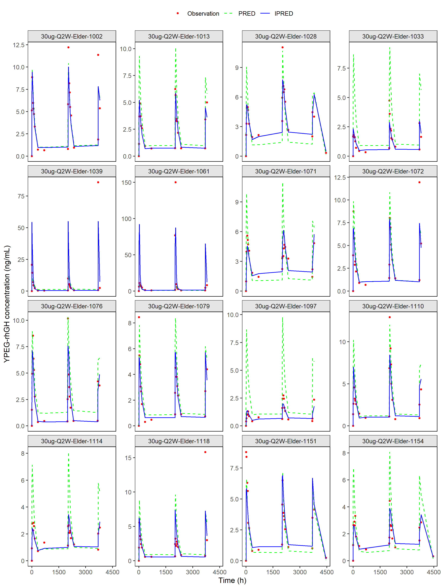
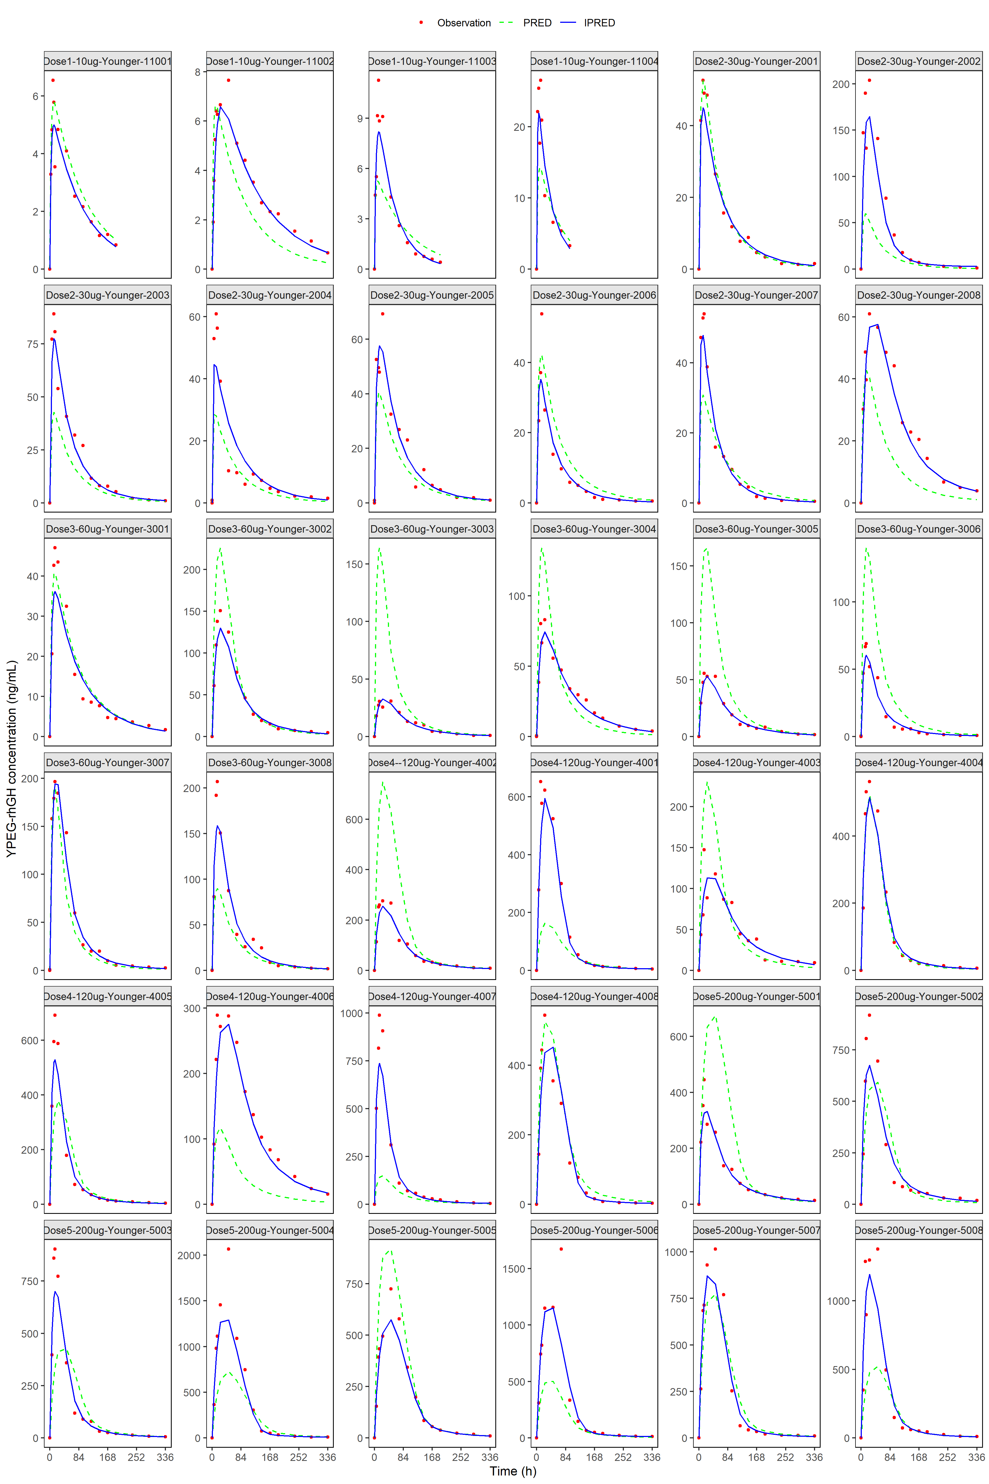

Supplemental Figure 2：Individual fitting curves (linear coordinate plots) for PK/PD (IGF-1) model in the elderly subject population
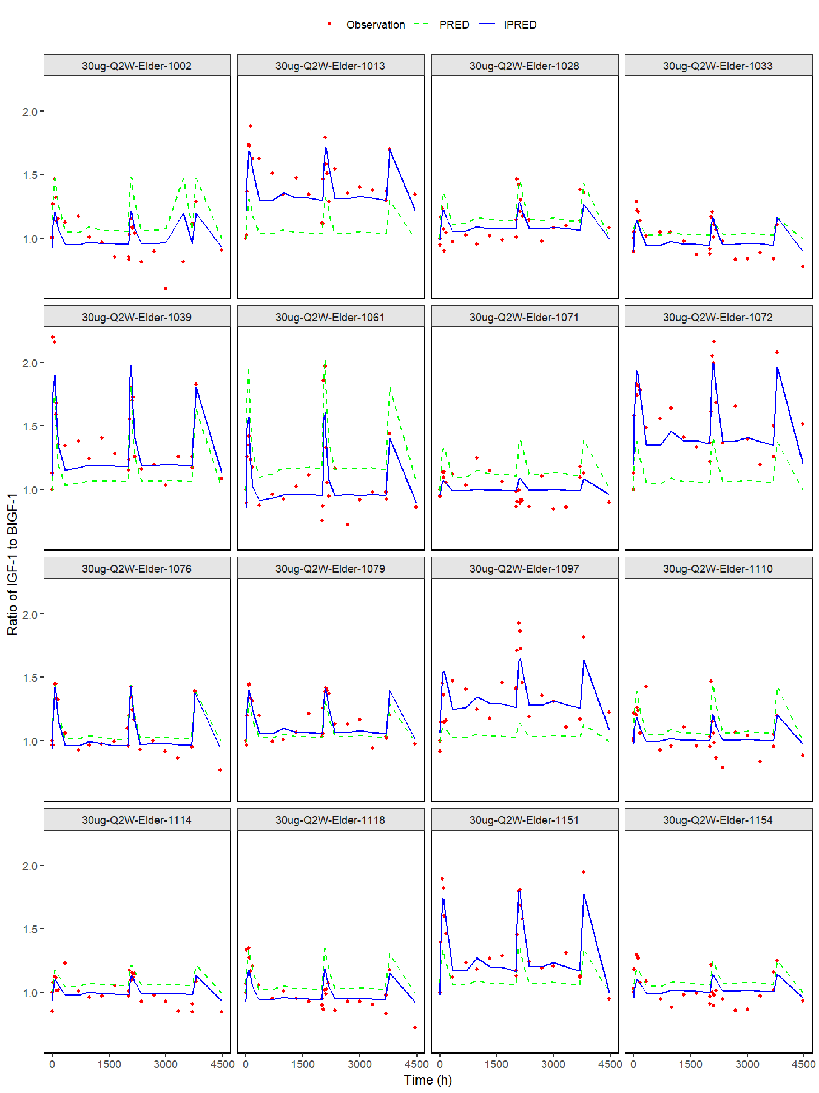

Supplemental Figure 3: Diagnostic goodness-of-fit plots for the two covariate models (Left: AGE; Right: TRIAL)
Full model:V_{max}-WEIGHT K_{a}-AGE V₁₋AGE V_{max}-AGE | Full model:V_{max}-WEIGHT K_{a}-TRIAL V₁- TRIAL V_{max}- TRIAL
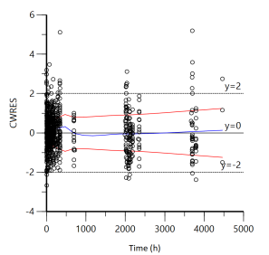 | 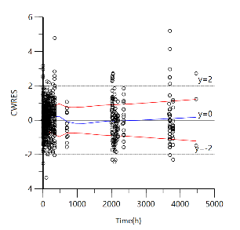
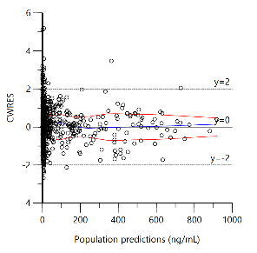 | 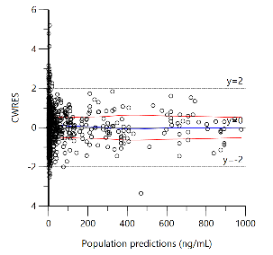
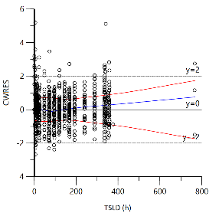 | 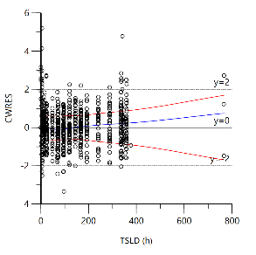
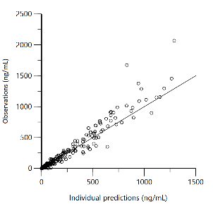 | 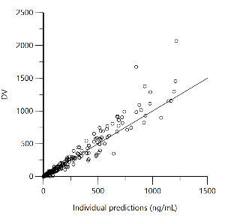
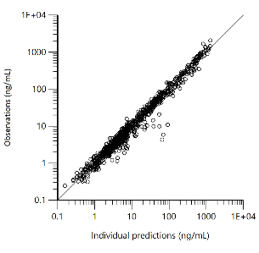 | 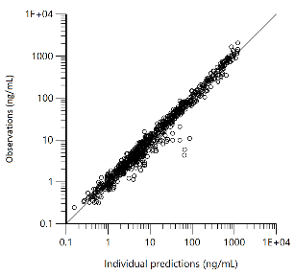
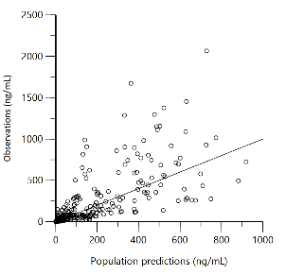 | 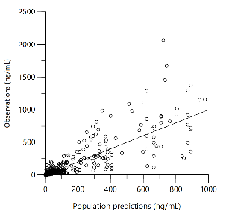
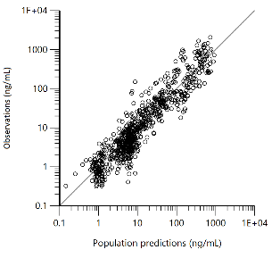 | 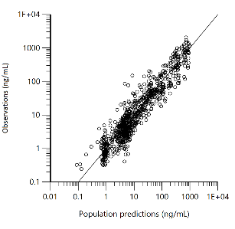

Supplemental Figure 4: Goodness-of-fit plots for the IDR model of IGF-1 relative-to-baseline ratios following YPEG-rhGH administration in healthy adult subjects. The top-left panel displays conditional weighted residuals (CWRES) versus time after the first dose. The top-middle and top-right panels show CWRES versus population predicted (PRED) and individual predicted (IPRED) values of IGF-1 relative-to-baseline ratios, respectively. The bottom-left and bottom-middle panels present observed IGF-1 relative-to-baseline ratios versus PRED and IPRED values, respectively. The bottom-right panel is a histogram of the probability density of CWRES. The red dashed lines represent the fitted trend lines.
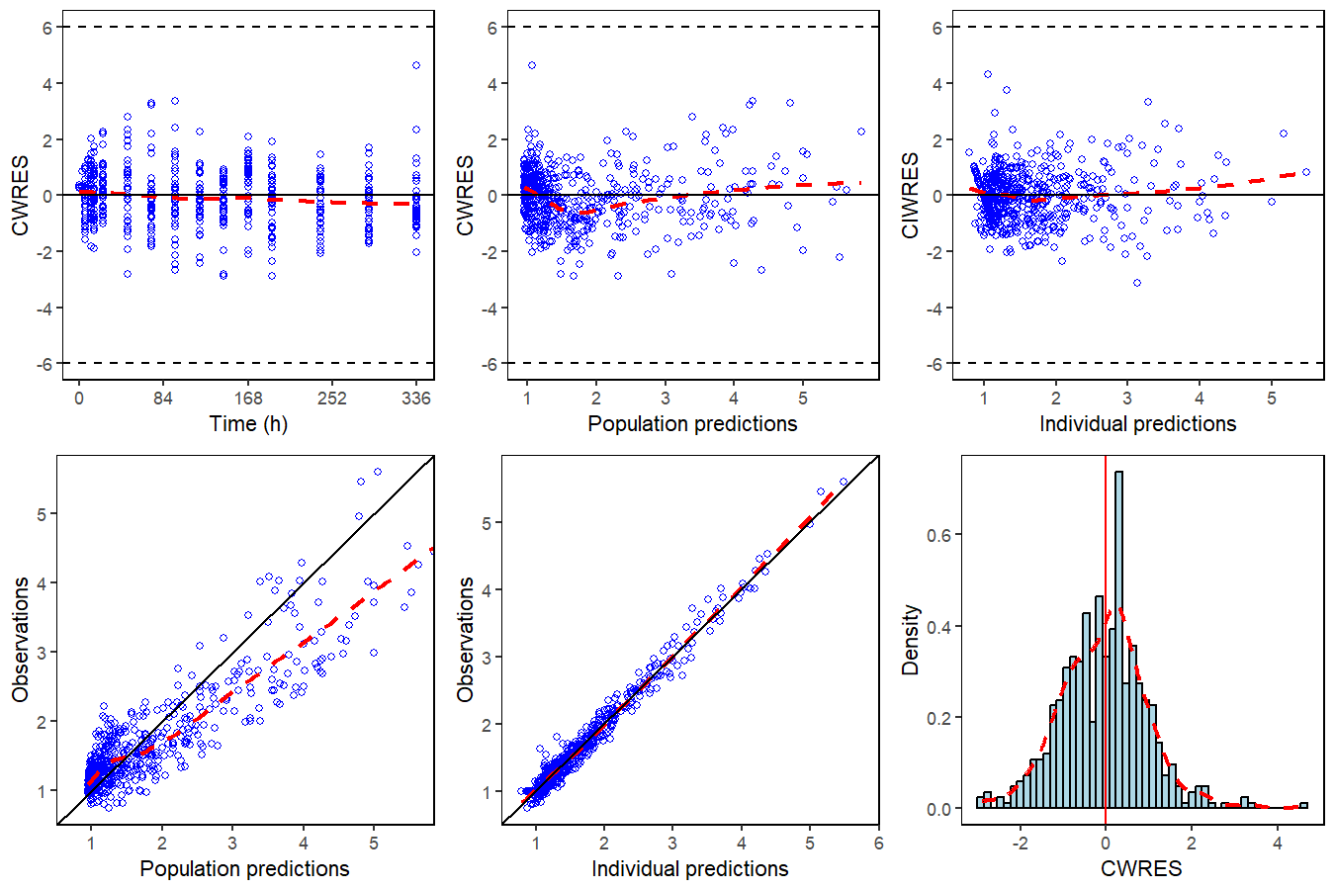
Supplemental Figure 5: Prediction-corrected visual predictive check (pvcVPC) for the IDR model of IGF-1 relative-to-baseline ratios following YPEG-rhGH administration in healthy adult subjects. Open circles represent the observed IGF-1 concentration ratios relative to baseline. The three lines from bottom to top correspond to the 10th, 50th (median), and 90th percentiles of the observed data, respectively. The shaded areas represent the 95% confidence intervals for the corresponding predicted percentiles.
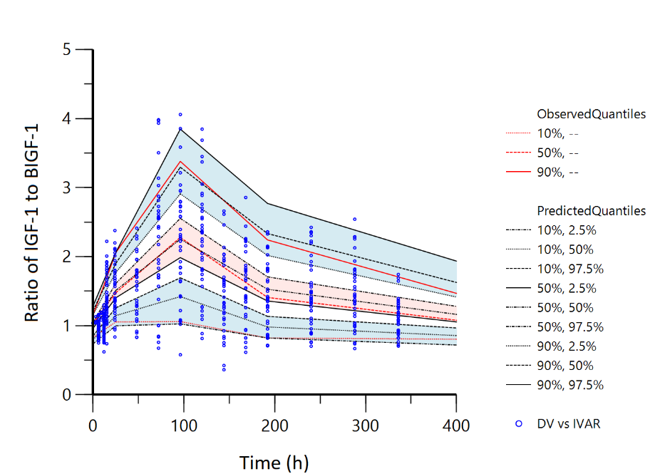
Supplemental figure 6: Diagnostic plots and individual fits of the PK/PD model using absolute IGF-1 values as the pharmacodynamic (PD) marker. The top panels show the model goodness-of-fit and predictive performance, including conditional weighted residuals (CWRES) versus time or predictions, observed versus individual predicted values, and population versus individual predictions. The bottom panels display individual fits with observed data points and model-predicted curves, demonstrating the model’s capability to describe the dynamic changes of IGF-1.
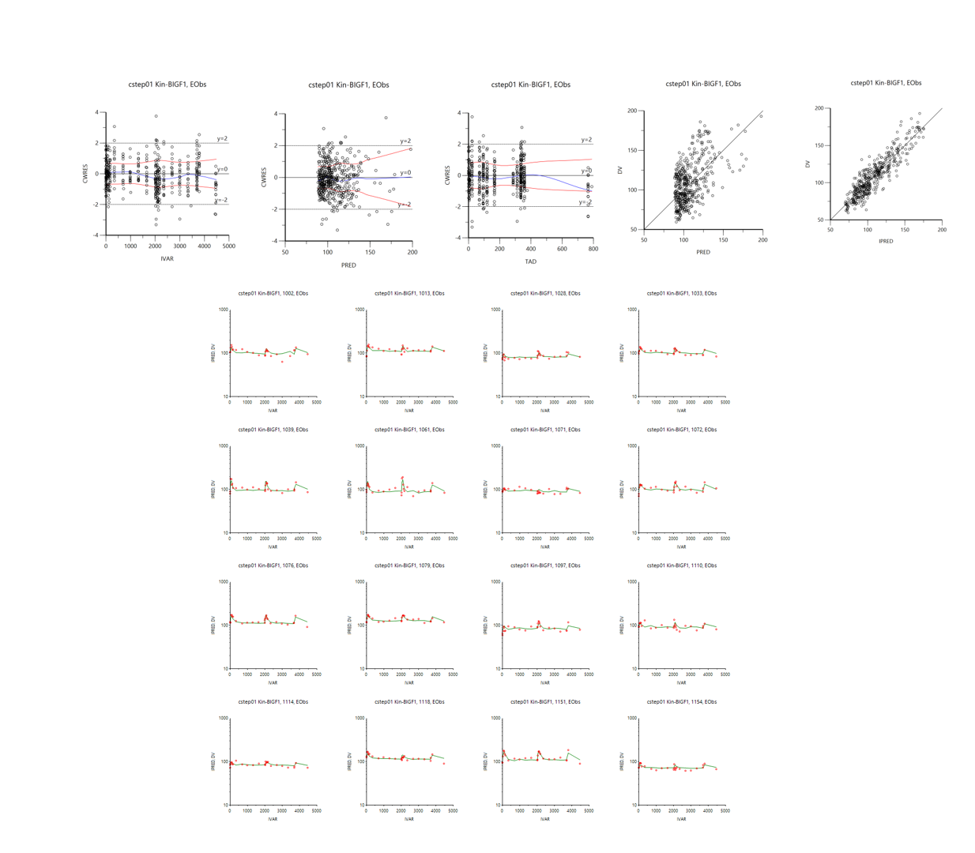

PopPK model equations
$$K_{a}(1/h)=0.01086×{\left(\frac{AGE}{35.5}\right)}^{−0.6957}$$
$$V_{1}/F(L)=2.387×{(\frac{AGE}{35.5})}^{1.470}$$
$$V_{2}/F\left(L\right)=21.42$$
$$K_{m}(μg/L)=70.08$$
$$V_{max}\left({μg}/h\right)=80.13×{\left(\frac{AGE}{35.5}\right)}^{0.7989}×{\left(\frac{WEIGHT}{70}\right)}^{2.202}$$
$${CL}_{2}/F\left(L/h\right)=0.05575$$

PopPK/PD model equations
$$\frac{dR_{\text{I}\text{GF-1}}}{dt}=0.023×(1+\frac{2.245×C}{50.74+C})−0.023×R_{\text{IGF-}1}$$

