**Metabolic alterations and cholesterol esterification in a low-grade diffuse astrocytoma patient who progressed to glioblastoma at recurrence: Case Report**

Omkar B. Ijare1,2,3,4,6, David S. Baskin1,2,3,4,6,7 Suzanne Z. Powell2,3,4,5,6, and Kumar Pichumani1,2,3,4,6

1Kenneth R. Peak Brain and Pituitary Tumor Treatment Center, Department of Neurosurgery,

Houston Methodist Hospital, Houston, TX 77030, USA,

2Houston Methodist Academic Institute, Houston, TX 77030, USA,

3Houston Methodist Research Institute, Houston, TX 77030, USA,

4Houston Methodist Neurological Institute, Houston, TX 77030, USA,

5Department of Pathology and Genomic Medicine, Houston Methodist Hospital, Houston, TX, USA,

6Weill Cornell Medical College, New York, NY 10065, USA, and

7Texas A&M University College of Medicine,Houston, TX 77030 USA.

**\*Correspondence to:**

Kumar Pichumani, Ph.D., Tel: 713 441 7190; E-Mail: [kpichumani@houstonmethodist.org](mailto:kpichumani@houstonmethodist.org)

and Omkar B. Ijare, Ph.D., Tel: 713 441 3547; E-Mail: [oijare@houstonmethodist.org](mailto:oijare@houstonmethodist.org)

***In vivo* 1H magnetic resonance spectroscopy (MRS) and CT/PET**

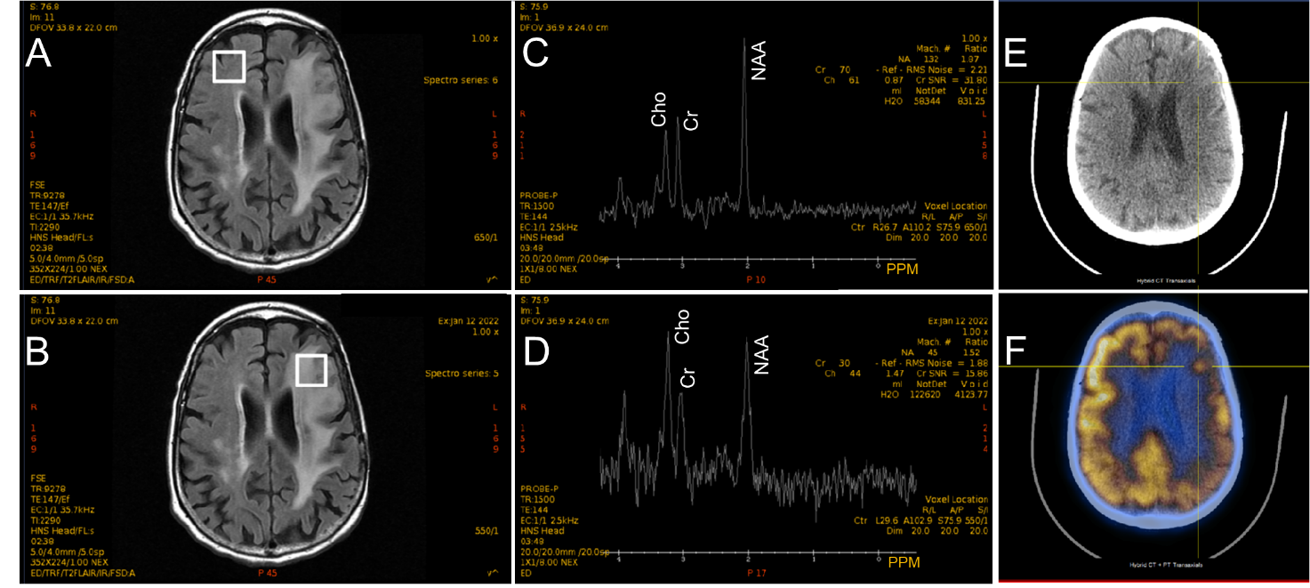

**Figure S1:** *In vivo* 1H MRS and 18F-FDG CT/PET data from the patient showing metabolic profiles of the tumor and non-tumor regions of the brain including 18F-FDG uptake by the tumor.(A) and (B) show axial slices of T2-FLAIR MR images and the location of the spectroscopic voxels (voxel size: 20x20x20 mm3) in the non-tumor and tumor regions of the patient brain. (C) and (D) show the *in vivo* 1H MR spectral profiles of non-tumor and tumor regions (TE = 144 ms; TR = 1500 ms). Figure 2D clearly shows the elevated levels of choline (Cho) and decreased levels of NAA, which are characteristics of a high-grade malignant glioma. (E) and (F) depict CT and CT/PET images showing the uptake of 18F-FDG by the recurrent tumor (crosshairs in Figure 2F).

The *in vivo* 1H magnetic resonance spectroscopy (MRS) of the recurrent tumor showed decreased levels of N-acetylaspartate (NAA) and elevated levels of choline, consistent with the high-grade glioma (Figure S1: D).The Choline-to-NAA (Cho/NAA) ratio which is considered to be a measure of tumor proliferation index was calculated from the peak intensities of the respective metabolite peaks from the non-tumor and tumor regions of the brain (Figure S1: C & D). This ratio for the tumor region was found to be 0.98, while for the non-tumor region this ratio was 0.46. Moreover, the 18F-fluorodeoxy glucose (18F-FDG) positron emission tomography (PET) performed when the patient showed tumor recurrence also showed abnormal uptake of 18F-FDG in the inferior left frontal lobe (Figure S1: F) close to the contrast enhanced tumor region in T1w MRI (Figure S1: E), suggesting the presence of malignant tissue in this region.