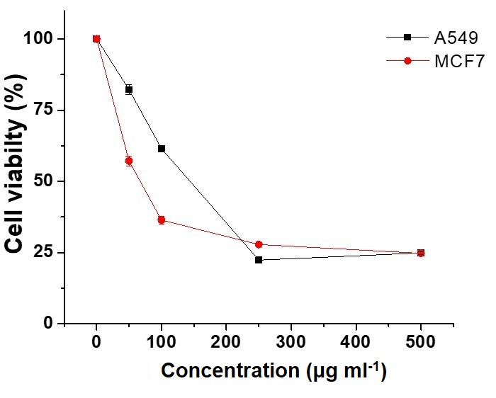
Figure S1. MTT assay for testing extract cytotoxicity at various concentrations (μg ml⁻¹) against lung (A549) and breast (MCF7) cancer cell lines after 48 hr of incubation.

