***Supplementary Material***

# Supplementary Figures

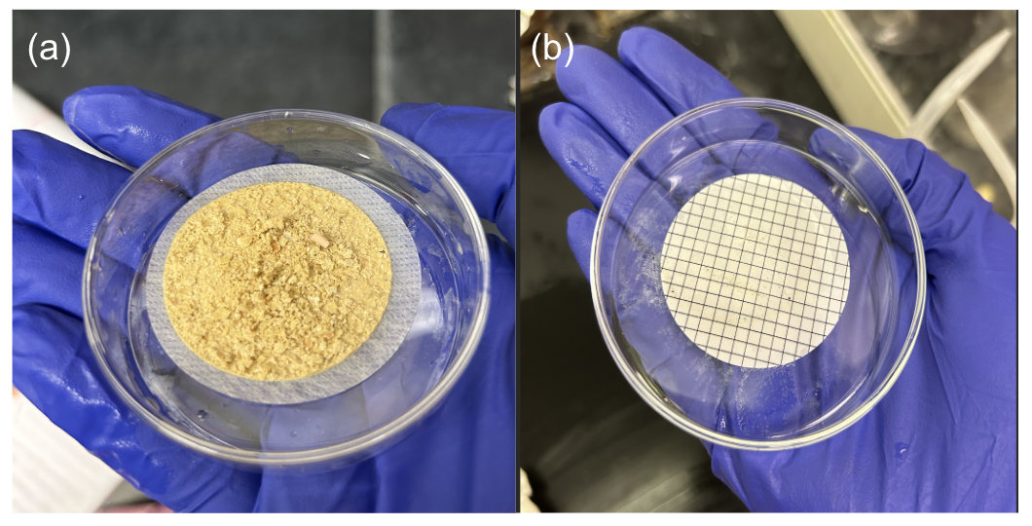

**Figure S1.** Residual calcium material after initial hydrogen peroxide digestion (a), compared to the same sample after treatment with peroxide digestion followed by overnight treatment with 0.1M EDTA/Triton X-100 (b).



**Figure S2.** Final MCE gridded filter for optical analysis of potential MP. The gridded filters are moved through in a snake-like pattern, with row numbers in the margin to allow for easy recording of potential microplastics.

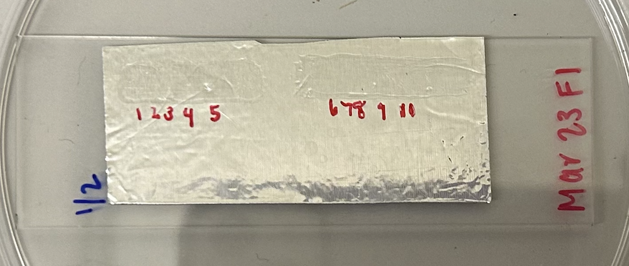

**Figure S3**. To confirm polymer type, subsampled potential MP were secured to a glass slide using SkinTac adhesive on metal tape. The slide was left to fully dry before FTIR analysis. The metal tape provided a background for IR analysis free of the adhesive.

# Supplementary Tables

**Table S1.** Food waste to manure ratio (%) across the sampling year. Months in bold indicate those for which samples were collected from the Digester, Lagoon, and Manure pit. Data courtesy of the co-digestion facility.

|  |  |
| --- | --- |
| Month | FW:Manure (%) |
| **JAN** | **67** |
| FEB | 22 |
| **MAR** | **5** |
| APR | 40 |
| **MAY** | **65** |
| JUN | 64 |
| **JUL** | **63** |
| AUG | 61 |
| **SEP** | **60** |
| OCT | 64 |
| **NOV** | **61** |

**Table S2.** Count of MP found in field and laboratory blanks (n = 1 per sampling time point). “nd” indicates not detected. Blanks were prepared by performing all sampling steps over an open 250 mL mason jar at the time of sampling and then treating the resulting jar as a typical sample. No blank correction was performed on the samples because of the very low number of confirmed microplastic in the blanks.

|  |  |  |  |
| --- | --- | --- | --- |
| **Month** | **Polymer** | **Morphology** | **Count** |
| Jan | HDPE | Fragments | 1 |
| Mar | PET | Fragments | 1 |
| PET | Fibers | 1 |
| May | nd | nd | 0 |
| Jul | nd | nd | 0 |
| Sep | PET | Fibers | 2 |
| Nov | PET | Fibers | 1 |

**Table S3.** Connecting letters report for Tukey’s HSD post-hoc results of Month*Location interaction term (F(10,36)) used to identify significant differences between sample month and location.

|  |  |  |  |
| --- | --- | --- | --- |
| **Month** | **Location** | **Connecting Letters** | **Least Squares Mean** |
| MAR | Lagoon | A | 2763.6 |
| JAN | Manure | AB | 2280.8 |
| JAN | Lagoon | AB | 2262.1 |
| JUL | Lagoon | ABC | 2045.0 |
| JAN | Digester | ABCD | 2003.1 |
| JUL | Digester | ABCD | 1968.3 |
| SEP | Digester | BCDE | 1864.4 |
| MAY | Digester | BCDE | 1829.5 |
| NOV | Digester | BCDEFG | 1688.1 |
| MAY | Lagoon | BCDEFG | 1583.1 |
| MAR | Digester | CDEFGH | 1347.1 |
| MAR | Manure | DEFGH | 1147.3 |
| JUL | Manure | EFGH | 1064.0 |
| NOV | Manure | FGH | 941.5 |
| SEP | Manure | GH | 837.1 |
| MAY | Manure | H | 546.6 |