Supplementary Material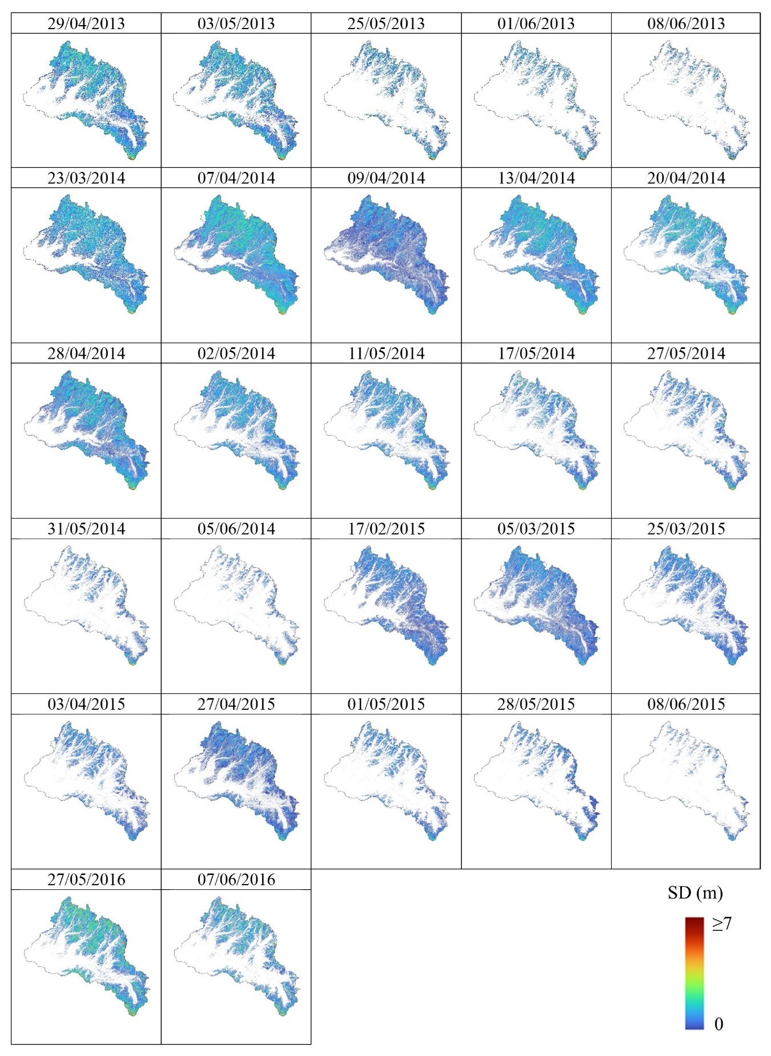

**Supplementary Figure 1.** Snow depth (SD) maps, and corresponding acquisition dates, provided by ASO at a spatial resolution of 3 m used to derive the snow cover maps employed in the computation of the morphological descriptors (MF1, MF2 and MF3). These SD maps were also resampled to a 500 m resolution and subsequently used for training and validation of the SD estimation models.