**Green synthesis of carbon nanospheres from *Vachellia nilotica* for pendimethalin removal**

Krupal Vidhyarthi1**†**, Gautam Priyadarshi2**†**, Bhakti Patel2, Santosh Kumar Sahu, Esha Rami1*, Dipak Kumar Sahoo3*, and Ashish Patel2*

1 Department of Life Sciences, Parul Institute of Applied Science, Parul University, Vadodara-391760, Gujarat, India; krupal5456@gmail.com (K.V.)

2 Department of Life Sciences, Hemchandracharya North Gujarat University, Patan-384265, Gujarat, India; priyadarshigautam411@gmail.com (G.P.); bhaktipatel2233@gmail.com (B.P.); santoshsahu.hngu@gmail.com (S.K.S)

3 Department of Veterinary Clinical Sciences, College of Veterinary Medicine, Iowa State University, Ames, Iowa, USA

**† These authors contributed equally and share the first authorship**

**\*Corresponding authors:** [esha.rami82036@paruluniversity.ac.in](mailto:esha.rami82036@paruluniversity.ac.in) (E.R.);

dsahoo@iastate.edu (D.K.S.); uni.ashish@gmail.com (A.P.)

**Supplementary Material**

**Table S1. Physico-chemical properties of PND.**

|  |  |
| --- | --- |
| Property | Value |
| Molecular formula | C₁₃H₁₉N₃O₄ |
| IUPAC Name | N-(1-ethylpropyl)-2,6-dinitro-3,4-xylidine |
| Molecular weight | 281.31 g/mol |
| CAS number | 40487-42-1 |
| Sructure |  |
| Appearance | Yellow-orange crystals/powder |
| Melting point | Yellow-orange crystals/powder |
| Boiling point | 54 to 60 °C |
| Solubility in water (25 at °C) | 0.3 to 0.54 mg/L(insoluble) |
| Solubility in organic solvents | Very soluble (acetone, methanol, xylene, etc.) |
| pKa (25 at °C) | 2.8 |
| log Kow | 5.2 |
| Half-life in soil | ~90 days |
| Vapor Pressure | 3.3 × 10⁻⁵ mmHg at 25 °C (low volatility) |

**Table S2. Liner and non-liner expression of adsorption kinetics and isotherm models.**

|  |  |  |  |
| --- | --- | --- | --- |
| Model | Linear form | Non-linear form | Parameters / Notes |
| Pseudo-first order (PFO) | $$log\left(q_{e}- q_{t}\right)=log\left(q_{e}\right)- \left(\frac{K_{1}}{2.303}\right)t$$ | $$q_{t}=q_{e}\left(1-e^{{-k}_{1}.t}\right)$$ | adsorption capacity *qe* (mg g-1) and *qt* (mg g-1) and *K1* is rate constant. |
| Pseudo-second order (PSO) |  |  | k2 is pseudo second-order rate constant (g/mg·min) |
| Intraparticle diffusion (IPD) | $$q_{e}={C+K}_{id}t^{1/2}$$ | same as linear form | kid is intraparticle diffusion rate constant (mg/g·min^0.5) and C is the intercept related to boundary level thickness. |
| Langmuir isotherm | $$\frac{c_{e}}{q_{e}}=\frac{1}{q_{m}K_{L}}+\frac{c_{e}}{q_{m}}$$ | $$q_{e}=\frac{q_{m}. K_{L}.C_{e}}{1+K_{L}.C_{e}}$$ | qm = maximum amount of adsorbent,  Ce = model constant,  KL= adsorption equilibrium constant. |
| Freundlich isotherm | $${log q}_{e}=logK_{f}+\left(\frac{1}{n}\right){log C}_{e}$$ | $$q_{e}=K_{F}.{C_{e}}^{1/n}$$ | Kf = adsorption capacity  n= adsorption intensity |
| Temkin isotherm | $$q_{e}=\frac{RT}{B_{T}}\ln{K_{T}+}\frac{RT}{B_{T}}lnc_{e}$$ | $$q_{e}=B_{T}×ln(K_{T}c_{e})$$ | B = Temkin constant,  RT/BT= heat of adsorption,  R= gas constant  T= temperature (K) |

**Table S3 Cost analysis for preparation of CNSs.**

|  |  |  |  |  |
| --- | --- | --- | --- | --- |
| Description of item required for | | Unit cost  (INR) | No. of Units | Price  (INR) |
| 1 | Biomass | 0 | 0 | 0 |
| 2 | Electricity |  |  | 39.6978 |
|  | 1. Microwave irradiation   (800 W for 3 min) | 5.2 per KWh | 0.04 KWh | 0.21 |
|  | 1. Muffle furnace   (3000 W for 2.5 hours) | 5.2 per KWh | 7.5 kWh | 39 |
|  | 1. Ultrasonication   (170 W for 30 minute) | 5.2 per KWh | 0.085 kWh | 0.442 |
|  | 1. Vortex   (55 W for 10 min) | 5.2 per KWh | 0.0092 kWh | 0.048 |
| 3 | Chemicals |  |  |  |
|  | 1. ferrocene | 550 per 25 gm | 0.150 g  (150 mg) | 3.30 |
|  | 1. ethanol | 140 per 500 mL | 100 mL (assumed) | 28 |
| 4 | Distilled Water | 20 Rs per L | 1 L | 20 |
| Total (per batch) | | | | 90.998 |

Approximate 91 (INR) was required to synthesize 200 mg of CNSs. Therefore, the cost of CNSs per gram will be 455 INR (~$5.45/g).

**Figure S1. pHZPC of CNSs using pH drift method.**

**Figure S2. Comparative PND removal efficiency at 50 mg L-1 concentration, 7 pH, 100 ml volume and 100 mg CNS and VNBC dose.**

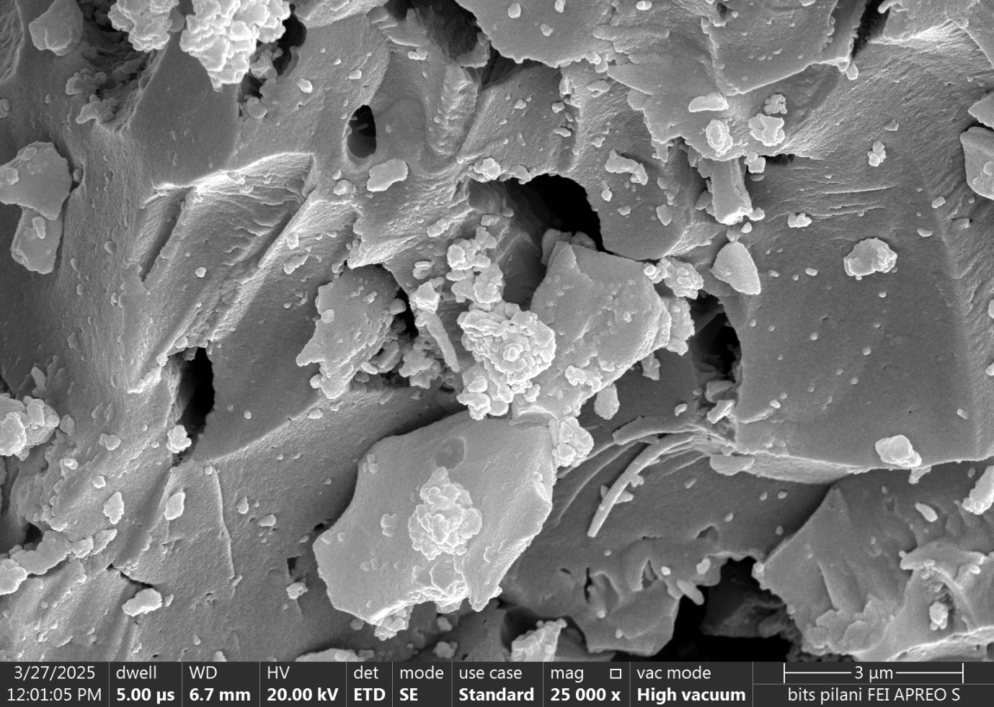

**Figure S3. FEG-SEM image of VNBC at 25000x magnification.**