**Supplementary Methods, Tables and Figures**

**List of contents**

**eTables**

**eTable 1** ICD codes forpsychiatric disorders 2

**eTable 2** Diagnosis of depression or a record of antidepressant prescription during postpartum period and risk of ASD in offspring 3

**eTable 3** Postpartum depression and risk of ASD in offspring of parents without prior depression or fewer than two antidepressant records before delivery 4

**eTable 4** Postpartum depression and risk of ASD in offspring of either parent with a depression history or at least two antidepressant records before delivery 5

**eTable 5** Postpartum depression and risk of ASD in offspring of either parent having an antidepressant prescription within one year before delivery 6

**eTable 6** Postpartum depression and risk of ASD in offspring followed up from age two onwards 7

**eTable 7** Postpartum depression and risk of ASD in offspring born to parents without ASD before delivery 8

**eFigures**

**eFigure 1** Scaled Schoenfeld residual plot to assess proportional hazards assumption 9

### **eTable 1** ICD codes for psychiatric disorders

|  |  |  |  |
| --- | --- | --- | --- |
| **Disorder** | **ICD-10** | **ICD-9** | **ICD-8** |
| Overall mental illness | F10-F99 | 291, 295, 296, 297, 298, 299, 300, 301, 302, 303, 304, 305, 306, 307, 308, 309, 311, 312, 313, 314, 315, 316, 317, 318, 319 | 291, 295, 296, 297, 298, 299, 300, 301, 302, 303, 304, 305, 306, 307, 308, 310, 311, 312, 313, 314, 315 |
| Depression | F32, F33, F341, F348, F349, F530 | 296B, 300E, 311, 301B | 296.0, 298.0, 300.4, 301.1 |
| ASD | F840, F841, F843, F845, F848, F849 | 299A |  |

**Table 2** Diagnosis of depression or a record of antidepressant prescription during postpartum period and risk of ASD in offspring

|  |  |  |  |  |  |  |  |  |
| --- | --- | --- | --- | --- | --- | --- | --- | --- |
| Postpartum depression | Total subjects | Person-years | ASD  (rate) | Model 1 | Model 2 | Model 3 | Model 4 | Model 5 |
|  | |  |  |  |  |  |  |  |
| Neither parent | 1,638,220 | 20,601,319 | 46,191 (224.2) | Reference | Reference | Reference | Reference | Reference |
| Fathers only | 47,858 | 381,898 | 1,467 (384.1) | 1.78 (1.69-1.87) | 1.52 (1.44-1.60) | 1.42 (1.35-1.50) | 1.25 (1.18-1.33) | 1.21 (1.14-1.28) |
| Mothers only | 84,306 | 614,310 | 2,954 (480.9) | 2.34 (2.25-2.43) | 2.03 (1.95-2.11) | 1.79 (1.72-1.87) | 1.50 (1.43-1.56) | 1.52 (1.46-1.58) |
| Both parents | 10,965 | 72,780 | 489 (671.9) | 3.44 (3.14-3.76) | 2.56 (2.34-2.81) | 2.08 (1.90-2.29) | 1.55 (1.41-1.71) | 1.58 (1.44-1.73) |

Abbreviations. ASD: Autism Spectrum Disorders.

Postpartum depression: any depression diagnosed within six weeks after delivery.

Hazard Ratios with 95% confidence intervals from Cox regression models, using age at follow-up as the underlying time scale, with robust standard errors. Incidence rate of ASD per 100,000 person years. Followed up all children from age one.

Model 1: Adjusted for birth year by cubic natural splines with 5 knots;

Model 2: Adjusted for birth year, preterm birth, maternal and paternal education, income and age at delivery.

Model 3: Adjusted for birth year, preterm birth, maternal and paternal education, income, age, and any diagnosis of depression before delivery.

Model 4: Adjusted for birth year, preterm birth, maternal and paternal education, income, age, and any diagnosis of depression or at least 2 records of antidepressant use before delivery.

Model 5: Adjusted for birth year, preterm birth, maternal and paternal education, income, age, and any mental illness or at least 2 records of antidepressant use before delivery. **Table 3** Postpartum depression and risk of ASD in offspring of parents without prior depression or fewer than two antidepressant records before delivery

|  |  |  |  |  |  |
| --- | --- | --- | --- | --- | --- |
| Postpartum depression | Total subjects | Person-years | ASD (rate) | Model 1 | Model 2 |
|  | |  |  |  |  |
| Neither parent | 1,493,406 | 19,666,196 | 42,876 (218.0) | Reference | Reference |
| Fathers only | 1,501 | 18,649 | 102 (546.9) | 2.38 (1.96-2.90) | 1.78 (1.47-2.16) |
| Mothers only | 4,571 | 54,932 | 265 (482.4) | 2.14 (1.89-2.41) | 1.86 (1.64-2.09) |
| Both parents | 33 | 387 | 4 (1033.9) | 4.65 (1.76-12.29) | 3.12 (1.18-8.20) |

Abbreviations. ASD: Autism Spectrum Disorders.

Postpartum depression: any depression diagnosed in the first year after delivery.

Hazard Ratios with 95% confidence intervals from Cox regression models, using age at follow-up as the underlying time scale, with robust standard errors. Incidence rate of ASD per 100,000 person years. Followed up all children from age one.

Model 1: Adjusted for birth year by cubic natural splines with 5 knots;

Model 2: Adjusted for birth year, preterm birth, maternal and paternal education, income and age at delivery.

**Table 4** Postpartum depression and risk of ASD in offspring of either parent with a depression history or at least two antidepressant records before delivery

|  |  |  |  |  |  |  |  |  |
| --- | --- | --- | --- | --- | --- | --- | --- | --- |
| Postpartum depression | Total subjects | Person-years | ASD  (rate) | Model 1 | Model 2 | Model 3 | Model 4 | Model 5 |
|  | |  |  |  |  |  |  |  |
| Neither parent | 259,770 | 1,773,092 | 6,871 (387.5) | Reference | Reference | Reference | Reference | Reference |
| Fathers only | 4,791 | 37,543 | 229 (610.0) | 1.46 (1.28-1.67) | 1.31 (1.14-1.49) | 1.31 (1.14-1.50) | 1.33 (1.16-1.52) | 1.34 (1.18-1.54) |
| Mothers only | 16,890 | 116,752 | 721 (617.5) | 1.58 (1.46-1.71) | 1.56 (1.44-1.68) | 1.45 (1.34-1.57) | 1.44 (1.34-1.56) | 1.46 (1.35-1.57) |
| Both parents | 387 | 2,756 | 33 (1197.4) | 3.10 (2.21-4.37) | 2.54 (1.80-3.57) | 2.30 (1.63-3.24) | 2.05 (1.45-2.89) | 2.15 (1.52-3.02) |

Abbreviations. ASD: Autism Spectrum Disorders.

Hazard Ratios with 95% confidence intervals from Cox regression models, using age at follow-up as the underlying time scale, with robust standard errors. Incidence rate of ASD per 100,000 person years. Followed up all children from age one.

Model 1: Adjusted for birth year by cubic natural splines with 5 knots;

Model 2: Adjusted for birth year, preterm birth, maternal and paternal education, income and age at delivery.

Model 3: Adjusted for birth year, preterm birth, maternal and paternal education, income, age, and any diagnosis of depression before delivery.

Model 4: Adjusted for birth year, preterm birth, maternal and paternal education, income, age, and any diagnosis of depression or at least 2 records of antidepressant use before delivery.

Model 5: Adjusted for birth year, preterm birth, maternal and paternal education, income, age, and any mental illness or at least 2 records of antidepressant use before delivery.

**Table 5** Postpartum depression and risk of ASD in offspring of either parent having an antidepressant prescription within one year before delivery

|  |  |  |  |  |  |  |  |  |
| --- | --- | --- | --- | --- | --- | --- | --- | --- |
| Postpartum depression | Total subjects | Person-years | ASD  (rate) | Model 1 | Model 2 | Model 3 | Model 4 | Model 5 |
|  | |  |  |  |  |  |  |  |
| Neither parent | 102,745 | 713,132 | 2,998 (420.4) | Reference | Reference | Reference | Reference | Reference |
| Fathers only | 3,420 | 25,289 | 153 (605.0) | 1.43 (1.22-1.68) | 1.29 (1.10-1.52) | 1.29 (1.08-1.53) | 1.32 (1.12-1.56) | 1.32 (1.12-1.56) |
| Mothers only | 12,487 | 81,125 | 492 (606.5) | 1.53 (1.39-1.69) | 1.52 (1.38-1.67) | 1.33 (1.21-1.48) | 1.36 (1.23-1.50) | 1.37 (1.25-1.51) |
| Both parents | 324 | 2,189 | 25 (1142.3) | 2.91 (1.96-4.31) | 2.42 (1.63-3.59) | 2.07 (1.39-3.09) | 1.88 (1.26-2.79) | 1.96 (1.32-2.91) |

Abbreviations. ASD: Autism Spectrum Disorders.

Hazard Ratios with 95% confidence intervals from Cox regression models, using age at follow-up as the underlying time scale, with robust standard errors. Incidence rate of ASD per 100,000 person years. Followed up all children from age one.

Model 1: Adjusted for birth year by cubic natural splines with 5 knots;

Model 2: Adjusted for birth year, preterm birth, maternal and paternal education, income and age at delivery.

Model 3: Adjusted for birth year, preterm birth, maternal and paternal education, income, age, and any diagnosis of depression before delivery.

Model 4: Adjusted for birth year, preterm birth, maternal and paternal education, income, age, and any diagnosis of depression or at least 2 records of antidepressant use before delivery.

Model 5: Adjusted for birth year, preterm birth, maternal and paternal education, income, age, and any mental illness or at least 2 records of antidepressant use before delivery.

**eTable 6** Postpartum depression and risk of ASD in offspring followed up from age two onwards

|  |  |  |  |  |  |  |
| --- | --- | --- | --- | --- | --- | --- |
| Postpartum depression | Total subjects | Person-years | ASD  (rate) | Model 1 | Model 2 | Model 3 |
|  | |  |  |  |  |  |
| Neither parent | 1,683,402 | 19,718,394 | 49,630 (251.7) | Reference | Reference | Reference |
| Fathers only | 5,989 | 50,053 | 330 (659.3) | 2.56 (2.29-2.85) | 1.87 (1.68-2.09) | 1.53 (1.36-1.71) |
| Mothers only | 19,915 | 150,952 | 983 (651.2) | 2.59 (2.43-2.76) | 2.22 (2.08-2.36) | 1.71 (1.60-1.83) |
| Both parents | 398 | 2,732 | 37 (1354.1) | 5.57 (4.04-7.69) | 3.58 (2.60-4.94) | 2.20 (1.59-3.05) |

Abbreviations. ASD: Autism Spectrum Disorders.

Postpartum depression: any depression diagnosed in the first year after delivery.

Hazard Ratios with 95% confidence intervals from Cox regression models, using age at follow-up as the underlying time scale, with robust standard errors. Incidence rate of ASD per 100,000 person years. Followed up all children from age two.

Model 1: Adjusted for birth year by cubic natural splines with 5 knots;

Model 2: Adjusted for birth year, preterm birth, maternal and paternal education, income and age at delivery.

Model 3: Adjusted for birth year, preterm birth, maternal and paternal education, income, age, and any diagnosis of depression before delivery.

**Table 7** Postpartum depression and risk of ASD in offspring born to parents without ASD before delivery

|  |  |  |  |  |  |  |
| --- | --- | --- | --- | --- | --- | --- |
| Postpartum depression | Total subjects | Person-years | ASD  (rate) | Model 1 | Model 2 | Model 3 |
|  | |  |  |  |  |  |
| Neither parent | 1,751,676 | 21,431,773 | 49,671 (231.8) | Reference | Reference | Reference |
| Fathers only | 6,252 | 56,005 | 330 (589.2) | 2.56 (2.30-2.85) | 1.88 (1.69-2.09) | 1.53 (1.37-1.72) |
| Mothers only | 21,360 | 171,297 | 982 (573.3) | 2.59 (2.43-2.76) | 2.22 (2.08-2.36) | 1.71 (1.60-1.83) |
| Both parents | 413 | 3,113 | 36 (1156.3) | 5.44 (3.92-7.54) | 3.50 (2.52-4.85) | 2.15 (1.55-2.99) |

Abbreviations. ASD: Autism Spectrum Disorders.

Postpartum depression: any depression diagnosed in the first year after delivery.

Hazard Ratios and 95% confidence intervals, as estimates of relative risk of ASD in offspring of parents with postpartum depression compared to offspring of parents without postpartum depression, were calculated from Cox regression models, using age at follow-up as the underlying time scale, with robust standard errors. Incidence rate of ASD per 100,000 person years. Followed up all children from age one.

Model 1: Adjusted for birth year by cubic natural splines with 5 knots;

Model 2: Adjusted for birth year, preterm birth, maternal and paternal education, income and age at delivery.

Model 3: Adjusted for birth year, preterm birth, maternal and paternal education, income, age, and any diagnosis of depression before delivery.

### **eFigures**

### **eFigure 1** Scaled Schoenfeld residual plot to assess proportional hazards assumption

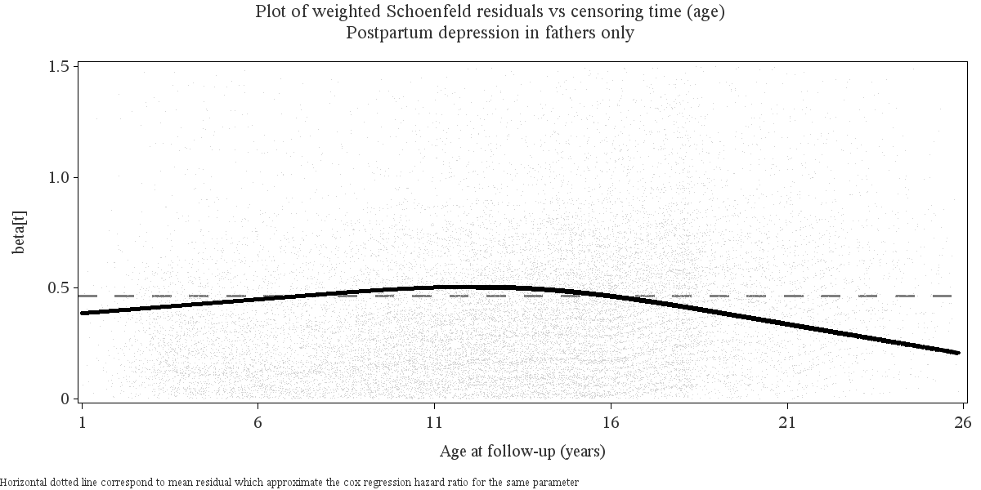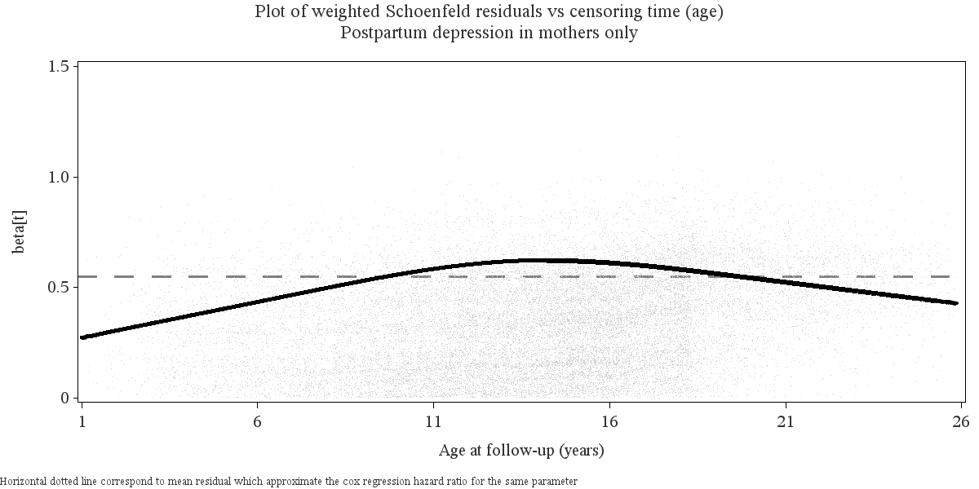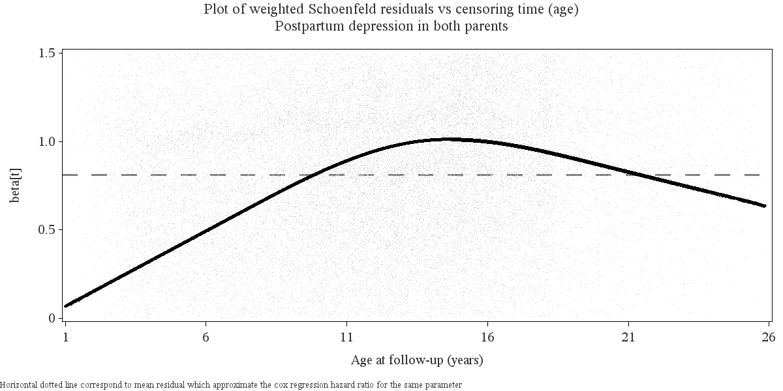

Note: The proportional hazards assumption of the Cox regression was visually examined by Schoenfeld residuals, where a lack of systematic patterns or trends over time indicates adherence to the assumption. The figure displays age-specific *log hazard ratios* (beta=0 reprents hazard ratio=1) for the risk of ASD, adjusted for birth year, preterm birth, maternal and paternal education, income, age, and any diagnosis of depression before delivery. The age-specific hazard ratios are estimated by the weighted Schoenfeld residuals on the y-axis and x-axis, respectively. The graph displays a smoother that represents the average expected risk at each age.