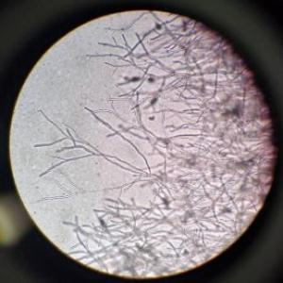
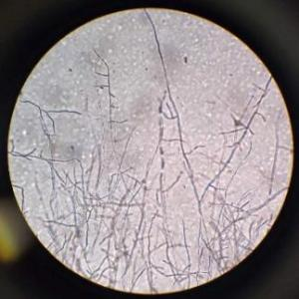
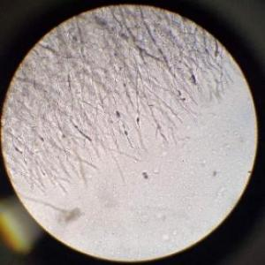
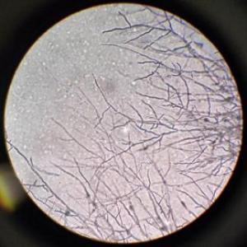
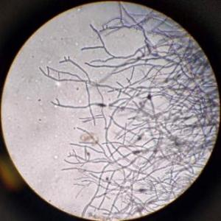
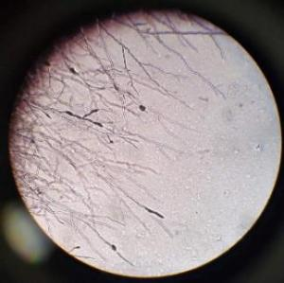
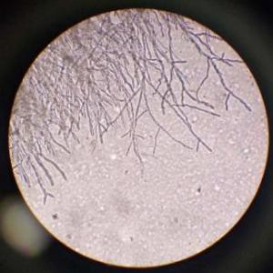
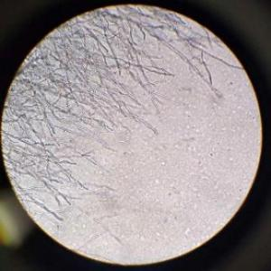
FH
FD1
FD2
FD6
FD7
FD3
FD4
FD5

Figure S1 Observation of mycelial morphology difference between the drug-resistant strains and their parents under ordinary light microscope
Note: FH is the parent. FD1 to FD7 were resistant strains. Observations were made at 10 magnification.
0h light exposure
12h light exposure
24h light exposure
Figure S2 Effects of different pH, temperature and illumination on mycelial growth of resistance strains
Note: Different lowercase letters in the figures indicate signiﬁcant differences among different strains at 0.05 level.
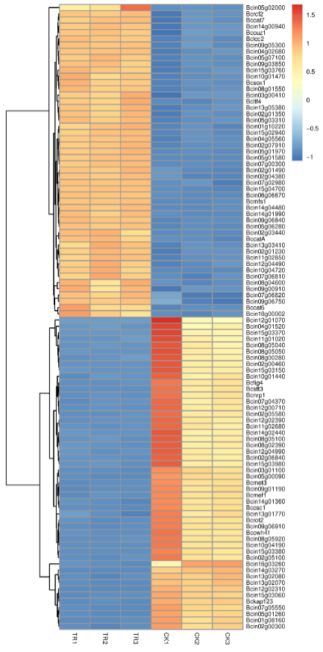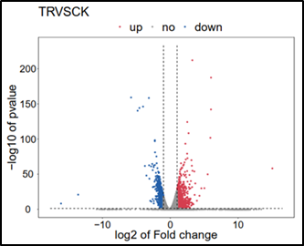
C
B
Figure S3 Histogram, volcano diagram and heat map of the statistical number of differentially expressed genes.
Note: A is the histogram of differentially expressed genes, red represents significantly differentially expressed up-regulated genes, blue represents significantly differentially expressed down-regulated genes, and gray represents the total number of differentially expressed genes. B is the volcanic map of differential genes, with log2(fold change) as abscissa and -log10(P value) as ordinate. The gray dots represent non-significant genes. C is heat map of differential genes. Red represents up-regulated genes, blue represents down-regulated genes.
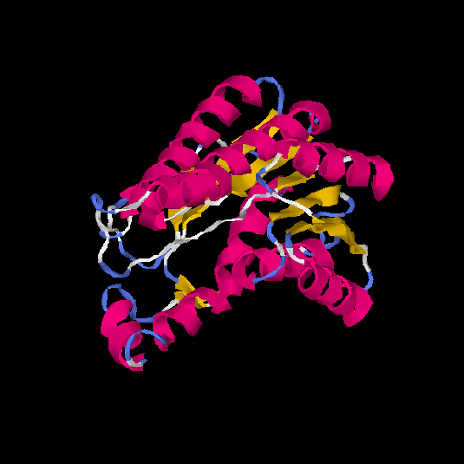
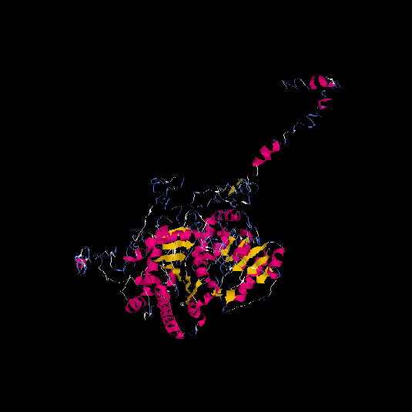
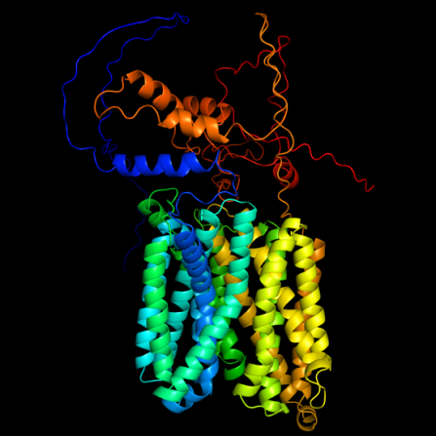
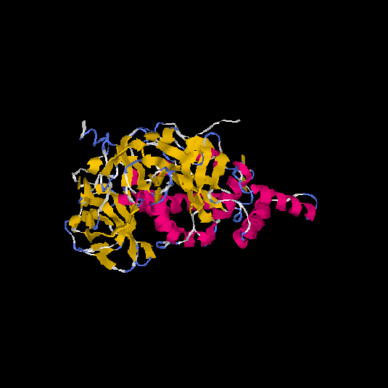
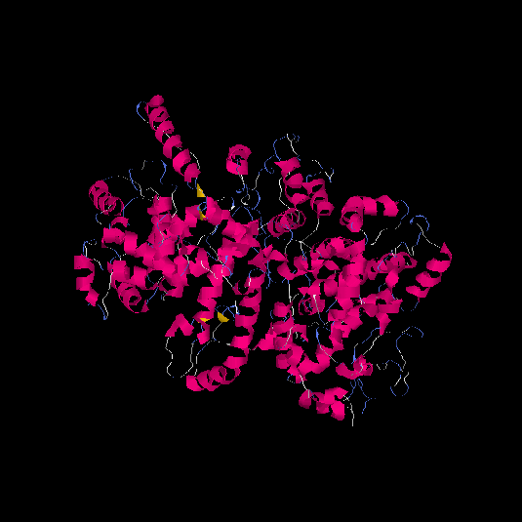
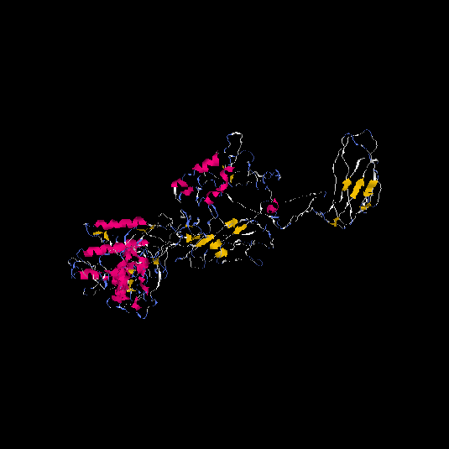
Figure S4 Construction of 3D models of target gene proteins.
Bcin15g03240
Bcin15g03290
Bcin08g00070
Bcin09g05760
Bcin07g04990
Bcin09g00290
Table S1 Pathogenicity assessment of parental and TDDE-resistant mutant strains on different host tissues.
Plant | Stains | Parent | FD1 | FD2 | FD4 | FD7
Strawberry leaves | Lesion Area (mm²) | 585.83±54.93 | 126.88±76.41*** | 323.36±46.93** | 224.75±71.61*** | 38.44±16.9***
Strawberry leaves | Relative Lesion Area (%) | 8.26±0.77 | 1.46±0.88*** | 4.16±0.6** | 2.55±0.81*** | 0.29±0.13***
Tomato leaves | Lesion Area (mm²) | 395.86±35.25 | 70.07±8.05*** | 144.17±25.33*** | 101.79±10.76*** | 27.67±1.41***
Tomato leaves | Relative Lesion Area (%) | 30.11±2.68 | 5.97±0.69*** | 13.73±2.41*** | 7.53±0.8*** | 2.22±0.11***
Tomato seedling | Lesion Area (mm²) | 702.87±35.68 | 33.51±0.5*** | 117.2±15.12*** | 265.11±24.07*** | 27±0.92***
Tomato seedling | Relative Lesion Area (%) | 30.6±1.55 | 1.8±0.03*** | 5.07±0.65*** | 14.44±1.31*** | 1.93±0.07***
Note: Data are presented as mean ± SD. Asterisks indicate significant differences compared to the parental strain as determined by Tukey's test (*p ≤ 0.05, **p ≤ 0.01, ***p ≤ 0.001). Relative Lesion Area (%) was calculated as (Lesion Area / Total Leaf Area) × 100%.

Table S2 SNP statistical results of drug-resistant strains
Sample | SNP number | Transition | Transvers | Ti/Tv | Heterozygosity | Homozygosity | Het-ratio
FD1 | 448 | 347 | 101 | 3.43 | 416 | 32 | 92.85%
FD2 | 408 | 321 | 87 | 3.68 | 377 | 31 | 92.4%
FD4 | 411 | 326 | 85 | 3.83 | 388 | 23 | 94.4%
FD7 | 456 | 376 | 121 | 3.97 | 420 | 35 | 96.5%

Table S3 Genes of SNP mutations were annotated in two or more mutants
Mutant number | Gene_ID | NR_annotation | Swiss_Prot_NAME
4 | Bcin02g00003 | hypothetical protein BCIN_02g00003  [Botrytis cinerea B05.10] | -
4 | Bcin02g00004 | hypothetical protein BCIN_02g00004  [Botrytis cinerea B05.10] | -
4 | Bcin02g00005 | hypothetical protein BCIN_02g00005  [Botrytis cinerea B05.10] | -
4 | Bcin02g00008 | hypothetical protein BCIN_02g00008  [Botrytis cinerea B05.10] | -
4 | Bcin02g00009 | hypothetical protein BCIN_02g00009  [Botrytis cinerea B05.10] | -
4 | Bcin11g05880 | hypothetical protein BCIN_11g05880  [Botrytis cinerea B05.10] | -
4 | Bcin11g06560 | hypothetical protein BCIN_11g06560  [Botrytis cinerea B05.10] | -
4 | Bcin14g00610 | Bcpg2 [Botrytis cinerea B05.10] | PG1
4 | Bcin14g00620 | hypothetical protein BCIN_14g00620  [Botrytis cinerea B05.10] | -
4 | Bcin15g00010 | hypothetical protein BCIN_15g00010  [Botrytis cinerea B05.10] | -
4 | Bcin15g03240 | hypothetical protein BCIN_15g03240  [Botrytis cinerea B05.10] | TRK2
4 | Bcin15g03250 | hypothetical protein BCIN_15g03250  [Botrytis cinerea B05.10] | -
4 | Bcin15g03290 | Bcabp1 [Botrytis cinerea B05.10] | Dbnl
4 | Bcin15g03310 | Bcgrx3 [Botrytis cinerea B05.10] | GRX3
4 | Bcin15g03410 | hypothetical protein BCIN_15g03410  [Botrytis cinerea B05.10] | MGA2
4 | Bcin15g03420 | Bcpmt2 [Botrytis cinerea B05.10] | PMT2
4 | Bcin15g03430 | putative high affinity glucose transporter protein [Botrytis cinerea BcDW1] | HGT1
4 | Bcin15g03440 | hypothetical protein BCIN_15g03440  [Botrytis cinerea B05.10] | CHS7
4 | Bcin15g03450 | Bcssl1 [Botrytis cinerea B05.10] | tfh47
4 | Bcin06g05180 | hypothetical protein BCIN_06g05180  [Botrytis cinerea B05.10] | SPBC3E7.04c
4 | Bcin07g00730 | hypothetical protein BCIN_07g00730  [Botrytis cinerea B05.10] | otaA
3 | Bcin01g00140 | Bcboa15 [Botrytis cinerea B05.10] | -
3 | Bcin10g06270 | hypothetical protein BCIN_10g06270  [Botrytis cinerea B05.10] | -
3 | Bcin11g00720 | hypothetical protein BCIN_11g00720  [Botrytis cinerea B05.10] | -
3 | Bcin11g00730 | hypothetical protein BCIN_11g00730  [Botrytis cinerea B05.10] | -
3 | Bcin13g00790 | Bcmrpl17 [Botrytis cinerea B05.10] | -
3 | Bcin13g00810 | Bcdao3 [Botrytis cinerea B05.10] | DAO1
3 | Bcin13g01020 | hypothetical protein BCIN_13g01020  [Botrytis cinerea B05.10] | -
3 | Bcin08g00070 | hypothetical protein BCIN_08g00070  [Botrytis cinerea B05.10] | UGT80B1
3 | Bcin09g00290 | hypothetical protein BCIN_09g00290  [Botrytis cinerea B05.10] | -
2 | Bcin06g02860 | hypothetical protein BCIN_06g02860  [Botrytis cinerea B05.10] | tea1
2 | Bcin06g02870 | hypothetical protein BCIN_06g02870  [Botrytis cinerea B05.10] | hhp1
2 | Bcin07g04990 | hypothetical protein BCIN_07g04990  [Botrytis cinerea B05.10] | lvr
2 | Bcin07g05000 | hypothetical protein BCIN_07g05000 [Botrytis cinerea B05.10] | -
2 | Bcin09g05760 | Bcef1a [Botrytis cinerea B05.10] | TEF1
2 | Bcin12g01630 | hypothetical protein BCIN_12g01630  [Botrytis cinerea B05.10] | -
2 | Bcin16g02970 | hypothetical protein BCIN_16g02970  [Botrytis cinerea B05.10] | ABCC1
2 | Bcin16g04560 | hypothetical protein BCIN_16g04560  [Botrytis cinerea B05.10] | -
0 | Bcin02g00006 | hypothetical protein BCIN_02g00006  [Botrytis cinerea B05.10] | -
0 | Bcin02g00007 | hypothetical protein BCIN_02g00007  [Botrytis cinerea B05.10] | -
0 | Bcin02g06410 | Bcsgd1 [Botrytis cinerea B05.10] | sgd1
0 | Bcin10g06250 | hypothetical protein BCIN_10g06250  [Botrytis cinerea B05.10] | -
0 | Bcin13g05150 | hypothetical protein BCIN_13g05150  [Botrytis cinerea B05.10] | -
Note: "0" is the wild-type variation itself, which occurs in each mutant.
Table S4 Annotation of differentially expressed genes.
Gene ID | Bcin15g03240 | Bcin15g03290 | Bcin08g00070 | Bcin09g00290 | Bcin07g04990 | Bcin09g05760
Gene Name | Bcin15g03240 | Bcabp1 | Bcin08g00070 | Bcin09g00290 | Bcin07g04990 | Bcef1a
GO | GO:0005887(integral component of plasma membrane); GO:0006812(cation transport); GO:0008324(cation transmembrane transporter activity); GO:0015079(potassium ion transmembrane transporter activity); GO:0016021(integral component of membrane); GO:0030007(cellular potassium ion homeostasis); GO:0055085(transmembrane transport) | GO:0003779(actin binding); GO:0005515(protein binding) | GO:0005975(carbohydrate metabolic process); GO:0016758(transferase activity, transferring hexosyl groups); GO:0030259(lipid glycosylation) | GO:0022857(transmembrane transporter activity); GO:0055085(transmembrane transport) | GO:0016491(oxidoreductase activity) | GO:0003746(translation elongation factor activity); GO:0003924(GTPase activity); GO:0005525(GTP binding); GO:0006414(translational elongation); GO:0006414(translational elongation)
KEGG | NA | NA | 00970(Aminoacyl-tRNA biosynthesis) | 00300(Lysine biosynthesis) | NA | 03013(RNA transport);
KO_ID | NA | NA | K01870 | K01705 | NA | K03231
EC | NA | NA | EC:6.1.1.5 | EC:4.2.1.36 | NA | NA
regulation | down | down | down | up | up | up
significant | yes | yes | yes | yes | yes | yes
NR annotation | hypothetical protein BCIN_15g03240 [B. cinerea B05.10] | Bcabp1 [B. cinerea B05.10] | hypothetical protein BCIN_08g00070 [B. cinerea B05.10] | hypothetical protein BCIN_09g00290 [B. cinerea B05.10] | hypothetical protein BCIN_07g04990 [B. cinerea B05.10] | Bcef1a [B. cinerea B05.10]
Swiss Prot Name | TRK2 | Dbnl | UGT80B1 |  | lvr | TEF1
Protein | Low-affinity potassium transport protein; Potassium transport protein | Drebrin-like protein；Drebrin-like protein; Bcabp1 | Sterol 3-beta-glucosyltransferase UGT80B1; Glyco_transf_28 domain-containing protein | MFS domain-containing protein | Uncharacterized protein | Elongation factor 1-alpha；Elongation factor 1-alpha 1
ID | P28584；Q10065 | Q62418；Q9JHL4 | Q9XIG1 |  |  | P02994；P0CY35
UniProt | A0A384K4V6 | A0A384K4P4 | A0A384JNQ5 | A0A384JRL5 | A0A384JN02 | A0A384JTH0

Table S5 Molecular docking values of target gene proteins
Gene_ID | Compound | Binding energy  (kcal/mol) | Ligand efficiency  (kcal/mol) | Inhibit constant  (µm) | Intermol energy  (kcal/mol) | Total energy  (kcal/mol) | Unbound  Energy  (kcal/mol)
Bcin15g03240 | TDDE | -5.68 | -0.44 | 68.24 | -7.17 | -0.31 | -0.31
Bcin15g03290 | TDDE | -4.68 | -0.36 | 370.56 | -6.17 | -0.29 | -0.29
Bcin08g00070 | TDDE | -5.02 | -0.39 | 210.51 | -6.51 | -0.29 | -0.20
Bcin09g00290 | TDDE | -5.54 | -0.43 | 86.59 | -7.03 | -0.32 | -0.32
Bcin07g04990 | TDDE | -5.19 | -0.4 | 156.95 | -6.68 | -0.27 | -0.27
Bcin09g05760 | TDDE | -4.91 | -0.38 | 250.22 | -6.41 | -0.3 | -0.3

Table S6 Primers for RT-PCR
Number | Primer Sequence | Sequence Definition | Sequence Length |  | Pair Rating |  | Product Length
qPCR-Bc4990-F | CGAGTGGGAATTTGTCTTGGGAGTC | Bcin07g04990.1 cds chromosome꞉ASM83294v1꞉7꞉1800159꞉1801432꞉-1 gene꞉Bcin07g04990 gene_biotype꞉protein_coding transcript_biotype꞉protein_coding | 777 |  | 81.4 |  | 269
qPCR-Bc4990-R | CCGCAGTCTTGAGCATTGGTGTA
qPCR-Bc0070-F | GACCAACTTCACCCTCGGCTTTAG | Bcin08g00070.1 cds chromosome꞉ASM83294v1꞉8꞉28309꞉32417꞉1 gene꞉Bcin08g00070 gene_biotype꞉protein_coding transcript_biotype꞉protein_coding | 2,481 |  | 80 |  | 256
qPCR-Bc0070-R | ACCACCACTTCTCCAATCCTTAACC
qPCR-Bc0290-F | CGCCATCGGACTCGCATGTATC | Bcin09g00290.1 cds chromosome꞉ASM83294v1꞉9꞉118772꞉122190꞉-1 gene꞉Bcin09g00290 gene_biotype꞉protein_coding transcript_biotype꞉protein_coding | 2,157 |  | 82 |  | 213
qPCR-Bc0290-R | CGCTGAACTCGTTCGTCAATGTTG
qPCR-Bc5760-F | ACATGATCGACAACTCCACCAACTG | Bcin09g05760.1 cds chromosome꞉ASM83294v1꞉9꞉2019376꞉2022075꞉-1 gene꞉Bcin09g05760 gene_biotype꞉protein_coding transcript_biotype꞉protein_coding gene_symbol꞉Bcef1a | 1,383 |  | 81.5 |  | 192
qPCR-Bc5760-R | GCACCGTTCCAATACCACCAATCT
qPCR-Bc4660-F | GCACCGTTGGCTCAAGAGAACAA | Bcin12g04660.1 cds chromosome꞉ASM83294v1꞉12꞉1581016꞉1583004꞉-1 gene꞉Bcin12g04660 gene_biotype꞉protein_coding transcript_biotype꞉protein_coding gene_symbol꞉Bctcp1 | 1,701 |  | 80.7 |  | 174
qPCR-Bc4660-R | CATCTTCGTTAGCATCGCCATCCTT
qPCR-Bc5620-F | TGGACACAGTGACGAGGCAAGA | Bcin13g05620.1 cds chromosome꞉ASM83294v1꞉13꞉2141440꞉2142928꞉1 gene꞉Bcin13g05620 gene_biotype꞉protein_coding transcript_biotype꞉protein_coding gene_symbol꞉Bccyb5 |  | 420 |  | 81 | 161
qPCR-Bc5620-R | GAATGATAGCGTAGAGACCGACACC
qPCR-Bc3240-F | GGCACAGTTGGTCTGAGTCTAGGA | Bcin15g03240.1 cds chromosome꞉ASM83294v1꞉15꞉1131808꞉1136350꞉1 gene꞉Bcin15g03240 gene_biotype꞉protein_coding transcript_biotype꞉protein_coding |  | 2,724 |  | 83.1 | 267
qPCR-Bc3240-R | GCCAGTGTTGACAGTTGCGAGAT
qPCR-Bc3290-F | AAGTGGAGGAGGACAATGGAAGAGT | Bcin15g03290.1 cds chromosome꞉ASM83294v1꞉15꞉1151345꞉1154603꞉1 gene꞉Bcin15g03290 gene_biotype꞉protein_coding transcript_biotype꞉protein_coding gene_symbol꞉Bcabp1 |  | 2,505 |  | 86.8 | 268
qPCR-Bc3290-R | GACAGGTGGAGGTGGTGGAGATT
P-33 | CGTCTGGATTGGTGGTTCTATT | - |  | - |  |  | -
P-34 | ACTCGTCGTACTCTTGCTTTG | - |  | - |  |  | -
Note: P-33 and P-34 are internal reference primers

Table S7 Orthologs and functional annotation of the leading candidate target gene Bcin15g03240 in representative fungal species.
Species | Ortholog / Description | Accession | Identity (%) | E-value | Query Cover (%) | Known/ Predicted Function
Saccharomyces cerevisiae | Trk1p | NP_012406.1 | 53.57 | 9e-153 | 68 | High-affinity potassium transporter
Saccharomyces cerevisiae | Trk2p | NP_012976.1 | 40.84 | 0.0 | 86 | Potassium transporter
Aspergillus nidulans | protein trkA | XP_050468222.1 | 49.88 | 2e-123 | 56 | Potassium transporter
Magnaporthe oryzae | potassium transport protein | ELQ32851.1 | 52.70 | 6e-136 | 54 | Potassium transport
Neurospora crassa | potassium transporter | XP_959511.2 | 34.70 | 2e-58 | 52 | Potassium transporter
Note: BLASTP analysis was performed against the non-redundant protein sequences (nr) database at NCBI. The orthologs listed represent the top significant hits from searches limited to each specified organism. The candidate gene Bcin15g03240 is consistently annotated as an integral component of membrane with cation transmembrane transporter activity, and its orthologs across these diverse fungal species are all known or predicted potassium transporters, underscoring its conserved functional role.

