Regioselective Synthesis of Novel Spiro-Isoxazolines Congeners as antimicrobial agents: In Vitro and In-silico Assessments
Rachid BOUZAMMIT ª, Soumia AIT ASSOU ^{b}, Mohammed ER-RAJY ^{c}, Noura AFLAK ^{d}, Lahoucine BAHSIS ^{e}, Mohammed CHALKHA ^{a,f,*}, Mohammed El HASSOUNI ^{b}, Mohammed LACHKAR ª, Taibi BEN HADDA ^{g} , Daryn BENSON ^{g} Abdullah A. ALYOUSEF^{h}, Mourad A. M. ABOUL-SOUD^{i}, John P. GIESY^{j,k,l} and Ghali AL HOUARI ^{a,*}

ªEngineering Laboratory of Organometallic, Molecular Materials and Environment (LIMOME), Faculty of Sciences, University Sidi Mohamed Ben Abdellah, 30000 Fez, Morocco.
^{b}Biotechnology, Environment, Agri-Food and Health Laboratory, Faculty of Sciences Dhar El Mahraz, Sidi Mohamed Ben Abdellah University, BP. 1796, Atlas, Fez, Morocco.
^{c}LIMAS Laboratory, Chemistry Department, Faculty of Sciences Dhar El Mahraz, Sidi Mohamed Ben Abdellah University, 30000 Fez, Morocco.
^{d}Team of Organic Chemistry and Valorization of Natural Substances, Faculty of Sciences, University Ibn Zohr, BP 8106, Cite Dakhla, 80000 Agadir, Morocco.
^{e}Faculté Polydisciplinaire de Safi, Université Cadi Ayyad, 46030 Safi, Morocco.
^{f}Laboratory of Materials Engineering for the Environment and Natural Resources, Faculty of Sciences and Techniques, University of Moulay Ismail, B.P 509, Boutalamine, 52000, Errachidia, Morocco.
^{g}Euromed University of Fes (UEMF), Road of Meknez, Fez 30000, Morocco.
^{h} Clinical Laboratory Sciences Department, College of Applied Medical Sciences, King Saud University, P.O. Box 17 10219, Riyadh 11433, Saudi Arabia
^{i}Center of Excellence in Biotechnology Research (CEBR), College of Applied Medical Sciences, King Saud University, P.O. Box 17 10219, Riyadh 11433, Saudi Arabia
^{j}Department of Veterinary Biomedical Sciences and Toxicology Centre, Western College of Veterinary Medicine, University of Saskatchewan, Saskatoon, SK S7N 5B4, Canada,
^{k}Department of Integrative Biology and Center for Integrative Toxicology, Michigan State University, East Lansing, MI 48824, USA
^{l}Department of Environmental Sciences, Baylor University, Waco, 76706, USA

*Corresponding authors: Mohammed CHALKHA (mohammed.chalkha1@usmba.ac.ma), Ghali AL HOUARI (ghalialhouari@gmail.com )
- General information
All the chemicals used were of analytical grade and were employed without further purification, sourced from commercial suppliers. The progress of the reactions was monitored by thin-layer chromatography (TLC) (Merck, silica gel 60 F254), with spots visualized under UV light (Vilber Lourmat, VL-215.LC). The melting points were determined with an uncertainty of ±2 °C using a Koﬂer Bench. The IR spectra were recorded in the range of 4000 to 450 cm⁻¹ on a Bruker Vertex 70 FT-IR spectrometer, and wavenumbers are given in cm⁻¹. The NMR spectra (¹H and ¹³C) were recorded at room temperature on a Bruker Avance II 300 UltraShield spectrometer (300 MHz for ¹H and 75 MHz for ¹³C) using CDCl₃ as the solvent. For the ¹³C NMR spectra, the APT experiment was used, providing information on the multiplicity of the ¹³C signals (CH₃, CH₂, CH, and Cq). In these spectra, the negative signals correspond to the CH₃ and CH carbons, while the positive signals correspond to the CH₂ and quaternary C carbons. The chemical shifts are expressed in ppm and the coupling constants J in Hertz (Hz). The spin multiplicities are reported as singlet (s), doublet (d), triplet (t), multiplet (m), doublet of doublets (dd), doublet of triplets (dt), and broad (br). High-resolution mass spectra were recorded on a Waters/Vion IMS-QTOF spectrometer, equipped with an electrospray ionization (ESI) source operating in both positive and negative ion modes.
- Method for synthesizing spiroisoxazolines
In a 100 ml Erlenmeyer flask, introduce 2 mmol of arylidene tetralone 1 and 2.4 mmol of aryl nitrile oxide 2. Dissolve these reactants in 15 ml of chloroform (CHCl₃), then add five drops of trimethylamine (Et₃N). Stir the mixture using a magnetic stirrer at room temperature (20-30 °C) for 34 hours to ensure the reaction is complete. The reaction progress is monitored periodically by thin-layer chromatography (TLC) using an appropriate eluent system (7/3: hexane/ether). Once the reaction is complete, transfer the mixture to a separating funnel and wash until a pH of 7 is achieved. Dry the product over anhydrous sodium sulfate and filter. Evaporate the chloroform from the organic layer under reduced pressure using a rotary evaporator. Finally, recrystallize the obtained solid in a mixture of ethanol/dichloromethane (8/2: EtOH/CH₂Cl₂) and collect the pure solids by vacuum filtration.
- (3a): 3',4-dimethyl-3-phenyl-3',4'-dihydro-1'H,4H-spiro[isoxazole-5,2'-naphthalene]-1'-one.
Orange crystals, m.p = 168-170 ºC, Yield 68%; IR (KBr, ν in cm⁻¹): ν =1700 (C=O); ¹H NMR (300 MHz, CDCl₃, δ in ppm): δ =1.11 (d, 3H, CH_{3(3’’)}, J = 7.2 Hz ), 1.30 (d, 3H, CH_{3(4’’)}, J = 7.2 Hz), 2.78-3.80 (dd, 2H_{4,} CH₂, J = 7.2 Hz), 2.90 (m, H₃), 4.31 (q, H_{4’iso}, J= 7.2 Hz), 7.26-7.35 (m, 2H-Ar), 7.42-7.47 (m, 3H-Ar), 7.53 (tt, 1H-Ar, J = 1.5 Hz, J = 6 Hz, J = 7.5 Hz), 7.78-7.98 (m, 2H-Ar), 7.96 (dd, 1H-Ar, J = 1.2 Hz, J = 6.6 Hz); ¹³C NMR (75 MHz, CDCl_{3,} δ in ppm): CH_{3(3’’)} (11.54), CH_{3(4’’)} (15.40), CH_{4’iso} (32.05), C₃ (40.65), C₄ (33.32), 40.65, C_{2,5’} (90.81), 126.67,127.37, 128.13, 128.41, 128.84, 129.41, 130.30, 130.80, 133.88, 141.12, 164.78, C_{3’}=N (164.78), C=O (192.04); Elementary analysis: (calculated /found) %C = 78.68/78.0103, %H = 6.22/6.2251, %N = 4.59/4.5427; ESI-QTOF-MS (m/z): mass calculated for [C₂₀H₁₉NO₂-H]⁺ : 306.14886, mass found: 306.14850.
- (3b): 3-(4-chlorophényl)-3',4-diméthyl-3',4'-dihydro-1'H,4H-spiro[isoxazole-5,2'-naphtalène]-1'-one.
White crystals, m.p = 170 ºC, Yield 84%; IR (KBr, ν in cm⁻¹): ν =1690 (C=O); ¹H NMR (300 MHz, CDCl₃, δ in ppm): δ =1.00 (d, 3H, CH_{3(3’’)}, J = 6.9 Hz), 1.18 (d, 3H, CH_{3(4’’)}, J = 7.2 Hz), 2.81-2.92 (m, 1H₄, 1H₃), 3.53 (dd, 1H₄, J = 4.5 Hz, J = 12.6 Hz), 4.29 (q, H_{4’iso}, J = 7.2 Hz), 7.36-7.41 (m, 2H-Ar), 7.56-7.66 (m, 3H-Ar), 7.79-7.87 (m, 3H-Ar); ¹³C NMR (75 MHz, CDCl_{3,} δ in ppm): CH_{3(3’’)} (11.74), CH_{3(4’’)} (15.34), CH_{4’iso} (31.51), C₄ (39.16), C₃ (40.00), C_{2,5}’ (91.21), 127.27, 127.32, 127.66, 129.26, 129.70, 130.28, 130.52, 134.78, 135.65, 141.62, C_{3’}=N (164.34), C=O (191.71); Elementary.analysis :.( calculated/found) %C=70.76/70.1565, %H=5.30/5.3095, %N=4.12/4.3207; ESI-QTOF-MS (m/z): mass calculated for [C₂₀H₁₈ClNO₂-H]⁺ : 340.10988, mass found: 340.10954.
- (3c): 3-(4-methoxyphenyl)-3',4-dimethyl-3',4'-dihydro-1'H,4H-spiro[isoxazole-5,2'-naphthalene]-1'-one.
Orange crystals, m.p = 208 ºC, Rdt 88%; IR (KBr, ν in cm⁻¹): ν =1690 (C=O); ¹H NMR (300 MHz, CDCl₃, δ in ppm); δ =1.10 (d, 3H, CH_{3(3’’)}, J = 6.9 Hz), 1.29 (d, 3H, CH_{3(4’’)}, J = 7.2 Hz), 2.77-3.78 (dd, 2H_{4,} CH₂, J = 1.5 Hz, J = 15.6 Hz), 2.90-2.95 (m, H₃), 3.96 (s, Ar-OCH₃), 4.22 (q, H_{4’iso}, J = 7.5 Hz), 6.79 (d, H-Ar, J = 8.4 Hz), 7.00-7.34 (m, 3H-Ar), 7.49-7.55 (m, 1H-Ar), 7.65-7.68 (dd, 1H-Ar, J = 2.1 Hz, J = 6.6 Hz), 7.82 (d, 1H-Ar, J = 2.1 Hz), 7.99 (dd, 1H-Ar, J = 0.9 Hz, J = 6.9 Hz), ¹³C NMR (75 MHz, CDCl_{3,} δ in ppm): CH_{3(3’’)} (11.53), CH_{3(4’’)} (15.35), CH_{4’iso} (31.99), C₄ (33.29), C₃ (40.72), Ar-OCH₃ (56.29), C_{2,5’} (90.83), 12.05, 121.85, 123.06, 126.68, 127.07, 128.11, 129.16, 129.41, 130.73, 133.91,141.09, C_{3’}=N (163.51), C=O (191.98); Elementary.analysis: (calculated/found) %C=75.13/74.8636, %H=6.26/5.6851, %N=4.17/3.7915; ESI-QTOF-MS (m/z): mass calculated for [C₂₁H₂₁NO₃-H]⁺ : 336.15942, mass found: 336.15905.
- (3d): 3',4-dimethyl-3-(p-tolyl)-3',4'-dihydro-1'H,4H-spiro[isoxazole-5,2'-naphthalene]-1'-one.
White crystals, m.p = 198-200 ºC, Yield 63%; IR (KBr, ν in cm⁻¹): ν =1690 (C=O); ¹H NMR (300 MHz, CDCl₃, δ in ppm): δ =1.10 (d, 3H, CH_{3(3’’)}, J = 7.2 Hz), 1.30 (d, 3H, CH_{3(4’’)}, J = 7.5 Hz), 2.41 (s, Ar-CH₃), 2.78-3.79 (dd, 2H_{4,} CH₂, J = 1.5 Hz, J = 15.6 Hz), 2.90-2.94 (m, H₃), 4.29 (q, H_{4’iso}, J = 7.5 Hz), 7.24-7.49 (m, 3H-Ar), 7.52 (tt, 1H-Ar, J = 1.5 Hz, J = 6 Hz, J = 7.5 Hz), 7.70 (d, 2H-Ar), 7.67 (dd, 1H-Ar, J = 1.2 Hz, J = 6.6 Hz); ¹³C NMR (75 MHz, CDCl_{3,} δ in ppm): CH_{3(3’’)} (11.59), CH_{3(4’’)} (15.40), Ar-CH₃ (21.50), CH_{4’iso} (32.06), C₄ (33.33), C₃ (40.65), C_{2,5’} (90.61), 125.55, 126.64,127.31, 128.12, 129.39, 129.54, 130.84, 133.82, 140.55, 141.11, C_{3’}=N (164.74), C=O (192.11); Elementary.analysis:.( calculated/found).%C=78.99/78.4700, %H=6.58/6.6016; %N=4.38/4.3599; ESI-QTOF-MS (m/z): mass calculated for [C₂₁H₂₁NO₂-H]⁺: 320.16451, mass found: 320.16395.
- Copies of IR, ¹H, ¹³C NMR and HRMS spectra of compounds

Spectra of compound 3a-d

Spectra of 3',4-dimethyl-3-phenyl-3',4'-dihydro-1'H,4H-spiro[isoxazole-5,2' naphthalen]-1'-one 3a
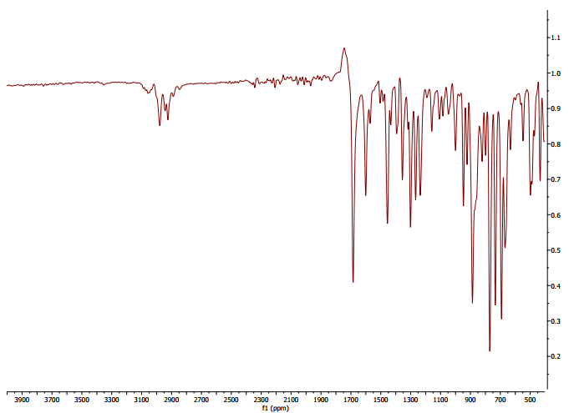
Figure 1. IR spectra of compound 3a
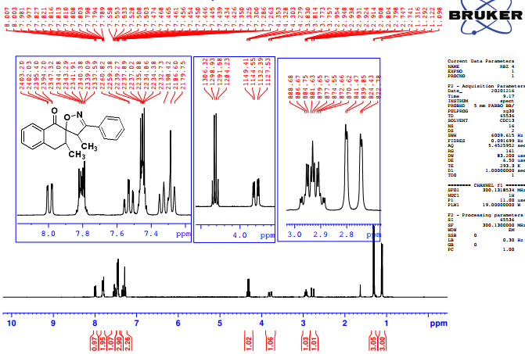
Figure 2. ¹H NMR spectrum (300 MHz, CDCl₃) of compound 3a
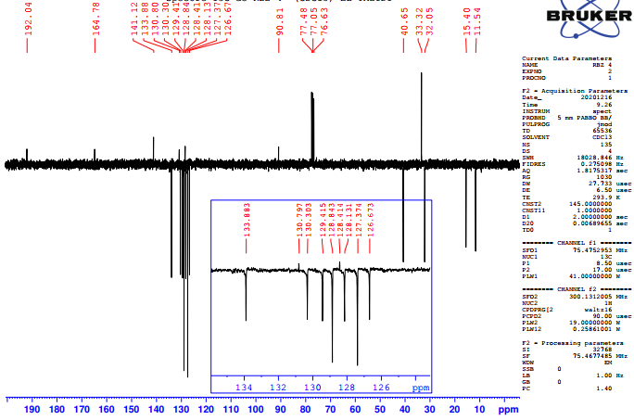
Figure 3. ¹³C NMR spectrum (75 MHz, CDCl₃) of compound 3a

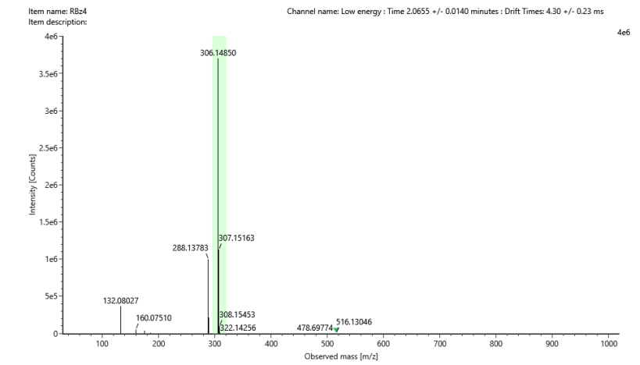
Figure 4. Mass spectrum of compound 3a

Spectra of 3-(4-chlorophenyl)-3',4-dimethyl-3',4'-dihydro-1'H,4H-spiro[isoxazole-5,2'-naphthalen]-1'-one 3b
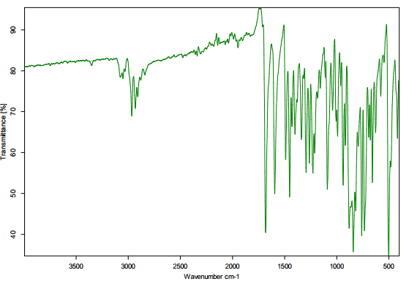
Figure 5. IR spectra of compound 3b
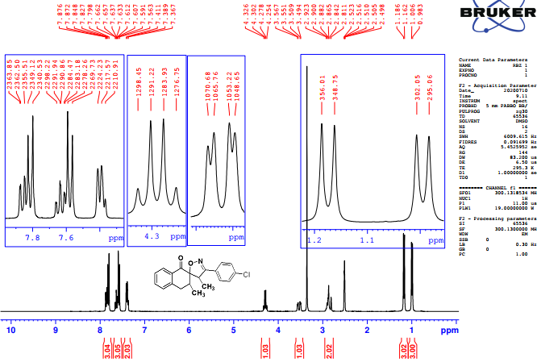
Figure 6. ¹H NMR spectrum (300 MHz, CDCl₃) of compound 3b

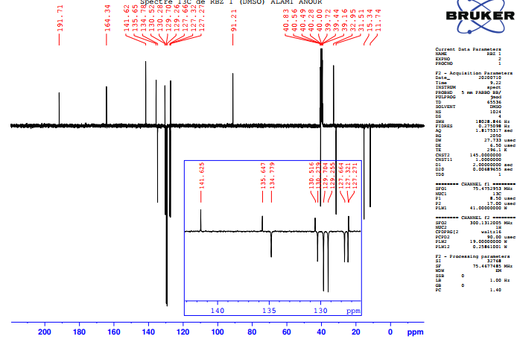
Figure 7. ¹³C NMR spectrum (75 MHz, CDCl₃) of compound 3b
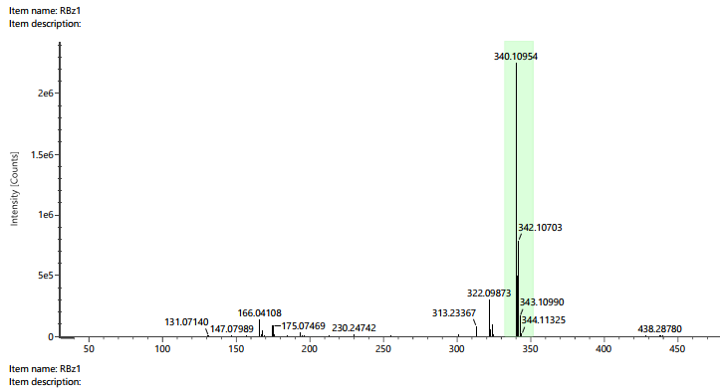
Figure 8. Mass spectrum of compound 3b

Spectra of 3',4-dimethyl-3-(p-tolyl)-3',4'-dihydro-1'H,4H-spiro[isoxazole-5,2'-naphthalen]-1'-one 3c
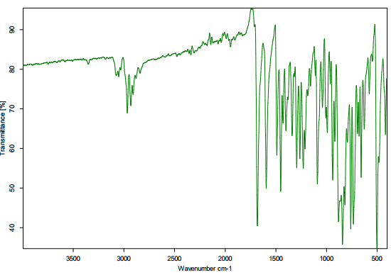
Figure 9. IR spectra of compound 3c
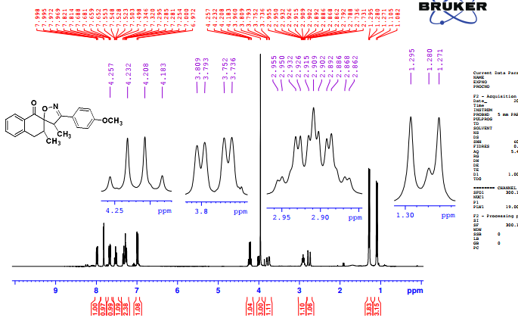
Figure 10. ¹H NMR spectrum (300 MHz, CDCl₃) of compound 3c
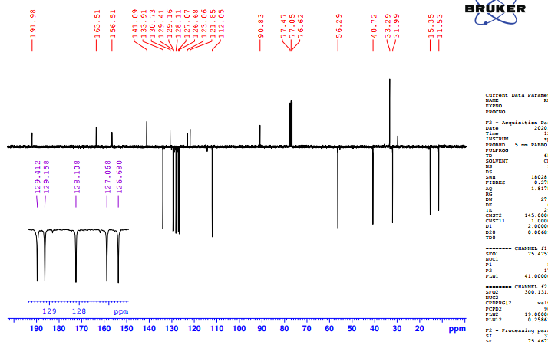
Figure 11. ¹H NMR spectrum (75 MHz, CDCl₃) of compound 3c
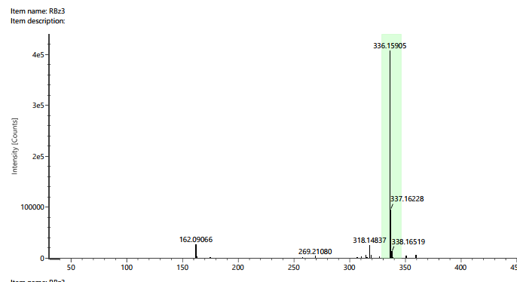
Figure 12. Mass spectrum of compound 3c

Spectra of 3',4-dimethyl-3-(p-tolyl)-3',4'-dihydro-1'H,4H-spiro[isoxazole-5,2'-naphthalen]-1'-one 3d
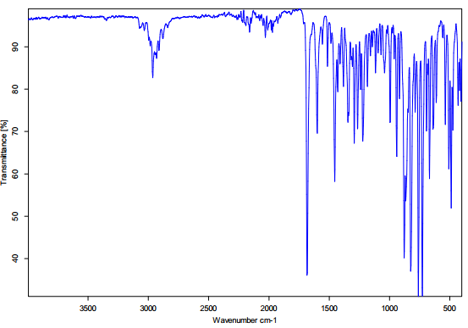
Figure 13. IR spectra of compound 3d
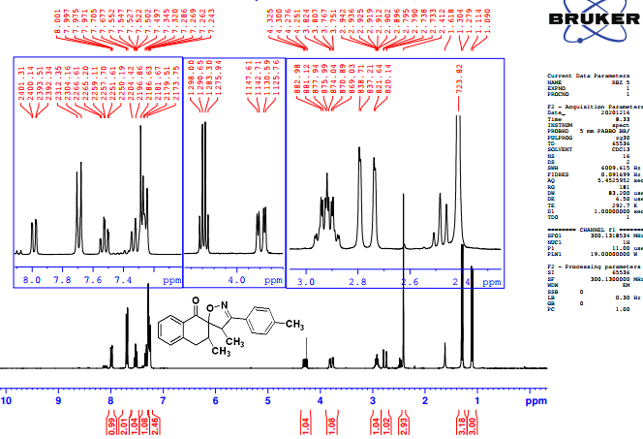
Figure 14. ¹H NMR spectrum (300 MHz, CDCl₃) of compound 3d
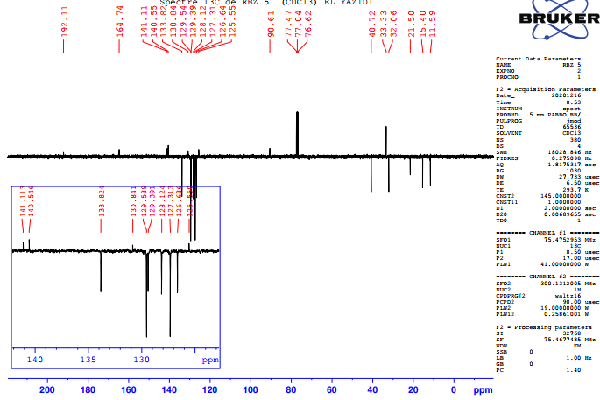
Figure 15. ¹³C NMR spectrum (75 MHz, CDCl₃) of compound 3d
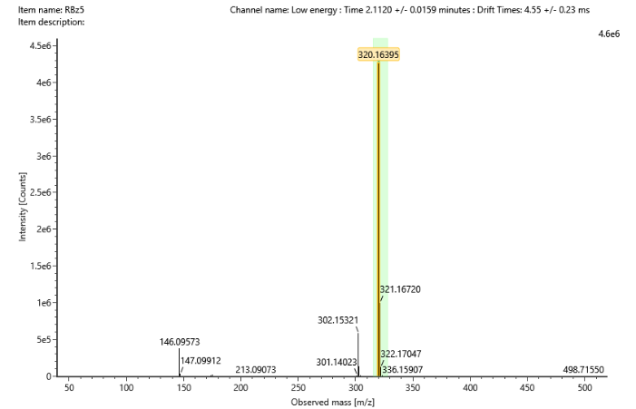
Figure 16. Mass spectrum of compound 3d.

