# *Supplementary Material*

**Metabolic engineering and comparative performance studies of *Synechocystis* sp. PCC 6803 strains for effective utilization of xylose.**

Saurabh Ranade1, Yan Zhang2, Mecit Kaplan1, Waqar Majeed3, Qingfang He1*

1 Department of Biology, University of Arkansas at Little Rock, Little Rock, AR, USA

2 Biotechnology Research Center, Shandong Academy of Agricultural Sciences, Jinan, Shandong, China

3 Center for Integrative Nanotechnology Sciences, University of Arkansas at Little Rock, Little Rock, AR, USA

**\* Correspondence:** Qingfang He, University of Arkansas at Little Rock, Department of Biology,

2801 South University Avenue, ETAS 426, Little Rock, AR, 72204, USA.

qfhe@ualr.edu

## 1. Supplementary Figure and Tables

### 1.1 Supplementary Figures

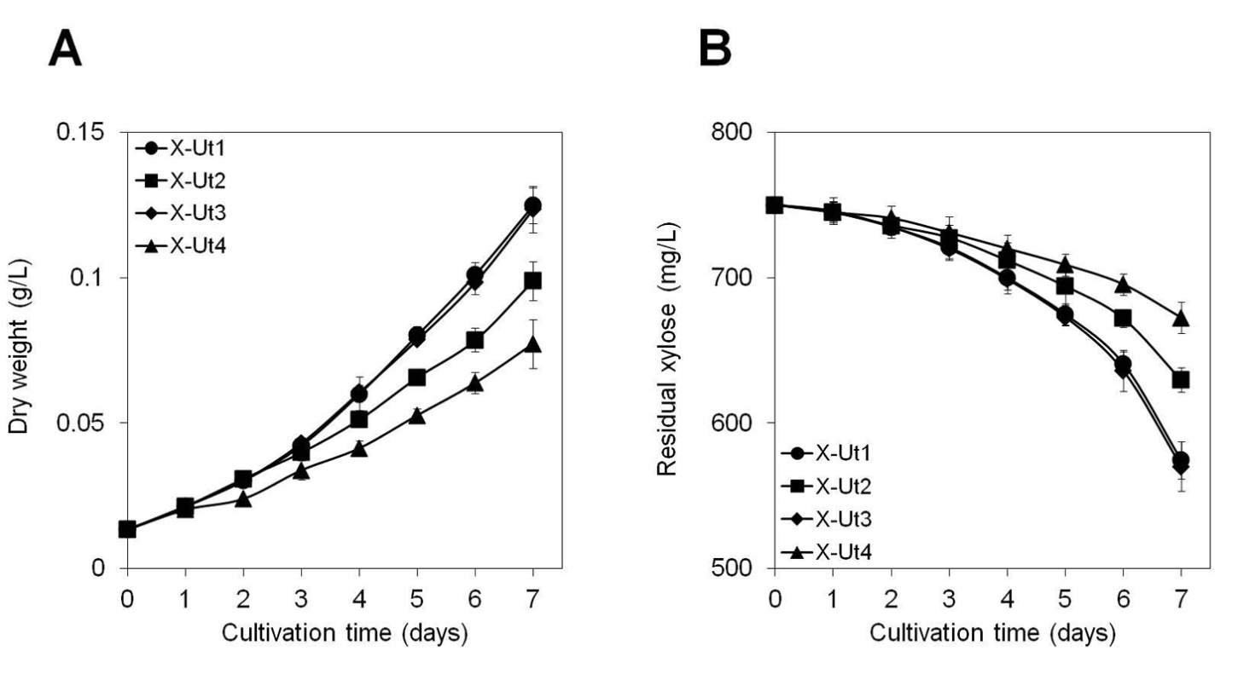

#### Supplementary Figure 1. Comprehensive growth and xylose consumption under LAHG conditions in the presence of 5 mM xylose.

*Synechocystis* strains carrying the xylose catabolic genes, *xylAB,* were grown in the presence of 5 mM (750 mg/L) xylose. **(A)** Dry biomass accumulation pattern and **(B)** xylose consumption pattern were studied over a period of 7 days. Measurements were made at 24-h intervals. Data were collected from three biological replicates and presented as means ± standard deviations.

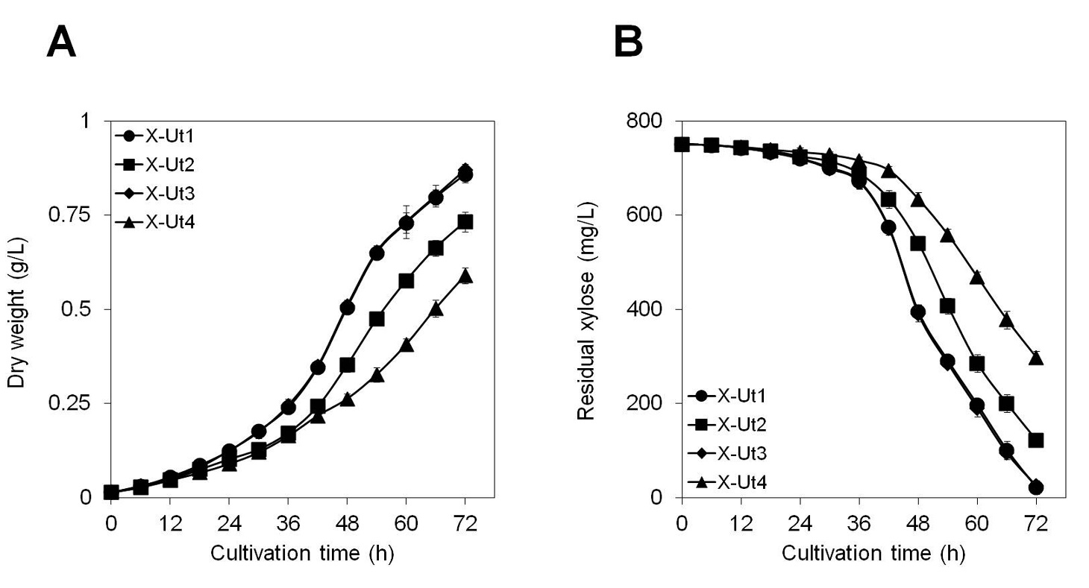

#### **Supplementary Figure 2. Comprehensive growth and xylose consumption under mixotrophy in the presence of 5 mM xylose**.

*Synechocystis* strains carrying the xylose catabolic genes, *xylAB,* were grown in the presence of 5 mM (750 mg/L) xylose. **(A)** Dry biomass accumulation pattern and **(B)** xylose consumption pattern were studied over a period of 3 days. Measurements were made at 6-h intervals. Data were collected from three biological replicates and presented as means ± standard deviations.

### 1.2 Supplementary Table

#### Supplementary Table 1. Maximum sugar uptake rates in the presence of 5 mM each of xylose and glucose.

|  |  |  |  |  |
| --- | --- | --- | --- | --- |
| Strain | Maximum sugar uptake rate (mg sugar g-1 DW h-1) | | | |
| LAHG | | Mixotrophy | |
| Xylose | Glucose | Xylose | Glucose |
| X-Ut1 | 17.24 ± 1.24 | 71.32 ± 5.03 | 25.82 ± 1.28 | 113.42 ± 7.85 |
| X-Ut2 | 16.59 ± 1.00 | 72.06 ± 3.35 | 26.14 ± 1.39 | 111.67 ± 4.86 |
| X-Ut3 | 17.00 ± 1.15 | 71.54 ± 2.25 | 26.05 ± 1.04 | 111.51 ± 5.20 |
| X-Ut4 | 15.47 ± 1.33 | 70.32 ± 3.15 | 26.22 ± 2.29 | 114.15 ± 9.42 |

*Synechocystis* strains carrying the xylose catabolic genes, *xylAB,* were grown in the presence of 5 mM (750 mg/L) xylose and 5 mM (900.8 mg/L) glucose. Maximum xylose and glucose uptake rates were calculated as mg sugar g-1 dry weight (DW) h-1 using a previously described formula (Munyon and Merchant, 1959). For all the strains, maximum xylose uptake rates were observed between the 6th and 7th day under LAHG conditions and between the 42nd and 48th hour under mixotrophy. Similarly, for all the strains, maximum glucose uptake rates were observed between the 3rd and 4th day under LAHG conditions and between the 30th and 36th hour under mixotrophy. Raw data were collected from three biological replicates. Uptake rate values obtained are presented as means ± standard deviations.

## 2. References

Munyon, W. H., and Merchant, D. J. (1959). The relation between glucose utilization, lactic acid production and utilization and the growth cycle of L strain fibroblasts. *Exp. Cell Res*. 17, 490-498.doi:10.1016/0014-4827(59)90069-2.