Supplementary Material

**Global DEM Errors Underpredict Coastal Vulnerability to Sea Level Rise and Flooding**

Scott Kulp*, Benjamin H. Strauss

**\* Correspondence:** Corresponding Author: [skulp@climatecentral.org](mailto:skulp@climatecentral.org)

|  |  |  |  |  |  |  |  |  |  |  |  |  |
| --- | --- | --- | --- | --- | --- | --- | --- | --- | --- | --- | --- | --- |
|  |  |  | **1m** | **2m** | **3m** | **4m** | **5m** | **6m** | **7m** | **8m** | **9m** | **10m** |
| **State** | **Population RE** | **5%** | -0.82 | -0.90 | -0.89 | -0.85 | -0.81 | -0.76 | -0.69 | -0.63 | -0.58 | -0.54 |
| **50%** | -0.28 | -0.38 | -0.44 | -0.44 | -0.42 | -0.40 | -0.32 | -0.31 | -0.28 | -0.27 |
| **95%** | 0.74 | 0.23 | -0.01 | -0.06 | -0.05 | -0.03 | -0.04 | -0.05 | -0.05 | -0.04 |
| **Pct Under** | 57% | 86% | 95% | 95% | 95% | 95% | 95% | 95% | 95% | 95% |
| **Land RE** | **5%** | -0.86 | -0.84 | -0.83 | -0.81 | -0.78 | -0.73 | -0.67 | -0.63 | -0.60 | -0.56 |
| **50%** | -0.47 | -0.50 | -0.45 | -0.41 | -0.37 | -0.34 | -0.32 | -0.30 | -0.28 | -0.25 |
| **95%** | 0.24 | 0.05 | -0.03 | -0.04 | -0.04 | -0.03 | -0.05 | -0.05 | -0.04 | -0.03 |
| **Pct Under** | 81% | 95% | 95% | 95% | 95% | 95% | 95% | 95% | 95% | 95% |
| **# Exposed States** | | 21 | 21 | 21 | 21 | 21 | 21 | 21 | 21 | 21 | 21 |
| **County** | **Population RE** | **5%** | -0.85 | -0.92 | -0.91 | -0.9 | -0.86 | -0.81 | -0.77 | -0.75 | -0.75 | -0.81 |
| **50%** | -0.26 | -0.47 | -0.47 | -0.44 | -0.41 | -0.39 | -0.35 | -0.31 | -0.28 | -0.25 |
| **95%** | 3.50 | 1.13 | 0.68 | 0.47 | 0.36 | 0.32 | 0.16 | 0.15 | 0.13 | 0.11 |
| **Pct Under** | 62% | 80% | 86% | 89% | 89% | 90% | 90% | 91% | 91% | 90% |
| **Land RE** | **5%** | -0.89 | -0.84 | -0.86 | -0.8 | -0.83 | -0.79 | -0.76 | -0.77 | -0.75 | -0.71 |
| **50%** | -0.37 | -0.42 | -0.41 | -0.42 | -0.39 | -0.37 | -0.33 | -0.31 | -0.29 | -0.27 |
| **95%** | 1.24 | 0.40 | 0.16 | 0.14 | 0.19 | 0.16 | 0.10 | 0.12 | 0.10 | 0.09 |
| **Pct Under** | 70% | 80% | 88% | 89% | 90% | 91% | 92% | 91% | 92% | 92% |
| **# Exposed Counties** | | 148 | 174 | 201 | 216 | 231 | 238 | 250 | 264 | 270 | 277 |
| **Municipality** | **Population RE** | **5%** | -0.91 | -0.93 | -0.94 | -0.93 | -0.93 | -0.89 | -0.84 | -0.8 | -0.78 | -0.76 |
| **50%** | -0.23 | -0.47 | -0.48 | -0.43 | -0.40 | -0.34 | -0.29 | -0.23 | -0.17 | -0.13 |
| **95%** | 4.47 | 1.71 | 0.77 | 0.50 | 0.46 | 0.26 | 0.18 | 0.12 | 0.09 | 0.08 |
| **Pct Under** | 61% | 78% | 84% | 86% | 86% | 86% | 86% | 86% | 85% | 83% |
| **Pct Over** | 38% | 21% | 15% | 13% | 12% | 11% | 10% | 9% | 8% | 8% |
| **Land RE** | **5%** | -0.90 | -0.92 | -0.92 | -0.91 | -0.90 | -0.87 | -0.82 | -0.79 | -0.75 | -0.73 |
| **50%** | -0.36 | -0.50 | -0.49 | -0.45 | -0.40 | -0.34 | -0.29 | -0.23 | -0.19 | -0.16 |
| **95%** | 2.67 | 0.80 | 0.44 | 0.33 | 0.21 | 0.19 | 0.15 | 0.10 | 0.07 | 0.05 |
| **Pct Under** | 68% | 81% | 86% | 88% | 88% | 88% | 88% | 88% | 87% | 86% |
| **Pct Over** | 31% | 18% | 13% | 12% | 10% | 10% | 9% | 8% | 8% | 7% |
| **# Exposed Towns** | | 1386 | 1703 | 1932 | 2115 | 2269 | 2419 | 2519 | 2619 | 2693 | 2754 |

Table S1: Relative error values at the 5/50/95th percentiles across exposed states, counties, and towns under SRTM-3. This table also lists the percentage of places in which SRTM-3 is underestimating exposure, as well as the total number of exposed places. Some municipalities see 100% exposure under both lidar and SRTM-3 (neither under- nor over-estimating), so the actual percentage of municipalities overestimating exposure is also included. Municipalities and counties in which less than 1% of the total are exposed in either SRTM-3 or lidar are not considered.

|  |  |  |  |  |  |  |  |  |  |  |
| --- | --- | --- | --- | --- | --- | --- | --- | --- | --- | --- |
|  | **1m** | **2m** | **3m** | **4m** | **5m** | **6m** | **7m** | **8m** | **9m** | **10m** |
| **SRTM-3 Population RE** | -0.36 | -0.62 | -0.62 | -0.57 | -0.51 | -0.44 | -0.37 | -0.31 | -0.26 | -0.22 |
| **SRTM-3 Land RE** | -0.52 | -0.51 | -0.5 | -0.47 | -0.43 | -0.39 | -0.35 | -0.33 | -0.3 | -0.27 |

Table S2: Population and Land exposure relative error for the contiguous USA (omitting VA and RI) under SRTM-3

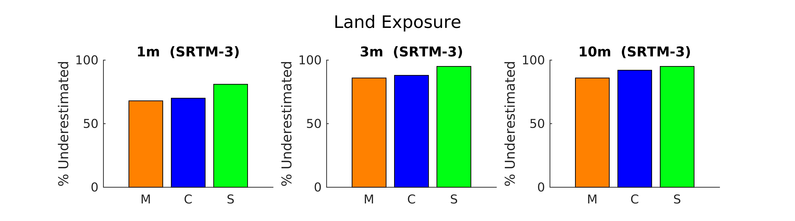

Figure S1: Bar graph of percent of places underestimating population and land exposure under SRTM-3, across Municipalities (M, orange), Counties (C, blue), and States (S, green).

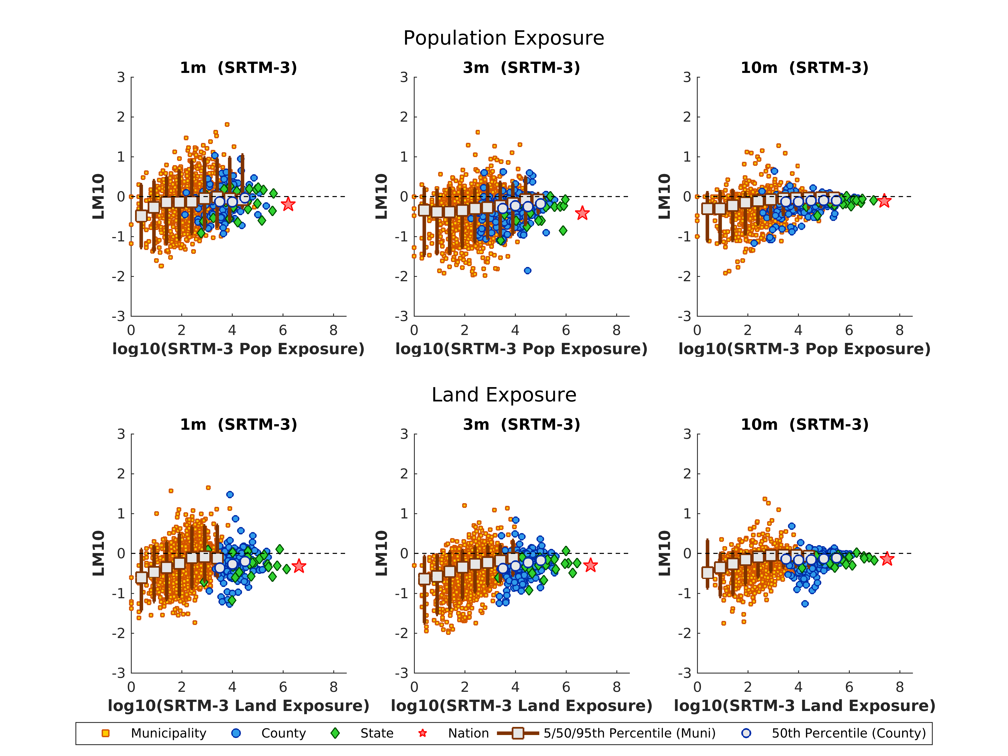

Figure S2: Scatter plot of LM10 vs estimated population and land exposure at individual places. LM10 is defined as log10([SRTM-3 exposure]/[lidar exposure]). Error bars for municipalities represent the 5/50/95th percentiles of LM10 values of neighboring points. County medians are also included, but error bars are removed to reduce clutter. Counties and municipalities with less than 1% exposure are not included.