Table S4: Top 10 enriched common regulatory elements from 1628 DETs promoters (Fold change > |2|, FDR<0.05) due to seed priming treatments.
Common Motif | Gene Num* | % in genes | Motif logo | Regulatory elements
TATANBDAC | 1477  (1163/314) | 90.7 | 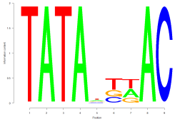 | TATA box /  MADS box factors
GCGAST | 1219  (953/266) | 74.9 | 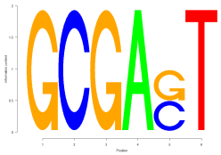 | Basic helix-loop-helix factors (bHLH)
TNNCCAVCG | 818  (632/186) | 50.2 | 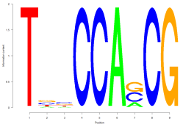 | Basic helix-loop-helix factors (bHLH)
GCACANAT | 649  (490/159) | 39.9 | 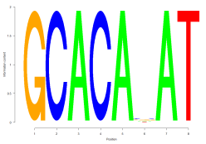 | CAAT box /  AP2/ERF domain
CGCGGA | 636  (499/137) | 39.1 | 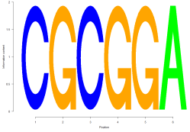 | CG-1 domain
GDGCGGHGH | 610  (451/159) | 37.5 | 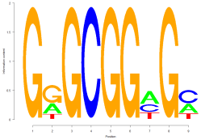 | GC box /  AP2/ERF domain
AHATAATAA | 558  (445/113) | 34.3 | 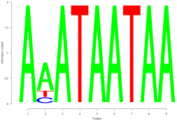 | MADS box factors
GCGGNGCG | 507  (402/105) | 31.1 | 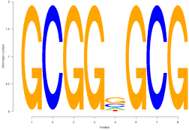 | GC box /  AP2/ERF domain
TNCGCGNDG | 481  (363/118) | 29.5 | 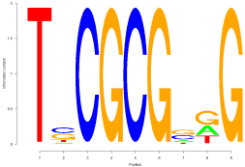 | Tryptophan cluster factors
GNNDCTCGCS | 381  (299/82) | 23.4 | 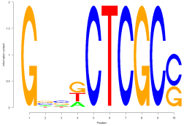 | Basic leucine zipper factors (bZIP)
- In brackets, nominator and denominator represent up-regulated and down-regulated gene number, respectively.

