***Supplementary Material***

**Nano shapes micro: Silver nanoparticles, ions and shape governing soil microbial functional diversity**

**Yujia Zhai1*, Marja Wouters2, Ellard R. Hunting1, Willie J.G.M. Peijnenburg1,2, and Martina G. Vijver1**

**\* Correspondence:** Yujia Zhai: y.zhai@cml.leidenunv.nl

1. **Supplementary Figure** **and Tables**
2. **Supplementary Figure**

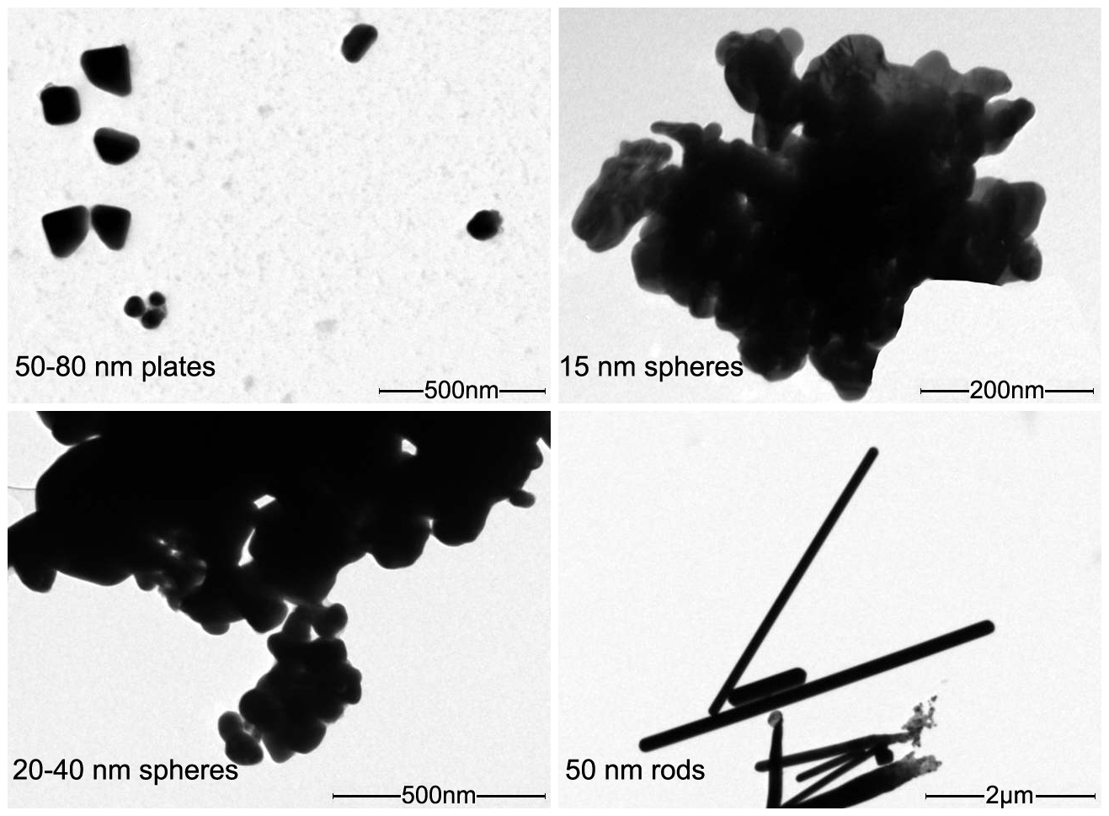

**Supplementary Figure 1. Transmission electron microscopic micrographs of the silver nanoparticles used in this study (50-80 nm plates, 15 nm spheres, 20-40 nm spheres and 50 nm rods particles) dissolved in egg water sensu Hua et al., 2014.**

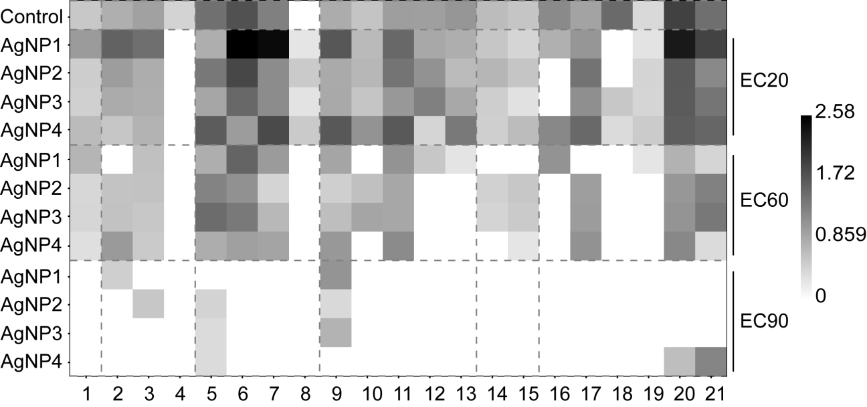

**Supplementary Figure 2. A heatmap for demonstrating utilization variation of substrates under four different AgNPs treatments at the EC20, 60 and 90 levels.** (1-Putrescine, 2-Tween 80, 3-Tween 40, 4- Glycogen, 5- L-Asparagine, 6-L-Serine, 7- Glycyl-L-glutamic acid, 8-L-Arginine, 9-D-Glucosaminic acid, 10-D-Galacturonic acid, 11-D-Galactonic acid γ-Lactone, 12-4-Hydroxy benzoic acid, 13-Itaconic acid, 14-Glucose -l-phosphate, 15-Pyruvic acid methyl ester, 16-D-Mannitol, 17-N-Acetyl-D-glucosamine, 18-β-Methyl-D-glucoside, 19-D-Cellobiose, 20-D-Xylose, 21-i-Erythritol; AgNP1-50-80 nm nanoplates, AgNP2-20-40 nm nanospheres, AgNP3-15 nm nanospheres, AgNP4-50 nm nanorods).

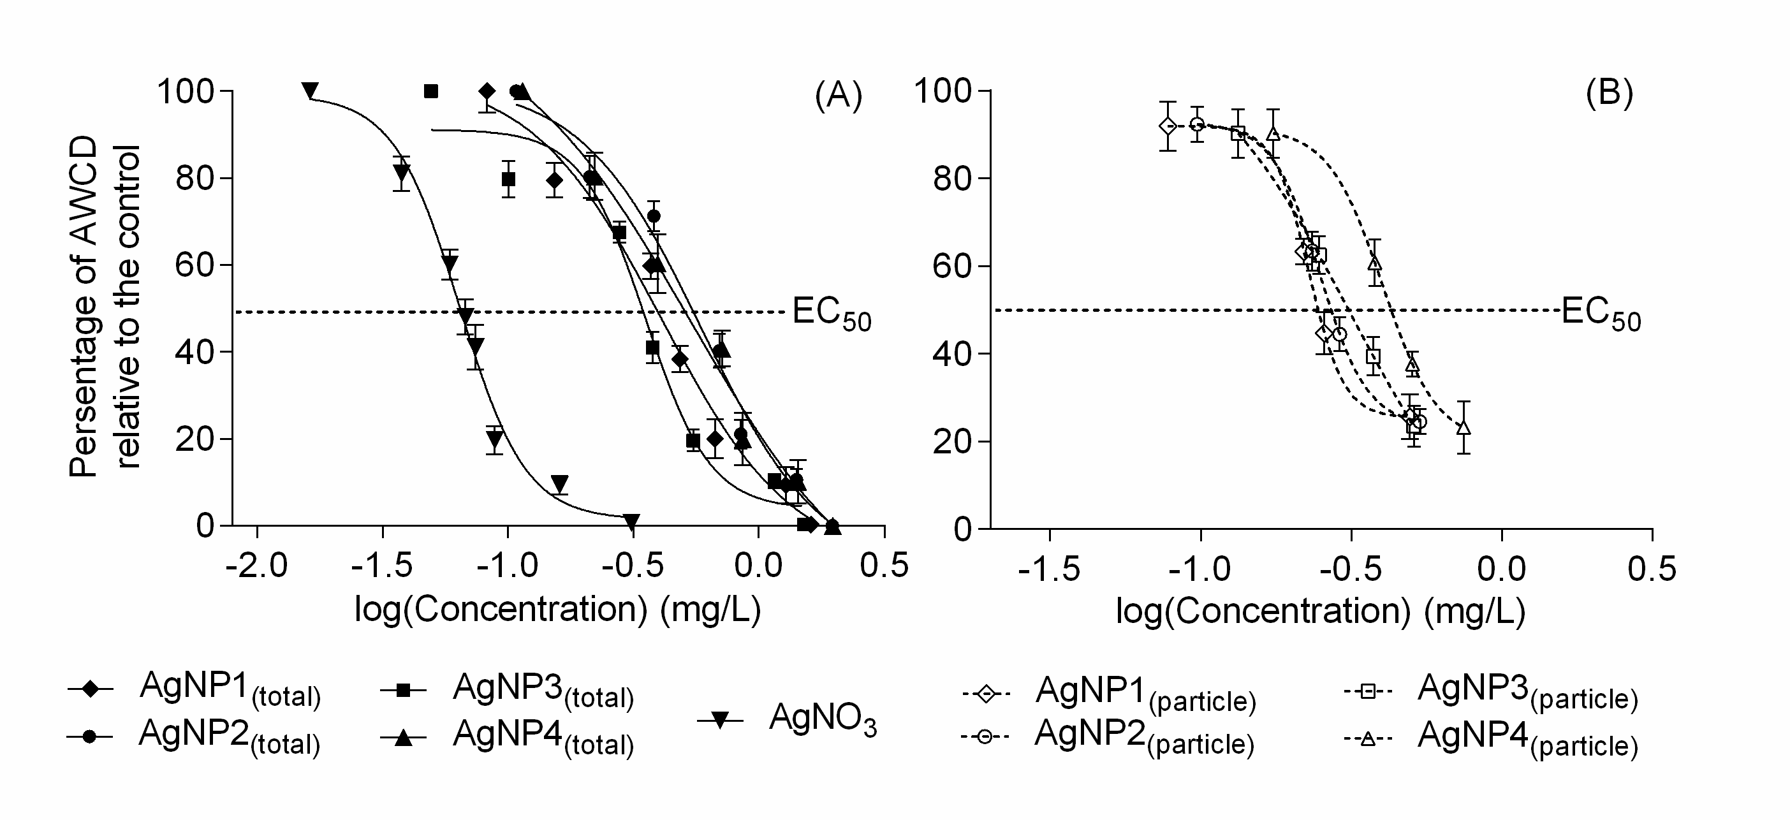

**Supplementary Figure 3. Dose-response curves of AWCD of soil extracts exposed to suspensions of (A) AgNPs(total) and AgNO3, and (B) AgNPs(particle) expressed as initial concentrations.** AWCD are plotted on the y-axis, actual log-transformed Ag concentrations are plotted on the x-axis. Data are mean ± SD (n= 3). (AgNP1-50-80 nm nanoplates, AgNP2-15 nm nanospheres, AgNP3-20-40 nm nanospheres, AgNP4-50 nm nanorods).**Supplementary Table**

**Supplementary Table 1.** Individual carbon sources and their classification in Biolog EcoPlate.

|  |  |  |  |
| --- | --- | --- | --- |
| Carbon source | Substrate | Chemical formula | Serial No. |
| Amines/amides | G4: Phenyethylamine | C8H11N | 30 |
| H4: Putrescine | C4H12N2 | 31 |
| Amino acids | A4: L-Arginine | C6H14N4O2 | 24 |
| B4: L-Asparagine | C4H8N2O8 | 25 |
| C4: L-Phenylalanine | C9H11NO2 | 26 |
| D4: L-Serine | C3H7NO3 | 27 |
| E4: L-Threonine | C4H9NO3 | 28 |
| F4: Glycyl-L-glutamic acid | C7H12N2O5 | 29 |
| Carbohydrates | A2: β-Methyl-D-glucoside | C7H14O6 | 8 |
| B2: D-Xylose | C5H10O5 | 9 |
| C2: i-Erythritol | C4H10O4 | 10 |
| D2: D-Mannitol | C6H14O6 | 11 |
| E2: N-Acetyl-D-glucosamine | C8H15NO6 | 12 |
| G1: D-Cellobiose | C12H22O11 | 6 |
| H1: α-D-Lactose | C12H22O11 | 7 |
| Carboxylic acids | A3: D-Galactonic acid γ-Lactone | C6H10O6 | 16 |
| B3: D-Galacturonic acid | C6H10O7 | 17 |
| C3: 2-Hydroxy benzoic acid | C7H6O3 | 18 |
| D3: 4-Hydroxy benzoic acid | C7H6O3 | 19 |
| E3: γ-Hydroxy butyric acid | C4H8O3 | 20 |
| F2: D-Glucosaminic acid | C6H13NO6 | 13 |
| F3: Itaconic acid | C5H6O4 | 21 |
| G3: α-Keto butyric acid | C4H6O3 | 22 |
| H3: D-Malic acid | C4H6O5 | 23 |
| Miscellaneous | B1: Pyruvic acid methyl ester | C4H6O3 | 1 |
| G2: D-Glucosaminic acid | C6H13O9P | 14 |
| H2: D,L-α-Glycerol-phosphate | C3H9O6P | 15 |
| Polymers | E1: α-Cyclodextrin | C36H60O30 | 4 |
| F1: Glycogen | (C6H10O5)*n* | 5 |
| C1: Tween 40 | - | 2 |
| D1: Tween 80 | - | 3 |

**Supplementary Table 2.** Statistics of the nonlinear fit of ion release profile for each AgNPs(total) and AgNPs(particle).

|  |  |  |  |  |  |  |  |
| --- | --- | --- | --- | --- | --- | --- | --- |
|  |  | | Total |  |  | Particle |  |
|  | *K* | | *P* | *R*2 | *K* | *P* | *R*2 |
| 50-80 nm nanoplates | | 0.019 | 0.501 | 0.839 | 0.020 | 0.423 | 0.850 |
| 15 nm nanospheres | | 0.015 | 0.484 | 0.942 | 0.014 | 0.406 | 0.916 |
| 20-40 nm nanospheres | | 0.010 | 0.396 | 0.811 | 0.009 | 0.314 | 0.842 |
| 50 nm nanorods | | 0.025 | 0.618 | 0.717 | 0.023 | 0.583 | 0.744 |