Supplement 10
Case study area description: Saronikos Gulf
Maria Pantazi, Nomiki Simboura, Panos Panayiotidis, Alexandra Pavlidou, Georgia Assimakopoulou, Nadia Papadopoulou, Chris Smith & Celia Vassilopoulou (HCMR) , Heliana Teixeira (IES-JRC)
Map
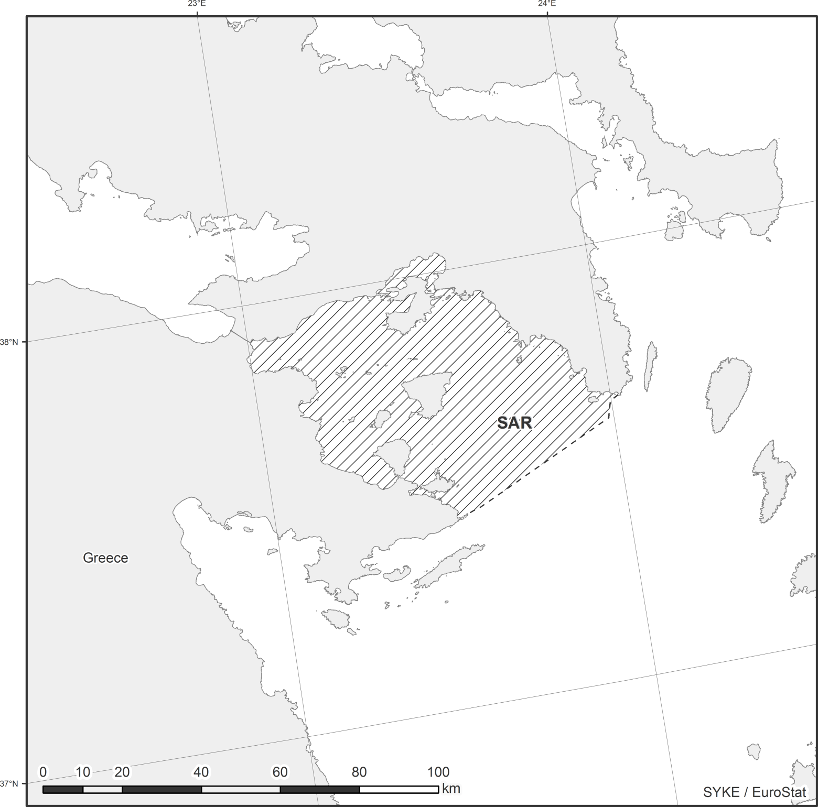
Biogeographical characteristics
The Saronikos Gulf is situated at the central Aegean Sea, northeast Mediterranean, between 37.30’N - 38.00’N and 24.01’E - 23.00’E. The length of its coastline is ~ 270 km, its surface ~ 2866 km² and its mean water depth is ~100 m, with the shallow (~30 m depth) Elefsis bay in the north. The bay is separated from the gulf by the island of Salamina, and the two areas are connected by narrow channels with sill depths of 25 m and 10 m. The gulf is the natural marine gateway of the city of Athens and Piraeus harbour, and is divided into a deeper western sub-basin and an eastern part. The islands of Salamina and Aigina and the plateau (~100 m) between them divide the gulf into the western Saronikos Gulf and the outer Saronikos Gulf. The northern area of the eastern part is called the “Inner Gulf” and is relatively flat, with a mean depth of 90 m. The Inner Gulf can be further divided into a deeper western sector with homogeneous muddy sediments and an eastern sector with more heterogeneous sediments and averagely lower depths. Typical temperature range in the water column is 12-15 ºC in the winter (February, March) and 13-28 ºC in the summer (August, September), and the salinity is 38-39 PSU (SoHelFI, 2007).
Biodiversity
Saronikos Gulf belongs to the rocky deep exposed coastal water body type according to a first phase typological scheme followed under the Water Framework Directive (Simboura et. al., 2005). Mainly biogenic sedimentation prevails on its sea floor, and its sediments are generally muddy sands and muds. Regarding nutrients and chlorophyll-a concentrations, the gulf is divided and characterized as follows: the Elefsis Bay has been characterized as eutrophic to high-mesotrophic, the Inner Saronikos Gulf as high-mesotrophic at its the shallower parts and low-mesotrophic at the area of Waste Water Treatment Plant (WWTP) outflow, while the outer Saronikos Gulf has been characterized as oligotrophic (Ignatiades et al., 1992; Karydis, 1999; Pagou, 2000; Siokou and Pagou, 2000). An evaluation of the status of the benthic communities based on benthic indices showed a gradient from a moderate ecological status at stations up to a distance of 8,000 m from the outfalls to good environmental and ecological status at more remote stations (Simboura et al., 2014).
Cetacean species recorded in Saronikos Gulf are the Fin whale (Balaenoptera physalus) which is classified as endangered on a global level (and protected by Greek Law PD 67/1981), the Striped dolphin (Stenella coeruleoalba), classified as vulnerable on a Mediterranean level, and the Short-beaked common dolphin (Delphinus delphis) classified as endangered on a Mediterranean level (Frantzis A. 2009). The last 2 species appear on the Red Data Book of Threatened Animals of Greece (2009). Twenty shark species have been recorded in the gulf, out of which 6 species are classified as endangered or critically endangered according to the IUCN list (Papaconstantinou C. et. al., 2014). Moreover, the loggerhead turtle (Caretta Caretta), considered as an entirely conservation-dependent species, has also been reported in Saronikos gulf, which although not included in its main spawning areas, it constitutes one of its foraging and/or wintering areas (Casale & Margaritoulis, 2010).The critically endangered Mediterranean monk seal is also reported in the area. A number of protected and threatened benthic invertebrates have also been reported from Saronikos (Katsanevakis et. al., 2011). Saronikos is a nursery ground for hake (Colloca et. al., 2015); a very important commercial species in Greece and the Mediterranean with its regional status being assessed as vulnerable (Abdul Malak et. al., 2011) and overexploited (Vasilakopoulos et. al., 2015). Saronikos is a hotspot for alien invasions and biopollution (Katsanevakis et. al., 2013) providing new alien biodiversity records (Zenetos et. al., 2015)
Human activities, pressures and their effects
The gulf is subjected to intense anthropogenic pressures as it is the marine border of the cities of Athens and Piraeus with ~4 million inhabitants. Along its northern coast (~135 km) there are numerous industrial activities including the industrial zone of Athens in the Elefsis embayment, oil refineries and Piraeus port, one of the largest in the Mediterranean. The Athens WWTP, situated on Psittalia Island in the inner part of the gulf, is considered the major source of nutrients and organic matter in the Saronikos Gulf. Organic matter inputs from the WWPT are present in both the particulate and dissolved phase (MERMAID D.1.1). The urban sewage discharge is believed to impose the most significant stress on the marine environment of the gulf, causing a clear pollution gradient along its coasts (Simboura et. al., 2005). However, a benthic indices’ trends analysis showed an upgrade of the condition of the benthic communities of Saronikos Gulf throughout the monitoring period (2000-2012) especially evident after 2004, when the advanced secondary biological treatment plant was completed and commissioned (Simboura et al., 2015).
A typically multi-gear and multi-species fishery exists in Saronikos Gulf, which is exerted by trawlers, purse-seiners and small-scale fishing vessels and is regarded as an important activity in the area. Moreover, the gulf is subject to the introduction of alien species, largely due to the area’s intense maritime traffic and the Lessepsian (i.e. through the Suez Canal) immigration phenomenon, which has been strongly affecting the wider Eastern Mediterranean basin during the last 2 decades (Tsiamis et. al., 2013). Other point sources are spread along the coasts and include marinas, touristic facilities and fish farms, while non-point pollution sources for the Saronikos Gulf include marine traffic (~5000 ships are recorded per year only for the port of Piraeus (REMPEC, 2008)) and possibly the atmospheric deposition of pollutants from the adjacent urban areas.
References
Abdul Malak, D. et al. (2011). Overview of the Conservation Status of the Marine Fishes of the Mediterranean Sea. Gland, Switzerland and Malaga, Spain: IUCN. vii + 61pp, http://www.greenpeace.org/turkey/PageFiles/293261/IUCN-red-list.pdf
Casale, P. and Margaritoulis, D (Eds.) (2010). Sea turtles in the Mediterranean: Distribution, threats and conservation priorities. Gland, Switzerland: IUCN. 294pp.
Colloca F, Garofalo G, Bitetto I, Facchini MT, Grati F, Martiradonna A, et al. (2015) The Seascape of Demersal Fish Nursery Areas in the North Mediterranean Sea, a First Step Towards the Implementation of Spatial Planning for Trawl Fisheries. PLoS ONE 10(3): e0119590. doi:10.1371/journal.pone.0119590
Frantzis A. 2009. Cetaceans in Greece: Present status of knowledge. Initiative for the Conservation of Cetaceans in Greece, Athens, Greece, 94 pp.
Ignatiades l., Vounatsou P. & Karydis M., 1992. A possible method for evaluating oligotrophy and eutrophication based on nutrient concentration scales. Mar. Poll. Bull., 24: 238-243.
Karydis Μ,. 1999. Evaluation report on the eutrophication level in coastal greek areas. Univ. of Aegean, Mytilini, February 1999 (in greek).
Katsanevakis et al 2011, "Protected" marine shelled molluscs: thriving in Greek seafood restaurants. Medit. Mar. Sci., 12/2, 2011, 429-438
Katsanevakis S, A. Zenetos, D. Poursanidis, A.L. Nunes, I. Deriu, K. Bogucarskis, A. C. Cardoso 2013. ELNAIS meets EASIN: distribution of marine alien species in Greece using EASIN mapping services and ELNAIS spatial data. Medit. Mar. Sci., 14/1, 2013, 95-98.
Pagou K., 2000. Assessment of the trophic conditions in the Inner Thermaikos Gulf. Technical Report for the Ministry of Environment, Planning and Public Works, NCMR, Athens, December 2000, 11p
Papaconstantinou C., 2014. Fauna Graeciae. An updated checklist of the fishes in the Hellenic Seas, Monographs on Marine Sciences, 7, Athens 2014, HCMR, 340 pp.
REMPEC, 2008. Study of Maritime Traffic Flows in the Mediterranean Sea. Final report -unrestricted version, Lloyd’s Marine Intelligence Unit, pp. 39.
Simboura N, Panayotidis P, Papathanassiou E., 2005. A synthesis of the Biological Quality Elements for the implementation of the European Water Framework Directive in the Mediterranean Ecoregion: the case of Saronikos Gulf. Ecological Indicators, 5: 253-266.
Simboura N, Zenetos A, Pancucci-Papadopoulou MA. Benthic community indicators over a long period ofmonitoring (2000–2012) of the Saronikos Gulf, Greece, EasternMediterranean. Environ. Monit. Assess. 2014;186:3809–21.
Simboura, N.,Tsapakis, M., Pavlidou, A., Assimakopoulou, G., Pagou, K., Kontoyiannis, H., Zeri, Ch., Krasakopoulou, E., Rousselaki, E., Katsiaras, N., Diliberto, S., Naletaki, M., Tsiamis, K., Gerakaris, V., Drakopoulou, V., Panayotidis, P., 2015. Assessment of the environmental status in Hellenic coastal waters (Eastern Mediterranean): from the Water Framework Directive to the Marine Strategy Water Framework Directive. Mediterr. Mar. Sci. 16/1, 46-64.
Siokou-Frangou I. & Pagou K., 2000. Assessment of the trophic conditions and ecological status in the Inner Saronikos Gulf. Technical Report for the Ministry of Environment, Planning and Public Works, NCMR, Athens, March 2000,43pp. (in greek and english edition)
SoHelFI, 2007, State of Hellenic Fisheries. C. Papaconstantinou, A. Zenetos, V. Vassilopoulou & G. Tserpes (Eds) HCMR Publ., 466 pp
Tsiamis, K., Balanika, K., Kleinteich, J., Salomidi, M., Pavlidou, A., Küpper, F. C., et al. (2013). Macroalgal community response to re-oligotrophication: a case study from Saronikos Gulf (Eastern Mediterranean, Greece). Marine Ecology Progress Series, 472, 73–85.
Vasilakopoulos P, C. D. Maravelias, G Tserpes, 2015, The Alarming Decline of Mediterranean Fish Stocks, Current Biology 24, 1643–1648, July 21, 2014
Zenetos et al 2015, New Mediterranean Biodiversity Records (April 2015), Medit. Mar. Sci., 16/1, 2015, 266-284

