Supplemental information
Table S1 Fungal strains and plasmids used in this study.
Table S2 Specific-primers used in this study for AflgcnE gene knock-out and complement.
Table S3 Specific-primers used in this study for construct AflGcnE-mCherry strains.
Table S4 Specific-primers used in this study for qRT-PCR.
Figure S1. Expression analysis of AflgcnE and verification of ΔAflgcnE and ΔAflgcnE-C strains. (A). Transcription level of AflgcnE at 24 h,48 h, 72 h and 144 h, strains were cultured in YES liquid media at 28℃ in dark condition, all transcription levels were normalized to β-tublin as the house keeping gene, and calculated by 2^{−ΔΔCT} method. (B). Graphic presentation present homologous recombination strategy to replace AflgcnE by a selective marker pyrG from Aspergillus fumigatus. The red box means the location of AflgcnE, the blue box means the selective marker gene pyrG, arrows and lines in purple were primers that used in this study to verify gene deletion. (C). Diagnostic PCR were performed to confirm the gene deletion and complemented strains, UA was confirmed by primers gcnE/UF and gcnE/UR, DA was confirmed by primers gcnE/DF and gcnE/DR. (D).Verification of gene deletion by RT-PCR analysis of gcnE expression in the fungi cultured in YES liquid media for 72 h, β-tublin gene was used as a reference.
Figure S2. Domain and phylogenetic tree analysis of Gcn5. (A). Domain analysis of Gcn5 from lower eukaryotic fungi to superior mammal animals, colour in grey means the unconserved regions, red box represents the GNAT domain, blue box represents DNA bromo domain, colour in yellow represents PCAF (P300/CBP-associated factor) domain. (B). A neighbor-joining phylogenetic tree was constructed by 18 species from Asperillus species to animals, scar bars=0.1.
Figure S3. Alignment of amino acid sequences of Gcn5 and its putative orthologs from fungi to plant and human. Identical and similar residues are shaded in black and gray, respectively.
Figure S4. Phenotype and inhibition growth rate of WT, ΔAflgcnE and ΔAflgcnE-C strains under osmotic stress and oxidative stress. (A).Morphology of WT, ΔAflgcnE and ΔAflgcnE-C strains under hyperosmotic stress generated by 1M NaCl and1M KCl, after 5 d at 37℃, inhibition of growth rate was relative to the growth rate of each untreated strain[Inhibition of growth rate=(The diameter of untreated strain-the diameter of treated strain)/(The diameter of untreated strain)×100%)]. (B).Growth inhibition under under hyperosmotic stress. (C). Morphologyunder oxidative stress generated by 0.5 mM tBOOH and 15mM H₂O₂. (D). Growth inhibitionunder oxidative stress, asterisk * represented p<0.05, asterisk ** represented p<0.01.

Supplemental Tables
Table S1 Fungal strains and plasmids used in this study
Table 1 Fungal strains and plasmids used in this study
Strains and plasmids name | Related gene type | Source
Aspergillus flavus NRRL3357 | Wild type | (Zhang et al., 2015)
PTSΔku70ΔpyrG | Δku70,ΔpyrG | (Chang et al., 2010)
PTSΔku70 | Δku70 | (Chang et al., 2010)
Aspergillus fumigatusAf293 | Wild type | (Kong et al., 2013)
ΔAflgcnE | Δku70, ΔgcnE::pyrG | This study
ΔAflgcnE-C | Δku70,Δgcn5::pyrG, ptr-gcnE | This study
Escherichia coli | DH5α | Takara, Japan
pPTR I | pPTR I | Takara, Japan
pPTR I-gcnE | pPTR I, +AflgcnE | This study

Table S2 Specific-primers used in this study for AflgcnE knockout andcomplement
Primer name | Sequence(5’-3’) | Application
gcnE/AF | TTGATTCCTGTCTCTGATAAAGTGAT | Amplifying upstream
gcnE/AR | GGGTGAAGAGCATTGTTTGAGGCTCTTGTTAAGTGTACAAGTAAGTAAAGAGG | Amplifying upstream
gcnE/BF | GCATCAGTGCCTCCTCTCAGACTCGATTGAATGATTGCATGAGCT | Amplifying downstream
gcnE/BF | CGAGGTTCCCTAAGGCATCAGA | Amplifying downstream
pyrG/PF | GCCTCAAACAATGCTCTTCACCC | Amplifying selective marker
pyrG/PR | GTCTGAGAGGAGGCACTGATGC | Amplifying selective marker
gcnE/NF | GACGGTTGGACACTAACTGCC | Amplifying homologous flagments
gcnE/NF | TGTACGACGGCTGAGGACTTC | Amplifying homologous flagments
gcnE/UF | GCACCAGGAAGTTGTATCGT | Gene deletion screen
gcnE/UR | TCGGGAGCAGCGTAGAT | Gene deletion screen
gcnE/DF | ATTGCTCGGCTACTTCAACTCA | Gene deletion screen
gcnE/DR | TGTGGAACAAGGGAAGACGATA | Gene deletion screen
gcnE/CF | CGTGGTACCGGCTGGGTGTACGAGATA | Amplifying complemented flagments
gcnE/CR | GTAGGTACCGGTTGCGGGAGGGATTAG | Amplifying complemented flagments

Table S3 Specific-primers used in this study for construct AflGcnE-mCherry strains
Primer name | Sequence(5’-3’) | Application
gcnE-P1 | ACGCCAAGATCCGTGCCT | Amplifying upstream
gcnE-P2 | CTCGCCCTTGCTCACCAT GTGGCCATCCGCCAGGT | Amplifying upstream
mCherry-P3 | ATGGTGAGCAAGGGCGAG | Amplifying mCherry
mCherry-P4 | GGGTGAAGAGCATTGTTTGAGGCCTACTTGTACAGCTCGTCCAT | Amplifying mCherry
pyrG-P5 | GCCTCAAACAATGCTCTTCACCC | Amplifying selective marker
pyrG-P6 | GTCTGAGAGGAGGCACTGATGC | Amplifying selective marker
gcnE /P7 | GCATCAGTGCCTCCTCTCAGACTCGATTGAATGATTGCATGAGCT | Amplifying downstream
gcnE /P8 | CGAGGTTCCCTAAGGCATCAGA | Amplifying downstream
AflgcnE-mCherry-P9 | GATCCGTTAAGTATCCCG | Nest primers for Aflgcn5-mCherry
AflgcnE-mCherry-P10 | AGCAGCCGAAACTCCTA | Nest primers for Aflgcn5-mCherry

Table S4 Specific-primers used in this study for qRT-PCR
Primer name | Sequence(5’-3’) | Application
gcnE/QF | AACAACGAGAACACGCCTTA | qRT-PCR
gcnE/QR | TGCGACCACTCGGGAATA | qRT-PCR
brlA/QF | GCCTCCAGCGTCAACCTTC | qRT-PCR
brlA/QR | TCTCTTCAAATGCTCTTGCCTC | qRT-PCR
abaA/QF | CACGGAAATCGCCAAAGAC | qRT-PCR
abaA/QR | TGCCGGAATTGCCAAAG | qRT-PCR
nsdC/QF | GCCAGACTTGCCAATCAC | qRT-PCR
nsdC/QR | CATCCACCTTGCCCTTTA | qRT-PCR
nsdD /QF | GGACTTGCGGGTCGTGCTA | qRT-PCR
nsdD /QR | AGAACGCTGGGTCTGGTGC | qRT-PCR
sclR /QF | CAATGAGCCTATGGGAGTGG | qRT-PCR
sclR /QR | ATCTTCGCCCGAGTGGTT | qRT-PCR
aflR/QF | AAAGCACCCTGTCTTCCCTAAC | qRT-PCR
aflR/QR | GAAGAGGTGGGTCAGTGTTTGTAG | qRT-PCR
aflS/QF | CGAGTCGCTCAGGCGCTCAA | qRT-PCR
aflS/QR | GCTCAGACTGACCGCCGCTC | qRT-PCR
aflC/QF | GTGGTGGTTGCCAATGCG | qRT-PCR
aflC/QR | CTGAAACAGTAGGACGGGAGC | qRT-PCR
aflD/QF | GTGGTGGTTGCCAATGCG | qRT-PCR
aflD/QR | CTGAAACAGTAGGACGGGAGC | qRT-PCR
aflK/QF | GAGCGACAGGAGTAACCGTAAG | qRT-PCR
aflK/QR | CCGATTCCAGACACCATTAGCA | qRT-PCR
aflO/QF | GATTGGGATGTGGTCATGCGATT | qRT-PCR
aflO/QR | GCCTGGGTCCGAAGAATGC | qRT-PCR
aflP/QF | ACGAAGCCACTGGTAGAGGAGATG | qRT-PCR
aflP/QR | GTGAATGACGGCAGGCAGGT | qRT-PCR
aflQ/QF | GTCGCATATGCCCCGGTCGG | qRT-PCR
aflQ/QR | GGCAACCAGTCGGGTTCCGG | qRT-PCR

Supplemental figures
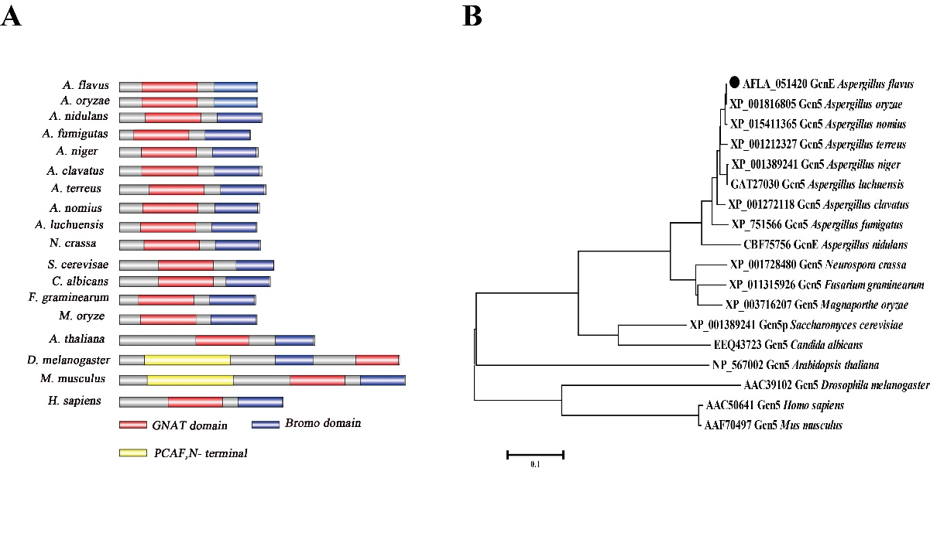
Figure S1
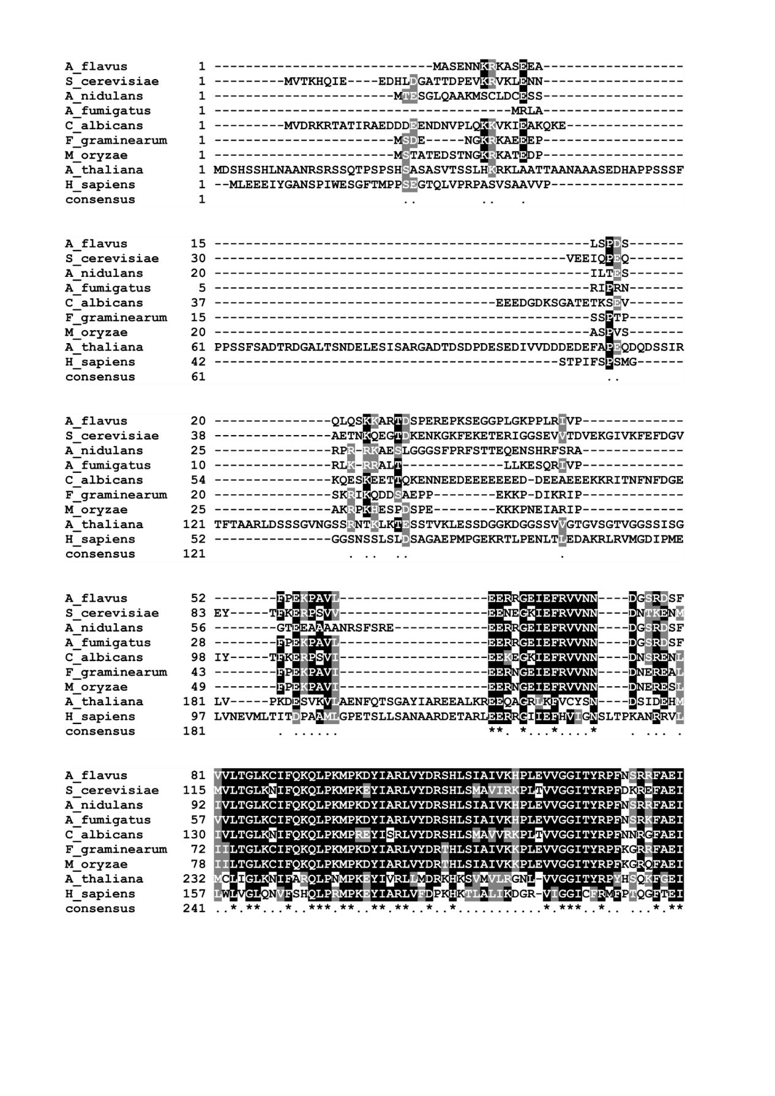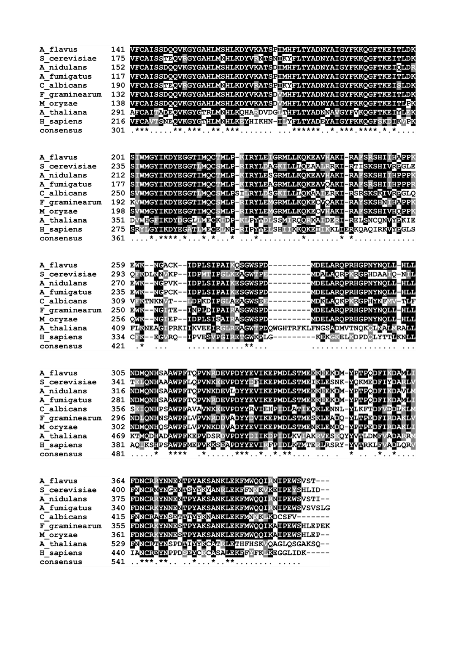
Figure. S2
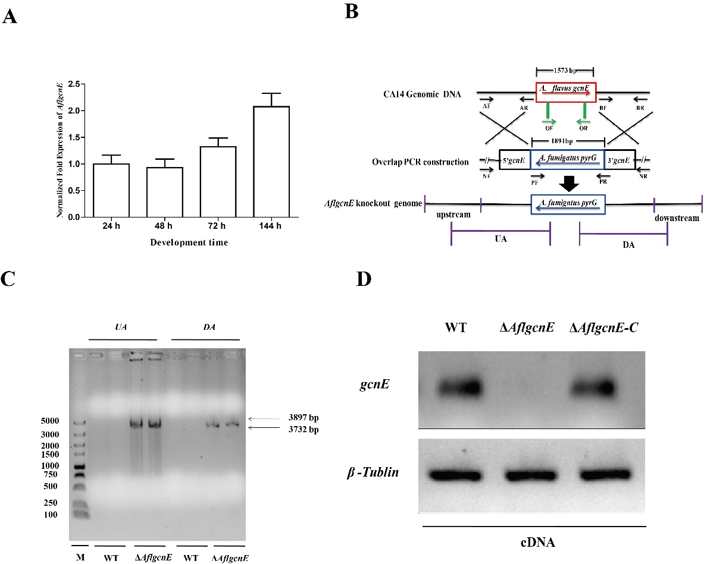
Figure. S3

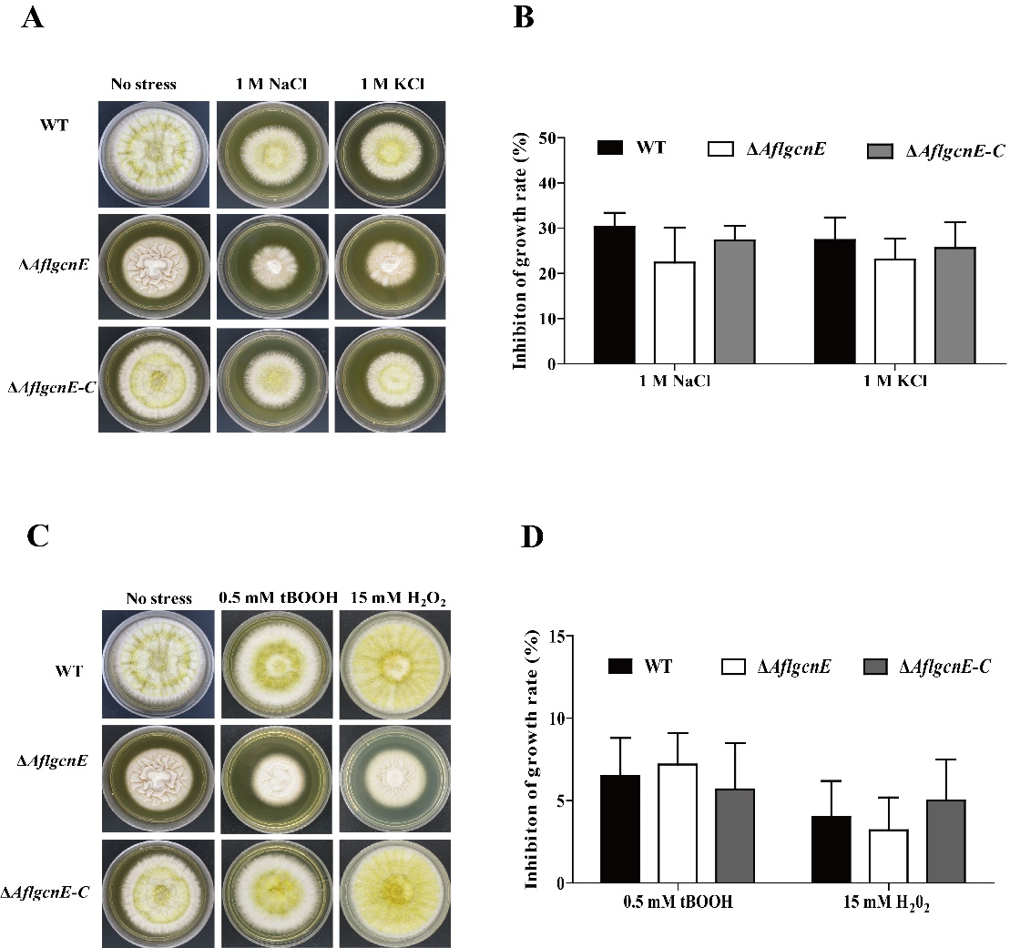
Figure. S4

