Supplementary Material

Microbial community structures of deep-sea hydrothermal vents on the ultraslow spreading Southwest Indian Ridge

Jian DING1, Yu ZHANG2, Han WANG1, Huahua JIAN1,Hao LENG1, Xiang XIAO12*

**\* Correspondence:**

Xiang XIAO  
xoxiang@sjtu.edu.cn

# Figures

Figure S1

Figure S1. Photographs of hydrothermal vent samples collected from the Longqi field at SWIR.

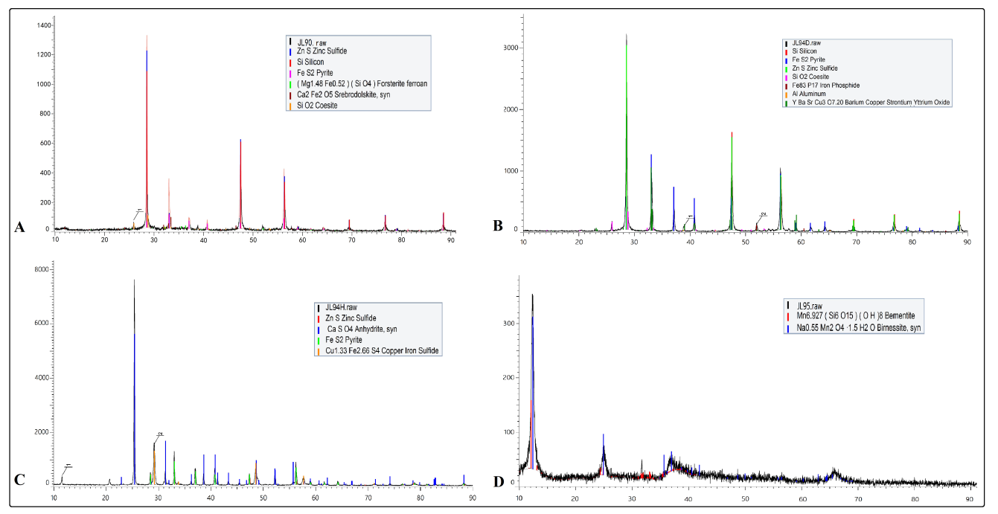

Figure S2. X-ray diffraction patterns of hydrothermal vent chimney samples colleted from the SWIR Longqi vent field.

A: JL90; B:JL94D; C:JL94H; D: JL95

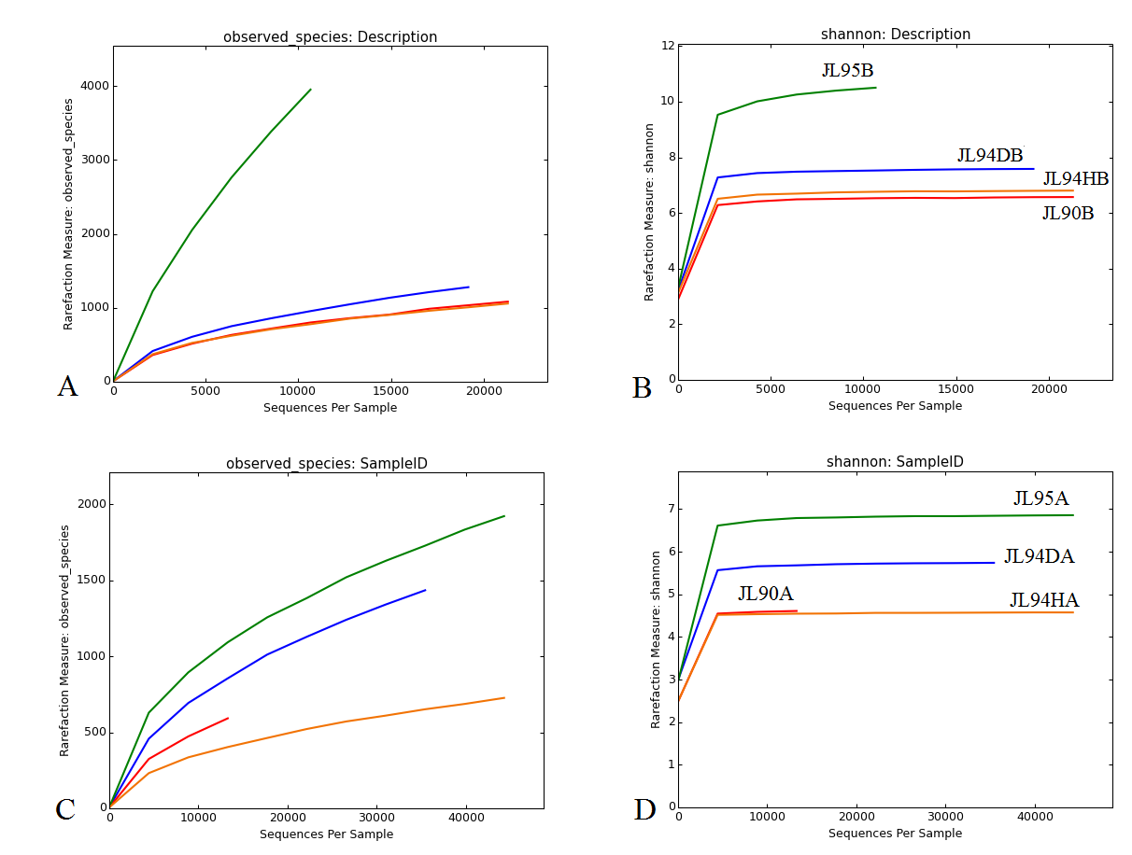

Figure S3. Rarefaction and shannon curves of bacterial (A, B) and archaeal (C, D) 16S rRNA amplicon libraries for chimney samples.

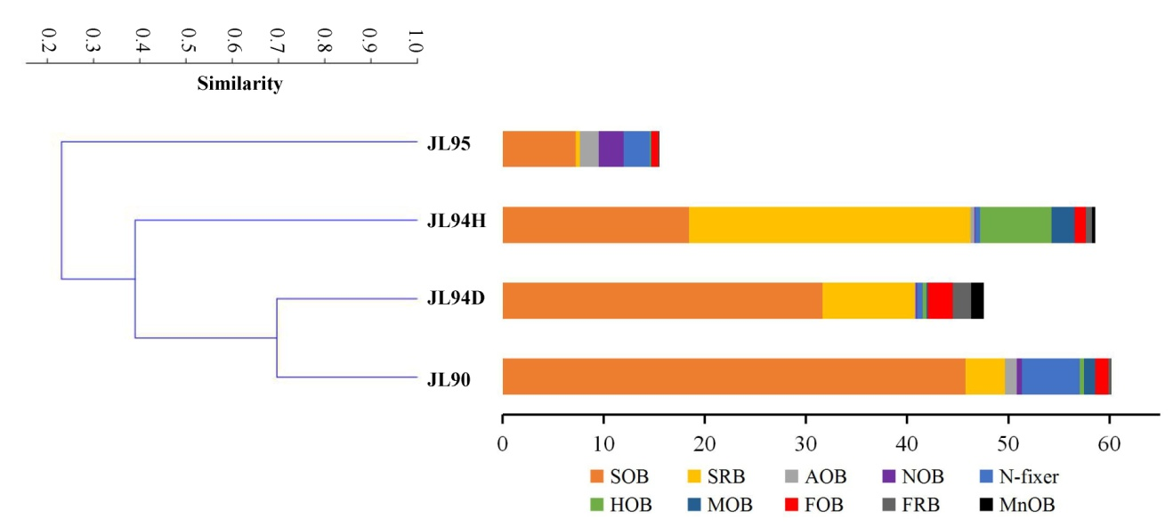

Figure S4. Clustering analysis of bacterial communitis with inferred ecologic roles. Sequence reads that matched a Silva reference database at 97% identity. SOB represents sulfur oxidizing bacterim; SRB, sulfate reducing bacterium; AOB, ammonia oxidizing bacterium; NOB, nitrite oxidizing bacterium, N-fixer, nitrogen fixation bacterium; HOB, hydrogen oxidizing bacterium; MOB, methane oxidizing bacterium; FOB, iron oxidizing bacterium; FRB, iron reducing bacterium; MnOB, manganese oxidizing bacterium; Table S1 provides more details of taxa related.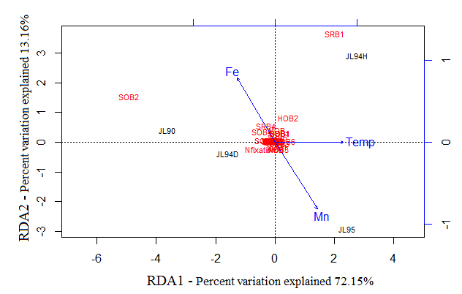

Figure S5 RDA analysis for the effect of environmental factors on bacterial communities with inferred function.

Fe: the component of iron; Temp: the temperature of fluid; Mn:the component of manganese

Figure S6

Figure S6. Venn diagrams showing the estimated OTU (97 identity threshold) richness shared among bacterial (A) and archaeal (B) communities from hydrothermal vent chimneys at Longqi field on SWIR. Shared OTU richness estimated were calculated using the program Qiime (version 1.9.0). Venn diagrams were plotted using the Venn Diagram package of R. Numbers in the Venn diagrams indicate number of OTUs. The table below the Venn diagrams showed the percent of sharing OTUs for each pair within all the four chimney samples.

# Table

Table S1 List for bacterial communities involved in the analysis of clustering and RDA

|  |  |  |  |  |  |
| --- | --- | --- | --- | --- | --- |
|  | Taxa |  | Taxa |  | Taxa |
| SOB1 | *Hydrogenivirga* | SRB5 | *Sulfurospirillum* | MOB | *Methylothermus* |
| SOB2 | *Helicobacteraceae* | SRB6 | *Thermosulfurimonas* | FOB | *Mariprofundus* |
| SOB3 | *Thiohalophilus* | AOB | *Nitrosococcus* | FRB | *Desulfuromusa* |
| SOB4 | *Thiotrichaceae* | NOB1 | *Nitrospira* | MnOB | *Roseobacter* |
| SOB5 | *Piscirickettsiaceae* | NOB2 | *Nitratifractor* |  |  |
| SOB6 | *Ectothiorhodospiraceae* | NOB3 | *Nitrosomonas* |  |  |
| SRB1 | *Thermodesulfovibrio* | N-fixer | *Rhizobiales* |  |  |
| SRB2 | *Desulfatiglans* | HOB1 | *Hydrogenobacter* |  |  |
| SRB3 | *Desulfobacteraceae* | HOB2 | *Persephonell* |  |  |
| SRB4 | *Desulfobulbaceae* | HOB3 | *Hydrogenimonas* |  |  |