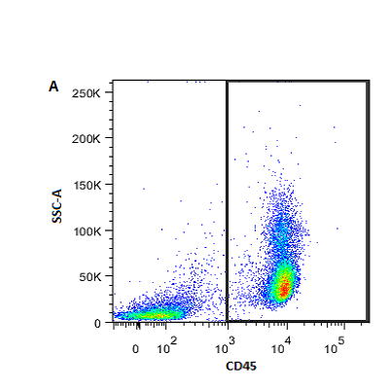 | 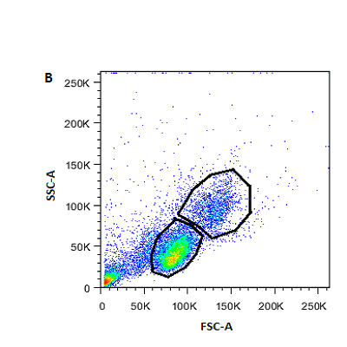 | 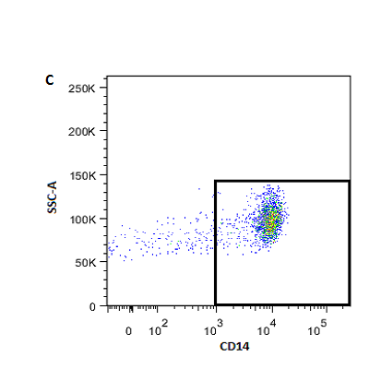
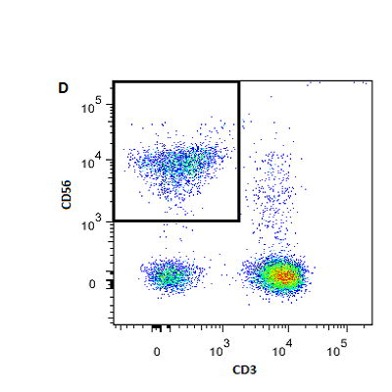 | 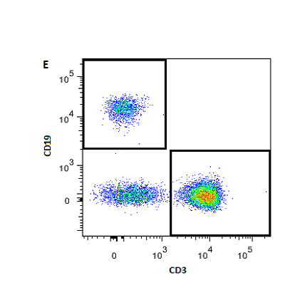 | 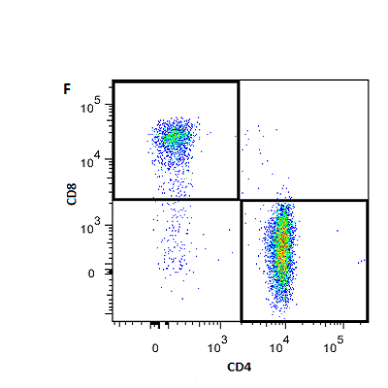
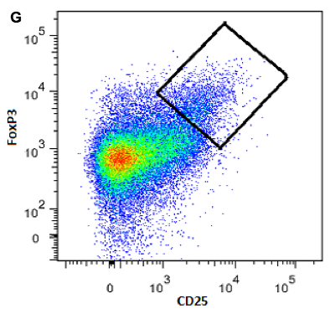 | 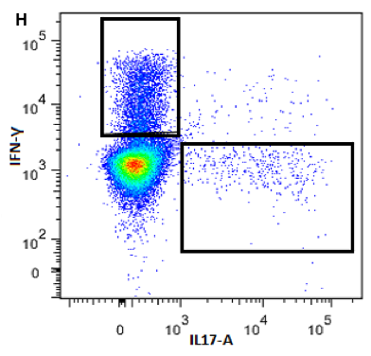 | 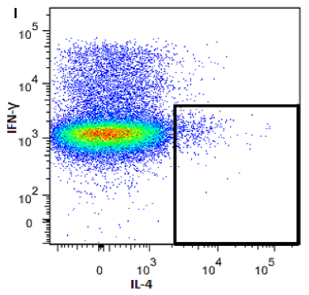

Supplementary figure 1 – gating strategies for determination of T-cells and T-cell subsets
Definition of PBMC subsets and gating strategy. (A) Selection of leukocytes. Gating was performed on CD45+ events, excluding platelets, erythrocytes and cell debris. (B) Selection of total lymphocytes (lower gate) and monocytes (upper gate) based of forward scatter (FSC-A) and side scatter (SSC-A). (C) Selection of CD14+ monocytes within the monocyte gate. (D) Selection of CD3-CD56+ natural killer cells within the lymphocyte gate. (E) Selection of T (CD3+ events, lower right gate) and B cells (CD19+ events, upper left gate) within the lymphocyte gate. (F) Selection of CD3+CD4+ T-helper cells (lower right gate) and CD3+CD8+ cytotoxic T cells (upper left gate). (G) Selection of CD3⁺CD4⁺CD25^{hi}FoxP3⁺ T-regulatory cells within the T cell gate. (H) Selection of CD3⁺CD4⁺IFN-γ⁺ Th1 cells (upper left gate) and CD3⁺CD4⁺IL17A⁺ Th17 cells (lower right gate) within the helper T cell gate. (I) Selection of CD3⁺CD4⁺IL4⁺ Th2 cells within the helper T cell gate.

Supplementary table 1. List of genes included in qPCR for determination of monocyte gene expression.
These genes have been found abnormally expressed in the monocytes in previous studies on various mood disorder patient groups (see text), some consistently, other occasionally. We therefore used the genes in this study again.
Gene | TaqMan assay ID | Corresponding protein
ADM | Hs00181605_m1 | Adrenomedulin
ATF3 | Hs00231069_m1 | Cyclic AMP-dependent transcription factor 3
BCL2A1 | Hs00187845_m1 | B cell lymphoma 2-related protein A1
BTG3 | Hs00199064_m1 | BTG family, member 3
CCL2 | Hs00234140_m1 | C-C chemokine ligand 2
CCL20 | Hs00355476_m1 | C-C chemokine ligand 20
CCL7 | Hs00171147_m1 | C-C chemokine ligand 7
CD9 | Hs00233521_m1 | Cluster of differentiation
CDC42 | Hs00741586_mH | Cell division control protein 42 homolog
CXCL2 | Hs00236966_m1 | C-X-C chemokine ligand 2
DHRS3 | Hs00191073_m1 | Short-chain dehydrogenase/reductase 3
DUSP2 | Hs00358879_m1 | Dual specificity protein phosphatase 2
EGR3 | Hs00231780_m1 | Early Growth Response 3
EMP1 | Hs00608055_m1 | Epithelial Membrane Protein 1
EREG | Hs00914313_m1 | Epiregulin
HGF | Hs00300159_m1 | Hepatocyte growth factor
HSPA1A/B | Hs00271229_s1 | Heat shock 70kDa protein 1
IFI44 | Hs00197427_m1 | Interferon Induced Protein 44
IFIT3 | Hs00382744_m1 | Interferon Induced Protein With Tetratricopeptide Repeats 3
IL1A | Hs00174092_m1 | Interleukin 1α
IL1B | Hs00174097_m1 | Interleukin 1β
IL1R1 | Hs00168392_m1 | Interleukin 1 receptor, type 1
IL6 | Hs00174131_m1 | Interleukin 6
IRAK2 | Hs00176394_m1 | Interkeukin 1 receptor-associated kinase-like 2
MAFF | Hs00202412_m1 | Musculoaponeurotic fibrosarcoma oncogene homolog F
MAPK6 | Hs00833126_g1 | Mitogen-activated protein kinase 6
MXD1 | Hs00231137_m1 | MAD protein
NAB2 | Hs00195573_m1 | Nerve growth factor-induced protein A-binding protein 2
NR3C1α | Hs00353740_m1 | Nuclear Receptor Subfamily 3 Group C Member 1 α (glucocorticoid receptor α)
NR3C1β | Hs00354508_m1 | Nuclear Receptor Subfamily 3 Group C Member 1 β (glucocorticoid receptor β)
PDE4B | Hs00387320_m1 | cAMP-specific 3',5'-cyclic phosphodiesterase 4B
PTGS2 | Hs00153133_m1 | Prostoglandin G/H synthase (cyclooxygenase)
PTPN7 | Hs00160732_m1 | Protein tyrosine phosphatase, non-receptor type 7
PTX3 | Hs00173615_m1 | Pentraxin-related protein 3
SERPINB2 | Hs00234032_m1 | Plasminogen activator inhibitor-2
STX1A | Hs00270282_m1 | Syntaxin-1A
THBD | Hs00264920_s1 | Thrombomodulin
TNF | Hs00174128_m1 | Tumor nectoris factor
TNFAIP3 | Hs00234712_m1 | Tumor nectoris factor, alpha-induced protein 3
Supplementary table 2. Principle component analysis for grouping of monocytes.
Shown are the pattern matrices, numbers are the correlations between the genes and components. Three fixed factors were extracted for both the HC and BD analyses, using oblimin rotation with a maximum of 25 iterations and listwise deletion of participants without complete data for all included genes.
The three found clusters in principle component analysis were largely similar to the clusters found in our previous studies on mood disorder patients (see text), though some of the lower ranking genes of cluster 1 (like HSPA1A/B) and of cluster 2 (like CD9) in the previous studies did not belong to these clusters in the present study anymore. We assume that in this study the power is insufficient to assign these genes to the molecular pathways due to their loose connection to the pathway.
 | Component
 | 1 | 2 | 3
IL1B | .978 | -.105 | -.125
CCL20 | .937 | -.048 | -.049
IL6 | .907 | -.043 | -.125
TNFAIP3 | .870 | -.282 | .136
CXCL2 | .739 | .332 | -.025
PDE4B | .734 | -.053 | .127
EREG | .731 | .252 | -.023
ATF3 | .719 | .054 | -.069
IL1A | .678 | .166 | .093
PTX3 | .652 | .403 | .077
PTGS2 | .609 | .177 | .195
DUSP2 | .578 | .422 | .008
TNF | .566 | .041 | -.094
ADM | .505 | .344 | -.128
BCL2A1 | .435 | .382 | -.203
CCL7 | -.046 | .961 | .128
NAB2 | -.104 | .952 | -.046
PTPN7 | -.056 | .921 | -.019
CCL2 | -.109 | .895 | .408
STX1A | .057 | .878 | -.175
THBD | -.033 | .801 | -.192
MAFF | .156 | .755 | .183
IRAK2 | .250 | .733 | .015
MAPK6 | .175 | .664 | -.034
DHRS3 | .034 | .637 | -.036
BTG3 | .344 | .605 | .105
SERPINB2 | .314 | .526 | .150
MXD1 | .341 | .519 | .181
IL1R1 | .082 | .485 | -.058
CDC42 | .371 | .447 | -.332
HSPA1A/B | .210 | -.301 | .159
CD9 | .121 | .257 | -.212
IFIT3 | -.085 | -.027 | .934
IFI44 | .053 | .168 | .861

Supplementary table 3. Complete results of the comparison of monocyte gene expression between BD patients and HC. Results are expressed as fold change relative to HC.
GENE | MEAN | 95% CI |  |  | P-VALUE
Cluster 1
IL1B | 0.72 | -0.76 | - | -0.17 | <0.001
CCL20 | 0.58 | -1.22 | - | -0.35 | <0.001
IL6 | 0.76 | -0.71 | - | -0.06 | .020
TNFAIP3 | 0.79 | -0.48 | - | -0.20 | <0.001
CXCL2 | 0.66 | -0.92 | - | -0.27 | <0.001
PDE4B | 0.83 | -0.45 | - | -0.10 | <0.001
EREG | 0.71 | -0.78 | - | -0.22 | <0.001
ATF3 | 1.08 | -0.06 | - | 0.28 | .210
IL1A | 0.62 | -1.02 | - | -0.35 | <0.001
PTX3 | 0.79 | -0.50 | - | -0.16 | <0.001
PTGS2 | 0.85 | -0.43 | - | -0.03 | .030
DUSP2 | 0.75 | -0.64 | - | -0.17 | <0.001
TNF | 0.79 | -0.53 | - | -0.14 | <0.001
ADM | 0.97 | -0.18 | - | 0.10 | .590
BCL2A1 | 0.84 | -0.46 | - | -0.03 | .030
Cluster 2
CCL7 | 0.93 | -0.62 | - | 0.40 | .670
NAB2 | 0.80 | -0.59 | - | -0.06 | .020
PTPN7 | 1.02 | -0.11 | - | 0.18 | .660
CCL2 | 1.05 | -0.29 | - | 0.43 | .700
STX1A | 0.97 | -0.37 | - | 0.26 | .750
THBD | 0.95 | -0.26 | - | 0.10 | .380
MAFF | 0.77 | -0.60 | - | -0.14 | <0.001
IRAK2 | 0.68 | -0.82 | - | -0.29 | <0.001
MAPK6 | 0.91 | -0.24 | - | -0.03 | .010
DHRS3 | 0.79 | -0.52 | - | -0.17 | <0.001
BTG3 | 1.00 | -0.12 | - | 0.13 | .960
SERPINB2 | 0.92 | -0.33 | - | 0.10 | .290
MXD1 | 1.05 | -0.02 | - | 0.17 | .120
IL1R1 | 1.11 | -0.04 | - | 0.34 | .110
CDC42 | 0.97 | -0.17 | - | 0.09 | .560
Interferon
IFIT3 | 1.04 | -0.16 | - | 0.26 | .630
IFI44 | 1.01 | -0.15 | - | 0.18 | .860
Other
HSPA1A/B | 0.98 | -0.11 | - | 0.07 | .610
CD9 | 1.18 | -0.05 | - | 0.52 | .100
Hepatocyte growth factor | 1.10 | 0.04 | - | 0.23 | <0.001
Glucocorticoïd receptors
GRα | 1.03 | 0.00 | - | 0.10 | .040
GRβ | 0.97 | -0.20 | - | 0.12 | .630

