Supplementary Material

Revisiting the neural basis of acquired amusia: Lesion patterns and structural changes underlying amusia recovery
Aleksi J. Sihvonen^{1,2}, Pablo Ripollés^{3,4,5}, Antoni Rodríguez-Fornells^{3,4,6}, Seppo Soinila⁷, and Teppo Särkämö².
¹Faculty of Medicine, University of Turku, 20520 Turku, Finland
²Cognitive Brain Research Unit, Department of Psychology and Logopedics, Faculty of Medicine, University of Helsinki, 00014 Helsinki, Finland
³Cognition and Brain Plasticity Group, Bellvitge Biomedical Research Institute (IDIBELL), L’Hospitalet de Llobregat, 08907 Barcelona, Spain
⁴Department of Cognition, Development and Education Psychology, University of Barcelona, 08035 Barcelona, Spain
⁵Poeppel Lab, Department of Psychology, New York University, 10003 NY, USA
⁶Catalan Institution for Research and Advanced Studies, ICREA, Barcelona, Spain
⁷Division of Clinical Neurosciences, Turku University Hospital and Department of Neurology, University of Turku, 20521, Turku, Finland.
*Correspondence: Dr. Aleksi J. Sihvonen: ajsihv@utu.fi

1. Results
1.1 Voxel-based morphometry: replication cohort
1.1.1 Grey and white matter volume: amusia
Using longitudinal VBM, we first evaluated GMV changes in the replication cohort from Turku. There were significant Time (6 months > Acute) interactions for following group contrasts: NA > NRA, RA > NRA, and NA > RA. The NRA group showed greater GMV decrease in right temporal (STG), frontal [middle frontal gyrus (MFG), IFG], subcortical (putamen), and limbic (amygdala, hippocampus) structures as well as in the right insula than either the NA or the RA groups (Supplementary Table 1, Supplementary Figure 1A and 1C). Additionally, compared to the NAs, the NRAs had greater GMV decrease in the right temporal [MTG, Heschl’s gyrus (HG), inferior temporal gyrus (ITG)], frontal [precentral gyrus (PreCG)], and subcortical (caudate, and thalamus) regions as well as in limbic areas [parahippocampal gyrus (PHG)]. The RA group had greater GMV decrease in the right parietal lobe [inferior parietal lobule (IPL), postcentral gyrus (PCG)] than the NA group, as shown by a Time (6 months > Acute) x Group (NA > RA) interaction (Supplementary Table 1, Supplementary Figure 1B).
A longitudinal VBM analysis for WMV changes yielded significant Time (6 months > Acute) x Group interactions for NA > NRA and NA > RA. The NRAs had greater WMV decrease in the right temporal (STG, MTG, ITG), frontal (PreCG, PCG, IFG), subcortical (putamen, caudate, thalamus) regions as well as in the right insula and hippocampus than the NAs (Supplementary Table 2, Supplementary Figure 2A). The RAs showed greater WMV decrease in the right frontoparietal (IPL, PreCG, and PCG) areas than the NAs (Supplementary Table 2, Supplementary Figure 2B).

1.1.2 Grey and white matter volume: pitch amusia
In the Scale subtest, compared to the NAs, the NRAs showed greater GMV decrease in right temporal (STG, HG), frontal [MFG, IFG, PreCG], subcortical (putamen, caudate), and limbic (amygdala, hippocampus) regions as well as in the right insula (Supplementary Table 3, Supplementary Figure 3A). In contrast, the RAs showed greater GMV decrease in the right thalamus, caudate, and IPL compared to the NAs (Supplementary Table 3, Supplementary Figure 3B).
Longitudinally, compared to the NAs, the NRAs showed greater WMV decrease in right temporal (STG, MTG, ITG), frontal [MFG, PreCG], subcortical (putamen, caudate, GP), and limbic (thalamus, hippocampus, PHG) regions as well as in the right insula and PCG and the midbrain (Supplementary Table 4, Supplementary Figure 4A).

1.1.3 Grey and white matter volume: rhythm amusia
In the Rhythm subtest, the NRAs showed greater GMV decrease in right temporal (STG, MTG, fusiform gyrus), frontal [IFG], subcortical (caudate), and limbic (amygdala, hippocampus, PHG) regions compared to the NAs (Supplementary Table 5, Supplementary Figure 5A). In contrast, compared to the NA group, the RAs showed greater GMV decrease in the right PCG, left precuneus, and bilaterally in the IPL (Supplementary Table 5, Supplementary Figure 5B).
Significant Time (6 months > Acute) x Group interactions in WMV were found in NA > NRA and NA > RA. Compared to the NAs, the NRAs showed greater WMV decrease in the midbrain and bilaterally in the cerebellum as well as in right inferior temporal (ITG, fusiform gyrus), subcortical (caudate), and limbic (thalamus, hippocampus, PHG) regions (Supplementary Table 6, Supplementary Figure 6A). The RAs showed greater WMW decrease in the right PCG and paracentral lobule compared to the NAs (Supplementary Table 6, Supplementary Figure 6B).
2. Tables and Figures
Supplementary Table 1 Grey matter volume decreases (6-month stage – acute stage) in amusia: Turku cohort.

6 MONTHS > ACUTE
Condition | Supplementary Figure 1 panel | Area name | Coordinates | Cluster size | t-value
Non-amusic >  Non-recovered amusic | A | Right Amygdala | 25 -1 -20 | 68942 | 5.26**
Non-amusic >  Non-recovered amusic | A | Right Inferior Frontal Gyrus (BA 13, 45, 47) | 37 20 -12
Non-amusic >  Non-recovered amusic | A | Right Middle Frontal Gyrus (BA 9, 10) | 42 13 36
Non-amusic >  Non-recovered amusic | A | Right Superior Temporal Gyrus (BA 22, 38, 42) | 38 21 -32
Non-amusic >  Non-recovered amusic | A | Right Heschl’s Gyrus (BA 41) | 53 -19 12
Non-amusic >  Non-recovered amusic | A | Right Middle Temporal Gyrus (BA 21, 38) | 47 10 -33
Non-amusic >  Non-recovered amusic | A | Right Inferior Temporal Gyrus (BA 20) | 51 -2 -33
Non-amusic >  Non-recovered amusic | A | Right Insula (BA 13) | 41 11 -7
Non-amusic >  Non-recovered amusic | A | Right Precentral Gyrus (BA 43) | 62 -8 12
Non-amusic >  Non-recovered amusic | A | Right Parahippocampal Gyrus (BA 35) | 21 -21 -18
Non-amusic >  Non-recovered amusic | A | Right Putamen | 17 10 -7
Non-amusic >  Non-recovered amusic | A | Right Hippocampus | 20 -12 -18
Non-amusic >  Non-recovered amusic | A | Right Caudate | 14 9 16 | 8852 | 5.26**
Non-amusic >  Non-recovered amusic | A | Right Thalamus | 5 -10 15
Non-amusic >  Recovered amusic | B | Right Inferior Parietal Lobule (BA 40) | 60 -33 46 | 6249 | 5.22**
Non-amusic >  Recovered amusic | B | Right Postcentral Gyrus (BA 2) | 65 -28 35
Recovered amusic >  Non-recovered amusic | C | Right Amygdala | 23 0 -24 | 3768 | 4.23*
Recovered amusic >  Non-recovered amusic | C | Right Hippocampus | 27 -8 -22
Recovered amusic >  Non-recovered amusic | C | Right Putamen | 16 10 -6
Recovered amusic >  Non-recovered amusic | C | Right Superior Temporal Gyrus (BA 38) | 37 18 -28
Recovered amusic >  Non-recovered amusic | C | Right Inferior Frontal Gyrus (BA 44, 45, 47) | 52 15 18 | 9344 | 3.70**
Recovered amusic >  Non-recovered amusic | C | Right Middle Frontal Gyrus (BA 9) | 47 20 38
Recovered amusic >  Non-recovered amusic | C | Right Insula (BA 13) | 46 11 5
Recovered amusic >  Non-recovered amusic | C | Right Superior Temporal Gyrus (BA 22) | 54 1 4
*p < 0.05 FWE-corrected at the cluster level
**p < 0.005 FWE-corrected at the cluster level
BA = Brodmann area

Supplementary Table 2 White matter volume decreases (6-month stage – acute stage) in amusia: Turku cohort.

6 MONTHS > ACUTE
Condition | Supplementary Figure 2 panel | Area name | Coordinates | Cluster size | t-value
Non-amusic >  Non-recovered amusic | A | Right Inferior Temporal Gyrus | 17 0 16 | 61962 | 5.84*
Non-amusic >  Non-recovered amusic | A | Right Superior Temporal Gyrus | 58 -24 3
Non-amusic >  Non-recovered amusic | A | Right Middle Temporal Gyrus | 53 -41 3
Non-amusic >  Non-recovered amusic | A | Right Precentral Gyrus | 53 -10 28
Non-amusic >  Non-recovered amusic | A | Right Postcentral Gyrus | 58 -21 32
Non-amusic >  Non-recovered amusic | A | Right Inferior Frontal Gyrus | 53 9 9
Non-amusic >  Non-recovered amusic | A | Right Putamen | 26 -10 6
Non-amusic >  Non-recovered amusic | A | Right Caudate | 13 9 5
Non-amusic >  Non-recovered amusic | A | Right Insula | 34 -12 17
Non-amusic >  Non-recovered amusic | A | Right Thalamus | 16 -21 17
Non-amusic >  Non-recovered amusic | A | Right Hippocampus | 22 -30 -5
Non-amusic > Recovered amusic | B | Right Postcentral Gyrus | 23 -35 50 | 6423 | 4.73*
Non-amusic > Recovered amusic | B | Right Precentral Gyrus | 38 -30 64
Non-amusic > Recovered amusic | B | Right Inferior Parietal Lobule | 34 -52 56
*p < 0.005 FWE-corrected at the cluster level

Supplementary Table 3 Grey matter volume decreases (6-month stage – acute stage) in pitch amusia: Turku cohort.
6 MONTHS > ACUTE
Condition | Figure 3 panel | Area name | Coordinates | Cluster size | t-value
Non-amusic >  Non-recovered amusic | A | Right Caudate | 15 5 21 | 61511 | 5.61**
Non-amusic >  Non-recovered amusic | A | Right Insula (BA 13) | 43 -1 -4
Non-amusic >  Non-recovered amusic | A | Right Inferior Frontal Gyrus (BA 44, 47) | 52 22 22
Non-amusic >  Non-recovered amusic | A | Right Middle Frontal Gyrus (BA 8, 11, 46, 47) | 52 49 -7
Non-amusic >  Non-recovered amusic | A | Right Superior Temporal Gyrus (BA 22, 38) | 49 -3 0
Non-amusic >  Non-recovered amusic | A | Right Heschl’s Gyrus (BA 41) | 52 -19 10
Non-amusic >  Non-recovered amusic | A | Right Precentral Gyrus (BA 6) | 65 0 24
Non-amusic >  Non-recovered amusic | A | Right Hippocampus | 27 -10 -19
Non-amusic >  Non-recovered amusic | A | Right Amygdala | 27 5 -20
Non-amusic >  Recovered amusic | B | Right Thalamus | 4 -12 0 | 4098 | 4.79*
Non-amusic >  Recovered amusic | B | Right Caudate | 19 -14 23
Non-amusic >  Recovered amusic | B | Right Inferior Parietal Lobule (BA 40) | 59 -41 39 | 2877 | 3.84*
*p < 0.05 FWE-corrected at the cluster level
**p < 0.005 FWE-corrected at the cluster level
BA = Brodmann area

Supplementary Table 4 White matter volume decreases (6-month stage – acute stage) in pitch amusia: Turku cohort.
6 MONTHS > ACUTE
Condition | Supplementary Figure 4 panel | Area name | Coordinates | Cluster size | t-value
Non-amusic >  Non-recovered amusic | A | Right Caudate | 17 0 16 | 58608 | 6.16*
Non-amusic >  Non-recovered amusic | A | Right Superior Temporal Gyrus | 52 -31 7
Non-amusic >  Non-recovered amusic | A | Right Middle Temporal Gyrus | 50 -23 -9
Non-amusic >  Non-recovered amusic | A | Right Inferior Temporal Gyrus | 56 -27 -17
Non-amusic >  Non-recovered amusic | A | Right Insula | 35 -21 18
Non-amusic >  Non-recovered amusic | A | Right Precentral Gyrus | 55 -3 23
Non-amusic >  Non-recovered amusic | A | Right Postcentral Gyrus | 56 -16 17
Non-amusic >  Non-recovered amusic | A | Right Inferior Frontal Gyrus | 23 25 -16
Non-amusic >  Non-recovered amusic | A | Right Parahippocampal Gyrus | 27 -28 -17
Non-amusic >  Non-recovered amusic | A | Right Hippocampus | 33 -28 -7
Non-amusic >  Non-recovered amusic | A | Right Midbrain | 10 -16 -19
Non-amusic >  Non-recovered amusic | A | Right Putamen | 28 14 3
Non-amusic >  Non-recovered amusic | A | Right Globus Pallidus | 19 -4 -2
Non-amusic >  Non-recovered amusic | A | Right Thalamus | 9 -4 6
Non-amusic > Recovered amusic | B | Right Insula | 30 -21 15 | 12395 | 4.75*
Non-amusic > Recovered amusic | B | Right Inferior Parietal Lobule | 30 -50 40
Non-amusic > Recovered amusic | B | Right Precuneus | 19 -50 40
Non-amusic > Recovered amusic | B | Right Superior Temporal Gyrus | 54 -36 14
Non-amusic > Recovered amusic | B | Right Putamen | 27 -12 10
Non-amusic > Recovered amusic | B | Right Caudate | 19 6 24 | 4851 | 3.86*
Non-amusic > Recovered amusic | B | Right Globus Pallidus | 19 -4 7
*p < 0.005 FWE-corrected at the cluster level

Supplementary Table 5 Grey matter volume decreases (6-month stage – acute stage) in rhythm amusia: Turku cohort.
6 MONTHS > ACUTE
Condition | Supplementary Figure 5 panel | Area name | Coordinates | Cluster size | t-value
Non-amusic >  Non-recovered amusic | A | Right Middle Temporal Gyrus (BA 38) | 40 6 -41 | 37033 | 5.33**
Non-amusic >  Non-recovered amusic | A | Right Superior Temporal Gyrus (BA 22, 38) | 38 14 -39
Non-amusic >  Non-recovered amusic | A | Right Fusiform Gyrus (BA 36) | 28 -6 -39
Non-amusic >  Non-recovered amusic | A | Right Inferior Frontal Gyrus (BA 9, 44, 45, 47) | 61 10 7
Non-amusic >  Non-recovered amusic | A | Right Parahippocampal Gyrus (BA 35) | 28 -28 -23
Non-amusic >  Non-recovered amusic | A | Right Hippocampus | 24 -5 -20
Non-amusic >  Non-recovered amusic | A | Right Amygdala | 25 -3 -23
Non-amusic >  Non-recovered amusic | A | Right Caudate | 11 14 9
Non-amusic >  Recovered amusic | B | Right Postcentral Gyrus (BA 1, 2) | 46 -30 41 | 5430 | 4.23**
Non-amusic >  Recovered amusic | B | Right Inferior Parietal Lobule (BA 40) | 43 -32 41
Non-amusic >  Recovered amusic | B | Left Precuneus (BA 7, 31) | -12 -50 40 | 3612 | 3.87*
Non-amusic >  Recovered amusic | B | Left Inferior Parietal Lobule (BA 40) | -39 -55 41
*p < 0.05 FWE-corrected at the cluster level
**p < 0.005 FWE-corrected at the cluster level
BA = Brodmann area

Supplementary Table 6 White matter volume decreases (6-month stage – acute stage) in rhythm amusia: Turku cohort.
6 MONTHS > ACUTE
Condition | Supplementary Figure 6 panel | Area name | Coordinates | Cluster size | t-value
Non-amusic >  Non-recovered amusic | A | Midbrain and pons | -11 -33 -41 | 8455 | 4.84*
Non-amusic >  Non-recovered amusic | A | Left Cerebellum | -19 -47 -44
Non-amusic >  Non-recovered amusic | A | Right Cerebellum | 22 -34 -33
Non-amusic >  Non-recovered amusic | A | Right Fusiform Gyrus | 30 -50 -6 | 10162 | 4.10*
Non-amusic >  Non-recovered amusic | A | Right Inferior Temporal Gyrus | 41 -5 -32
Non-amusic >  Non-recovered amusic | A | Right Parahippocampal Gyrus | 36 -18 -20
Non-amusic >  Non-recovered amusic | A | Right Hippocampus | 30 -25 2
Non-amusic >  Non-recovered amusic | A | Right Thalamus | 23 -32 7
Non-amusic >  Non-recovered amusic | A | Right Caudate | 8 5 2
Non-amusic > Recovered amusic | B | Right Postcentral Gyrus | 33 -27 49 | 6933 | 4.61*
Non-amusic > Recovered amusic | B | Right Paracentral Lobule | 28 -26 59
*p < 0.005 FWE-corrected at the cluster level
Supplementary Figure 1 Grey matter VBM results of Turku patients: amusia.
Time (6 months > Acute) x Group interactions for grey matter volume. (A) Non-amusic vs. non-recovered amusics; (B) Non-amusic vs. recovered amusics; (C) Recovered vs. non-recovered amusics. Results are thresholded at a whole-brain uncorrected p < 0.005 at the voxel level (extent threshold: k > 100 voxels) using MNI coordinates. Only clusters surviving an FWE-corrected p < 0.05 threshold are reported and labelled (see also Supplementary Table 1). Bar plots for GMV differences in 6 months – Acute in significant clusters (Supplementary Table 1) are shown: bar = mean, error-bar = standard error of the mean. CAU = caudate, HG = Heschl's gyrus, IFG = inferior frontal gyrus, INS = insula, IPL = inferior parietal lobule, MFG = middle frontal gyrus, MTG = middle temporal gyrus, PCG = postcentral gyrus, PreCG = precentral gyrus, PUT = putamen, STG = superior temporal gyrus.
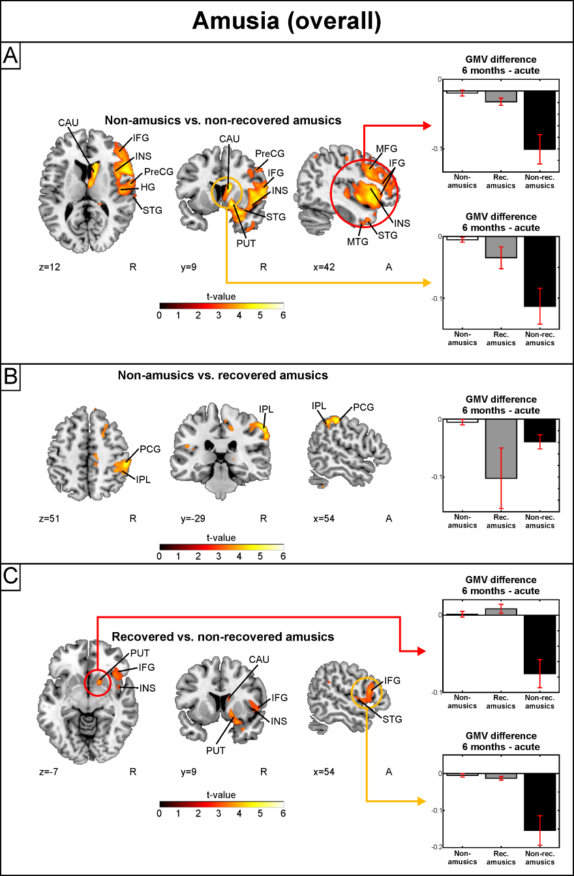
Supplementary Figure 2 White matter VBM results of Turku patients: amusia.
Time (6 months > Acute) x Group interactions for white matter volume. (A) Non-amusic vs. non-recovered amusics; (B) Non-amusic vs. recovered amusics. Results are thresholded at a whole-brain uncorrected p < 0.005 at the voxel level (extent threshold: k > 100 voxels) using MNI coordinates. Only clusters surviving an FWE-corrected p < 0.05 threshold are reported and labelled (see also Supplementary Table 2). Bar plots for GMV differences in 6 months – Acute in significant clusters (Supplementary Table 2) are shown: bar = mean, error-bar = standard error of the mean. CAU = caudate, HIP = hippocampus, IFG = inferior frontal gyrus, INS = insula, IPL = inferior parietal lobule, MTG = middle temporal gyrus, PCG = postcentral gyrus, PUT = putamen, PreCG = precentral gyrus, STG = superior temporal gyrus, THA = thalamus.
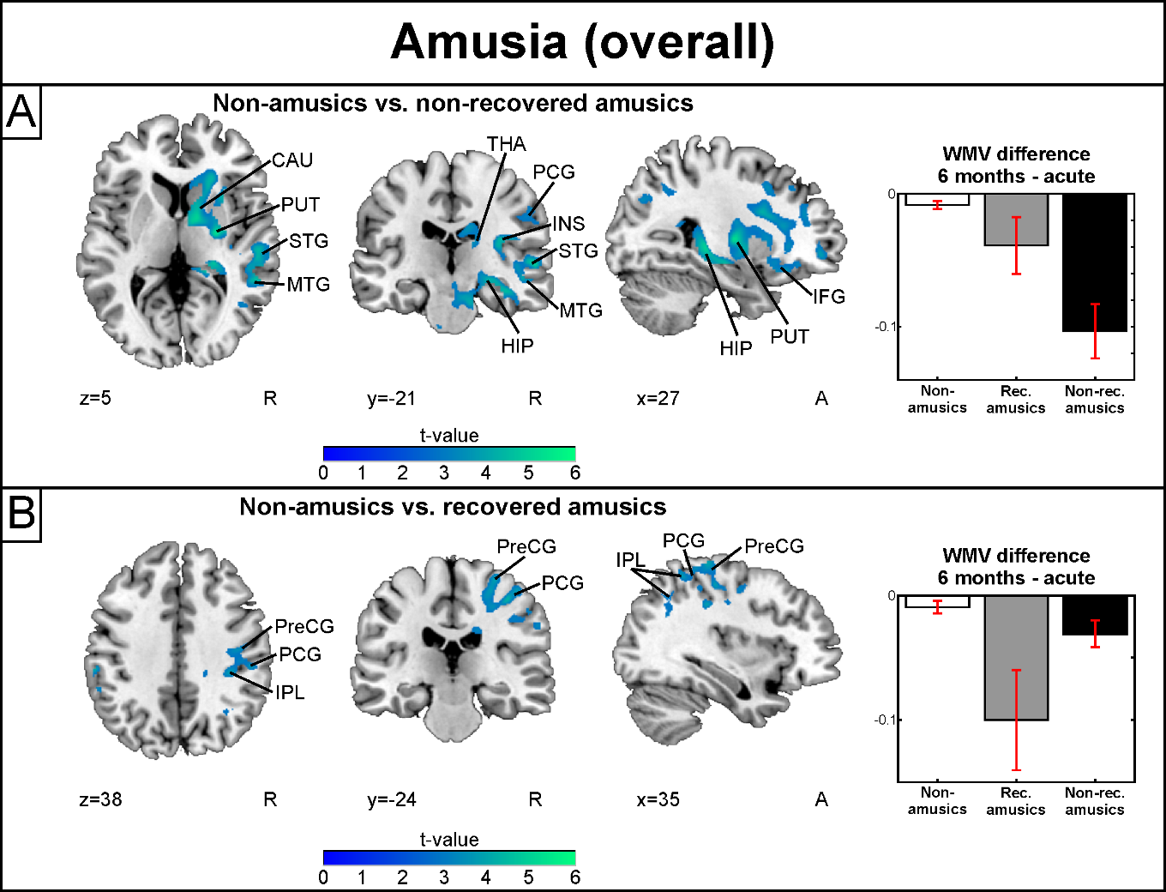
Supplementary Figure 3 Grey matter VBM results of Turku patients: pitch amusia.
Time (6 months > Acute) x Group interactions for grey matter volume. (A) Non-amusic vs. non-recovered amusics; (B) Non-amusic vs. recovered amusics. Results are thresholded at a whole-brain uncorrected p < 0.005 at the voxel level (extent threshold: k > 100 voxels) using MNI coordinates. Only clusters surviving an FWE-corrected p < 0.05 threshold are reported and labelled (see also Supplementary Table 3). Bar plots for GMV differences in 6 months – Acute in significant clusters (Supplementary Table 3) are shown: bar = mean, error-bar = standard error of the mean. AMY = amygdala, CAU = caudate, HG = Heschl’s gyrus, HIP = hippocampus, IFG = inferior frontal gyrus, INS = insula, IPL = inferior parietal lobule, MFG = middle frontal gyrus, PreCG = precentral gyrus, STG = superior temporal gyrus, THA = thalamus.
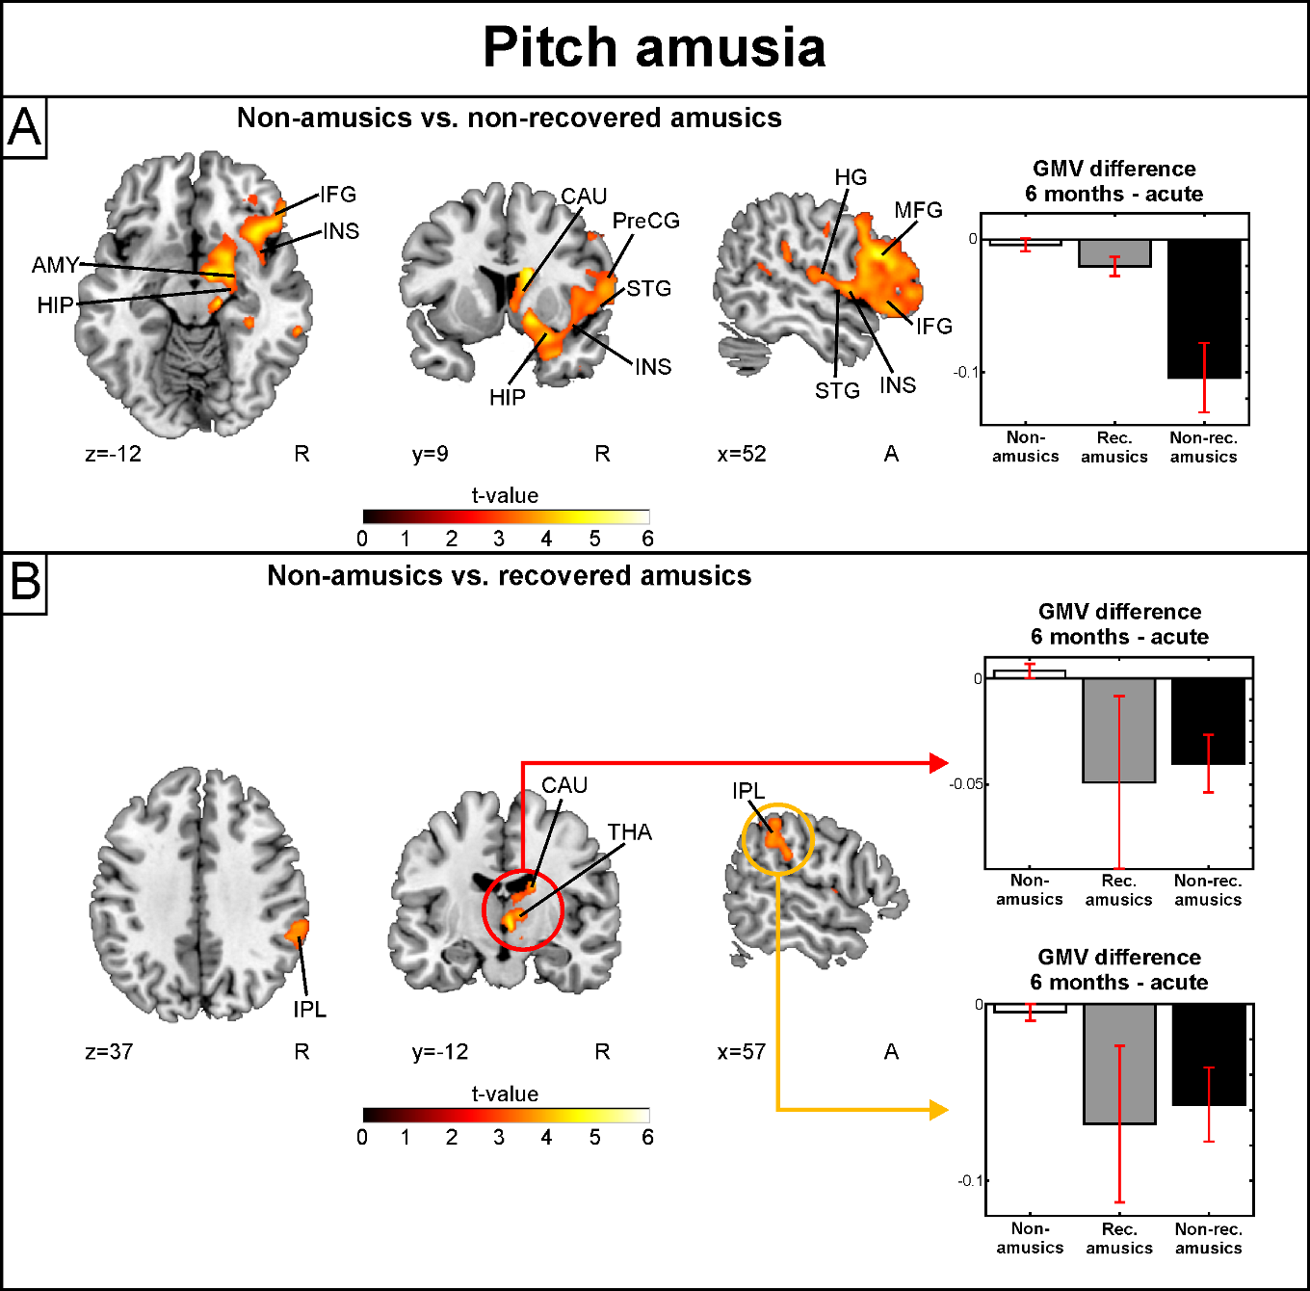
Supplementary Figure 4 White matter VBM results of Turku patients: pitch amusia.
Time (6 months > Acute) x Group interactions for white matter volume. (A) Non-amusic vs. non-recovered amusics; (B) Non-amusic vs. recovered amusics. Results are thresholded at a whole-brain uncorrected p < 0.005 at the voxel level (extent threshold: k > 100 voxels) using MNI coordinates. Only clusters surviving an FWE-corrected p < 0.05 threshold are reported and labelled (see also Supplementary Table 4). Bar plots for GMV differences in 6 months – Acute in significant clusters (Supplementary Table 4) are shown: bar = mean, error-bar = standard error of the mean. CAU = caudate, GP = globus pallidus, HIP = hippocampus, INS = insula, IFG = inferior frontal gyrus, IPL = inferior parietal lobule, ITG = inferior temporal gyrus, MTG = middle temporal gyrus, PCG = postcentral gyrus, PreCG = precentral gyrus, PUT = putamen, STG = superior temporal gyrus.
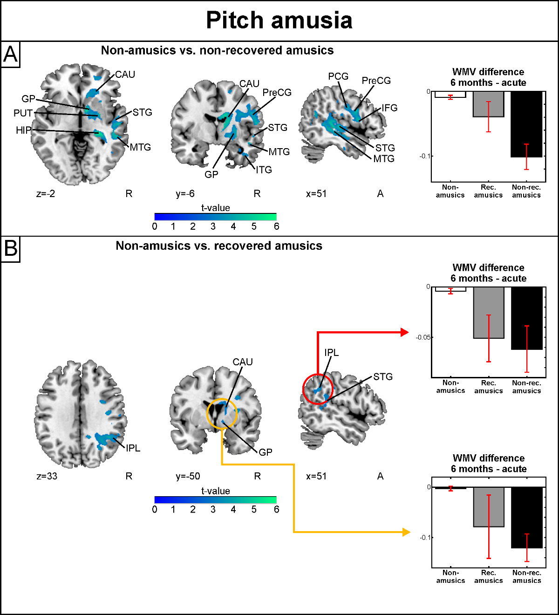
Supplementary Figure 5 Grey matter VBM results of Turku patients: rhythm amusia.
Time (6 months > Acute) x Group interactions for grey matter volume. (A) Non-amusic vs. non-recovered amusics; (B) Non-amusic vs. recovered amusics. Results are thresholded at a whole-brain uncorrected p < 0.005 at the voxel level (extent threshold: k > 100 voxels) using MNI coordinates. Only clusters surviving an FWE-corrected p < 0.05 threshold are reported and labelled (see also Supplementary Table 5). Bar plots for GMV differences in 6 months – Acute in significant clusters (Supplementary Table 5) are shown: bar = mean, error-bar = standard error of the mean. CAU = caudate, IFG = inferior frontal gyrus, INS = insula, IPL = inferior parietal lobule, PCG = postcentral gyrus, STG = superior temporal gyrus.
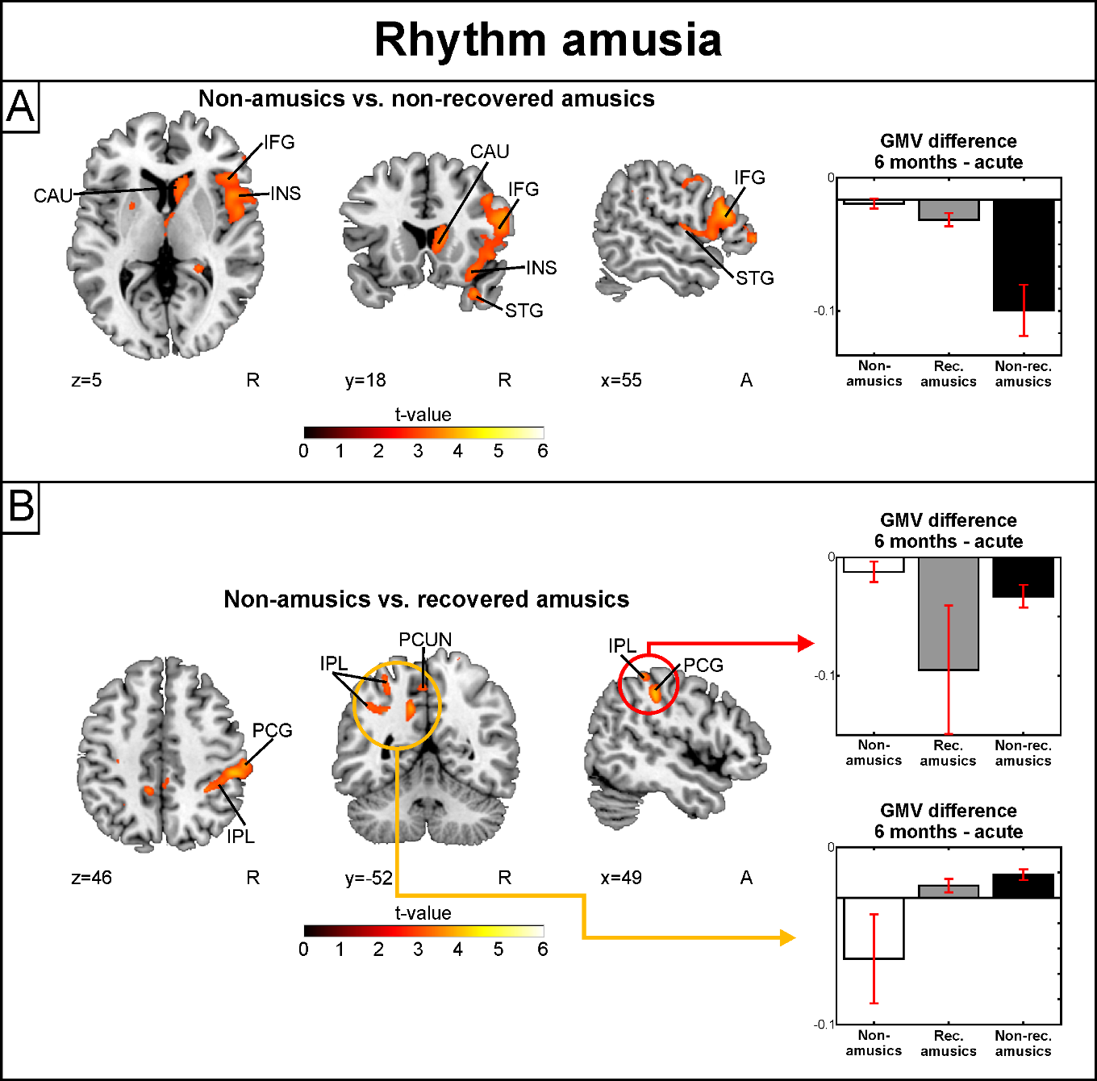
Supplementary Figure 6 White matter VBM results of Turku patients: rhythm amusia.
Time (6 months > Acute) x Group interactions for white matter volume. (A) Non-amusic vs. non-recovered amusics; (B) Non-amusic vs. recovered amusics. Results are thresholded at a whole-brain uncorrected p < 0.005 at the voxel level (extent threshold: k > 100 voxels) using MNI coordinates. Only clusters surviving an FWE-corrected p < 0.05 threshold are reported and labelled (see also Supplementary Table 6). Bar plots for GMV differences in 6 months – Acute in significant clusters (Supplementary Table 6) are shown: bar = mean, error-bar = standard error of the mean. FG = fusiform gyrus, IPL = inferior parietal lobule, ITG = inferior temporal gyrus, MB = midbrain, PCL = paracentral lobule, PCG = postcentral gyrus.
