**Supplemental Table 1: Specifics for CLOCK and β-catenin antibodies.** The table details the source, concentration used and the immunogen sequence that the antibodies bind to.

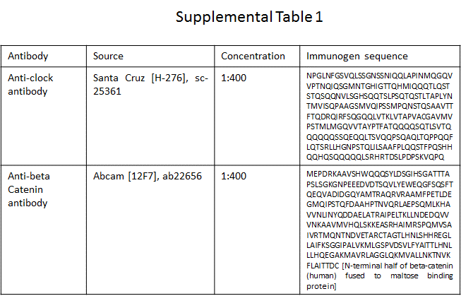

The clock antibody used in this experiment has been discontinued and the company no longer provides the appropriate peptide, however the antibody has been tested successfully in previous studies. (Falcon et al., 2013; Xu et al., 2015)