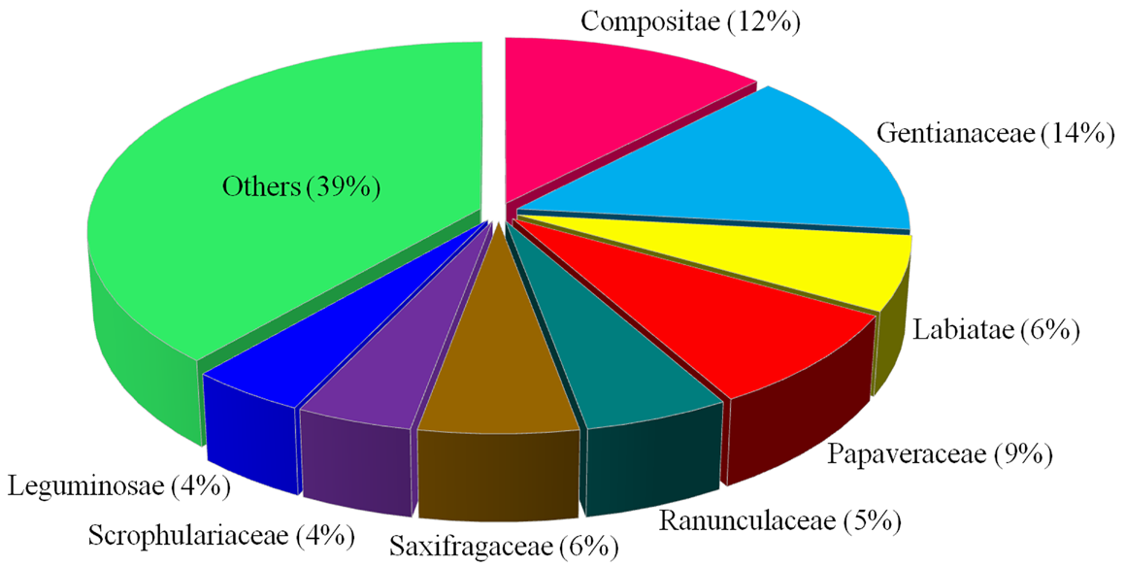
Supplementary Figure S1 Families distribution of traditional Tibetan medicines used in the treatment of liver diseases.

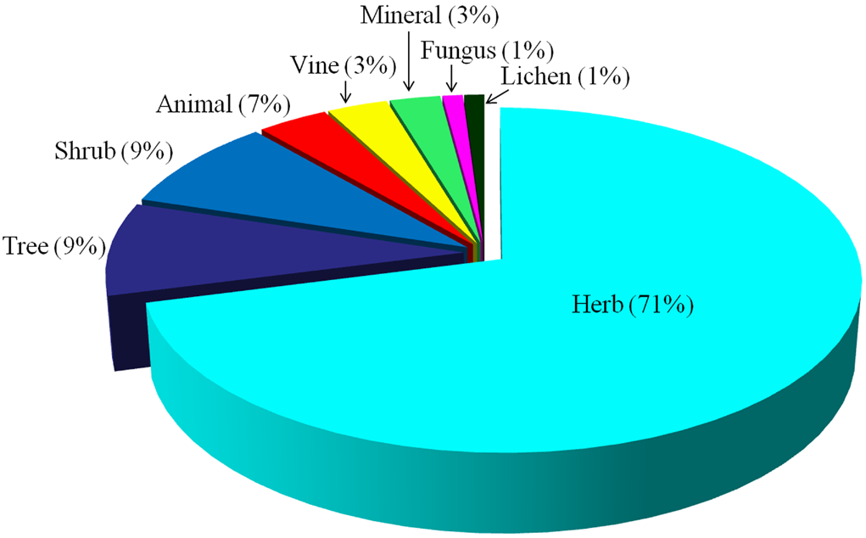
Supplementary Figure S2 Life forms of traditional Tibetan medicines used in the treatment of liver diseases.

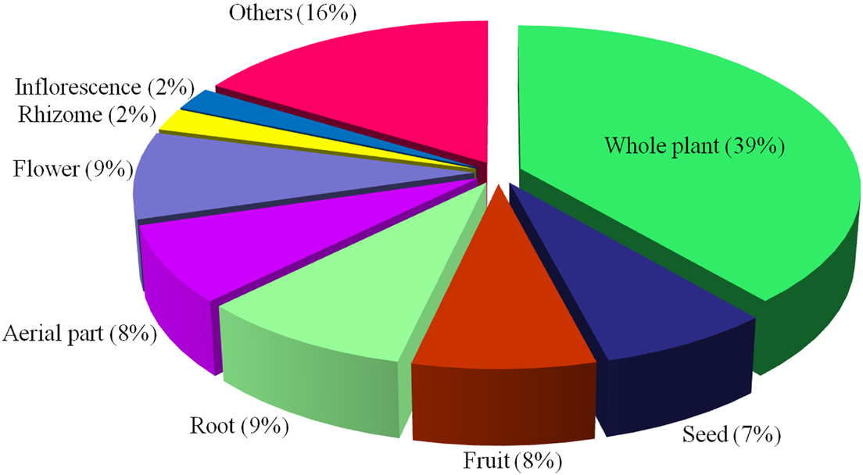
Supplementary Figure S3 Parts of traditional Tibetan medicines used in the treatment of liver diseases.

Supplementary Table S1 The related information of the 22 monographs referenced in our paper
No. | Monograph | Author | The type of author | Ethnic group of author | Data origin of the monograph | Publication date of the monograph | Press of the monograph | Main content of the monograph | Language of the monograph | The type of the monograph | The number of species extracted from the monograph in our paper
1 | Jing Zhu Materia Medica | Dimaer, D. Z. P. C. | Tibetan doctor | Tibetan | Ancient document and ethnobotanical survey | 2012 | Shanghai Science and Technology Press | Drug classification | Chinese version translated by maojizhu | Print edition | 33
2 | Dictionary of Chinese Ethnic Medicine | Jia, M. R. and Zhang, Y. | Botanist and scientist, respectively | Han Chinese | Data compilation | 2016 | China Medical Science and Technology Press | Drug compilation | Chinese | Print edition | 67
3 | Chinese Tibetan Materia Medica | Luo, D. S. | Scientist and botanist | Han Chinese | Ethnobotanical survey | 1997 | Ethnic Publishing Press | Drug introduction | Chinese | Print edition | 31
4 | Drug Standards of Tibetan Medicine | Chinese Pharmacopoeia Commission | National institution | — | Data compilation | 1995 | Ministry of Health of the People's Republic of China | Pharmacopeia | Chinese | Print edition | 20
5 | Chinese Tibetan Medicine (vol. 1-3) | Qinghai Institute for Drug Control | Local institution | — | Ethnobotanical survey | 1996 | Shanghai Science and Technology Press | Drug introduction | Chinese | Print edition | 15
6 | Chinese Herbalism for Tibetan Medicine | Editorial Board of Chinese Herbalism | National institution | — | Data compilation | 2002 | Shanghai Science and Technology Press | Drug compilation | Chinese | Print edition | 14
7 | Yunnan Province Annals (Medicine Annals) | Yunnan Editorial Board of Local Chronicles | Local institution | — | Data compilation | 1995 | Yunnan People’s Publishing Press | Drug compilation | Chinese | Print edition | 11
8 | Tibetan Medicine Annals | Yang, Y. C. | Scientist and botanist | Han Chinese | Ancient document and ethnobotanical survey | 1991 | Qinghai People's Publishing Press | Drug introduction | Chinese | Print edition | 9
9 | Commonly Used Tibetan Medicine Annals | Tian, S. Q. | Scientist | Han Chinese | Data compilation | 1997 | Sichuan Science and Technology Press | Drug compilation | Chinese | Print edition | 9
10 | Diqing Tibetan Medicine | Yang, J. S. and Chuchen, J. C. | Botanist and Tibetan doctor, respectively | Han Chinese and Tibetan, respectively | Ethnobotanical survey | 1987 | Nationalities Publishing Press of Yunnan | Drug introduction | Chinese | Print edition | 9
11 | Tibetan Medicine Standards | Health Bureau of Tibet, Qinghai, Sichuan, Gansu, Yunnan, and Xinjiang | Local institution | — | Data compilation | 1979 | Qinghai People’s Publishing Press | Pharmacopeia | Chinese | Print edition | 8
12 | Drug Illustration of Qinghai-Tibet Plateau (vol. 1-3) | Qinghai Institute of Plateau Biology | Local institution | — | Ethnobotanical survey | 1972, 1975 and 1978 | Qinghai People’s Publishing Press | Drug introduction | Chinese | Print edition | 7
13 | Chinese Ethnic Medicine Annals (vol. 1) | Editorial Board of Chinese Ethnic Medicine | Local institution | — | Data compilation | 1984 | People's Medical Publishing Press | Drug compilation | Chinese | Print edition | 6
14 | Chinese Ethnic Medicine Annals (vol. 2) | Editorial Board of Chinese Ethnic Medicine | Local institution | — | Data compilation | 1990 | People's Medical Publishing Press | Drug compilation | Chinese | Print edition | 4
15 | Chinese Ethnic Medicine Annals (vol. 3) | Editorial Board of Chinese Ethnic Medicine | Local institution | — | Data compilation | 2000 | Sichuan National Publishing Press | Drug compilation | Chinese | Print edition | 2
16 | Illustrated Handbook of Ethnic Medicine of Shangri-La | Yunnan University of TCM | University | — | Ethnobotanical survey | 2008 | Yunnan Science and Technology Press | Drug introduction | Chinese | Print edition | 2
17 | Medicinal Animals of Qinghai-Tibet Plateau | Ye, B. L. and Guo, P. J. | Scientist | Unknown | Ethnobotanical survey | 1998 | Shaanxi Science and Technology Press | Drug introduction | Chinese | Print edition | 1
18 | Annotation of Commonly Used Tibetan Medicine Prescription | Wu, H. C., Wang, M. S., and Dang, H. Q. | Scientist | Unknown | Data compilation | 2002 | Qinghai People's Publishing Press | Prescription compilation | Chinese | Print edition | —
19 | Jing Jing Materia Medica | Gawu, D. J. | Scientist | Tibetan | Ethnobotanical survey | 1993 | Ethnic Publishing Press | Drug introduction | Tibetan | Print edition | 7
20 | Gannan Tibetan Medicine Flora of Qinghai-Tibet Plateau | Du, P. | Scientist | Han Chinese | Ethnobotanical survey | 2006 | Gansu Science and Technology Press | Drug introduction | Chinese | Print edition | 13
21 | Newly Revised Jing Zhu Materia Medica | Luo, D. S. | Scientist and botanist | Han Chinese | Ancient document and ethnobotanical survey | 2004 | Sichuan Science and Technology Press | Drug classification | Chinese | Print edition | 41
22 | Medicinal Minerals of Qinghai-Tibet Plateau | Xing, Z. G., Hu, X. M., Zhao, D. F., and Guo, P. J. | Scientist | Unknown | Data compilation | 1985 | Qinghai People’s Publishing Press | Drug compilation | Chinese | Print edition | 1

Supplementary Table S2 Natural Tibetan medicines for the treatment of liver diseases in traditional Tibetan medical system
No. | Latin name | Tibetan name | Family | Life form | Used part | Treated liver diseases | Reported biological activities associated with liver diseases
1 | Acalypha australis L. | Jia-xiao | Euphorbiaceae | Herb | Whole plant | Hepatitis (Du, 2006) | No report
2 | Aconitum naviculare (Brühl) Stapf | Bang-ga | Ranunculaceae | Herb | Whole plant | Hepatitis and liver heat (Chinese Pharmacopoeia Commission, 1995; Tian, 1997) | No report
3 | Aconitum tanguticum (Maxim.) Stapf | Bang-ga | Ranunculaceae | Herb | Whole plant | Hepatitis and liver heat (Chinese Pharmacopoeia Commission, 1995; Dimaer, 2012; Luo, 2004) | Inhibition of the proliferation of hepatocellular carcinoma cells HepG-2 (Fu, 2008)
4 | Aegypius monachus Linnaeus | Qia-guo | Accipitridae | Animal | Bone | Liver ascites (Editorial Board of Chinese Ethnic Medicine, 1984) | No report
 |  |  |  |  | Bile | Liver diseases (Editorial Board of Chinese Ethnic Medicine, 1984; Luo, 1997) | No report
5 | Agrimonia pilosa Ledeb. | Zhe-ma | Rosaceae | Herb | Root or whole plant | Icterohepatitis (Jia and Zhang, 2016) | Inhibition of the proliferation of hepatocellular carcinoma cells HepG-2 (Song and Hao, 2011)
6 | Ajuga lupulina Maxim. | Sheng-di | Labiatae | Herb | Whole plant | Toxic hepatic injury (Qinghai Institute of Plateau Biology, 1972, 1975 and 1978; Jia and Zhang, 2016) | No report
7 | Ajuga lupulina Maxim. var. major Diels | Sheng-di | Labiatae | Herb | Whole plant | Toxic hepatic injury (Luo, 2004; Luo, 1997) | No report
8 | Alum (KAl(SO₄)₂·12H₂O) | Da-cuo-er | — | Mineral | — | Hepatitis (Xing et al., 1985) | No report
9 | Anemone obtusiloba D.Don | Su-ga | Ranunculaceae | Herb | Aerial part, root or fruit | Hepatitis (Health Bureau of Tibet, Qinghai, Sichuan, Gansu, Yunnan, and Xinjiang, 1979) | No report
10 | Anemone rivularis Buch. -Ham. ex DC. | Su-ga | Ranunculaceae | Herb | Aerial part, root or fruit | Hepatitis (Luo, 1997) | No report
11 | Artemisia demissa Krasch. | Cha-er-wang-mu-bao | Compositae | Herb | Whole plant | Liver heat (Qinghai Institute for Drug Control, 1996) | No report
12 | Artemisia frigida Willd. | Kan-jia-ga-bu | Compositae | Herb | Aerial part | Liver heat (Luo, 1997) | No report
13 | Artemisia hedinii Ostenf. | Sang-zi-na-bo | Compositae | Herb | Aerial part | Acute icterohepatitis (Chinese Pharmacopoeia Commission, 1995; Jia and Zhang, 2016) | No report
14 | Artemisia scoparia Waldst. & Kitam. | Cha-er-wang-ga-bao | Compositae | Herb | Whole plant | Icterohepatitis and liver heat (Qinghai Institute for Drug Control, 1996; Editorial Board of Chinese Ethnic Medicine, 2000) | Antioxidant and anti-inflammatory activities (Habib and Waheed, 2013; Singh et al., 2009)
15 | Berberis brachypoda Maxim. | Ji-er-wa | Berberidaceae | Shrub | Root, stem or their endothelium | Icterohepatitis (Jia and Zhang, 2016) | No report
16 | Bidens bipinnata L. | Qie-cai-man-ba | Compositae | Herb | Whole plant | Hepatitis (Luo, 2004) | Hepatoprotective effects against CCl₄-induced acute liver injury and liver fibrosis (Zhong et al., 2007; Yuan et al., 2008)
17 | Bidens pilosa L. | Qie-cai-man-ba | Compositae | Herb | Whole plant | Hepatitis (Dimaer, 2012; Luo, 2004) | No report
18 | Brassica rapa L. | Xiong-ma | Cruciferae | Herb | Root-tuber | Toxic hepatopathy (Jia and Zhang, 2016) | No report
19 | Bupleurum chinense DC. | Si-ri-a-sai-er-bao | Umbelliferae | Herb | Root | Hepatitis (Du, 2006) | Hepatoprotective effect and inhibition of the proliferation of hepatocellular carcinoma cells SMMC-7721 (Wang and Nan, 2008; Yang et al., 2012)
20 | Bupleurum marginatum Wall. ex DC. | Si-la-ga-bao | Umbelliferae | Herb | Root | Hepatitis (Du, 2006) | Hepatoprotective effect (Du et al., 2014)
21 | Calendula officinalis L. | Ge-gong-mai-duo | Compositae | Herb | Inflorescence | Liver diseases (Jia and Zhang, 2016) | No report
22 | Cardamine pratensis L. | Ou-ba-en-bao | Cruciferae | Herb | Aerial part | Hepatitis (Jia and Zhang, 2016) | No report
23 | Cassia fistula Linn. | Dong-ka | Leguminosae | Tree | Fruit | Hepatitis, toxic hepatopathy and liver heat (Chinese Pharmacopoeia Commission, 1995; Dimaer, 2012; Tian, 1997) | No report
24 | Catabrosa aquatica (L.) P. Beauv. | Dang-bu-ga-re | Gramineae | Herb | Whole plant | Hepatitis (Dimaer, 2012; Luo, 2004; Luo, 1997) | No report
25 | Chrysosplenium carnosum Hook.f. & Thomson | Ya-ji-ma | Saxifragaceae | Herb | Whole plant | Acute icterohepatitis, liver cirrhosis and liver heat (Luo, 2004; Jia and Zhang, 2016) | No report
26 | Chrysosplenium davidianum Decne. ex Maxim. | Ya-ji-ma | Saxifragaceae | Herb | Whole plant | Acute icterohepatitis (Yunnan Editorial Board of Local Chronicles, 1995) (Yang and Chuchen, 1987) | No report
27 | Chrysosplenium griffithii Hook.f. & Thomson | Ya-ji-ma | Saxifragaceae | Herb | Whole plant | Acute icterohepatitis, liver cirrhosis and liver heat (Dimaer, 2012; Health Bureau of Tibet, Qinghai, Sichuan, Gansu, Yunnan, and Xinjiang, 1979; Yunnan Editorial Board of Local Chronicles, 1995) | No report
28 | Chrysosplenium lanuginosum Hook.f. & Thomson | Ya-ji-ma | Saxifragaceae | Herb | Whole plant | Acute icterohepatitis and liver cirrhosis (Luo, 2004) | No report
29 | Chrysosplenium nepalense D.Don | Ya-ji-ma | Saxifragaceae | Herb | Whole plant | Acute icterohepatitis and liver cirrhosis (Jia and Zhang, 2016; Yunnan Editorial Board of Local Chronicles, 1995) | No report
30 | Chrysosplenium nudicaule Bunge | Ya-ji-ma | Saxifragaceae | Herb | Whole plant | Acute icterohepatitis, liver necrosis and liver cirrhosis (Dimaer, 2012; Editorial Board of Chinese Ethnic Medicine, 1990; Editorial Board of Chinese Herbalism, 2002) | No report
31 | Chrysosplenium uniflorum Maxim. | Ya-ji-ma | Saxifragaceae | Herb | Whole plant | Acute icterohepatitis and hepatitis (Jia and Zhang, 2016) | No report
32 | Cinnabar (HgS) | Jue-la | — | Mineral | — | Liver heat (Luo, 1997; Qinghai Institute for Drug Control, 1996) | No report
33 | Cinnamomum cassia (L.) J.Presl | Xing-ca | Lauraceae | Tree | Bark | Liver diseases (Yunnan Editorial Board of Local Chronicles, 1995; Editorial Board of Chinese Herbalism, 2002) | No report
34 | Cinnamomum mairei H.Lév. | Xing-ca | Lauraceae | Tree | Bark | Liver diseases (Jia and Zhang, 2016) | No report
35 | Cissampelopsis volubilis (Blume) Miq. | Sai-bao-gu-zhui | Compositae | Herb | Whole plant | Icterohepatitis (Luo, 2004; Luo, 1997) | No report
36 | Clematis aethusifolia Turcz. | Yi-meng-ga-bu | Ranunculaceae | Vine | Aerial part | Hepatic schistosomiasis (Luo, 1997) | No report
37 | Codonopsis convolvulacea Kurz | Ni-wa | Campanulaceae | Herb | Flower | Liver heat (Editorial Board of Chinese Herbalism, 2002) | No report
38 | Comastoma pedunculatum (Royle ex G. Don) Holub | Di-wa | Gentianaceae | Herb | Whole plant | Icterohepatitis (Du, 2006; Yang, 1991) | No report
39 | Comastoma pulmonarium (Turcz.) Toyok. | Jia-di-jia-zha | Gentianaceae | Herb | Whole plant | Liver heat (Luo, 2004; Yang and Chuchen, 1987) | No report
40 | Commiphora myrrha (Nees) Engl. | Ge-ge-le | Burseraceae | Tree | Resin | Liver diseases (Gawu, 1993) | Hepatoprotective activity (Ahmad et al., 2015)
41 | Coriolus versicolor (L. ex Fr.) Quel. | Yun-zhi | Polyporaceae | Fungus | Fruiting body | Hepatitis B and chronic hepatitis (Yunnan University of TCM, 2008) | No report
42 | Corydalis adunca Maxim. | Pa-meng-si-wa | Papaveraceae | Herb | Whole plant | Liver heat (Luo, 1997; Editorial Board of Chinese Ethnic Medicine, 1990) | No report
43 | Corydalis bungeana Turcz. | Jia-zhou-si-wa | Papaveraceae | Herb | Whole plant | Chronic hepatitis and icterohepatitis (Luo, 1997; Jia and Zhang, 2016) | Hepatoprotective activity (Han et al., 2009)
44 | Corydalis curviflora Maxim. ex Hemsl. | Qia-po-zi-zi-man-ba | Papaveraceae | Herb | Whole plant | Hepatitis (Luo, 1997) | No report
45 | Corydalis dasyptera Maxim. | Ge-zhou-se-bu | Papaveraceae | Herb | Whole plant | Icterohepatitis (Dimaer, 2012; Jia and Zhang, 2016) | No report
46 | Corydalis delphinioides Fedde | Pa-xia-ga-man-ba | Papaveraceae | Herb | Whole plant | Liver diseases (Luo, 1997; Yunnan University of TCM, 2008) | No report
47 | Corydalis nigroapiculata C.Y.Wu | Gu-zhu-si-wa | Papaveraceae | Herb | Whole plant | Icterohepatitis (Editorial Board of Chinese Ethnic Medicine, 2000) | No report
48 | Corydalis pauciflora (Steph. ex Willd.) Pers. | Ba-xia-wa | Papaveraceae | Herb | Whole plant | Hepatitis (Luo, 2004) | No report
49 | Corydalis scaberula Maxim. | Dong-ri-si-ba | Papaveraceae | Herb | Whole plant | Hepatitis and liver heat (Chinese Pharmacopoeia Commission, 1995; Dimaer, 2012; Jia and Zhang, 2016) | No report
50 | Corydalis stricta Steph. ex DC. | Pa-meng-si-wa | Papaveraceae | Herb | Whole plant | Hepatitis (Jia and Zhang, 2016) | No report
51 | Corydalis taliensis Franch. | Ba-ri-ba-da-man-ba | Papaveraceae | Herb | Whole plant | Hepatitis (Luo, 1997) | No report
52 | Corydalis tangutica Peschkova | Qia-po-zi-zi-ma-ba | Papaveraceae | Herb | Whole plant or root | Hepatitis (Luo, 2004; Jia and Zhang, 2016) | No report
53 | Corydalis tsayulensis C.Y.Wu & H.Chuang | Zha-sang | Papaveraceae | Herb | Whole plant or root | Hepatitis (Jia and Zhang, 2016; Editorial Board of Chinese Herbalism, 2002) | No report
54 | Crepis lignea (Vaniot) Babc. | Za-chi | Compositae | Herb | Root | Icterohepatitis (Luo, 2004) | No report
55 | Cuscuta australis R.Br. | Zhu-xia-ba | Convolvulaceae | Herb | Seed or Whole plant | Hepatitis (Du, 2006) | No report
56 | Cuscuta chinensis Lam. | Niu-xia-qiong-wa | Convolvulaceae | Herb | Whole plant | Icterohepatitis (Dimaer, 2012; Jia and Zhang, 2016) | Hepatoprotective and antioxidant effects (Yen et al., 2007)
57 | Cynanchum forrestii Schltr. | E-du-mu-niu | Asclepiadaceae | Herb | Whole plant | Hepatitis (Yang and Chuchen, 1987) | No report
58 | Dalbergia odorifera T.C. Chen | Zhan-tan-ma-bao | Leguminosae | Tree | Heartwood | Liver heat (Yang, 1991) | No report
59 | Delphinium batangense Finet & Gagnep. | Xia-gang-ba | Ranunculaceae | Herb | Aerial part | Liver heat (Jia and Zhang, 2016) | No report
60 | Dracocephalum calophyllum Hand.-Mazz. | Yao-qing-lan | Labiatae | Herb | Whole plant or Aerial part | Hepatitis (Luo, 2004; Yunnan Editorial Board of Local Chronicles, 1995) | No report
61 | Dracocephalum heterophyllum Benth. | Ji-zi-qing-bao | Labiatae | Herb | Aerial part | Icterohepatitis (Chinese Pharmacopoeia Commission, 1995; Tian, 1997) | Protective effects against hypoxia-induced liver injury and ConA-induced acute hepatitis (Ma et al., 1995; Zheng et al., 2016)
62 | Dubyaea atropurpurea (Franch.) Stebbins | Za-chi-na-bo | Compositae | Herb | Whole plant or inflorescence | Hepatitis (Yunnan Editorial Board of Local Chronicles, 1995) | No report
63 | Entada phaseoloides (L.) Merr. | Qing-ba-xiao-xia | Leguminosae | Vine | Seed | Liver heat and toxic hepatopathy (Chinese Pharmacopoeia Commission, 1995; Dimaer, 2012; Tian, 1997) | No report
64 | Ephedra equisetina Bunge | Cai-dun-mu | Ephedraceae | Shrub | Aerial part | Liver heat (Dimaer, 2012; Luo, 1997; Qinghai Institute for Drug Control, 1996) | No report
65 | Erodium stephanianum Willd. | Xin-tuo-li-ga-bao | Geraniaceae | Herb | Whole plant | Hepatitis (Du, 2006) | No report
66 | Fallopia aubertii (L.Henry) Holub | Le-zhe | Polygonaceae | Shrub | Stem | Liver heat (Qinghai Institute of Plateau Biology, 1972, 1975 and 1978; Qinghai Institute for Drug Control, 1996) | No report
67 | Ferrum | Jiu-tai | — | Mineral | — | Toxic hepatopathy (Qinghai Institute for Drug Control, 1996; Yang and Chuchen, 1987) | No report
68 | Fraxinus sikkimensis (Lingelsh.) Hand.-Mazz. | Da-bu-sang | Oleaceae | Tree | Bark | Liver heat (Luo, 2004; Yunnan Editorial Board of Local Chronicles, 1995) | No report
69 | Ganoderma sinense Zhao. Xu et Zhang | Guo-xia-mo-bu | Polyporaceae | Fungus | Fruiting body | Hepatitis (Luo, 1997) | No report
70 | Gentiana crassicaulis Duthie ex Burkill | Jie-ji-na-bao | Gentianaceae | Herb | Flower | Hepatitis and liver heat (Dimaer, 2012; Health Bureau of Tibet, Qinghai, Sichuan, Gansu, Yunnan, and Xinjiang, 1979; Jia and Zhang, 2016) | No report
71 | Gentiana macrophylla Pall. | Jie-ji-na-bao | Gentianaceae | Herb | Flower or whole plant | Hepatitis (Dimaer, 2012; Jia and Zhang, 2016) | Protective effects against alcohol and CCl₄-induced liver injury (Kang et al., 2012; Zhang et al., 2014)
72 | Gentiana waltonii Burkill | Jie-ji-na-bao | Gentianaceae | Herb | Root | Icterohepatitis (Luo, 2004; Jia and Zhang, 2016) | No report
73 | Gentiana lhassica Burkill | Jie-ji-na-bao | Gentianaceae | Herb | Whole plant | Hepatitis (Luo, 2004) | No report
74 | Gentiana futtereri Diels & Gilg | Jie-ji-mo-bao | Gentianaceae | Herb | Flower | Hepatitis (Dimaer, 2012; Luo, 2004; Jia and Zhang, 2016) | Protective effect against CCl₄-induced liver injury (Tang, 2011)
75 | Gentiana obconica T.N.Ho | Jie-ji-mo-bao | Gentianaceae | Herb | Flower | Hepatitis (Luo, 2004; Jia and Zhang, 2016) | No report
76 | Gentiana erectosepala T.N.Ho | Jie-ji-en-bao | Gentianaceae | Herb | Flower | Hepatitis (Luo, 2004; Jia and Zhang, 2016) | No report
77 | Gentiana rhodantha Franch. ex Hemsl. | Jie-ji-ma-bao | Gentianaceae | Herb | Whole plant | Liver heat and icterohepatitis (Jia and Zhang, 2016) | No report
78 | Gentiana robusta King ex Hook.f. | Jie-ji-ga-bao | Gentianaceae | Herb | Root | Icterohepatitis (Luo, 2004; Yang and Chuchen, 1987) | No report
79 | Gentiana straminea Maxim. | Jie-ji-ga-bao | Gentianaceae | Herb | Flower | Hepatitis (Chinese Pharmacopoeia Commission, 1995; Dimaer, 2012) | No report
80 | Gentiana tibetica King ex Hook.f. | Jie-ji-ga-bao | Gentianaceae | Herb | Whole plant or flower | Icterohepatitis (Dimaer, 2012; Jia and Zhang, 2016; Yang, 1991) | No report
81 | Gentiana nubigena Edgew. | Bang-jian | Gentianaceae | Herb | Flower | Hepatitis (Du, 2006; Health Bureau of Tibet, Qinghai, Sichuan, Gansu, Yunnan, and Xinjiang, 1979) | No report
82 | Gentiana purdomii C.Marquand | Bang-jian | Gentianaceae | Herb | Flower | Hepatitis (Health Bureau of Tibet, Qinghai, Sichuan, Gansu, Yunnan, and Xinjiang, 1979; Jia and Zhang, 2016) | No report
83 | Gentiana szechenyii Kanitz | Bang-jian | Gentianaceae | Herb | Flower | Hepatitis (Health Bureau of Tibet, Qinghai, Sichuan, Gansu, Yunnan, and Xinjiang, 1979; Jia and Zhang, 2016) | No report
84 | Gentiana algida Pall. | Bang-jian | Gentianaceae | Herb | Whole plant | Hepatitis (Jia and Zhang, 2016) | No report
85 | Gentiana algida Pall. var. przewalskii (Maxim.) Kusn. | Bang-jian | Gentianaceae | Herb | Flower | Hepatitis (Jia and Zhang, 2016) | No report
86 | Gentianopsis barbata (Froel.) Ma | Jia-di | Gentianaceae | Herb | Whole plant | Icterohepatitis, liver heat and hepatitis (Luo, 2004; Jia and Zhang, 2016) | No report
87 | Gentianopsis grandis (Harry Sm.) Ma | Jia-di | Gentianaceae | Herb | Whole plant | Hepatitis (Luo, 2004; Jia and Zhang, 2016) | No report
88 | Gentianopsis paludosa (Hook.f.) Ma | Jia-di | Gentianaceae | Herb | Whole plant | Icterohepatitis and hepatitis (Chinese Pharmacopoeia Commission, 1995; Dimaer, 2012; Jia and Zhang, 2016) | Protective effect against CCl₄-induced liver injury (Ren et al., 2008)
89 | Geum aleppicum Jacq. | Za-e-bao | Rosaceae | Herb | Whole plant | Hepatitis (Luo, 2004; Luo, 1997) | No report
90 | Gossampinus malabarica Merr. | Na-ka-bu-sa | Bombacaceae | Tree | Flower | Liver heat (Chinese Pharmacopoeia Commission, 1995; Dimaer, 2012; Gawu, 1993) | Protective effects on immunological liver injury and liver fibrosis (Wu et al., 2012; Tang et al., 2014)
91 | Halenia corniculata (L.) Cornaz | Jia-di-ran-guo | Gentianaceae | Herb | Aerial part | Acute icterohepatitis and hepatitis B (Jia and Zhang, 2016) | Protective effect against D-galactosamine-induced liver injury (Gui et al., 2015)
92 | Herminium alaschanicum Maxim. | Wang-la-man-ba | Orchidaceae | Herb | Tuber | Chronic hepatitis (Luo, 2004) | No report
93 | Hippophae rhamnoides L. | Da-bu | Elaeagnaceae | Shrub or tree | Fruit | Liver diseases (Dimaer, 2012; Jia and Zhang, 2016) | Hepatoprotective and antioxidant effects (Geetha et al., 2008; Ting et al., 2011), and antiproliferative activity on human liver cancer cell lines HepG-2 (Grey et al., 2010)
94 | Hippuris vulgaris L. | Dong-bu-ga-la | Hippuridaceae | Herb | Whole plant or rhizome | Hepatitis (Dimaer, 2012; Qinghai Institute of Plateau Biology, 1972, 1975 and 1978) | No report
95 | Holarrhena antidysenterica (Roth) Wall. ex A.DC. | Du-mo-niu | Apocynaceae | Tree | Seed | Liver diseases (Chinese Pharmacopoeia Commission, 1995; Tian, 1997) | No report
96 | Hypericum bellum H.L. Li | Jia-xiang-wang-qiu | Guttiferae | Shrub | Fruit | Hepatitis (Luo, 2004; Yunnan Editorial Board of Local Chronicles, 1995) | No report
97 | Inula helenium L. | Ma-nu-ba-zha | Compositae | Herb | Root | Liver diseases (Jia and Zhang, 2016) | No report
98 | Iris ensata Thunb. | Zhe-ze | Iridaceae | Herb | Seed | Icterohepatitis (Jia and Zhang, 2016) | No report
99 | Iris lactea Pall. var. chinensis (Fisch.) Koidz. | Mu-zhe | Iridaceae | Herb | Seed | Icterohepatitis (Jia and Zhang, 2016) | No report
100 | Ixeris chinensis (Thunb. ex Thunb.) Nakai | Za-chi | Compositae | Herb | Whole plant | Icterohepatitis (Luo, 2004) | Hepatoprotective effect (Lin et al., 1994)
101 | Juniperus formosana Hayata | Xiu-ba-cai-jian | Cupressaceae | Tree | Fruit | Liver diseases (Luo, 1997) | No report
102 | Lagopsis supina (Steph. ex Willd.) Ikonn.-Gal. | Xing-tuo-li-ga-bao | Labiatae | Herb | Aerial part | Liver heat (Yunnan Editorial Board of Local Chronicles, 1995) | No report
103 | Lamium amplexicaule L. | Zha-xi-ge-ze | Labiatae | Herb | Whole plant | Icterohepatitis (Du, 2006; Yunnan Editorial Board of Local Chronicles, 1995) | No report
104 | Lancea tibetica Hook. f. & Thomson | Wa-ya-he-ba | Scrophulariaceae | Herb | Whole plant | Hepatitis (Jia and Zhang, 2016) | No report
105 | Limonite | Jia-he-ji-duo | — | Mineral | — | Toxic hepatopathy (Gawu, 1993) | No report
106 | Lithospermum erythrorhizon Siebold & Zucc. | Zhi-mao-he | Boraginaceae | Herb | Root | Hepatitis (Du, 2006) | Protective effect against CCl₄-induced liver injury (Feng et al., 2010)
107 | Lomatogonium micranthum Harry Sm. | Ji-he-di | Gentianaceae | Herb | Whole plant | Acute icterohepatitis (Du, 2006; Yang, 1991) | No report
108 | Lycopodium japonicum Thunb. | Qu-sen-de-mo | Lycopodiaceae | Herb | Whole plant | Hepatitis (Luo, 1997) | No report
109 | Nigella damascena L. | Si-re-na-bu | Ranunculaceae | Herb | Seed | Hepatitis, hepatomegaly and hepatic schistosomiasis (Luo, 1997; Qinghai Institute for Drug Control, 1996) | Protective effect against alcohol-induced liver injury (Yu et al., 2016)
110 | Orchis latifolia L. var. angustata Maxim. | Wang-la | Orchidaceae | Herb | Tuber | Chronic hepatitis (Luo, 1997; Qinghai Institute of Plateau Biology, 1972, 1975 and 1978) | No report
111 | Oroxylum indicum (L.) Kurz | Zhan-ba-ga | Bignoniaceae | Tree | Seed | Hepatitis (Dimaer, 2012; Qinghai Institute for Drug Control, 1996; Gawu, 1993) | No report
112 | Pedicularis cranolopha Maxim. | Lu-ru-se-bao | Scrophulariaceae | Herb | Flower | Liver heat and hepatitis (Jia and Zhang, 2016; Gawu, 1993) | No report
113 | Pedicularis dichotoma Bonati | Ji-zi-ma-bao | Scrophulariaceae | Herb | Whole plant | Hepatitis (Jia and Zhang, 2016) | No report
114 | Phyllophyton tibeticum (Jacq ex Benth.) C.Y. Wu | Nian-du-ba | Labiatae | Herb | Whole plant | Hepatitis and toxic hepatic injury (Health Bureau of Tibet, Qinghai, Sichuan, Gansu, Yunnan, and Xinjiang, 1979) | No report
115 | Picrorhiza scrophulariiflora Pennell | Hong-lian-mo-bu | Scrophulariaceae | Herb | Rhizome | Liver heat (Yang and Chuchen, 1987; Editorial Board of Chinese Herbalism, 2002) | Hepatoprotective, immunomodulatory and anti-inflammatory activities (Smit et al., 2000; Liu et al., 2002)
116 | Polygonum sinomontanum Sam. | Ran-bu-ka-tu | Polygonaceae | Herb | Whole plant or rhizome | Liver heat (Qinghai Institute for Drug Control, 1996) | No report
117 | Populus cathayana Rehder | Ma-geng | Salicaceae | Tree | Branch or leaf | Hepatitis (Luo, 2004) | No report
118 | Prunella hispida Benth. | Xia-gu-cuo | Labiatae | Herb | Seed | Hepatitis and liver heat (Jia and Zhang, 2016) | No report
119 | Pseudolysimachion longifolium (L.) Opiz | Wa-xia-ga | Scrophulariaceae | Herb | Whole plant | Hepatitis (Jia and Zhang, 2016) | No report
120 | Pyrethrum tatsienense (Bureau & Franch.) Ling ex C.Shih | A-xia-sai-er-jun | Compositae | Herb | Whole plant or inflorescence | Hepatitis (Jia and Zhang, 2016) | Protective effect on acute hepatic injury induced by D-galactosamine (Lin et al., 2011)
121 | Rheum officinale Baill. | Jun-zha | Polygonaceae | Herb | Root or fruit | Acute viral hepatitis (Jia and Zhang, 2016) | No report
122 | Rheum palmatum L. | Jun-zha | Polygonaceae | Herb | Root or fruit | Liver diseases and acute viral hepatitis (Jia and Zhang, 2016; Editorial Board of Chinese Herbalism, 2002) | Antiviral effects against duck hepatitis B virus (Chung et al., 1997)
123 | Rhododendron anthopogon D. Don | Ta-li-ga-bao | Ericaceae | Shrub | Leaf | Liver cancer and hepatomegaly (Luo, 2004) | No report
124 | Rhododendron anthopogonoides Maxim. | Da-li | Ericaceae | Shrub | Flower and branch | Liver cancer and hepatomegaly (Qinghai Institute of Plateau Biology, 1972, 1975 and 1978) | No report
125 | Rhododendron primuliflorum Bureau & Franch. | Da-li | Ericaceae | Shrub | Flower and branch | Liver cancer and hepatomegaly (Jia and Zhang, 2016) | No report
126 | Ribes alpestre Wall. ex Decne. | Sai-guo | Saxifragaceae | Shrub | Fruit | Hepatitis (Luo, 2004) | No report
127 | Ribes himalense Royle ex Decne. | Sai-guo | Saxifragaceae | Shrub | Fruit or stem endothelium | Hepatitis (Jia and Zhang, 2016; Editorial Board of Chinese Herbalism, 2002) | No report
128 | Rosa bella Rehder & E.H.Wilson | Sai-guo | Rosaceae | Shrub | Fruit | Hepatitis (Luo, 2004; Jia and Zhang, 2016) | No report
129 | Rumex acetosa L. | Xiao-mang | Polygonaceae | Herb | Root or rhizome | Hepatitis (Luo, 1997) | No report
130 | Salix microstachya var. bordensis (Nakai) C.F. Fang | Jiang-ma | Salicaceae | Shrub | Root, stem or their endothelium | Icterohepatitis (Luo, 2004) | No report
131 | Salsola collina Pall. | Da-cai-er | Chenopodiaceae | Herb | Aerial part | Liver heat (Luo, 1997) | No report
132 | Salvia bifidocalyx C.Y.Wu & Y.C.Huang | Huang-hua-shu-wei-cao | Labiatae | Herb | Flower | Hepatitis (Yang and Chuchen, 1987) | No report
133 | Salvia flava Forrest ex Diels | Ji-zi-se-bao | Labiatae | Herb | Root | Hepatitis (Jia and Zhang, 2016) | No report
134 | Sambucus chinensis Lindl. | Yu-gou-xiang-na-bao | Caprifoliaceae | Herb | Whole plant | Liver heat (Luo, 2004) | Protective effect on acute hepatic injury induced by D-galactosamine, CCl₄ or ConA (Yang et al., 2006)
135 | Saussurea arenaria Maxim. | Za-chi-wa-mao-ka | Compositae | Herb | Whole plant | Hepatitis (Qinghai Institute of Plateau Biology, 1972, 1975 and 1978) | No report
136 | Saussurea brunneopilosa Hand.-Mazz. | Za-chi-ba-mo-ka | Compositae | Herb | Aerial part | Hepatitis (Chinese Pharmacopoeia Commission, 1995; Editorial Board of Chinese Herbalism, 2002) | No report
137 | Saussurea graminea Dunn | Za-chi-ba-mao-ka | Compositae | Herb | Aerial part or inflorescence | Hepatitis (Chinese Pharmacopoeia Commission, 1995; Luo, 1997) | No report
138 | Sedum multicaule Wall. ex Lindl. | Can-a-wu-zi | Crassulaceae | Herb | Whole plant | Hepatitis (Luo, 1997) | No report
139 | Senecio scandens Buch.-Ham. ex D.Don | Sai-bao-gu-zhui | Compositae | Herb | Whole plant | Icterohepatitis (Luo, 2004) | Hepatoprotective, antioxidant, antiviral, and anti-inflammatory effects (Wang et al., 2013)
140 | Skimmia multinervia C.C. Huang | Xie-kan | Rutaceae | Tree | Leaf | Liver heat (Gawu, 1993) | No report
141 | Sonchus arvensis L. | Zha-chi-na-bo | Compositae | Herb | Whole plant | Icterohepatitis and liver diseases (Luo, 2004; Jia and Zhang, 2016) | Hepatoprotective effect (Alkreathy et al., 2014)
142 | Sophora alopecuroides L. | Ji-wa | Leguminosae | Herb | Seed | Icterohepatitis (Luo, 2004) | Hepatoprotective effect (Yang et al., 2008)
143 | Sophora glauca var. albescens Rehder | Ji-wa | Leguminosae | Tree | Seed | Icterohepatitis (Jia and Zhang, 2016) | No report
144 | Sophora davidii (Franch.) Pavol. | Jie-bei-zhai-bu | Leguminosae | Shrub | Seed | Icterohepatitis (Luo, 2004; Yang and Chuchen, 1987) | No report
145 | Sphaerophysa salsula (Pall.) DC. | La-wa-sa-ma | Leguminosae | Shrub | Root or fruit | Chronic hepatitis and liver cirrhosis (Du, 2006) | No report
146 | Stachys sieboldii Miq. | Dong-na-duan-chi | Labiatae | Herb | Whole plant | Hepatitis (Luo, 2004; Yang, 1991) | No report
147 | Strophanthus divaricatus (Lour.) Hook. & Arn. | Tu-mu-rong | Apocynaceae | Shrub | Seed | Liver heat (Dimaer, 2012; Jia and Zhang, 2016) | No report
148 | Styrax macrocarpus Cheng | Ge-ge-le | Styracaceae | Tree | Resin | Liver diseases (Luo, 1997) | No report
149 | Sus scrofa domestica Brisson | Pa-cha | Suidae | Animal | Blood | Toxic hepatic injure (Health Bureau of Tibet, Qinghai, Sichuan, Gansu, Yunnan, and Xinjiang, 1979; Qinghai Institute for Drug Control, 1996) | No report
150 | Synotis erythropappa (Bureau & Franch.) C. Jeffrey & Y.L. Chen | Yu-gu-xing | Compositae | Herb | Whole plant | Liver heat (Luo, 2004) | No report
151 | Taraxacum eriopodum (D.Don) DC. | Ku-mang | Compositae | Herb | Whole plant | Liver diseases (Jia and Zhang, 2016) | No report
152 | Taraxacum lugubre Dahlst. | Ke-er-mang | Compositae | Herb | Whole plant | Hepatitis (Du, 2006) | No report
153 | Tephroseris rufa (Hand.-Mazz.) B.Nord. | Sai-bao-gu-zhui | Compositae | Herb | Whole plant | Icterohepatitis (Luo, 2004; Yang, 1991) | No report
154 | Thalictrum acutifolium (Hand. -Mazz.) B. Boivin | Si-la-na-bu-man-ba | Ranunculaceae | Herb | Inflorescence or fruit | Hepatitis, hepatomegaly and hepatic schistosomiasis (Luo, 1997; Qinghai Institute of Plateau Biology, 1972, 1975 and 1978) | No report
155 | Thalictrum foliolosum DC. | Gong-bu-e-zheng | Ranunculaceae | Herb | Root or rhizome | Viral hepatitis (Luo, 2004; Luo, 1997) | No report
156 | Thalictrum rutifolium Hook. f. & Thomson | E-zhen | Ranunculaceae | Herb | Flower or fruit | Viral hepatitis, hepatomegaly and hepatic schistosomiasis (Du, 2006) | No report
157 | Thamnolia subuliformis (Ehrh.) Culb. | Sai-er-gu | Icmadophilaceae | Lichen | Whole body | Hepatitis and liver heat (Editorial Board of Chinese Herbalism, 2002; Yang, 1991) | No report
158 | Thladiantha setispina A.M. Lu & Zhi Y. Zhang | Sai-ji-mei-duo | Cucurbitaceae | Vine | Seed | Liver heat and icterohepatitis (Yang, 1991) | No report
159 | Thlaspi arvense L. | Zhai-ka | Cruciferae | Herb | Seed | Liver diseases (Editorial Board of Chinese Herbalism, 2002) | No report
160 | Tinospora capillipes Gagnep. | Le-zhe | Menispermaceae | Vine | Rattan cane | Hepatitis and liver heat (Chinese Pharmacopoeia Commission, 1995; Editorial Board of Chinese Ethnic Medicine, 1990) | No report
161 | Tongoloa dunnii (H. Boissieu) H. Wolff | Si-la-ga-bao | Umbelliferae | Herb | Fruit | Hepatitis (Jia and Zhang, 2016) | No report
162 | Trichosanthes lepiniana (Naudin) Cogn. | Se-ji-mei-duo | Cucurbitaceae | Vine | Seed | Icterohepatitis (Luo, 2004) | No report
163 | Trona | Pu-duo | — | Mineral | — | Toxic hepatopathy (Tian, 1997; Editorial Board of Chinese Herbalism, 2002) | No report
164 | Usnea diffracta Vain. | Ou-guai | Usneaceae | Lichen | Whole body | Liver heat (Gawu, 1993) | No report
165 | Verbena officinalis L. | Ma-ben-cou | Verbenaceae | Herb | Whole plant | Hepatitis (Editorial Board of Chinese Ethnic Medicine, 1984; Qinghai Institute for Drug Control, 1996) | Hepatoprotective and anti-inflammatory effects (Deepak and Handa, 2000; Yu, 2013)
166 | Vicia cracca L. | Xi-wu-sai | Leguminosae | Herb | Whole plant | Icterohepatitis (Jia and Zhang, 2016) | No report

