SL.NO | RT | NAME | IUPAC NAME | MOL.WT  (g/mol) | MOL. FORMULA | STRUCTURE | REFERENCE NUMBER
1. | 12.08 | 2-Buten-1-ol,3 methyl | 3-methyl-2-butenol | 86.132 | C₅H₁₀O | 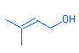 | NIST CAS # 556-82-1 #ions=51
2. | 14.13 | 3-Buten-2-one, 4-(2,6,6-trimethyl-2-cyclohexen-1-yl)-,(E)- | 4-(2,6,6-Trimethyl-2-cyclohexenyl)-3-buten-2-one | 192.297 | C₁₃H₂₀O | 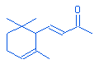 | NIST CAS # 127-41-3 #ions=136
3. | 15.67 | Tetradecanoic acid, ethyl ester | Ethyl myristate | 256.424 | C₁₆H₃₂0₂ | 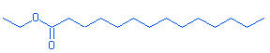 | NIST MS 1 OF 100  (124-06-1) #ions=120
4. | 16.72 | Pentadecanoic acid, ethyl ester | Ethyl pentadecanoate | 270.457 | C₁₇H₃₄0₂ | 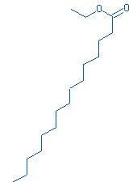 | NIST MS 1 OF 100  (41114-00-) #ions=131
5. | 17.05 | Pentadecanoic acid, 14-methyl-methyl ester | Methyl 14-methylpentadecanoate | 270.457 | C₁₇H₃₄O₂ | 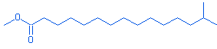 | NIST MS 2 OF 100  (5129-60-2 #ions=104
6. | 17.78 | Hexadecanoic acid, ethyl ester | Ethyl palmitate | 284.477 | C₁₈H₃₆O₂ | 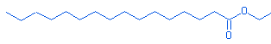 | NIST MS 1 OF 100  (628-97-7) #ions=170
7. | 18.48 | Ethanol,2-(9,12-Octadecadienyloxy)-, (Z,Z)- | 2-[(9Z,12Z)-9,12-Octadecadien-1-yloxy]ethanol | 310.514 | C₂₀H₃₈O₂ | 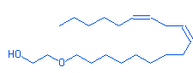 | NIST MS 6 OF 100  (17367-08- #ions=263
8. | 18.8 | 10-Octadecenoic acid, methyl ester | Methyl (10E)-10-octadecenoate | 296.488 | C₁₉H₃₆O₂ | 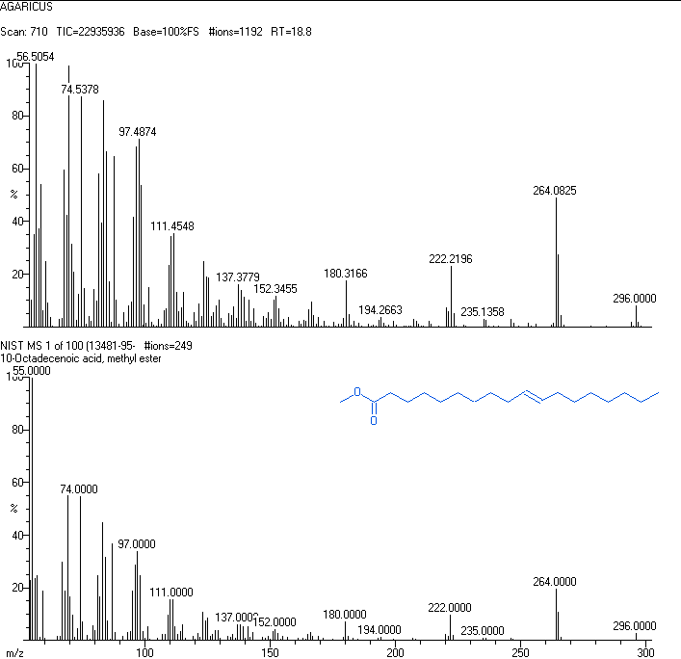 | NIST MS 1 OF 100  (13481-95- #ions=249
9. | 19.45 | 9,12-Octadecadienoic acid,ethyl ester | Ethyl (9Z,12Z)-9,12-octadecadienoate | 308.506 | C₂₀H₃₆O₂ | 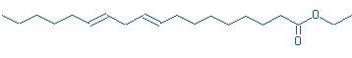 | NIST MS 1 OF 100  (7619-08-1 #ions=134
10. | 19.72 | Heptadecanoic acid, 15-methyl, ethyl ester | Ethyl 15-methylheptadecanoate | 312.541 | C₂₀H₄₀O₂ | 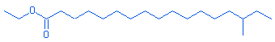 | NIST MS 1 OF 100  (57274-46- #ions=148
11. | 20.27 | Isopropyl linoleate | Isopropyl (9Z,12Z)-9,12-octadecadienoate | 322.533 | C₂₁H₃₈O₂ | 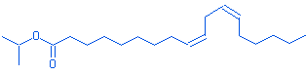 | NIST MS 8 OF 100  (22882-95- #ions=150
12. | 21.22 | Cyclopropaneoctanoic acid, 2((2-((2-ethylcyclopropyl)methyl)cyclopropyl) methyl methyl ester) | - | 334.53 | C₂₂H₃₈O₂ | 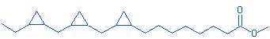 | NIST MS 3 OF 100  (10152-71- #ions=157
13. | 21.48 | Octadecyl methacrylate | octadecyl 2-methylprop-2-enoate | 338.576 | C₂₂H₄₂O₂ | 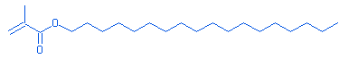 | NIST MS 100 OF 100  (112-08- #ions=193
14. | 22.9 | Docosanoic acid, methyl ester | Methyl docosanoate | 354.619 | C₂₃H₄₆O₂ | 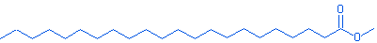 | NIST MS 1 OF 100  (929-77-1) #ions=191
15. | 23.7 | Docosanoic acid, ethyl ester | Ethyl docosanoate | 368.646 | C₂₄H₄₈O₂ | 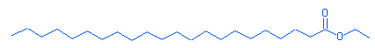 | NIST MS 1 OF 100  (5908-87-2) #ions=161
16. | 25.15 | 9-octadecenoic acid (Z), 2-butoxyethyl ester | 2-Butoxyethyl (9Z)-9-octadecenoate | 382.620 | C₂₄H₄₆O₃ |  | NIST MS 31 OF 100  (109-39-7 #ions=230
17. | 27.02 | Ethyl tetra cosanoate | Ethyl tetracosanoate | 396.7 | C₂₆H₅₂O₂ | 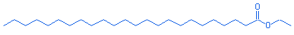 | NIST MS 2 OF 100  (24634-95- #ions=187

Table 3-Compounds present in Agaricus endoxanthus (AE) extract analysed using GC-MS

