Supplementary Material
The correlation of adsorption behavior between ciprofloxacin hydrochloride and the active sites of Fe-doped MCM-41
Ying Wu, Yiming Tang*, Laisheng Li, Peihong Liu, Xukai Li, Weirui Chen, Ying Xue
* Correspondence: Yiming Tang: y.tang@m.scnu.edu.cn

Supplementary Figures and Tables

Supplementary Figures
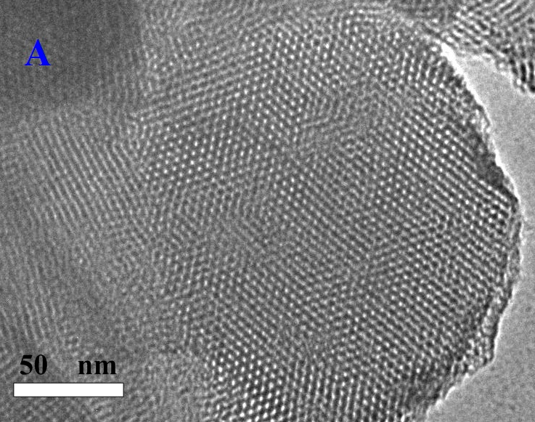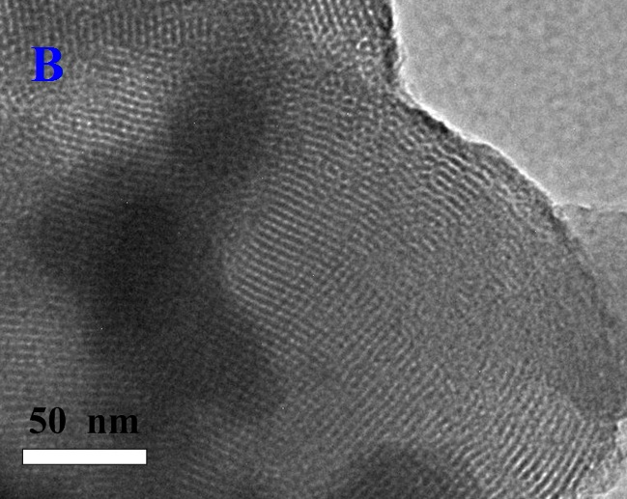
Supplementary Figure S1. TEM images of pure MCM-41 (A) and Fe-MCM-41(20) (B).

Supplementary Figure S2. FT-IR spectra of CPX, Fe-MCM-41 and CPX-adsorbed Fe-MCM-41over the range 4000-400 cm⁻¹.

Supplementary Tables
Supplementary Table S1. Structural properties of adsorbents.
Sample | S_{BET} (m² g⁻¹) | Pore diameter (nm) | Pore Volume (cm³ g⁻¹)
MCM-41 | 1002.1 | 3.2 | 0.79
Fe-MCM-41 (160) | 894.7 | 3.5 | 0.79
Fe-MCM-41 (80) | 883.2 | 3.6 | 0.80
Fe-MCM-41 (40) | 822.6 | 3.8 | 0.79
Fe-MCM-41 (20) | 625.6 | 4.3 | 0.68

