**Supplementary Material**

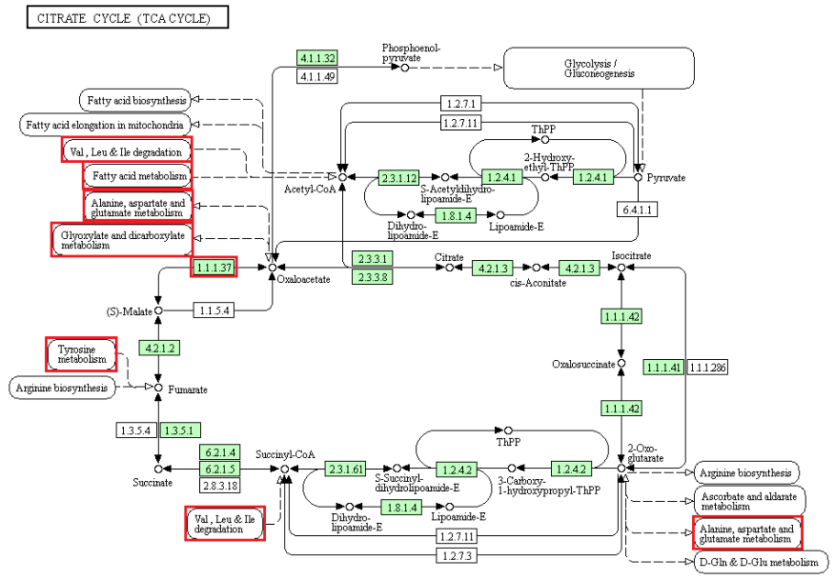

**Figure S1. Enzymes mapped to TCA cycle and metabolic pathways associated with infection of tick cells by the flavivirus, LGTV.** Boxes denote genes assigned via Kyoto Encyclopedia of Genes and Genomes (KEGG) software (Kanehisa et al., 2017) to “citrate cycle (TCA cycle)” and pathways associated with the TCA cycle. Green boxes denote orthologous gene models identified from BLAST similarity search of the *Ixodes scapularis* IscaW1 gene model set (Gulia-Nuss et al., 2016) downloaded from VectorBase (Giraldo-Calderon et al., 2015). Red boxes denote tick genes or pathways with genes that are potentially associated with viral infection and identified via RNAi-induced transcript knockdown studies in *Ixodes ricinus* (Weisheit et al., 2015) and *I. scapularis* cell lines (Grabowski et al., 2017a).

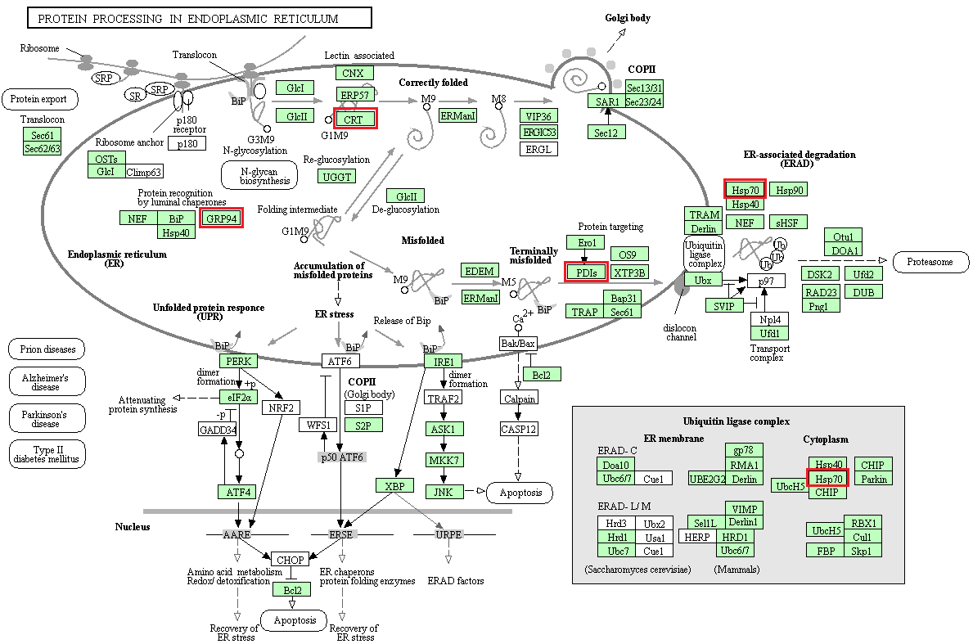

**Figure S2. Proteins mapped to protein processing pathways in the endoplasmic reticulum that may be associated with infection of tick cells by the flavivirus, LGTV.** Boxes denote genes assigned via Kyoto Encyclopedia of Genes and Genomes (KEGG) software (Kanehisa et al., 2017) to “protein processing in endoplasmic reticulum”. Green boxes denote orthologous gene models identified from BLAST similarity search of the *Ixodes scapularis* IscaW1 gene model set (Gulia-Nuss et al., 2016) downloaded from VectorBase (Giraldo-Calderon et al., 2015). Red boxes denote tick genes that are potentially associated with viral infection and identified via RNAi-induced transcript knockdown studies in *Ixodes ricinus* (Weisheit et al., 2015) and *I. scapularis* cell lines (Grabowski et al., 2017a).

**Table S1. Cellular pathways associated with differential protein expression following flaviviral infection of the tick, mosquito and human cell.**

|  |  |  |  |
| --- | --- | --- | --- |
| **KEGG cellular function and Pathway** | **Host system/Flavivirus** | | |
| ***Ixodes* spp. ticks/ TBEV & LGTV1** | ***Aedes* spp. mosquitoes/**  **DENV2** | ***Homo sapiens*/**  **HCV, DENV & JEV3** |
| **Genetic information processing** | | | |
| Ribosome | X | X | X |
| Protein processing in ER4 | X | X | X |
| Spliceosome | X | X | X |
| RNA transport | X |  | X |
| mRNA surveillance pathway | X |  | X |
| Proteasome | X |  | X |
| RNA degradation | X | X | X |
| Ubiquitin-mediated proteolysis | X |  | X |
| Base excision repair | X |  | X |
| Protein export | X | X | X |
| **Metabolism** | | | |
| Pyruvate metabolism5 | X | X | X |
| Citrate cycle (TCA) 4 | X | X | X |
| Glyoxylate & dicarboxylate metabolism4,5 | X | X | X |
| Oxidative phosphorylation | X | X | X |
| Valine, leucine & isoleucine degradation4,5 | X | X | X |
| Propanoate metabolism4,5 | X | X | X |
| Glutathione metabolism | X | X | X |
| N-Glycan biosynthesis | X |  | X |
| Aminoacyl-tRNA biosynthesis | X |  | X |
| Lysine degradation5 | X | X | X |
| Purine metabolism | X | X | X |
| Pyrimidine metabolism4 | X | X | X |
| Fructose and mannose metabolism | X | X | X |
| Alanine, aspartate and glutamate metabolism4 | X | X | X |
| D-Glutamine and D-glutamate metabolism | X |  | X |
| **Cellular processes** | | | |
| Phagosome | X | X | X |
| Lysosome | X |  | X |
| Peroxisome | X | X | X |
| **Environmental information processing** | | | |
| mTOR signaling pathway | X | X | X |
| **Organismal systems** | | | |
| Dorso-ventral axis formation | X |  | X |

1(Weisheit et al., 2015; Grabowski et al., 2016)

2(Tchankouo-Nguetcheu et al., 2010; Patramool et al., 2011; Zhang et al., 2013b; Chisenhall et al., 2014)

3(Pattanakitsakul et al., 2007; Diamond et al., 2010; Kanlaya et al., 2010; Zhang et al., 2013a)

4Knockdown of transcripts for protein(s) in this pathway reduced LGTV replication

5Knockdown of transcript for protein(s) in this pathway reduced LGTV genome replication