Supplemental Material for Review (Integrated)-

**Validating the Copenhagen Psychosocial Questionnaire (COPSOQ-II): Identifying Psychosocial Risk Factors in a Sample of School Principals**

[Note: Supplemental Materials are designed to be included on the journal’s external website that is hot-linked to the published article, but is not printed as part of the (printed) published article.]

<<TABLE OF CONTENTS>>

**The Medium Version of the COPSOQ-II** 2

**The Short Version of the COPSOQ-II** 2

**Detailed Correlations with Covariates** 3

**Tables SI1-SI4 & annex Tables SA1-SA16** *Please see Excel file for these tables* 7

**Development of the COPSOQ**

Kristensen et al. (2005) developed three versions of the instrument: a “long”, “medium”, and “short” (“short” renamed to “core” in COPSOQ-III) version. The long version of the COPSOQ-II, the most widely used in research, is based on 41 scales (127 items), the medium version is based on 28 scales (87 items), and the short version is based on 23 scales, (40 items). The medium length version excludes whole scales present in the long version, while the short version excludes both entire scales and items within scales. The medium and short versions are recommended for use in practical settings, such as with work environment professionals (Pejtersen, Kristensen, Borg, and Bjorner (2010) and have been used regularly for evaluating risk assessment in the workplace and the psychosocial work environment in several countries, such as Denmark, Spain, and Germany (Moncada et al., 2014).

Theoretically, the original COPSOQ is based on this work by Kompier (2004; see above) and the COPSOQ items have been developed to cover all of the major theories of workplace functioning and thus, the important aspects defined by them. Many items are used verbatim from their sources, such as those from the Setterlind Stress Profile (Setterlind & Larson, 1995), the Whitehall II questionnaire (Ferrie, 2004), the SF-36® Health Survey questionnaire (SF-36; Hays, Sherbourne, & Mazel, 1993), and other (Skandinavian) instruments such as the QPS-Nordic (Dallner et al., 2000).

Pejtersen, Kristensen, et al. (2010) in their study used the second order (see main manuscript) structure for exploratory factor analyses, which were conducted separately within each domain. All COPSOQ items are measured on Likert scales, but with a range of 13 response option anchors to guard against common method bias. Furthermore, the COPSOQ includes several single items assessing Offensive Behaviors as a quantitative measure, such as (number of…) Threats of Violence, Bullying, Unpleasant Teasing. These will however, due to their different structure, not be the focus of the present investigation.

**The Medium Version of the COPSOQ-II**

For examining the first-order factor structure of the COPSOQ-II medium version, we again compared the three different models: (4) a CFA, (5) ESEM with target rotation, and (6) a set ESEM approach with target rotation.

**CFA model.** The CFA model for the medium version fit the data satisfactory again with CFI = .92, TLI = .90, being minimally acceptable (see Table SA1 for more details). However, correlations (*M* │ *r* │= .337) between factors were also partly very high with values up to│ *r* │= .879 and 14% of the *r*s >.5, or <-.5 (see Table SA2).

**ESEM.** We ran the model as an ESEM with target rotation model fit improved.015; see Table SA1). Correlations (*M*│ *r* │= .253) dropped with the highest │*r* │= .80 and only 7% of the correlations were above absolute .50 (see Table SA3).

**ESEM-set.** In the ESEM-set approach with target rotations, model fit remained good and was not substantially different than the ESEM model with regard to cut-off values (ΔCFI < .01, ΔTLI < .01, ΔRMSEA < .015; see Table SA1). Further, correlations on average were again higher (*M* │ *r* │= .302), but the highest was again lower │*r* │= .77 and only 7% of the correlations were above absolute .50 (see Table SA4).

**Factor loadings.** The factor loadings for the CFA were again slightly higher than those of the ESEM and ESEM-set model (*M* = .76, *M* = .67, and *M* = .72 respectively) but reveal only small differences, in line with the long version of the COPSOQ-II. Again, almost all 83 items load more positively on the ESEM-set factor that they were designed to measure and less positively on all other factors (see Table SA 11-13).

**The Short Version of the COPSOQ-II**

For examining the first-order factor structure of the COPSOQ-II we again compared results of a CFA (7) with those of an ESEM (8) and a ESEM-set (9).

**CFA model.** Results for the CFA revealed a good model fit with CFI = .96, TLI = .94 (see Table SA1 for more details). However, correlations between factors were also partly very high (*M*│ *r* │= .349) with values up to│ *r* │= .859 and 16% of the correlations were above absolute .50 (see Table SA5).

**ESEM model.** Applying an ESEM with target rotation model to the data improved model fit (ΔCFI > .01, ΔTLI > .01, ΔRMSEA > .015; see Table SA1). Correlations were reduced (*M*│ *r* │= .282), the highest being │ *r* │= .781 and only 9% of the correlations were above absolute .50 (see Table SA6).

**ESEM-set model.** The pattern of results remained for the core version and thus, results of the ESEM-set showed slightly worse, but similar model fit as the ESEM model (ΔCFI > .01, ΔTLI > .01, ΔRMSEA < .015; see Table SA1). The highest correlation (*M*│ *r* │= .273) was also│ *r* │= .781 and 10% of the correlations were above absolute .50 (see Table SA7).

**Factor loadings.** Factor loadings for the CFA model showed an average loading of *M* = .78, those for the ESEM and ESEM-set model were *M* = .70 and *M* = .74 respectively (see Table SA 14-16).

**Detailed Correlations with Covariates**

In this excerpt we focus on correlations of covariates with the COPSOQ-II dimensions larger than │ r │= .3, [all p < .001] only, for an overview of all correlations see Table 5 in manuscript).

**Stress sources.** Based on our literature review we examined correlations with several typical stress sources of school principals.

The *sheer quantity of work* item as expected correlated significantly highest with the Demands at Work dimension Quantitative Demands (*r* =.553). This indicates convergent as well as divergent validity. Other notable correlations where with other Demands at Work dimensions such as Work Pace (*r* = .399) and Emotional Demands (*r* = .383). Further it correlated moderately to highly with the Health and Wellbeing dimensions Perceived Stress (*r* = .433) and Sleeping Troubles (*r* = .404). Additionally, it correlated with the Work-Individual Interface dimension Work-Family Conflict (*r* = .541) and the Interpersonal Relations and Leadership dimension Role Conflicts (*r* = .311). Finally*, sheer quantity of work* correlated negatively with the Work Organization and Job Contents dimension Influence (*r* = -.316).

As hypothesized *Expectations of the employer* correlated highest with the Interpersonal Relations And Leadership dimension Rewards (*r* =-.411) as well as Role Conflicts (*r* =.324) and Predictability (*r* =-.324). It also correlated with the Demands at Work dimensions Stress, Sleeping Troubles, and Depression (*r* =.309, *r* = .337, *and r* = 327 respectively). Furthermore, it correlated moderately with the Work Individual Interface dimension Job Satisfaction (*r* =.388) and Work-Family Conflict (*r* =.341). Other notable correlations where the Demands at Work dimensions Quantitative Demands (*r* = .553) and Emotional Demands (*r* = .333). Finally, it also correlated with the Work Organisation and Job Contents dimension Influence (*r* =- .343) and Commitment to the Workplace (*r* = -.319).

*Student related issues* correlated moderately to highly with the Demands at Work dimension Emotional Demands (*r* = .334) and not larger than │ r │= .3 with any other scales confirming convergent and divergent validity as well.

*Parent related issues* showed the same pattern and also correlated moderately to highly with the Demands at Work dimension Emotional Demands (*r* = .362) and not larger than │ r │= .3 with any other scales again showing convergent and divergent validity.

*Financial management issues* correlated as expected highest with the Interpersonal Relations And Leadership dimension Role Conflicts (*r* =.324) thus, showing convergent and divergent validity. Other notable correlations where with the Demands At Work dimension Emotional Demands (*r* = .313).

*Inability to get away from the school* correlated as expected highest with the Work Individual Interface dimension Work-Family Conflict (*r* =.378).

*Interpersonal conflicts* in contrast to our hypothesized showed its highest correlation with the Interpersonal Relations And Leadership dimension Role Conflicts (*r* =.384), followed closely, however, (negatively) with the Values At The Workplace level dimension Trust In Management (*r* = -.376) in line with our criteria for convergent and divergent validity. It also correlated │ *r* │> .3 with the Interpersonal Relations And Leadership dimension and Social Community At Work (*r* = -.363). Additionally, it correlated moderately to highly with the Health And Wellbeing Dimensions, Sleeping Troubles (*r* = .332) and Depressive Symptoms (*r* = .335) and the Demands at Work dimension Emotional Demands (*r* = .333).

**Depression, autonomy, and confidence.** *Depression* unsurprisingly and in line with our a priori assumptions, correlated highest with the Health And Well-Being dimensions Depressive Symptoms (*r* = .60), which indicated convergent and divergent validity, Sleeping Troubles (*r* = .542), Cognitive Stress Symptoms (*r* = .426), Stress (*r* = .432), Somatic Stress Symptoms (*r* = 432), and Burnout (*r* = .361). *Depression* also showed a high negative correlations with the Work Organization and Job Contents dimension Commitment To The Workplace (*r* = -.571) and Influence (*r* = -.335). Furthermore, *Depression* correlated with several Work-Individual Interface dimensions; negatively with Job Satisfaction (*r* = -.596), but positively with Job Insecurity (*r* = .351) and Work-Family Conflict (*r* = .374). There were also correlations with the Demands At Work dimensions Emotional Demands (*r* = .414) and Quantitative Demands (*r* = .304). Further it correlated moderately with the Interpersonal Relations And Leadership dimensions Role Conflicts (*r* = .378) and negatively with Job Rewards (*r* = -.379), Role Clarity (*r* = -.32), Social Community At Work (*r* = -.315), and Job Predictability (*r* = -.306). Finally*, depression* correlated negatively with the Values At The Workplace level dimensions Trust In Management (*r* = -.332) and Justice (*r* = -.312).

*Autonomy* as hypothesized correlated highest with the Work Organization And Job Contents dimension Influence (*r* = .396). Therefore we could again show convergent and divergent validity of the COPSOQ-II. Further it showed moderate correlations with the Interpersonal Relations And Leadership dimension Role Clarity (*r* =.358), the Work-Individual Interface dimension Job Satisfaction (*r* = .318), and the Work Organization And Job Contents dimension Meaning Of Work (*r* = .321).

*Confidence,* only correlated higher than │ *r* │= .3 with Self-Efficacy (*r* = .449), which also provided strong evidence for convergent and divergent validity.

|  |  |  |  |  |  |
| --- | --- | --- | --- | --- | --- |
| Dimension | Abbreviation | Alpha | Alpha 95% CI | Omega | Omega 95% CI |
| Burnout | BO | 0.911 | 0.905, 0.918 | 0.915 | 0.908, 0.921 |
| Stress | ST | 0.884 | 0.876, 0.893 | 0.888 | 0.879, 0.896 |
| Troubles sleeping | SL | 0.891 | 0.882, 0.900 | 0.896 | 0.887, 0.904 |
| Depressive symptoms | DS | 0.814 | 0.798, 0.829 | 0.816 | 0.800, 0.831 |
| Somatic stress symptoms | SO | 0.701 | 0.678, 0.724 | 0.716 | 0.694, 0.738 |
| Cognitive stress symptoms | CS | 0.873 | 0.863, 0.884 | 0.875 | 0.864, 0.885 |
| Self-efficacy | SE | 0.787 | 0.771, 0.804 | 0.789 | 0.773, 0.805 |
| Job insecurity | JI | 0.655 | 0.618, 0.693 | 0.701 | 0.662, 0.740 |
| Job satisfaction | JS | 0.815 | 0.797, 0.834 | 0.819 | 0.801, 0.837 |
| Work-family conflict | WF | 0.859 | 0.849, 0.870 | 0.873 | 0.864, 0.883 |
| Family-work conflict | FW* | - | - | - | - |
| Job predictability | PR* | - | - | - | - |
| Job rewards | RE | 0.863 | 0.850, 0.877 | 0.869 | 0.857, 0.881 |
| Role clarity | CL | 0.849 | 0.835, 0.864 | 0.852 | 0.839, 0.867 |
| Role conflicts | CO | 0.835 | 0.821, 0.849 | 0.839 | 0.826, 0.853 |
| Quality of leadership | QL | 0.914 | 0.907, 0.922 | 0.915 | 0.907, 0.922 |
| Social support from colleagues | SC | 0.782 | 0.763, 0.800 | 0.775 | 0.756, 0.794 |
| Social support from supervisor | SS | 0.872 | 0.862, 0.883 | 0.871 | 0.861, 0.882 |
| Social community | SW | 0.802 | 0.784, 0.820 | 0.8 | 0.780, 0.820 |
| Quantitative demands | QD | 0.833 | 0.817, 0.848 | 0.836 | 0.820, 0.851 |
| Work pace | WP | 0.874 | 0.864, 0.883 | 0.887 | 0.878, 0.896 |
| Cognitive demands | CD | 0.766 | 0.749, 0.783 | 0.770 | 0.753, 0.788 |
| Emotional demands | ED | 0.792 | 0.776, 0.807 | 0.798 | 0.783, 0.814 |
| Demands for hiding emotions | HE | 0.647 | 0.616, 0.677 | 0.662 | 0.630, 0.694 |
| Influence | IN | 0.734 | 0.714, 0.754 | 0.738 | 0.718, 0.758 |
| Possibilities for development | PD | 0.790 | 0.775, 0.805 | 0.818 | 0.804, 0.831 |
| Variation | VA* | - | - | - | - |
| Meaning of work | MW | 0.846 | 0.832, 0.861 | 0.848 | 0.833, 0.864 |
| Commitment to the workplace | CW | 0.758 | 0.738, 0.779 | 0.760 | 0.739, 0.781 |
| Trust in management | TM | 0.732 | 0.709, 0.755 | 0.741 | 0.719, 0.763 |
| Mutual trust between employees | TE | 0.842 | 0.829, 0.856 | 0.861 | 0.849, 0.872 |
| Justice | JU | 0.836 | 0.821, 0.851 | 0.839 | 0.824, 0.853 |
| Social responsibility | SI | 0.802 | 0.787, 0.817 | 0.847 | 0.834, 0.861 |

Note. * = two item scales.

**Alternative Depiction of Figure 1**

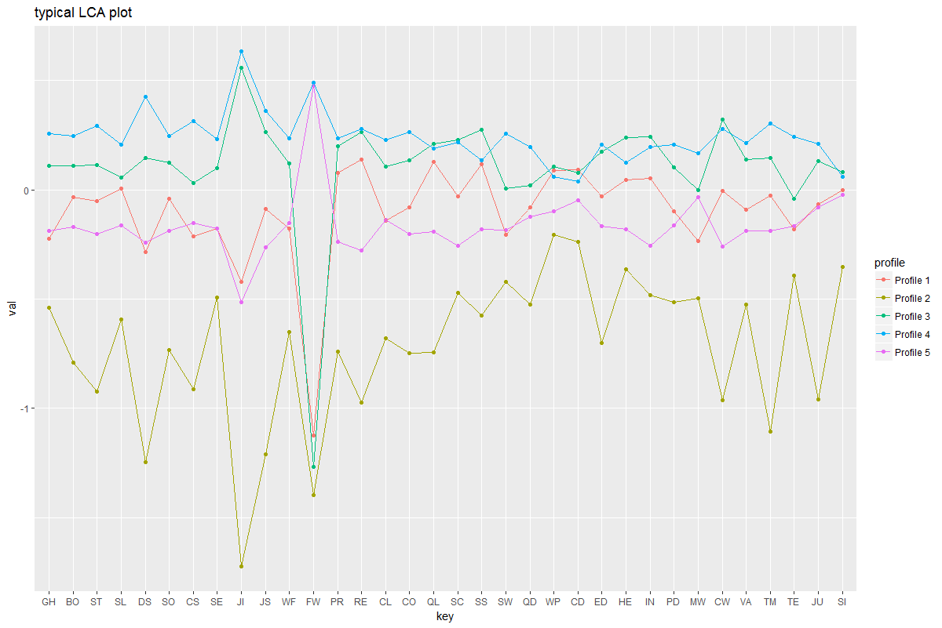

Alternative Figure 1. The five-profile solution based on finite Gaussian mixture modelling (Fraley et al., 2014). See Table 1 for a list of scale Abbreviations. For an alternative depiction see full text.

**Tables SI1-SI4 & annex Tables SA1-SA16***Please see Excel file for these tables or online* <https://figshare.com/s/c69bde7bbd73e8de70f2>