Supplementary Material

Fine-scale biogeographical boundary delineation and sub-population resolution in the *Symbiodinium thermophilum* coral symbiont group from the Persian / Arabian Gulf and Gulf of Oman

Benjamin C.C. Hume1,2*, Cecilia D’Angelo2,4, John Burt3 & Jörg Wiedenmann2,4

**\* Correspondence:** Benjamin C C Hume: benjamin.hume@kaust.edu.sa

# Supplementary Figures and Tables

**Table S1**: PsbAncr sequences used in the construction of the maximum parsimony network.

|  |  |  |  |  |  |  |  |  |  |
| --- | --- | --- | --- | --- | --- | --- | --- | --- | --- |
| **ID** | **Collection Site** | **Collection Date** | **Accession Number** | **Host Species** | **ID** | **Collection Site** | **Collection Date** | **Accession Number** | **Host Species** |
| BH1415 | Dalma | Sept 2012 | KM458276 | *P. harrisoni* | BH1668 | Umm Al Quwain | March 2013 | KP280258 | *P. lutea* |
| BH1448 | Dalma | Sept 2012 | KM458286 | *P. harrisoni* | BH1456 | Umm Al Quwain | March 2013 | KM458291 | *P. lutea* |
| BH1413 | Dalma | Sept 2012 | KM458274 | *P. harrisoni* | BH1669 | Umm Al Quwain | March 2013 | KP280260 | *P. lutea* |
| BH1414 | Dalma | Sept 2012 | KM458275 | *P. harrisoni* | BH1457 | Umm Al Quwain | March 2013 | KP280261 | *P. lutea* |
| BH1450 | Dalma | Sept 2012 | KM458288 | *P. lutea* | BH1660 | Umm Al Quwain | March 2013 | KP280262 | *P. lutea* |
| BH1449 | Dalma | Sept 2012 | KM458287 | *P. lutea* | BH1392 | Umm Al Quwain | March 2013 | KM458294 | *P. lutea* |
| BH1692 | Dalma | Sept 2012 | KP280211 | *P. lutea* | BH1458 | Umm Al Quwain | March 2013 | KM458292 | *P. lutea* |
| BH1690 | Dalma | Sept 2012 | KP280212 | *P. harrisoni* | BH1427 | Umm Al Quwain | March 2013 | KM458284 | *P. lutea* |
| BH1643 | Dalma | Sept 2012 | KP280213 | *P. harrisoni* | BH1679 | Umm Al Quwain | March 2013 | KP280265 | *P. lutea* |
| BH1411 | Dalma | Sep 2012 | KM458273 | *P. harrisoni* | BH1688 | Umm Al Quwain | March 2013 | KP280266 | *P. lutea* |
| BH1647 | Dalma | Sept 2012 | KP280215 | *P. harrisoni* | BH1675 | Ras Al-Kaimah | March 2013 | KP280267 | *Porites sp.* |
| BH1691 | Dalma | Sept 2012 | KP280216 | *P. harrisoni* | BH1621 | Ras Al-Kaimah | March 2013 | KP280268 | *Porites sp.* |
| BH1447 | Dalma | Sept 2012 | KP280217 | *P. harrisoni* | BH1671 | Ras Al-Kaimah | March 2013 | KP280269 | *Porites sp.* |
| BH1693 | Dalma | Sept 2012 | KP280218 | *P. lutea* | BH1672 | Ras Al-Kaimah | March 2013 | KP280270 | *Porites sp.* |
| BH1416 | Dalma | Sept 2012 | KP280219 | *P. harrisoni* | BH1676 | Ras Al-Kaimah | March 2013 | KP280271 | *Porites sp.* |
| BH1702 | Saadiyat | Sept 2012 | KP280220 | *P. lobata* | BH1623 | Ras Al-Kaimah | March 2013 | KP280272 | *Porites sp.* |
| BH1704 | Saadiyat | Sept 2012 | KP280221 | *P. lobata* | BH1620 | Ras Al-Kaimah | March 2013 | KP280273 | *Porites sp.* |
| BH1708 | Saadiyat | Sept 2012 | KP280222 | *P. lobata* | BH1624 | Ras Al-Kaimah | March 2013 | KP280275 | *Porites sp.* |
| BH1356 | Saadiyat | Sept 2012 | KM458293 | *P. lutea* | BH1670 | Ras Al-Kaimah | March 2013 | KP280276 | *Porites sp.* |
| BH1422 | Saadiyat | Sept 2012 | KM458279 | *P. lutea* | BH1673 | Ras Al-Kaimah | March 2013 | KP280277 | *Porites sp.* |
| BH1451 | Saadiyat | Sept 2012 | KM458289 | *P. lobata* | BH1678 | Ras Al-Kaimah | March 2013 | KP280278 | *Porites sp.* |
| BH1417 | Saadiyat | Sept 2012 | KM458277 | *P. lutea* | BH1680 | Ras Al-Kaimah | March 2013 | KP280279 | *Porites sp.* |
| BH1419 | Saadiyat | Sept 2012 | KM458278 | *P. lutea* | BH1677 | Ras Al-Kaimah | March 2013 | KP280280 | *Porites sp.* |
| BH1699 | Saadiyat | Sept 2012 | KP280227 | *P. lutea* | BH1683 | Ras Al-Kaimah | March 2013 | KP280281 | *Porites sp.* |
| BH1701 | Saadiyat | Sept 2012 | KP280228 | *P. lutea* | BH1497 | Ras Al-Kaimah | March 2013 | KP280282 | *Porites sp.* |
| BH1705 | Saadiyat | Sept 2012 | KP280229 | *P. lutea* | BH1625 | Ras Al-Kaimah | March 2013 | KP280283 | *Porites sp.* |
| BH1706 | Saadiyat | Sept 2012 | KP280230 | *P. lutea* | BH1682 | Ras Al-Kaimah | March 2013 | KP280284 | *Porites sp.* |
| B315 | Saadiyat | Sept 2012 | KP280231 | *P. harrisoni* | BH1681 | Ras Al-Kaimah | March 2013 | KP280285 | *Porites sp.* |
| BH1696 | Saadiyat | Sept 2012 | KP280232 | *P. harrisoni* | BH1674 | Ras Al-Kaimah | March 2013 | KP280286 | *Porites sp.* |
| BH1641 | Saadiyat | Sept 2012 | KP280233 | *P. lobata* | B21549 | Musandam | March 2013 | KP280287 | *P. lobata* |
| BH1703 | Saadiyat | Sept 2012 | KP280234 | *P. harrisoni* | B21550 | Musandam | March 2013 | KP280288 | *P. lobata* |
| BH1642 | Saadiyat | Sept 2012 | KP280235 | *P. harrisoni* | BH1652 | Musandam | March 2013 | KP280289 | *P. lobata* |
| BH1698 | Saadiyat | Sept 2012 | KP280236 | *P. lutea* | BH1616 | Musandam | March 2013 | KP280290 | *P. lutea* |
| BH1487 | Saadiyat | Sept 2012 | KP280237 | *P. lobata* | BH1617 | Musandam | March 2013 | KP280291 | *P. lobata* |
| BH1639 | Saadiyat | Sept 2012 | KP280239 | *P. lutea* | B21551 | Musandam | March 2013 | KP280292 | *P. lutea* |
| BH1700 | Saadiyat | Sept 2012 | KP280240 | *P. harrisoni* | B21552 | Musandam | March 2013 | KP280293 | *P. lutea* |
| BH1453 | Saadiyat | Sept 2012 | KM458290 | *P. lobata* | B21553 | Musandam | March 2013 | KP280294 | *P. lutea* |
| BH1636 | Ras Ghanada | Sept 2012 | KP280242 | *P. lutea* | B21554 | Musandam | March 2013 | KP280295 | *P. lutea* |
| BH1547 | Ras Ghanada | Sept 2012 | KP280243 | *P. lobata* | BH1649 | Musandam | March 2013 | KP280296 | *P. lobata* |
| BH1632 | Ras Ghanada | Sept 2012 | KP280244 | *P. lobata* | BH1653 | Musandam | March 2013 | KP280297 | *P. lutea* |
| BH1634 | Ras Ghanada | Sept 2012 | KP280245 | *P. harrisoni* | BH1655 | Musandam | March 2013 | KP280298 | *P. lutea* |
| BH1635 | Ras Ghanada | Sept 2012 | KP280246 | *P. harrisoni* | B341 | Musandam | March 2013 | KP280299 | *P. lutea* |
| BH1548 | Ras Ghanada | Sept 2012 | KP280247 | *P. lutea* | BH1659 | Musandam | March 2013 | KP280300 | *P. lutea* |
| BH1631 | Ras Ghanada | Sept 2012 | KP280248 | *P. harrisoni* | B21556 | Musandam | March 2013 | KP280301 | *P. lobata* |
| BH1633 | Ras Ghanada | Sept 2012 | KP280249 | *P. harrisoni* | BH1658 | Musandam | March 2013 | KP280302 | *P. lobata* |
| BH1664 | Umm Al Quwain | March 2013 | KP280250 | *P. lutea* | B21557 | Musandam | March 2013 | KP280303 | *P. lobata* |
| BH1425 | Umm Al Quwain | March 2013 | KM458282 | *P. lutea* | BH1656 | Musandam | March 2013 | KP280304 | *P. lobata* |
| BH1662 | Umm Al Quwain | March 2013 | KP280252 | *P. lutea* | BH1614 | Musandam | March 2013 | KP280305 | *P. lobata* |
| BH1428 | Umm Al Quwain | March 2013 | KM458285 | *P. lutea* | BH1615 | Musandam | March 2013 | KP280306 | *P. lobata* |
| BH1424 | Umm Al Quwain | March 2013 | KM458281 | *P. lutea* | B21561 | Fujairah | Sept 2012 | KP280307 | *P. lobata* |
| BH1628 | Umm Al Quwain | March 2013 | KP280255 | *P. lutea* | BH1550 | Fujairah | Sept 2012 | KP280308 | *P. lobata* |
| BH1426 | Umm Al Quwain | March 2013 | KM458283 | *P. lutea* | B21560 | Fujairah | Sept 2012 | KP280309 | *P. lobata* |
| BH1423 | Umm Al Quwain | March 2013 | KM458280 | *P. lutea* | B334 | Fujairah | Sept 2012 | KP280310 | *P. lobata* |

Sequences with accession numbers beginning KM are from: Hume *et al.* 2015 (Hume et al., 2015)and represent the samples used to define *Symbiodinium thermophilum*.

Sequences with accession numbers beginning KP are from D’Angelo *et al.* 2015(D'Angelo et al., 2015).

**Table S2**: Number of samples and depth of sequencing for the nrDNA marker

|  |  |  |
| --- | --- | --- |
| **Collection Site** | **Colonies Collected** | **Average clones sequenced per coral colony** |
| Dalma | 5 | 8 |
| Saadiyat | 23 | 6 |
| Ras Ghanada | 4 | 6 |
| Umm Al Quwain | 4 | 11 |
| Ras Al-Kaimah | 6 | 8 |
| Musandam West | 4 | 7 |
| Musandam East | 3 | 6 |
| Fujairah | 12 | 6 |
| Muscat | 1 | 14 |

**Table S3**: Distance matrix used in Mantel tests (km).

|  |  |  |  |  |  |  |  |  |  |
| --- | --- | --- | --- | --- | --- | --- | --- | --- | --- |
|  | DAL | SAD | RAG | UMM | RAK | MW | ME | FUJ | MUC |
| DAL | 0 |  |  |  |  |  |  |  |  |
| SAD | 230 | 0 |  |  |  |  |  |  |  |
| RAG | 268 | 38 | 0 |  |  |  |  |  |  |
| UMM | 400 | 170 | 132 | 0 |  |  |  |  |  |
| RAK | 439 | 209 | 171 | 39 | 0 |  |  |  |  |
| MW | 494 | 264 | 226 | 94 | 55 | 0 |  |  |  |
| ME | 516 | 286 | 248 | 106 | 77 | 22 | 0 |  |  |
| FUJ | 634 | 404 | 366 | 234 | 195 | 140 | 118 | 0 |  |
| MUC | 997 | 767 | 729 | 597 | 558 | 503 | 481 | 363 | 0 |

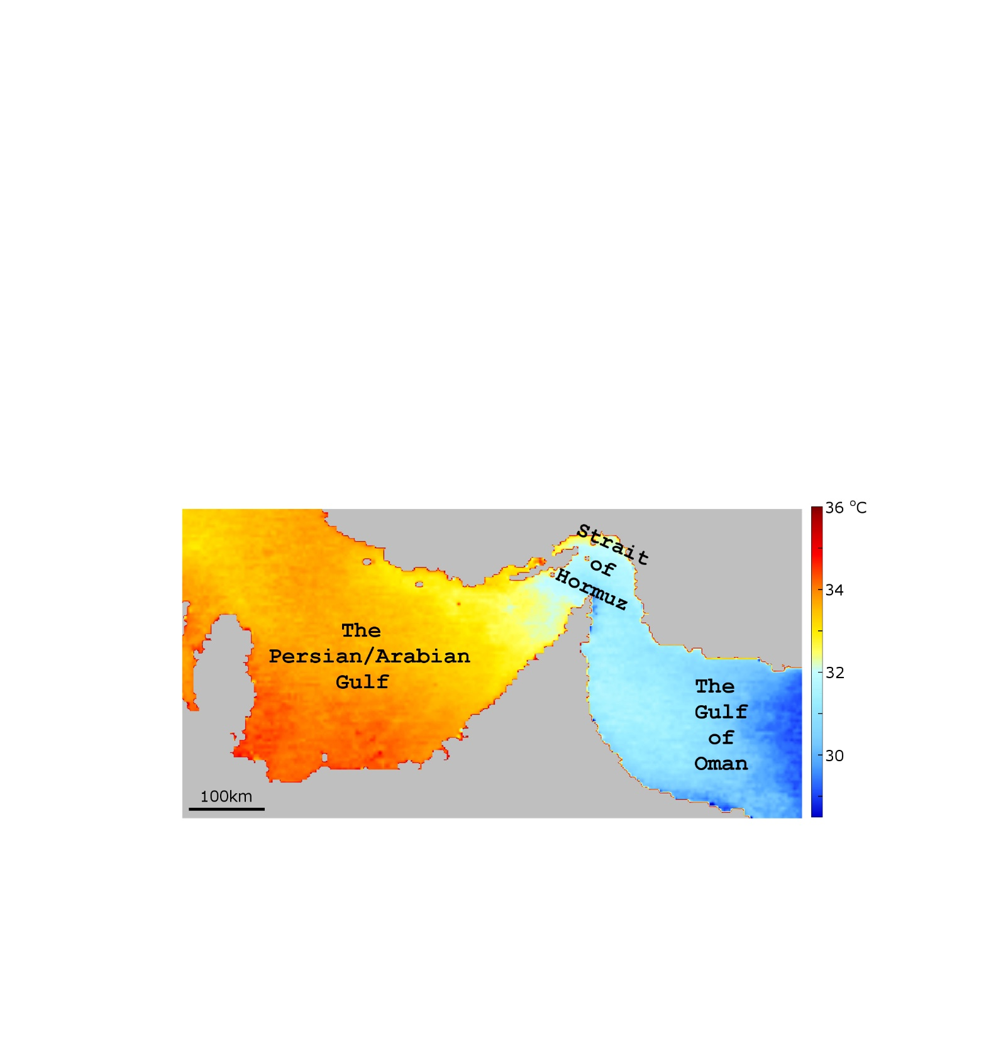

**Figure S1**: Aqua MODIS SST (11 µ daytime) August climatology 2002-2015.

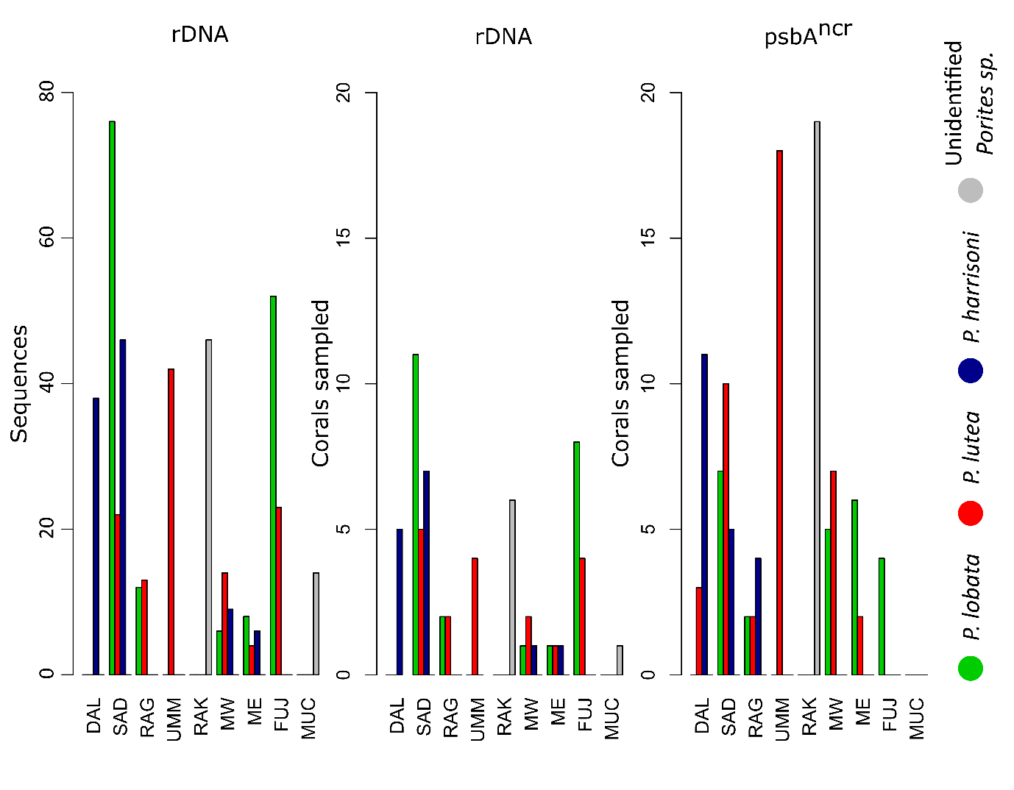

**Figure S2:** Sampling frequencies by site and species. For the rDNA marker, given the cloning strategy employed in this study, sampling frequencies are given both by total number of sequences returned and number of corals sampled, both by site and species.

# Code S1: Mothur, R and Python scripts

Example Mothur, R and Python scripts used in this study are available at <https://github.com/didillysquat/PAG-Code>

# References

D'Angelo, C., Hume, B.C.C., Burt, J., Smith, E.G., Achterberg, E.P., and Wiedenmann, J. (2015). Local adaptation constrains the distribution potential of heat-tolerant *Symbiodinium* from the Persian/Arabian Gulf. *ISME J* 9**,** 2551-2560. doi: 10.1038/ismej.2015.80.

Hume, B.C.C., D'Angelo, C., Smith, E.G., Stevens, J.R., Burt, J., and Wiedenmann, J. (2015). *Symbiodinium thermophilum* sp nov., a thermotolerant symbiotic alga prevalent in corals of the world's hottest sea, the Persian/Arabian Gulf. *Scientific Reports* 5. doi: 10.1038/srep08562.