Supplementary Material

Composition of Dissolved Organic Matter in Pore Waters of Anaerobic Marine Sediments Analyzed by 1H Nuclear Magnetic Resonance Spectroscopy

Christina A. Fox, Hussain A. Abdulla, David J. Burdige, James P. Lewicki, Tomoko Komada*

**\* Correspondence:** [tkomada@sfsu.edu](mailto:tkomada@sfsu.edu)

# Calculating DOC concentrations from normalized 1H NMR spectra

The total area under the normalized spectrum is the sum of relative contributions from each 1H type,

(total area under normalized spectrum) *=* *f*1*+ f*2 *+ … + f*i *=* 1 (1)

where *f*iis the fraction of total protons found in compound class *i*. We cast the above in DOC units as follows:

*DOH* / (*r*HCbulk) *=* *DOH* *(*f*1*/r*HC1 *+ f*2*/r*HC2*+ … + f*i*/r*HCi) = *DOC* (2)

where *DOH* and *DOC* are dissolved organic H and C concentrations of the bulk sample, *r*HCbulk is the H/C ratio of the bulk sample, and *r*HCi is the H/C ratio of compound class *i*. To solve Eq (2), we first assigned *r*HCbulk for each depth interval using Fourier Transform Ion Cyclotron Resonance Mass Spectrometry (FTICR-MS) data obtained for these same samples (Supplementary Table 1). We then assigned *r*HCi values for all peaks except CRAM according to their corresponding biochemical compound classes (Table 1), leaving the *r*HCi value of CRAM in the version of Eq. (2) for each sample as the sole unknown variable. We then calculated a depth-independent, single best-fit *r*HCi value of CRAM that minimized the difference between calculated DOC and the known DOC (Supplementary Table S1) for each sample using an error-minimization routine (Solver in Microsoft Excel). This gave a *r*HCi value of 1.4 for CRAM, which falls within the range of H/C ratios (0.75-1.50) reported for CRAM (Hertkorn et al. 2006).

# Supplementary Figures and Tables

**Supplementary Table 1.** Molar H/C ratios of bulk DOM determined by FTICR-MS and DOC concentrations (Burdige et al., 2016) of SBB pore waters. FTICR-MS data were acquired as described in Abdulla et al. (2018).

|  |  |  |
| --- | --- | --- |
| **Depth (cm)** | **H/C** | **DOC (mM)** |
| 0.5 | 1.73 | 0.279 |
| 1.5 | 1.58 | 0.314 |
| 11.0 | 1.55 | 0.509 |
| 25.5 | 1.50 | 0.657 |
| 37.5 | 1.45 | 1.122 |
| 80.2 | 1.40 | 1.967 |
| 135.3 | 1.45 | 2.625 |
| 145.3 | 1.40 | 2.734 |
| 182.3 | 1.43 | 2.972 |
| 230.3 | 1.44 | 3.522 |
| 242.3 | 1.41 | 3.602 |
| 262.3 | 1.41 | 3.766 |
| 302.3 | 1.44 | 4.176 |
| 342.3 | 1.43 | 4.450 |
| 362.3 | 1.41 | 4.508 |
| 392.3 | 1.40 | 4.865 |
| 432.3 | 1.43 | 4.996 |

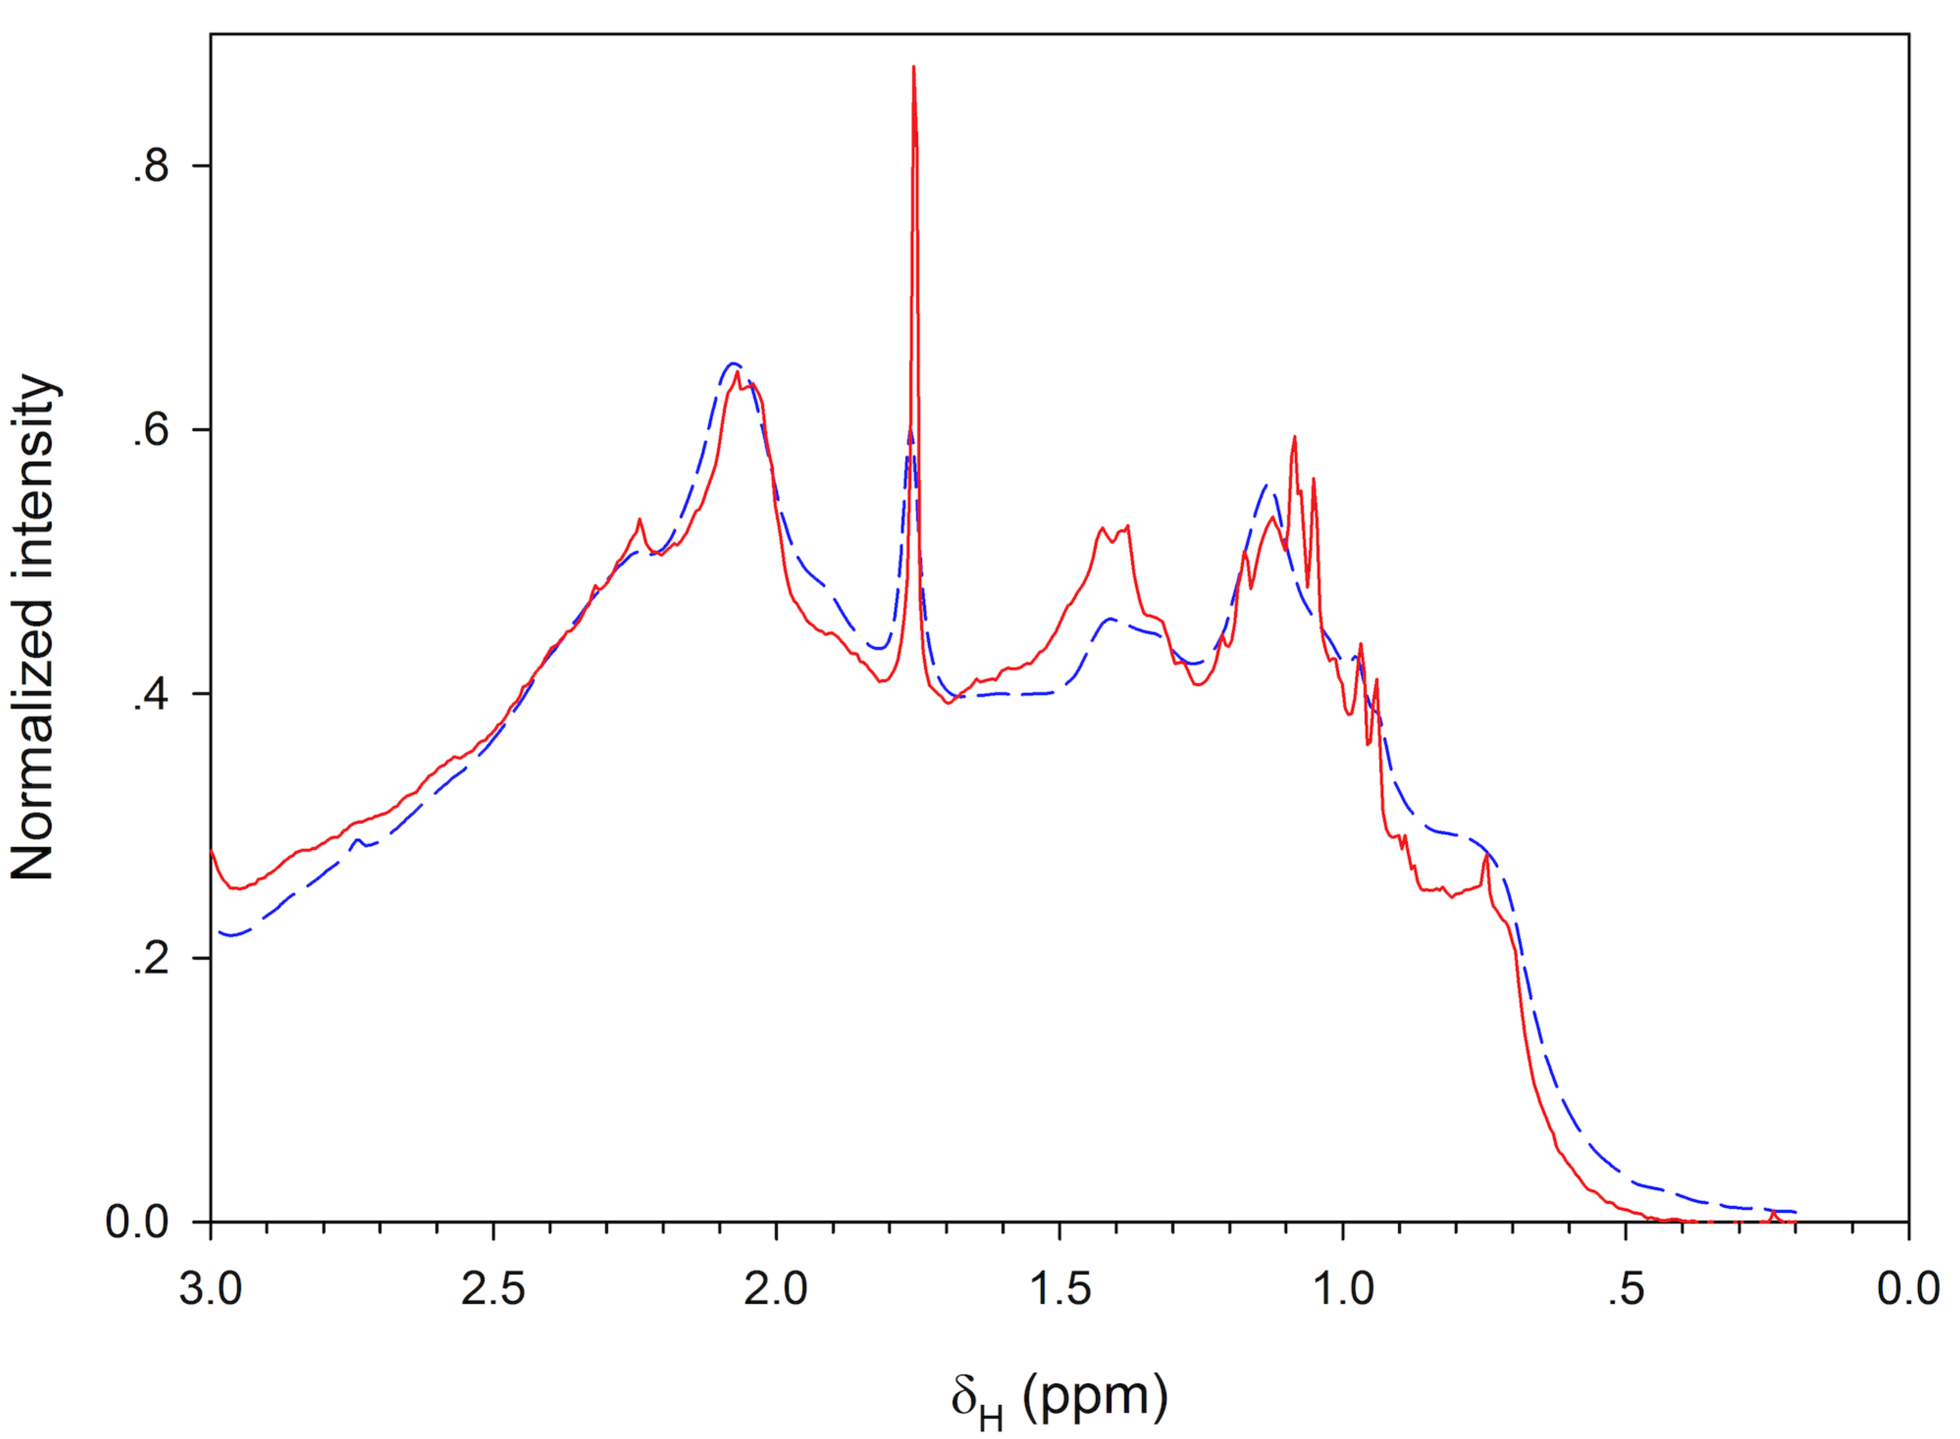

**Supplementary Figure 1.** 1H NMR spectra acquired on the 400-MHz (dashed blue line) and 600-MHz (solid red line) spectrometers normalized between 0.2-3.0 ppm. Average of all samples collected from depths >90 cm are shown.

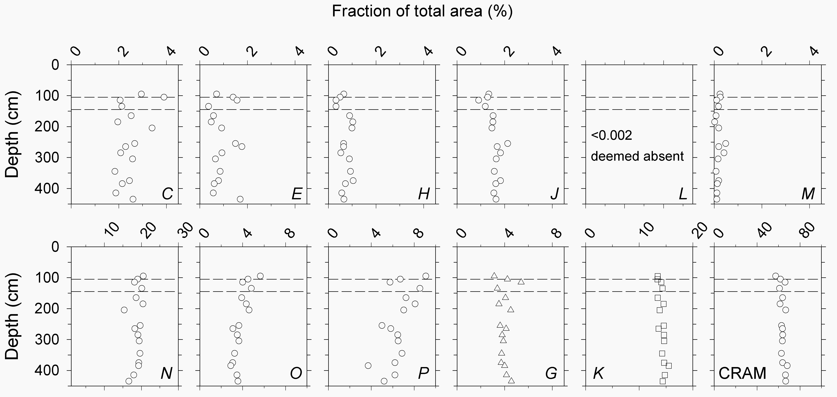

**Supplementary Figure 2.** Depth variability in the areas of normalized spectra attributed to peaks (*C-M*) and bands (*N, O, P, G, K*, and total CRAM) obtained on the 600 MHz instrument. Horizontal dashed lines indicate the upper and lower bounds of the sulfate-methane transition zone (SMTZ, 125±20 cm; see Section 4.1.1.).

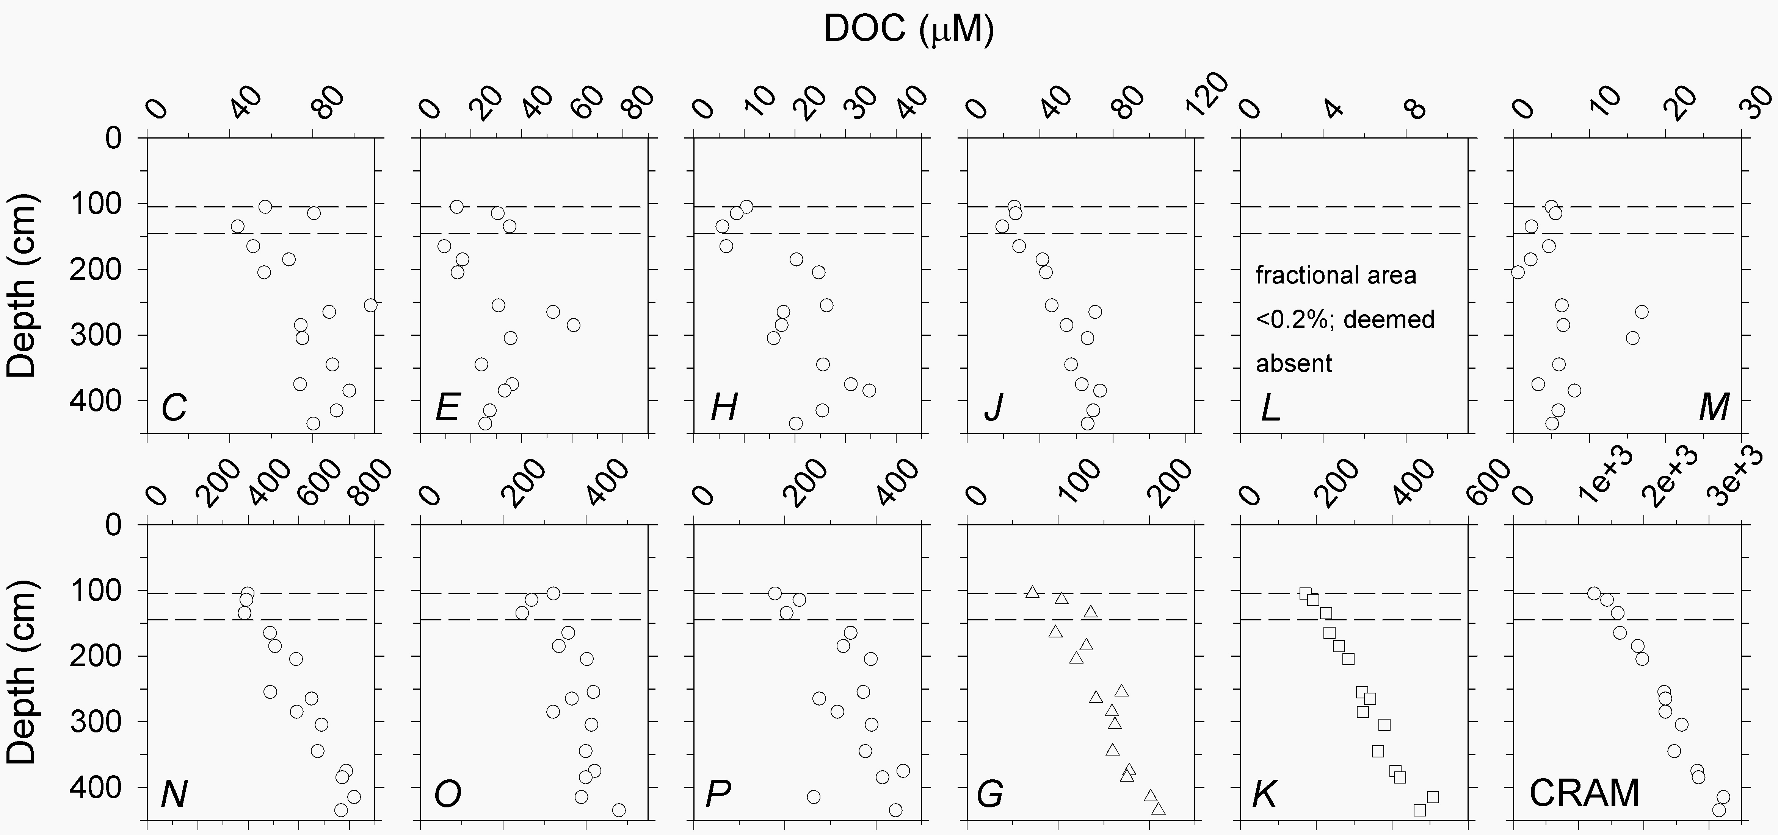

**Supplementary Figure 3.** DOC concentrations (μM) attributed to peaks (*C*-*M*), bands (*N-P*, *G*, *K*), and CRAM. Bands *G* and *K* are considered parts of CRAM. DOC values were calculated from peak areas in the normalized spectra obtained on the 600 MHz instrument as described in S1. Dashed lines indicate the upper and lower bounds of the sulfate-methane transition zone (SMTZ, 125±10 cm; see Section 4.1.1.).

# References

Abdulla, H. A., Burdige, D. J., and Komada, T. (2018). Accumulation of Deaminated Peptides in Anoxic Sediments of Santa Barbara Basin. *Geochim. Cosmochim. Acta* 223, 245–258.

Burdige, D. J., Komada, T., Magen, C., and Chanton, J. P. (2016). Modeling studies of dissolved organic matter cycling in Santa Barbara Basin (CA, USA) sediments. *Geochim. Cosmochim. Acta* 195, 100–119.

Hertkorn, N., Benner, R., Frommberger, M., Schmitt-Kopplin, P., Witt, M., Kaiser, K., et al. (2006). Characterization of a major refractory component of marine dissolved organic matter. *Geochim. Cosmochim. Acta* 70, 2990–3010.

Hertkorn, N., Harir, M., Koch, B., Michalke, B., and Schmitt-Kopplin, P. (2013). High-field NMR spectroscopy and FTICR mass spectrometry: powerful discovery tools for the molecular level characterization of marine dissolved organic matter. *Biogeosciences* 10, 1583–1624.