Supplementary Material

Precrop functional group identity affects yield of winter barley but less so high carbon amendments in a mesocosm experiment

**Richard van Duijnen1, Julien Roy2,3, Werner Härdtle1, Vicky M. Temperton1\***

1Institute of Ecology, Leuphana University Lüneburg, Lüneburg, Germany

2Institut für Biologie, Ökologie der Pflanzen, Freie Universität Berlin, Berlin, Germany

3Berlin-Brandenburg Institute of Advanced Biodiversity Research, Berlin, Germany

**Corresponding author:**Vicky M. Temperton  
[vicky.temperton@leuphana.de](mailto:vicky.temperton@leuphana.de)

# Running title: Precrop and Carbon Supplementary Figures and Tables

## Supplementary Figures

C:\Users\Richard van Dujinen\Documents\Planned exp 2016\Mesocosm Exp Data\Rtest\Weather data\Testplot_Blackwhite.tif

**Supplementary Figure 1.** Daily average temperature (grey line), moving average of 20 days (solid black line) and total monthly precipitation (grey bars) during this study. Data from the weather station in Wendisch Evern (53°12’49.0”N 10°28’13.1”E).

C:\Users\Richard van Dujinen\Documents\Planned exp 2016\Mesocosm Exp Data\leachate data\Testplot.tif

**Supplementary Figure 2.** Correlation of nitrate measured in leachate with the UV method (x-axis) and ion chromatography (y-axis) of leachate sampled at the third time point (28/11/16).

C:\Users\Richard van Dujinen\Documents\Planned exp 2016\Mesocosm Exp Data\Rtest\Graphs & Tables\Precrop grain and straw.tif

**Supplementary Figure 3.** Precrop grain yield and straw biomass at maturity. Grain yield is the total seed mass without spikes (barley) or pods (canola, faba bean, lupine) and straw biomass is all other aboveground biomass. Values are means ± se (*n=*30).

**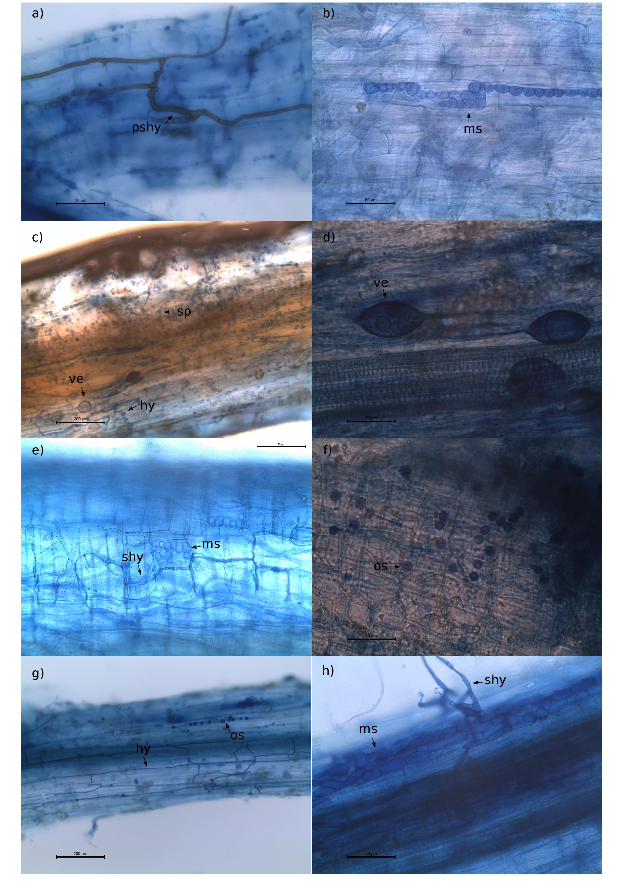Supplementary Figure 4.** Fungal structures in precrop roots at respective harvest time. Roots were stained with Trypan blue. The following structures were observed: **(A)** Unidentified regularly pigmented septate hyphae (pshy) and **(B)** microsclerotia (ms) / alternatively moniliform cells (mc) in spring barley roots. **(C)** Glomeromycotina-like vesicules (ve), hypha (hy) and spores (sp) and **(D)** Glomeromycotina-like vesicules (ve) in faba bean roots. **(E)** Septate hyphae (shy) and microsclerotia (ms) and **(F)** Olpidium spores (op) in lupin roots. **(G)** Extracellular hyphae (hy) and Olpidium spores (os), and **(H)** microsclerotia (ms) and associated regularly septate hyphae (shy) in canola roots (composite root samples).