# SUPPLEMENTARY INFORMATION

# Tables

|  |  |
| --- | --- |
| Table S1. Compositional Analysis of Acid (1% w/w H2SO4) Pretreated Corn Stover | |
| Constituent | Acid Pretreated Corn Stover  % (w/w) dry basis | |
| Glucan | 54.3 | |
| Xylan | 2.0 | |
| Arabinan | 1.1 | |
| Galactan | 0.8 | |
| Lignin | 34.3 | |
| Ash | 6.8 | |
| Lowest Moisture Content Achieved through Centrifugation | 64.2% g/ wet g of solids | |

|  |  |
| --- | --- |
| Table S2. Stoichiometry used to calculate yields |  |
|  | Eq. [1a] |
|  | Eq. [1b] |
|  | Eq. [1c] |
|  | Eq. [1d] |
|  | Eq. [2] |
|  | Eq. [3] |

# Figures

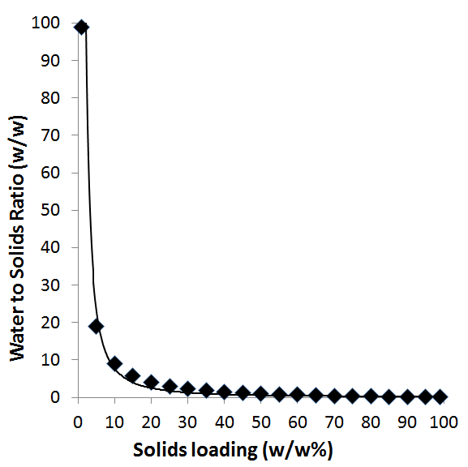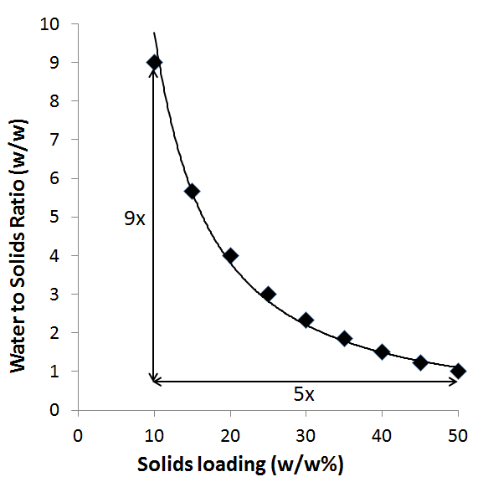

(a) (b)

Figure S1. Depicting the impact of increasing insoluble biomass loading in calculated curves: (a) Ratio of mass of water to that of solids in a slurry with increasing biomass loading (b) Focus on a range with solids loading increasing from 10% to 50% (w/w); while there is a 5X increase in solids loading, there is a 9X drop in water to solids ratio

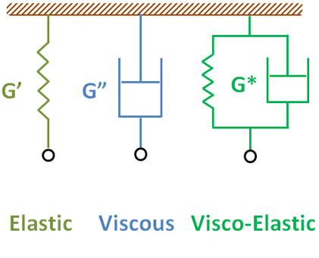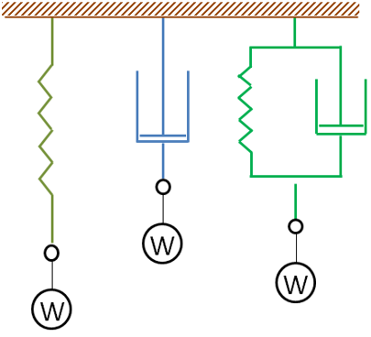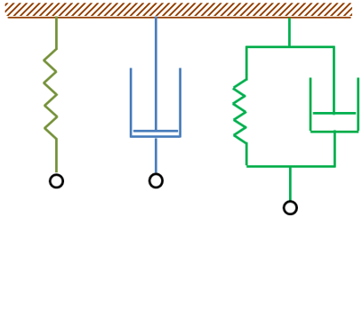

1. (b) (c)

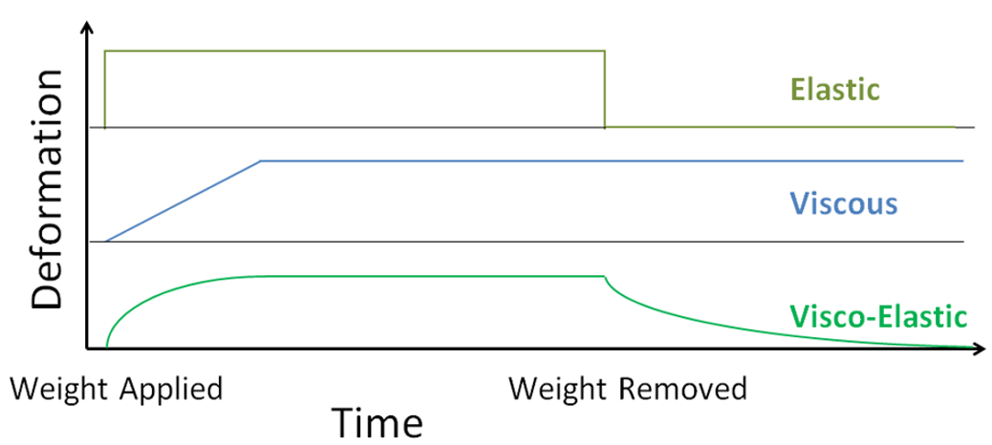

(d)

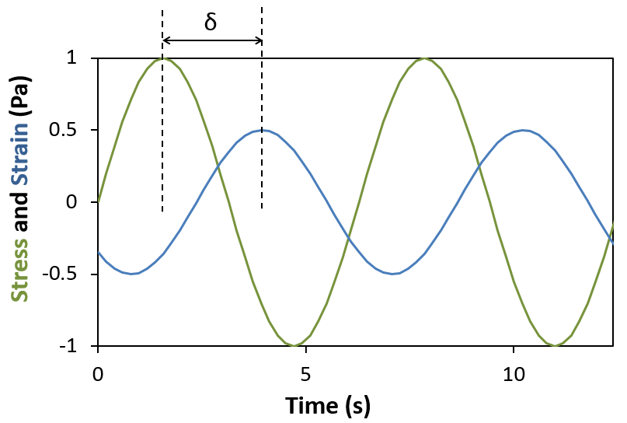

(e)

**Figure S2**. Theory of visco-elasticity explained through Kelvin Model; Elements at (a) Initial state, (b) Steady state after applying a weight, (c) Steady state after removing the weight, (d) Profile of deformation occurring in each of the elements due to application of the weight, and (e) profile of oscillatory stress and the corresponding strain against time, depicting phase angle.

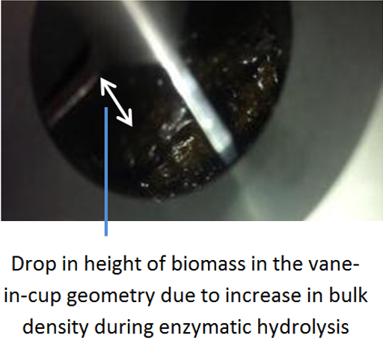 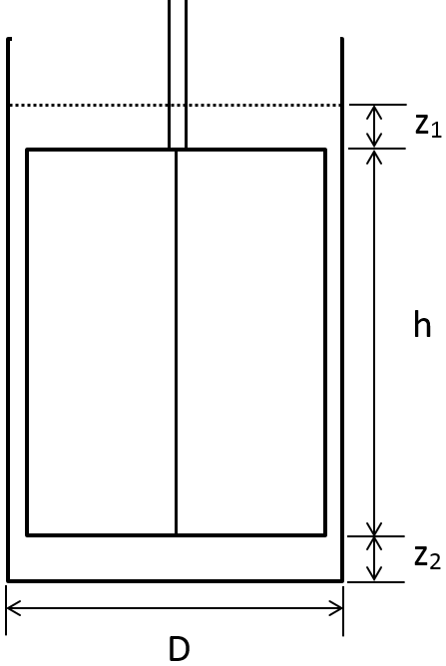

(a) (b)

**Figure S3**. (a) Drop in volume of IL pretreated switchgrass after 6 hours of enzymatic hydrolysis and (b) A depiction of level of sample required to obtain accurate and repeatable measurements in a cup with vane geometry; z1 = expected height of sample above vane, z2 = gap between bottom of vane and bottom of cup, h = height of vane, and D = diameter of cup

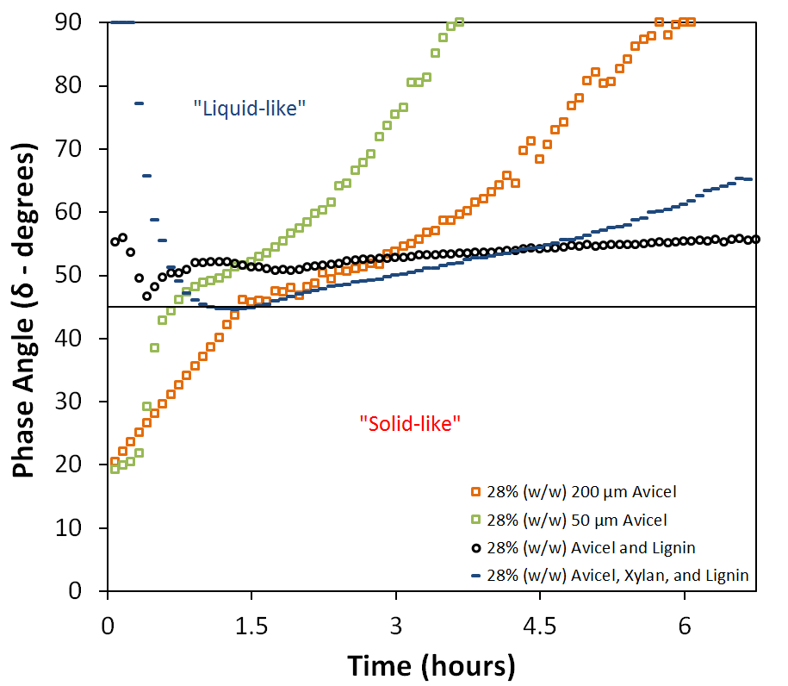

**Figure S4**. Phase Angle profile of enzymatic hydrolysis at 80 mg protein/g glucan of Novozymes Cellic® CTec2of 28% (w/w) Avicel in different scenarios, with varying compositions and particle sizes and tested on the rheometer at 10 Mz frequency and 10 Pa amplitude during oscillations

# Videos

[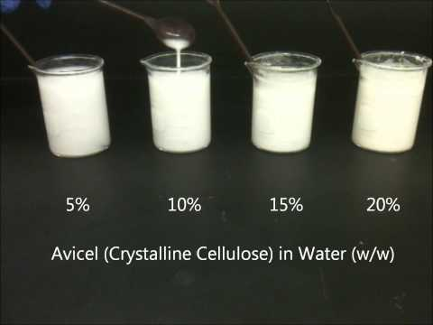](https://www.youtube.com/watch?v=PH5IF3X5tpw)

1. <https://www.youtube.com/watch?v=PH5IF3X5tpw>

[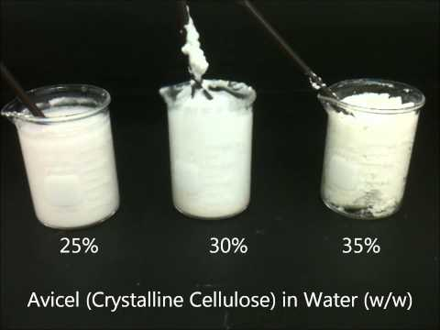](https://www.youtube.com/watch?v=Kbz0EE6iftk)

1. <https://www.youtube.com/watch?v=Kbz0EE6iftk>

**Video S1**. Microcrystalline cellulose (Avicel®PH101) in water (g dry insoluble solids/ g slurry) at various concentrations to depict different levels of flowability: (a) Liquid-like behavior when loaded to a mass ratio of up to 0.2; and (b) Solid-like behavior when mixed with water at a mass ratio of 0.25 and above

[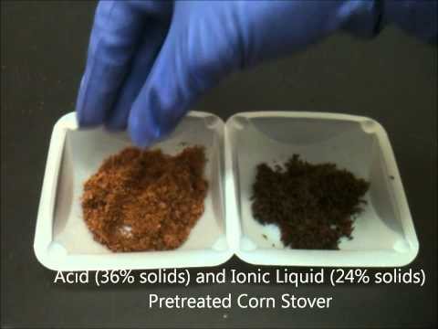](https://www.youtube.com/watch?v=sE2Fd5amBB4)

<https://www.youtube.com/watch?v=sE2Fd5amBB4>

**Video S2**. Acid and Ionic Liquid Pretreated Corn Stover at 36 and 24% (w/w) insolubles concentration, maximum achievable with centrifugation after pretreatment at 10% (w/w) insolubles concentration

[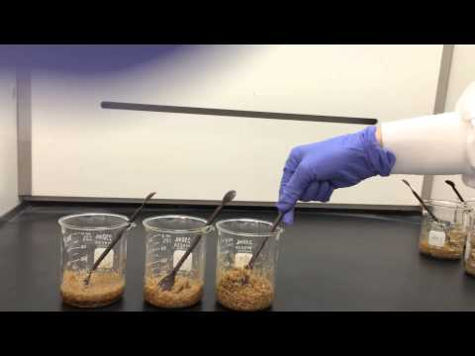](https://www.youtube.com/watch?v=HHHvuWpZmI4)

**Video S3**. Corn Stover in water (g dry insoluble solids/g slurry) at various concentrations of 5, 10, and 15%.