Supplementary Material

Glyco-engineered anti-human PD-L1 antibody mediates stronger CD8 T cell activation than its normal glycosylated and non-glycosylated counterparts

Christoph Goletz*, Timo Lischke, Ulf Harnack, Phillip Schiele, Antje Danielczyk, Johanna Rühmann, and Steffen Goletz

**\* Correspondence:** Christoph Goletz: Christoph.Goletz@glycotope.com

# Supplementary Tables

**Supplementary Table 1:** Summary of FcγRIIIa binding of αPDL1WT and αPDL1GE

|  |  |  |
| --- | --- | --- |
| **antibody** | **EC50 *[µg/ml]*** | **relative potency** |
| αPDL1WT | 27.12 | - |
| αPDL1GE | 6.81 | 3.98 |

|  |  |  |  |  |  |  |  |  |  |  |  |  |  |  |  |  |
| --- | --- | --- | --- | --- | --- | --- | --- | --- | --- | --- | --- | --- | --- | --- | --- | --- |
|  | **% CD25+ of ...** | **Medium** | | | **αPDL1NG** | | | | **αPDL1WT** | | | | **αPDL1GE** | | | |
|  | **Mean** | SEM | N | **Mean** | SEM | N |  | **Mean** | SEM | N |  | **Mean** | SEM | N |  |
| **total PBMC from donor A** | **CD8 T cells** | **7,7** | 1,5 | 2 | **11,7** | 5,4 | 2 | n.s. | **11,2** | 0,3 | 2 | n.s. | **53,4** | 1,4 | 2 | ** |
| **CD4 T cells** | **19,2** | 2,6 | 2 | **24,1** | 8,4 | 2 | n.s. | **20,2** | 0,5 | 2 | n.s. | **38,0** | 4,0 | 2 | n.s. |
| **isolated T cells from donor B** | **CD8 T cells** | **14,8** | 1,2 | 2 | **20,0** | 2,1 | 2 | n.s. | **26,2** | 0,3 | 2 | * | **41,5** | 0,6 | 2 | *** |
| **CD4 T cells** | **35,4** | 4,5 | 2 | **43,2** | 1,9 | 2 | n.s. | **47,5** | 0,4 | 2 | n.s. | **48,2** | 2,7 | 2 | n.s. |
| **isolated T cells from donor C** | **CD8 T cells** | **20,0** | 2,3 | 2 | **34,8** | 1,0 | 2 | n.s. | **42,8** | 2,1 | 2 | * | **52,1** | 4,5 | 2 | ** |
| **CD4 T cells** | **20,4** | 3,7 | 2 | **21,3** | 1,2 | 2 | n.s. | **27,9** | 4,7 | 2 | n.s. | **30,4** | 1,3 | 2 | n.s. |
| **total PBMC from donor D** | **CD8 T cells** | **6,1** | 0,7 | 2 | **10,9** | 3,0 | 2 | n.s. | **6,9** | 0,0 | 2 | n.s. | **43,7** | 1,4 | 2 | *** |
| **CD4 T cells** | **20,0** | 3,0 | 2 | **23,2** | 3,5 | 2 | n.s. | **16,7** | 0,9 | 2 | n.s. | **22,8** | 2,2 | 2 | n.s. |
| **total PBMC from donor E** | **CD8 T cells** | **0,9** | 0,5 | 2 | **2,6** | 0,6 | 2 | n.s. | **6,4** | 0,6 | 2 | n.s. | **7,3** | 1,6 | 2 | * |
| **CD4 T cells** | **5,1** | 1,0 | 2 | **8,9** | 0,5 | 2 | n.s. | **13,1** | 2,4 | 2 | n.s. | **9,7** | 0,1 | 2 | n.s. |
| **total PBMC from donor F** | **CD8 T cells** | **0,6** | 0,4 | 2 | **0,9** | 0,1 | 2 | n.s. | **3,3** | 0,6 | 2 | n.s. | **6,5** | 0,5 | 2 | ** |
| **CD4 T cells** | **7,9** | 1,4 | 2 | **8,3** | 0,0 | 2 | n.s. | **13,8** | 2,0 | 2 | n.s. | **13,7** | 0,5 | 2 | n.s. |
| **isolated T cells from donor G** | **CD8 T cells** | **13,4** | 0,5 | 2 | **25,2** | 3,7 | 2 | n.s. | **24,8** | 3,9 | 2 | n.s. | **33,6** | 0,8 | 2 | * |
| **CD4 T cells** | **22,6** | 0,5 | 2 | **40,5** | 3,3 | 2 | n.s. | **42,1** | 4,1 | 2 | * | **46,9** | 1,4 | 2 | * |
| **isolated T cells from donor H** | **CD8 T cells** | **23,0** | 4,0 | 2 | **34,1** | 1,5 | 2 | n.s. | **34,5** | 3,1 | 2 | n.s. | **43,1** | 0,4 | 2 | * |
| **CD4 T cells** | **44,0** | 2,5 | 2 | **52,5** | 0,3 | 2 | n.s. | **56,6** | 3,0 | 2 | n.s. | **55,4** | 0,1 | 2 | n.s. |

**Supplementary Table 2**: Summary of CD8 and CD4 T cell activation in MLR assays using different donors. The table shows the Mean, SEM and number of replicates of relative frequencies of CD25+ in CD8 T cells and CD4 T cells measured in MLR assays using isolated T cells of total PBMCs from different donors as responder cells. Significance was tested against the medium control. P values were determined by using a One-Way ANOVA and a Bonferroni post test (*p < 0.05; **p < 0.01; ***p < 0.001; ****p < 0.0001; ns = not significant).

# Supplementary Figures

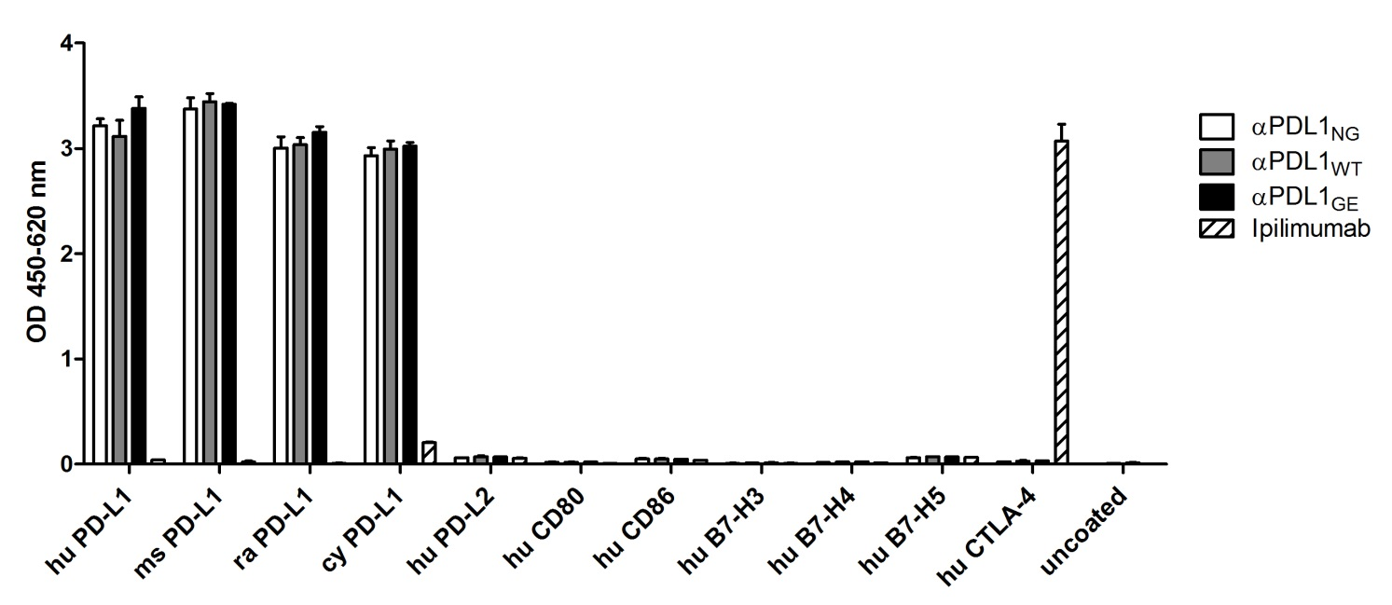

**Supplementary Figure 1:** Cross-reactivity ELISA for binding to PD-L1 from other species and for other B7 family members. OD450-620 values were plotted for αPDL1NG (white), αPDL1WT (gray), αPDL1GE (black), and ipilimumab (anti-human CTLA-4, shaded) to show antibody binding of plate-bound PD-L1 from human, mouse, rat and cynomolgus monkey, as well as binding to plate-bound human PD-L2, CD80, CD86, B7-H3, B7-H4, B7-H5, and CTLA-4. Test antibodies were incubated with saturating concentrations and detected with a secondary goat anti-hu IgG Fc-POD antibody. Statistics: mean and SD of duplicates were plotted. Data are representative of two independent experiments.

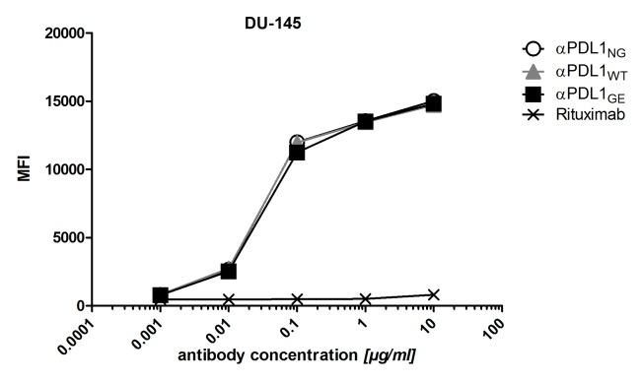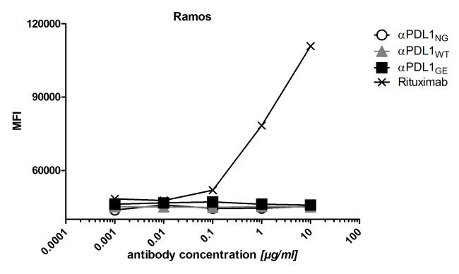

**Supplementary Figure 2:** Binding of anti-human PD-L1 variants to PD-L1+ DU-145 and PD-L1– Ramos cells determined in flow cytometry. The median fluorescence intensity is plotted against increasing concentrations of αPDL1NG (open circles), αPDL1WT (gray triangles), αPDL1GE (black squares), and rituximab (anti-human CD20; black crosses). Rituximab was used as a positive control for binding to CD20+ Ramos cells. Test antibodies were detected using a secondary F(ab)2 fragment goat anti-human IgG+IgM (H+L) PE-conjugated antibody. Statistics: mean and SD of duplicates were plotted in all graphs. Data are representative of two independent experiments.

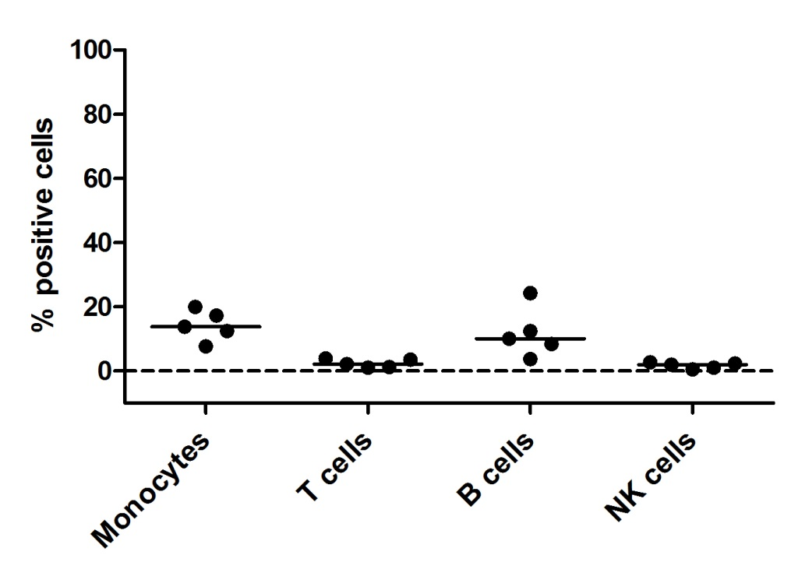

**Supplementary Figure 3**: Expression of PD-L1 on PBMC subsets. PD-L1 expression on different immune cell populations of PBMCs from five different healthy donors was analyzed by a flow cytometry using a biotinylated anti-PD-L1 antibody. PBMC were blocked with human IgG prior to staining. Binding of anti-PD-L1 antibody was detected with Streptavidin-PE. Co-staining with fluorescence-labelled anti-CD19, -CD3, -CD14 and -CD56 allowed for gating on monocytes, T cells, B cells and NK cells, respectively. Statistics: besides individual data points, the median was plotted.

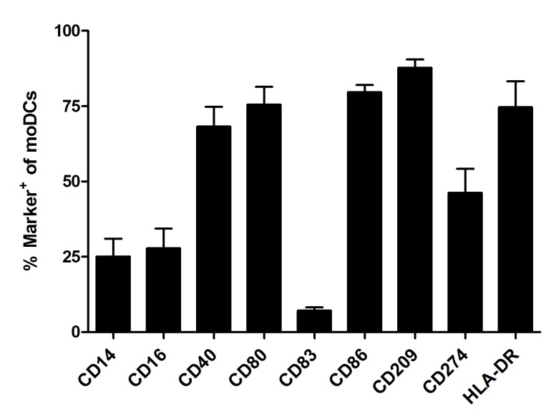

**Supplementary Figure 4**: Phenotype of monocyte-derived dendritic cells. The monocyte-derived dendritic cells (moDC) used for the MLR were phenotyped by flow cytometry according to expression of various differentiation molecules. The relative frequencies of CD14+, CD16+, CD40+, CD80+, CD83+, CD86+, CD209+, CD274+, and HLA-DR+ cells were plotted. Statistics: mean and SEM of ten individual experiments were plotted.

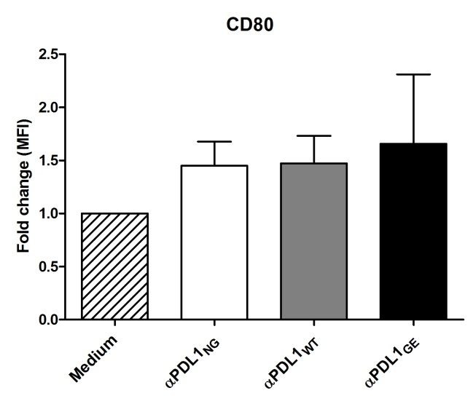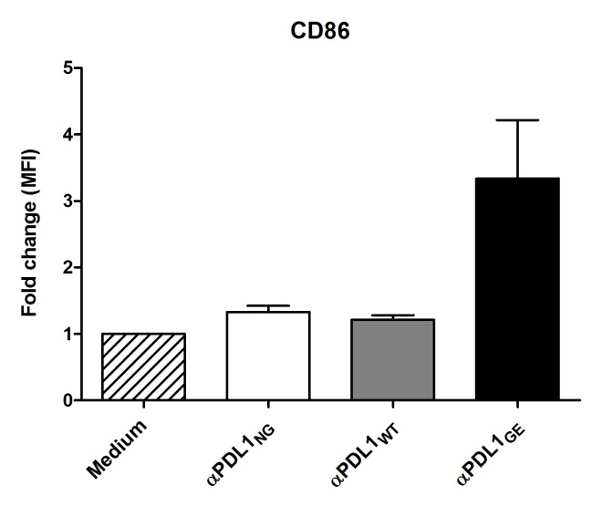

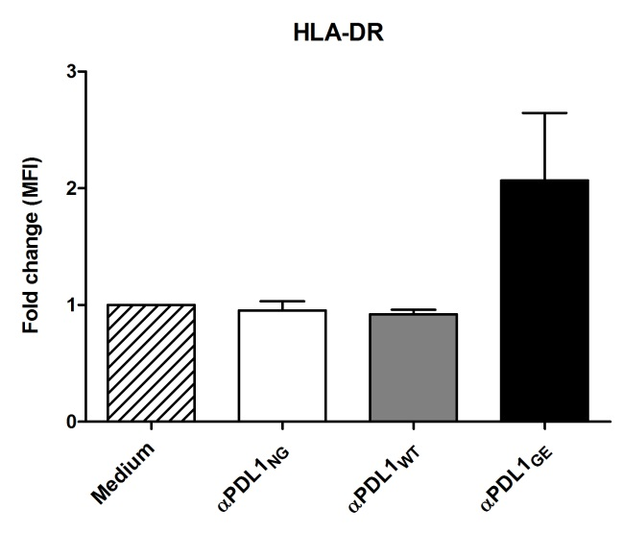

**Supplementary Figure 5**: Phenotype of moDCs on day 5 of the MLR. The phenotype of moDC used for the MLR was determined on day 5 of MLR by flow cytometric analysis. MoDC incubated together with T cells (from donor A) and one of the three anti-PD-L1 variants αPDL1NG (white bars), αPDL1WT (gray bars) and αPDL1GE (black bars) or only medium (striped bar) were analyzed. The fold changes in the median fluorescence intensity (MFI) relative to the medium control of CD80+, CD86+ and HLA-DR+ cells in moDC were plotted. Statistics: mean and SEM of four individual experiments were plotted.

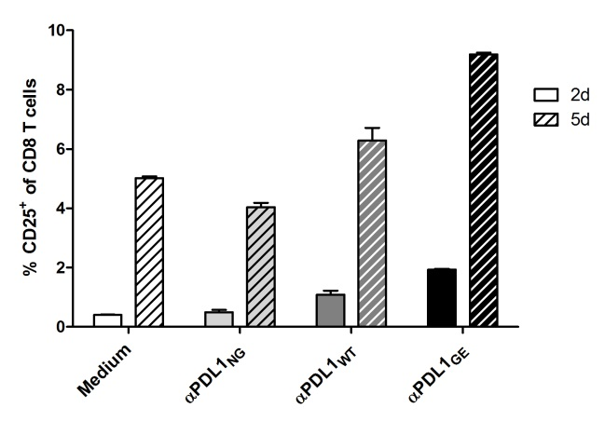 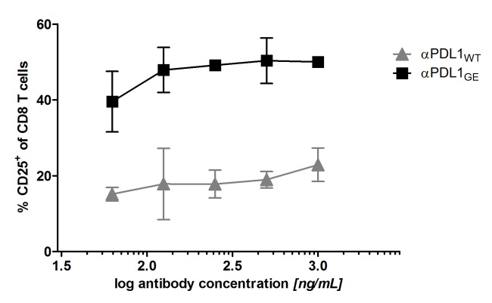

**Supplementary Figure 6**: CD8 T cell activation in a MLR determined on day 2 vs. day 5 and MLR using a concentration series of αPDL1WT and αPDL1GE. (6-1) The activation status of CD8 T cells (donor A) in a MLR in absence (white bars) and presence of αPDL1NG (light gray bars), αPDL1WT (dark gray bars), αPDL1GE (black bars) was determined on day 2 (open bars) and 5 (striped bars) by flow cytometric analysis. The relative frequencies of CD25+ in CD8 T cells were plotted. (6-2) The activation status of CD8 T cells (donor A) in a MLR in presence of increasing concentrations of αPDL1WT (gray triangles) and αPDL1GE (black squares) was determined on day 5 by flow cytometric analysis. The relative frequencies of CD25+ in CD8 T cells were plotted. Statistics: mean and SD of duplicates were plotted in all graphs. Data using increasing concentrations of anti-PD-L1 antibodies are representative of two independent experiments.

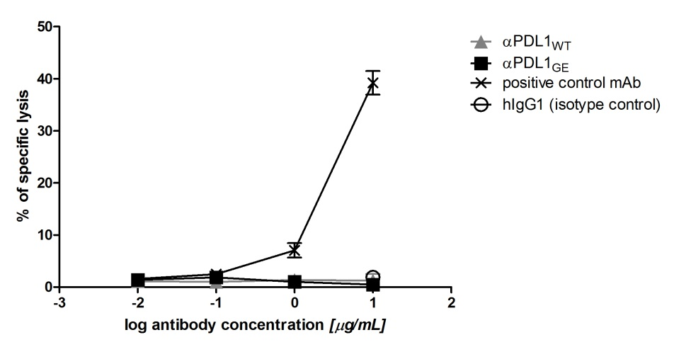

**Supplementary Figure 7:** ADCC assay with ZR-75-1 as target cells. KHYG-1-CD16aV (effectors) were incubated with europium-loaded ZR-75-1 cells (targets) in presence of αPDL1WT (gray triangles), αPDL1GE (black squares), a positive control antibody (black crosses) and a hIgG1 isotype control (white circles) for 5 h with an effector-to-target ratio of 30:1 to determine the specific lysis of target cells. Percentage of specific lysis was plotted against increasing concentrations of test antibody. Statistics: mean and SD of triplicates were plotted. Data are representative of two independent experiments.

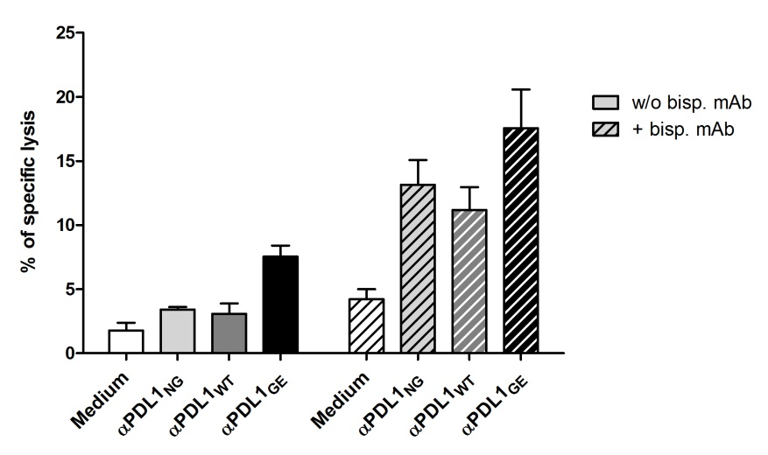

**Supplementary Figure 8:** Representative cytotoxicity experiment with pre-activated isolated T cells from donor C pre-activated in a MLR for 5 days in presence of αPDL1NG (light gray bars), αPDL1WT (dark gray bars) and αPDL1GE (black bars). T cells isolated from MLR without addition of test antibody (medium; white bar) served as negative control. Pre-activated T cells were incubated with europium-loaded ZR-75-1 cells for 5 h in ratio of 20:1. The cytotoxicity assay was performed in absence and presence (striped bars) of a bispecific antibody binding to a tumor antigen on ZR-75-1 and to CD3 on T cells. The percentage of specific target cell lysis is shown. Statistics: mean and SEM of triplicates were plotted.