Supplementary Data

A type I interferon and IL-10 induced by Orientia tsutsugamushi infection suppresses antigen-specific T cells and their memory responses

Chan-Ki Min^{1,2,†}, Hong-Il Kim^{1,2,†}, Na-Young Ha^{1,2}, Yuri Kim^{1,2}, Eun-Kyung Kwon^{1,2}, Nguyen Thi Hai Yen^{1,2}, Je-In Youn^{2,3}, Yoon Kyung Jeon⁴, Kyung-Soo Inn⁵,
Myung-Sik Choi¹, and Nam-Hyuk Cho^{1,2,3,6,*}

¹Department of Microbiology and Immunology, Seoul National University College of Medicine, Seoul, Republic of Korea, ²Department of Biomedical Sciences, Seoul National University College of Medicine, Seoul, Republic of Korea, ³Wide River Institute of Immunology, Seoul National University College of Medicine, Gangwon-do, Republic of Korea, ⁴Department of Pathology, Seoul National University College of Medicine, Seoul, Republic of Korea, ⁵Department of Pharmaceutical Science, College of Pharmacy, Kyung Hee University, Seoul, Republic of Korea, ⁶Institute of Endemic Disease, Seoul National University Medical Research Center and Bundang Hospital, Seoul, Republic of Korea

† These authors contributed equally.

* Correspondence:
Dr. Nam-Hyuk Cho
chonh@snu.ac.kr

Table S1. The frequencies and absolute counts of T cells in spleens of recovered mice at 6 weeks after infection.
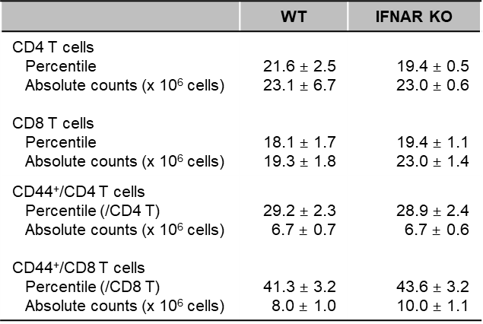

Table S2. The frequencies and absolute counts of total and apoptotic T cells in spleens of mice
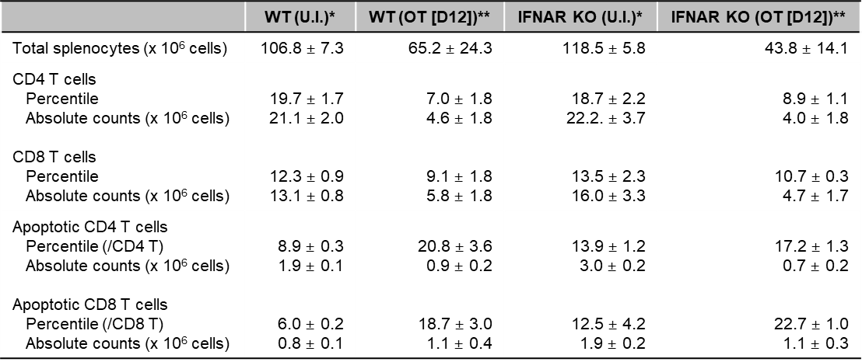
*, U.I., uninfected
**, OT [D12], at day 12 after infection with O. tsutsugamushi.

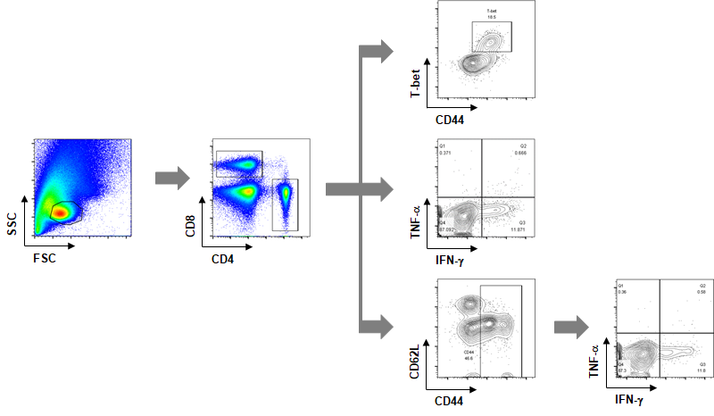
Figure S1. Gating strategies for T cell analysis by flow cytometry.

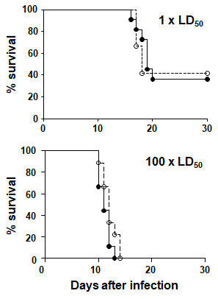
Figure S2. Survival rate of wild type (closed circles) and IFNAR KO (open circles) mice infected with different doses of O. tsutsugamushi (upper, 1 x LD₅₀; lower, 100 x LD₅₀). n = 10 mice/group.

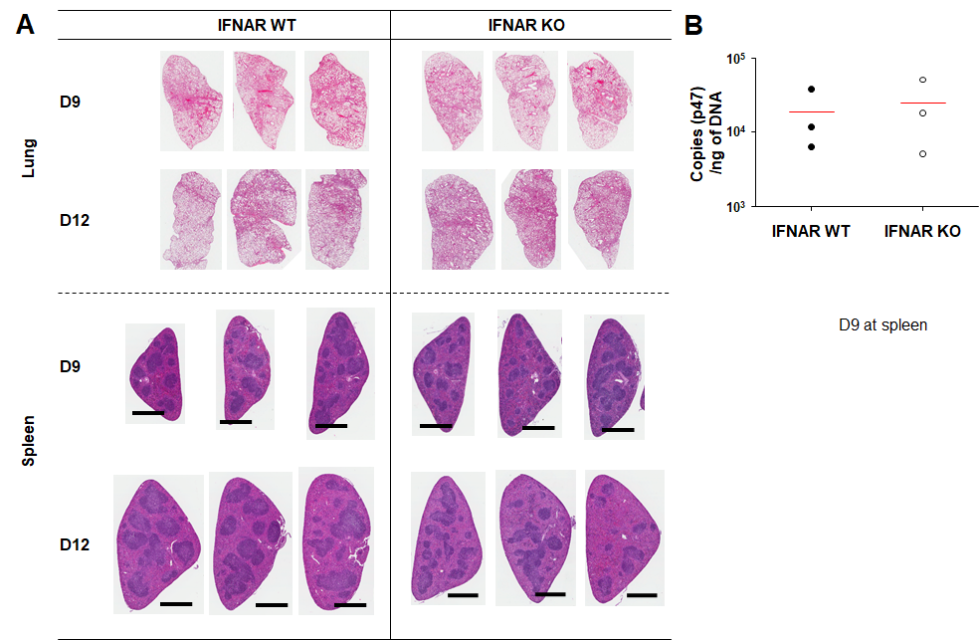

Figure S3. Histological pathology of lungs and spleens of infected mice and the bacterial loads in spleens. (A) Lung and spleen sections collected from mice at the indicated days after infection were stained with hematoxylin and eosin and representative scanned images are presented. Bar, 1 mm. (B) Bacterial loads in the spleens of infected mice (wild type or IFNAR KO, n = 3/group) collected 9 days after infection were assessed by qRT-PCR using primer sets detecting the p47 gene of O. tsutsugamushi.

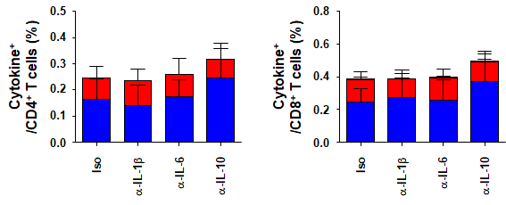
Figure S4. Splenocytes were collected from IFNAR KO mice, infected with O. tsutsugamushi, and analyzed for production of IFN-γ and/or TNF-α in CD4 or CD8 T cells by flow cytometry. Splenocytes (2 × 10⁶ cells/24-well) isolated from IFNAR KO mice were infected with O. tsutsugamushi for one day and further incubated in the presence of tetracycline (0.3 μg/ml) for three more days. Neutralizing monoclonal antibodies, such as anti-IL-1β, anti-IL-6, and anti-IL-10, as well as isotype control antibody (Iso), were added to the culture media (10 μg/ml each/24-well) of the infection assays. Cells were then stimulated with 10 μg of TSA56 for an additional 18 h and 1 μg of Golgiplug for the final 6 h in humidified CO₂ atmosphere at 37°C. Harvested splenocytes were stained with specific antibodies and analyzed by flow cytometry. Data represent mean + SD from three independent experiments. Blue box, IFN-γ-positive; red box, TNF-α-positive; yellow box, IFN-γ and TNF-α-positive.

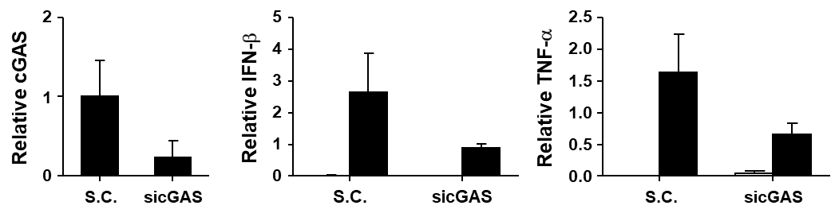

Figure S5. Induction of type I IFNs by O. tsutsugamushi infection is dependent on cGAS. MEFs were transfected with 20 nM of non-silencing control siRNA (S.C.) or siRNA against cGAS (sicGAS, Sense: CUG AAC ACU GGC AGC UAC U and Antisense: A GUA GCU GCC AGU GUU CAG) using Lipofectamine 2000 (Thermo Fisher Scientific, Waltham, MA). Cells were incubated for 2 more days and infected with O. tsutsugamushi. Total RNAs were harvested and relative expressions of cGAS, IFN-β, and TNF-α mRNA were analyzed at 4 h after infection as describe in Fig. 1. Data represent mean + SD from three independent experiments. White box, uninfected; black box, infected.

