SUPPLEMENTARY MATERIAL

FT-IR, MNR SPECTRA OF SUBSTITUTED 1H-5-MERCAPTO-1,2,4-TRIAZOLE DERIVATIVES

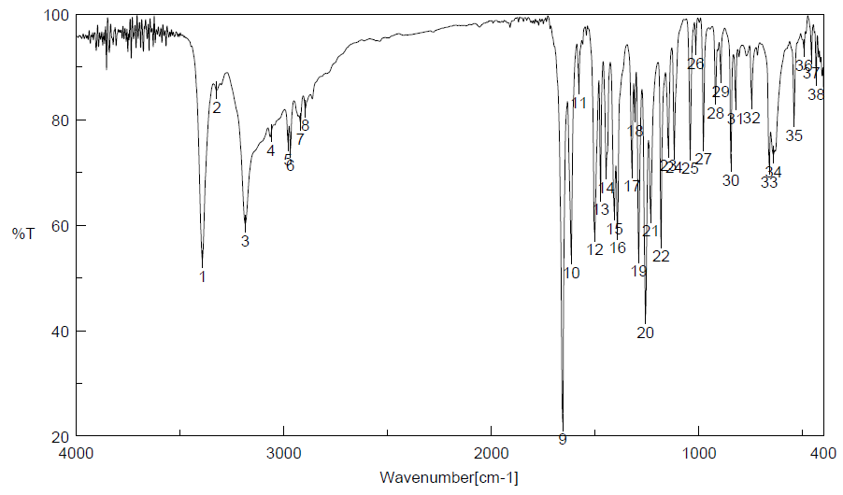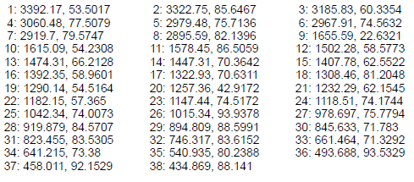
Figure 1.FTIR spectra of compound 1H-3-(4-ethoxyphenyl)-5-aminocarbonyl-methylsulfanyl-1,2,4-triazole (TZ53.3)

Figure 2. 1H-MNR spectra of compound 1H-3-(4-ethoxyphenyl)-5-aminocarbonyl-methylsulfanyl-1,2,4-triazole (TZ53.3)
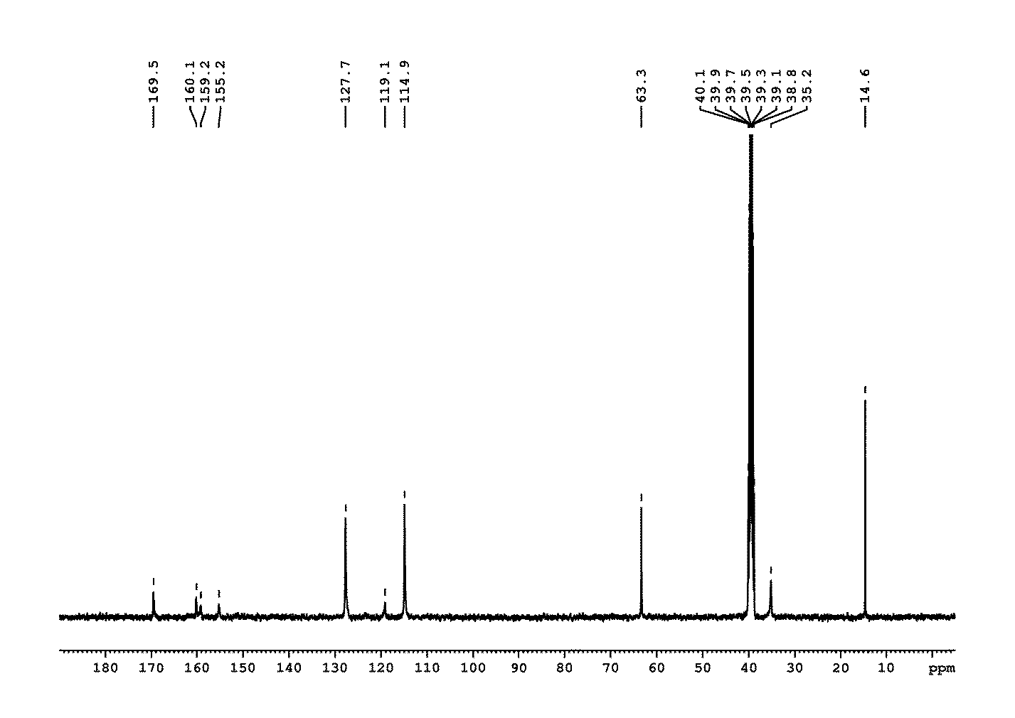Figure 3. 13C-MNR spectra of compound 1H-3-(4-ethoxyphenyl)-5-aminocarbonyl-methylsulfanyl-1,2,4-triazole (TZ53.3)

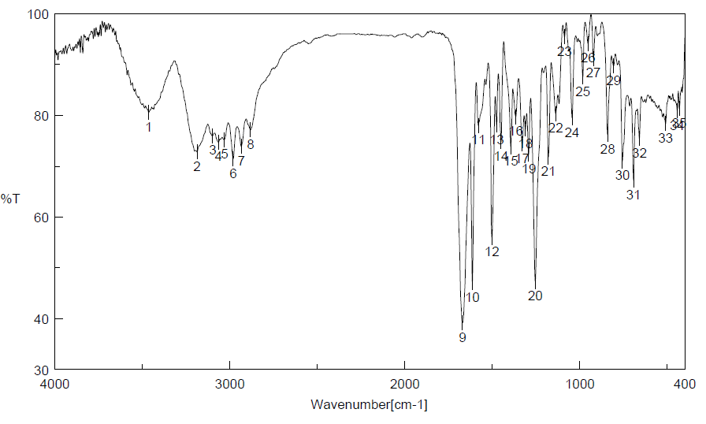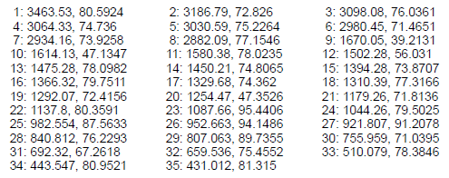
Figure 4.FTIR spectra of compound1H-3-(4-ethoxyphenyl)-5-benzylidenehydrazino-carbonyl-methylsulfanyl-1,2,4-triazole (TZ53.7)

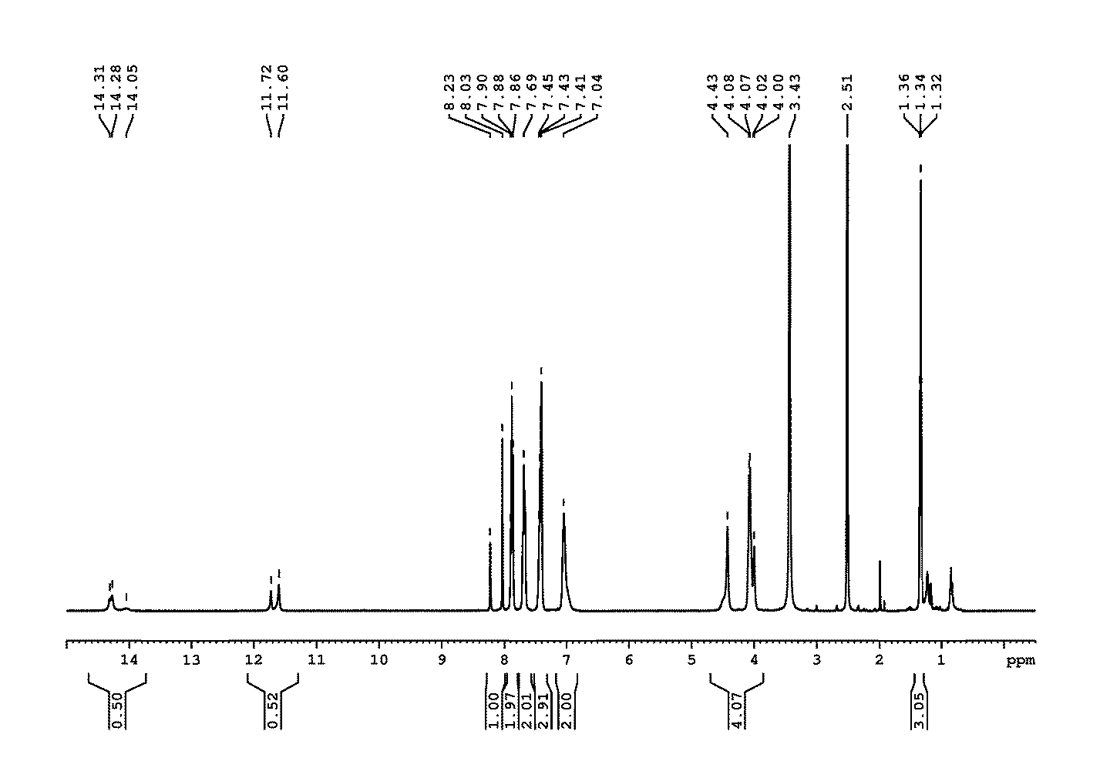Figure 5. 1H-MNR spectra of compound1H-3-(4-ethoxyphenyl)-5-benzylidenehydrazino-carbonyl-methylsulfanyl-1,2,4-triazole (TZ53.7)
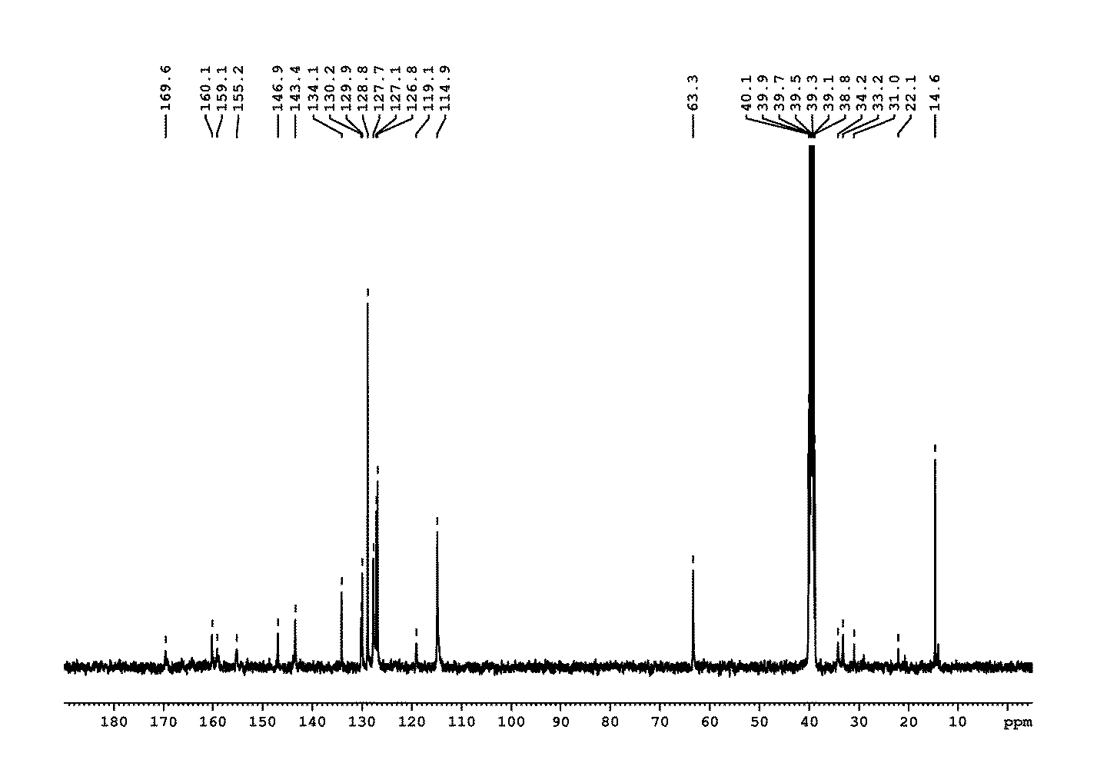Figure 6. 13C-MNR spectra of compound1H-3-(4-ethoxyphenyl)-5-benzylidenehydrazino-carbonyl-methylsulfanyl-1,2,4-triazole (TZ53.7)

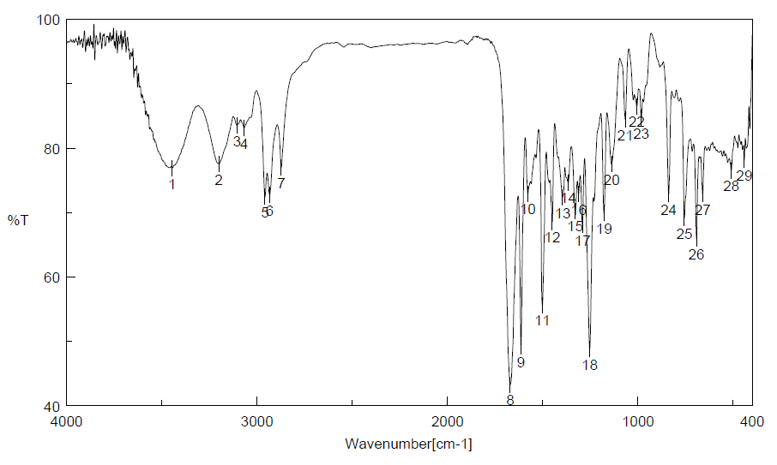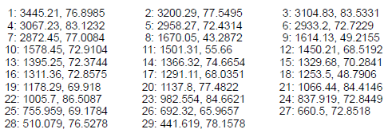
Figure 7. FTIR spectra of compound1H-3-(4-n-butoxyphenyl)-5-benzylidenehydrazino-carbonyl-methylsulfanyl-1,2,4-triazole (TZ55.7)

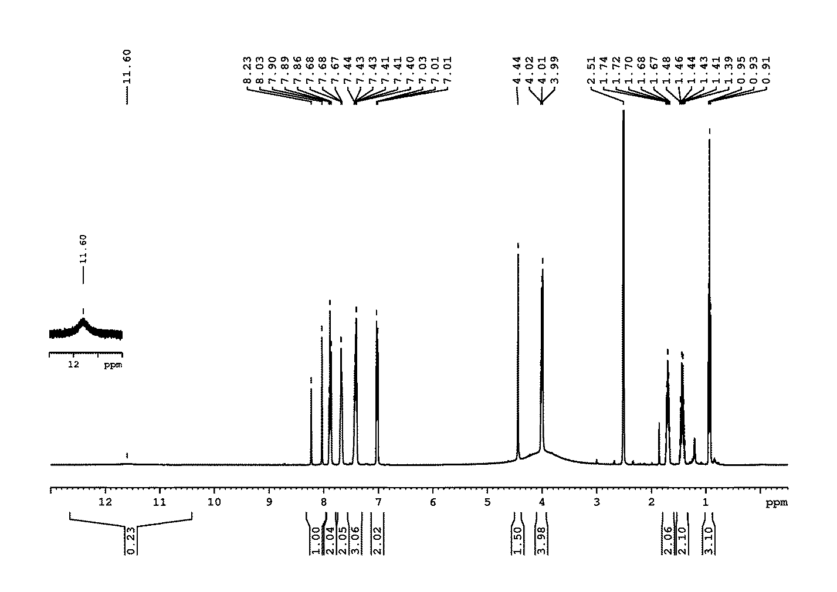Figure 8. 1H-MNR spectra of compound1H-3-(4-n-butoxyphenyl)-5-benzylidenehydrazino-carbonyl-methylsulfanyl-1,2,4-triazole (TZ55.7)
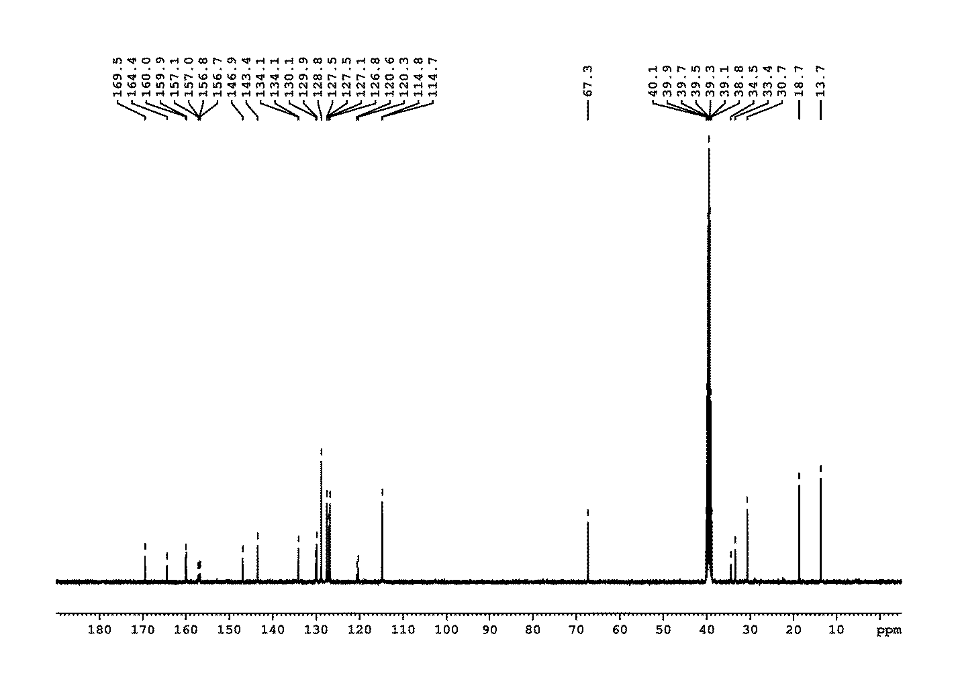Figure 9. 13C-MNR spectra of compound1H-3-(4-n-butoxyphenyl)-5-benzylidenehydrazino-carbonyl-methylsulfanyl-1,2,4-triazole (TZ55.7)

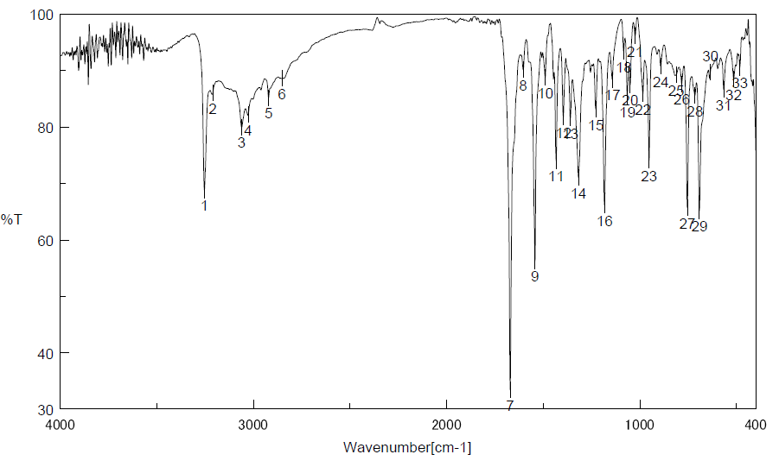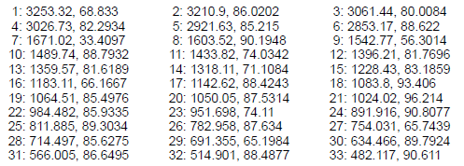
Figure 10. FTIR spectra of compound1H-3-stiril-5-benzylidenehydrazino-carbonyl-methylsulfanyl-1,2,4-triazole (TZ3a.7)

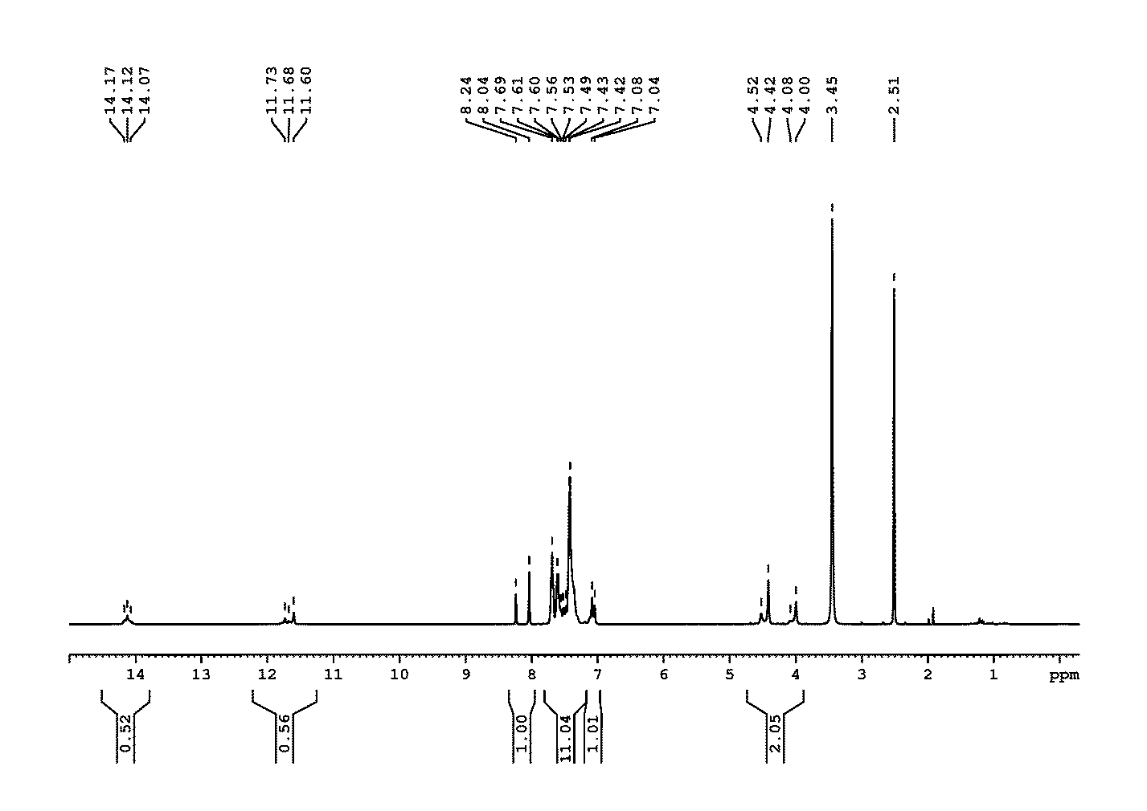Figure 11. 1H-MNR spectra of compound1H-3-stiril-5-benzylidenehydrazino-carbonyl-methylsulfanyl-1,2,4-triazole (TZ3a.7)
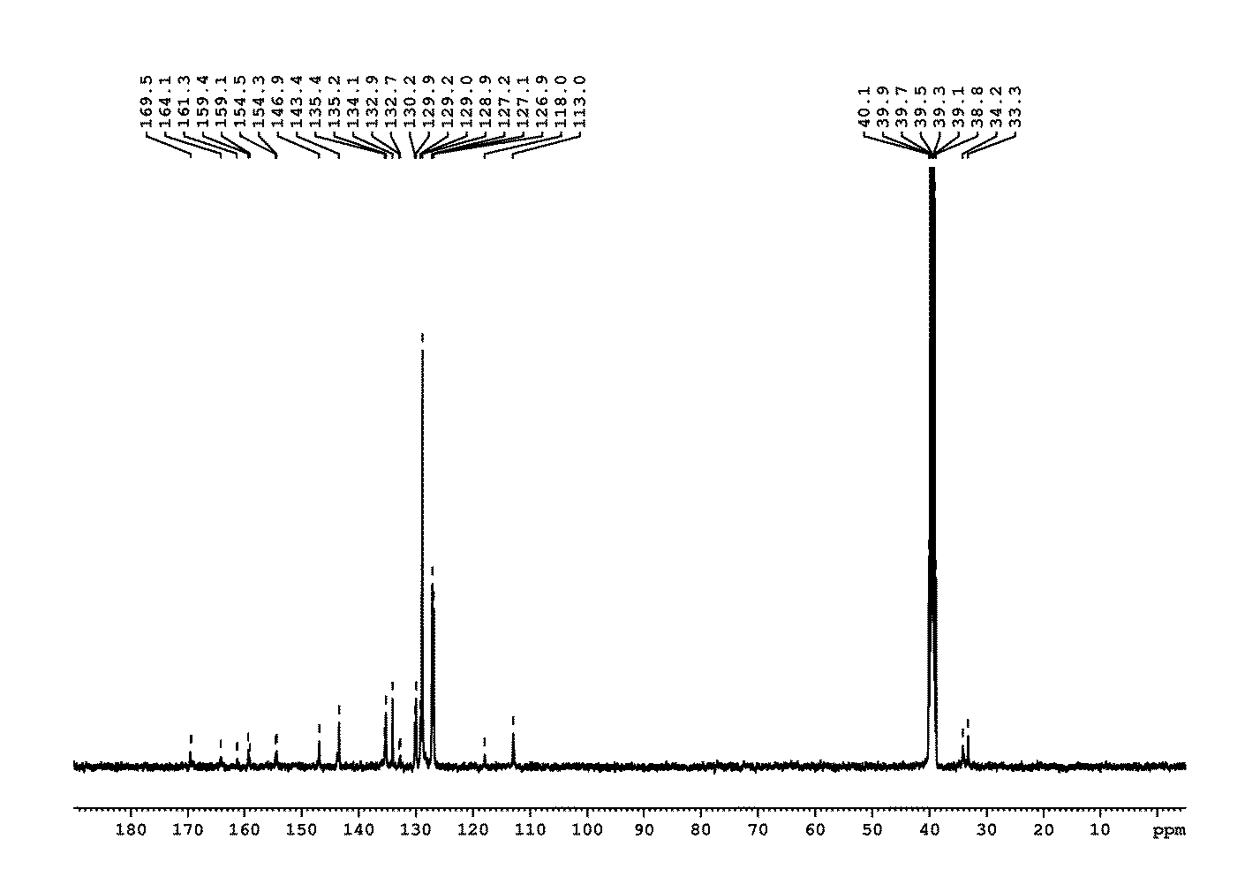Figure 12. 13C-MNR spectra of compound1H-3-stiril-5-benzylidenehydrazino-carbonyl-methylsulfanyl-1,2,4-triazole (TZ3a.7)

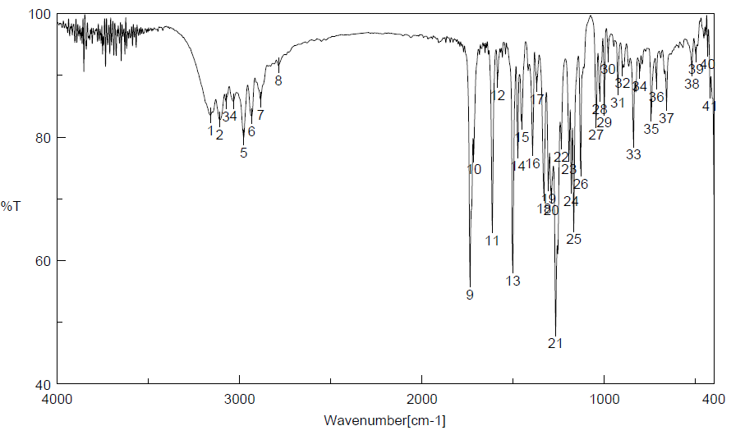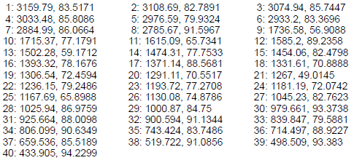
Figure 13. FTIR spectra of compound1H-3-(4-ethoxyphenyl)-5-ethoxycarbonyl-methylsulfanyl-1,2,4-triazole (TZ 53.11)

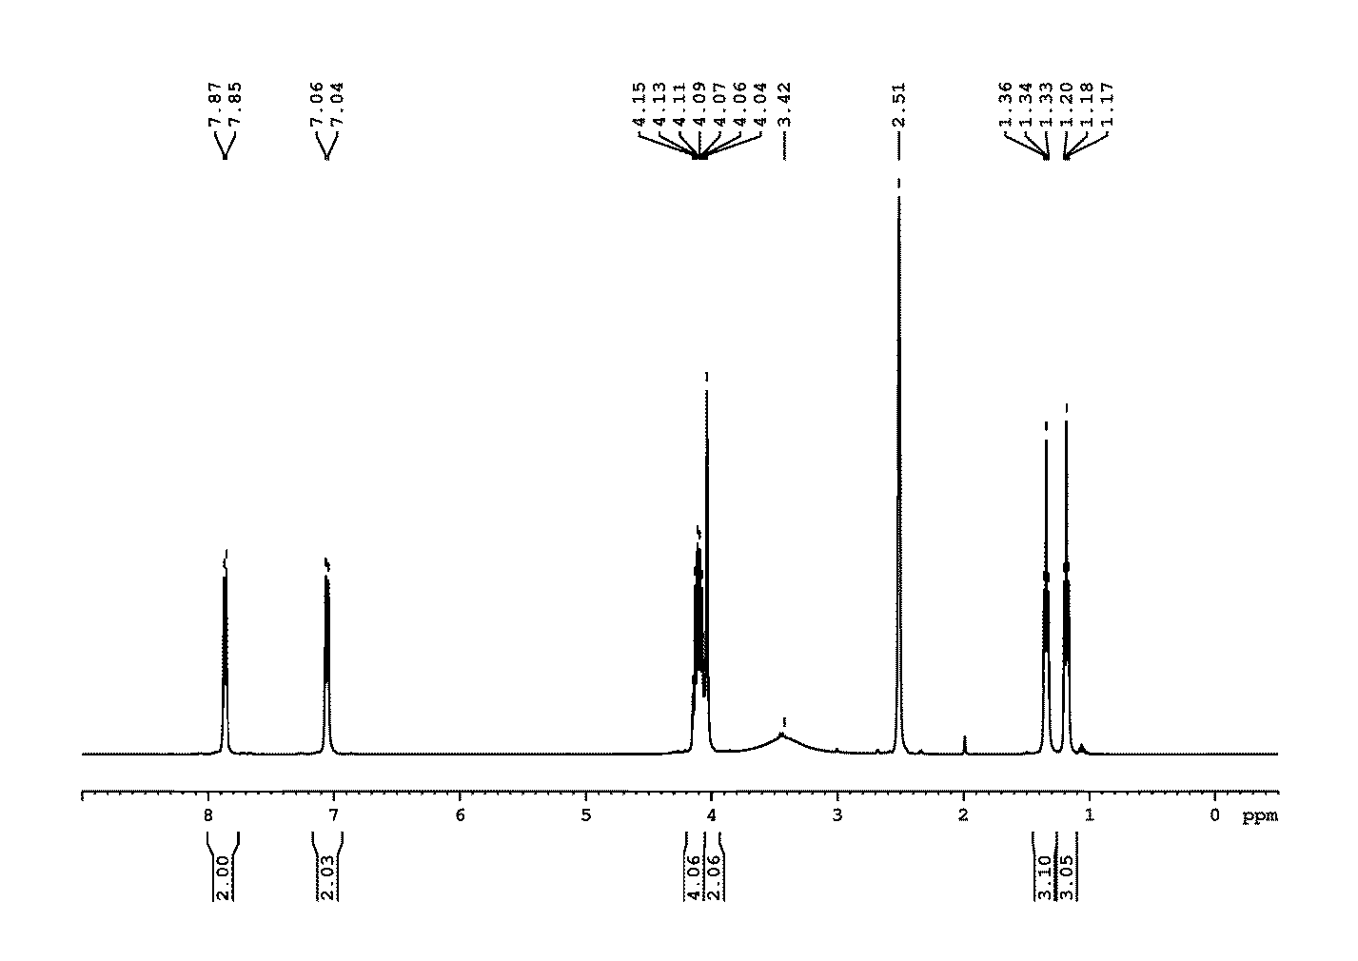Figure 14. 1H-MNR spectra of compound1H-3-(4-ethoxyphenyl)-5-ethoxycarbonyl-methylsulfanyl-1,2,4-triazole (TZ 53.11)
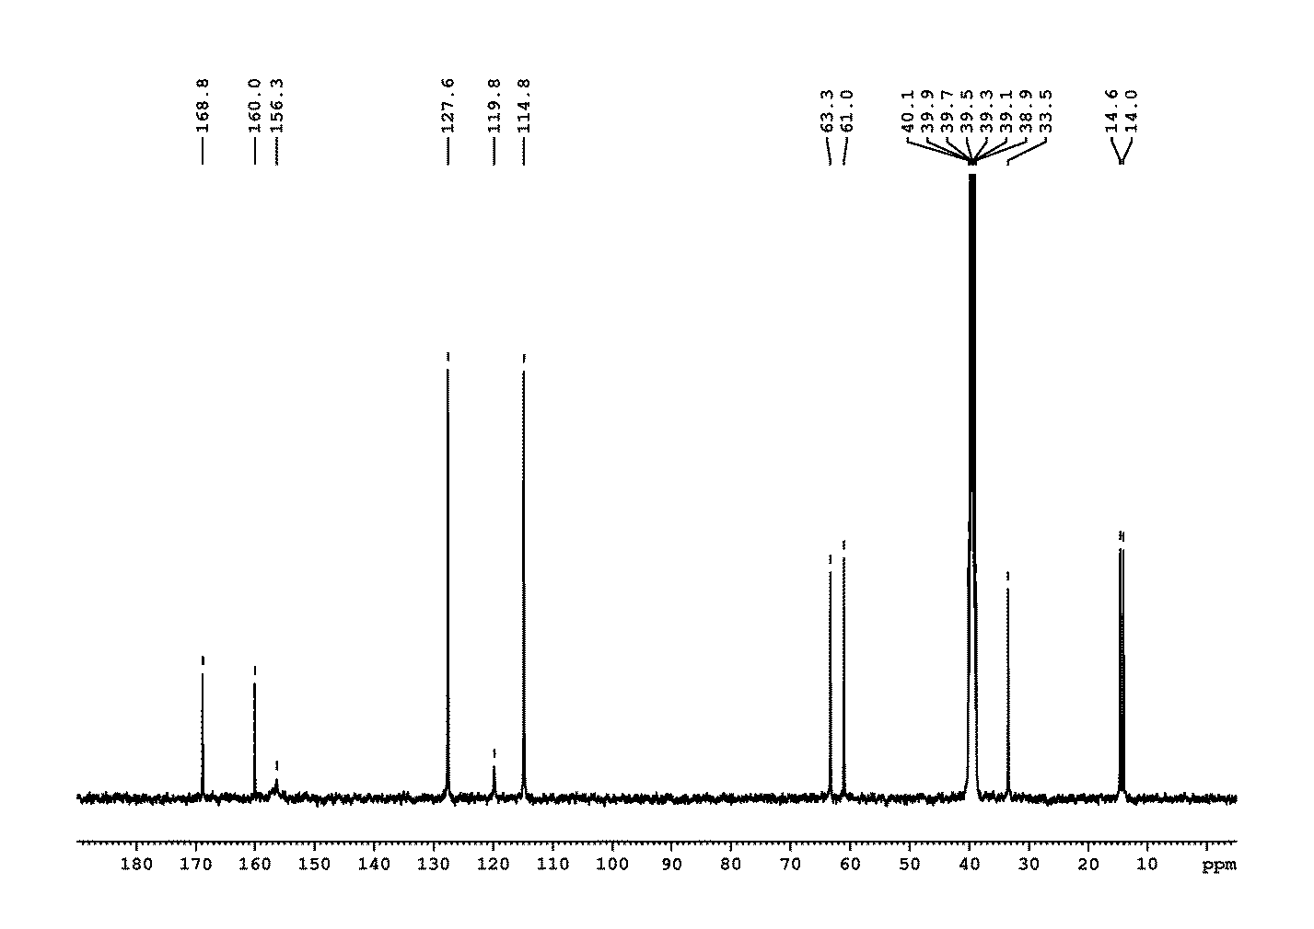Figure 15. 13C-MNR spectra of compound1H-3-(4-ethoxyphenyl)-5-ethoxycarbonyl-methylsulfanyl-1,2,4-triazole (TZ 53.11)

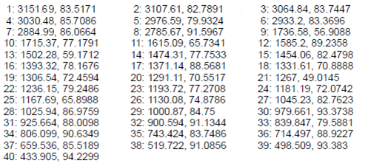
Figure 16. FTIR spectra of compound1H-3-(4-n-butoxiiphenyl)-5-ethoxycarbonyl-methylsulfanyl-1,2,4-triazole (TZ 55.11)

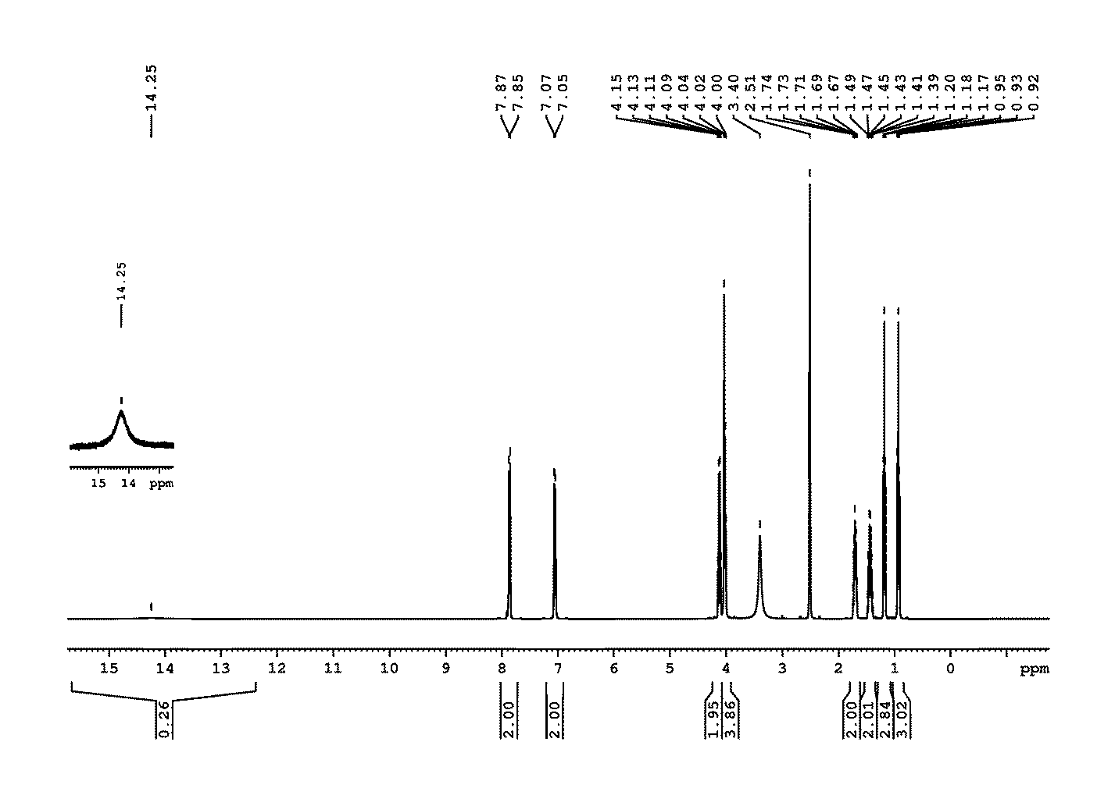Figure 17. 1H-MNR spectra of compound1H-3-(4-n-butoxyphenyl)-5-ethoxycarbonyl-methylsulfanyl-1,2,4-triazole (TZ 55.11)
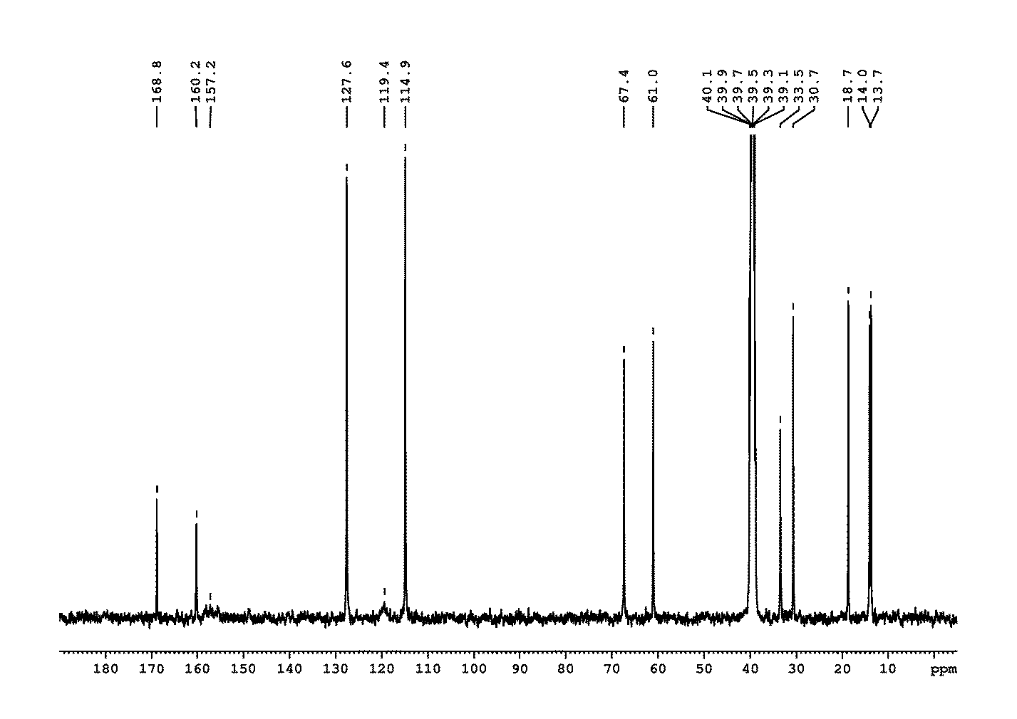Figure 18. Spectra a ¹³C-RMN compusului 1H-3-(4-n-butoxyphenyl)-5-ethoxycarbonyl-methylsulfanyl-1,2,4-triazole (TZ 55.11)

