*Figure 1.* Graphical representation of the 6-cluster solution in two samples.

*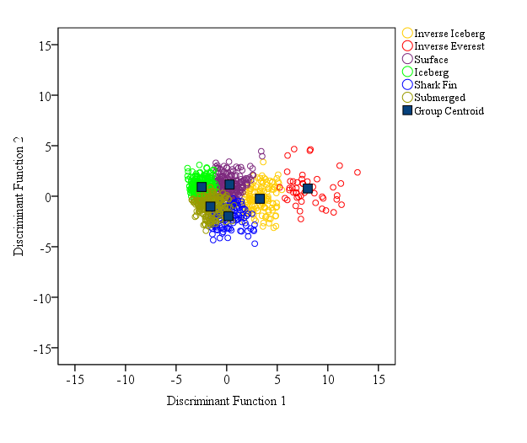*

*Figure 2.* Distribution of cases in Dataset 1 (*N =* 929) for Functions 1 and 2.