# Supplemental Tables and Figures

Supplemental Table 1 - Summary of contaminants that were removed from the 16S Illumina sequencing data.

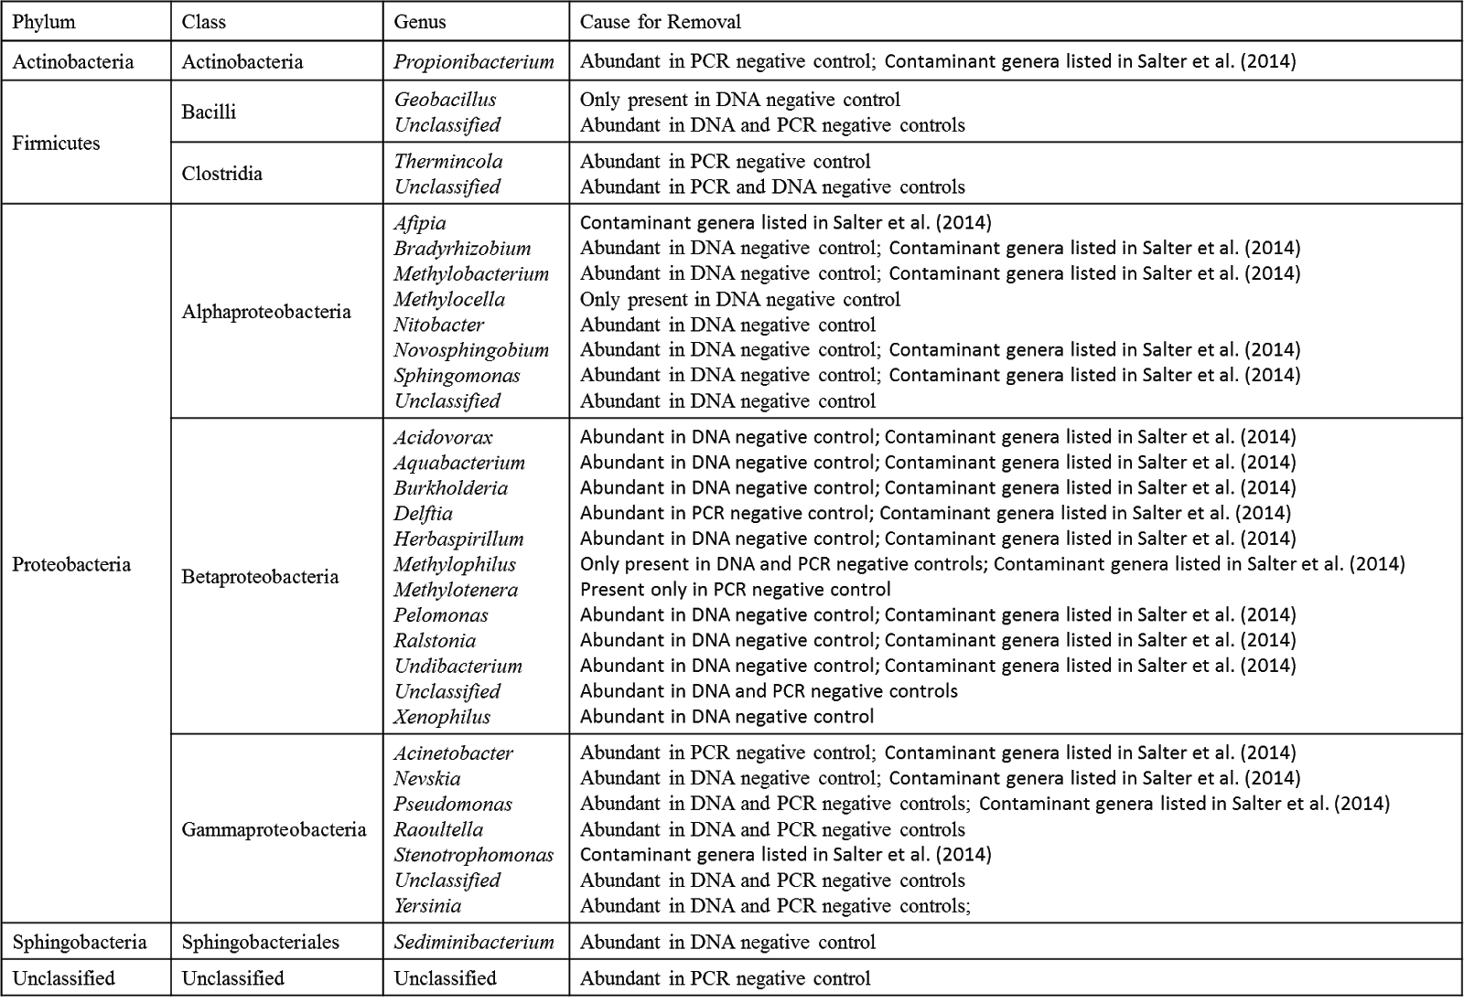

Supplemental Table 2 – Sequence numbers before and after contaminant removal for individual samples, as well as the number and percent of contaminant sequences that were removed.

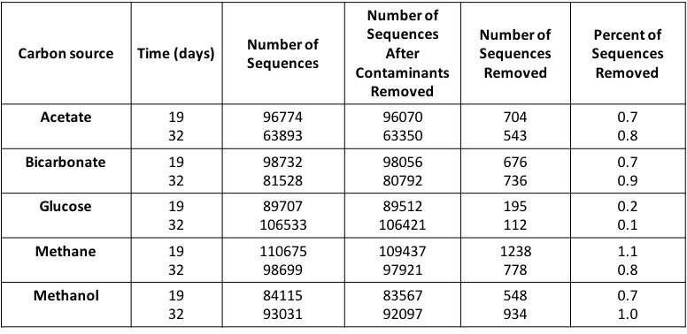

Supplemental Figure 1 - NanoSIMS images of microbial cells before incubation.  The left panel illustrates 12C14N ion counts that identify microbial cells.  The middle and right panel show the ratio image of 13C/12C and 15N/14N, respectively, showing no detectable increase in 13C/12C or 15N/14N observed for analyzed microbial cells.

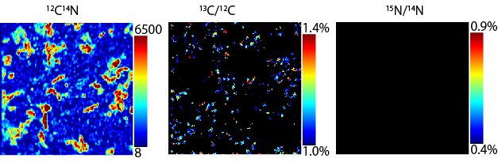

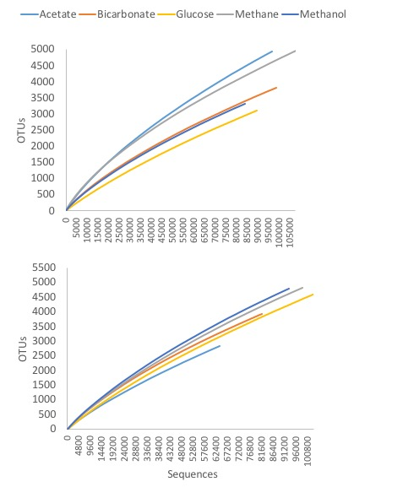Supplemental Figure 2 - Rarefaction curves for flowback microbial communities at 19 (top), and 32 (bottom) days.